FACULTY COUNCIL MEETING
3:00 p.m., Tuesday, March 21, 2023
Room 412 Student Union

AGENDA

- Roll call
- Approval of the February 14, 2022 minutes
- Approval of agenda
- Special reports
  - Aaron Smith – Information Security Officer/Director
  - Jamey Jacob – Oklahoma Aerospace Institute for Research and Education
- President’s report and comments on matters of interest to the faculty
- Provost’s report on recommendations made by the Faculty Council and comments on matters of interest to the faculty
- Vice Presidents’ reports and comments on matters of interest to the faculty
- Faculty Council Chair’s report
- Reports of liaison representatives
  - Emeriti – Barbara Miller
The Executive Board has approved working with the Foundation to name another scholarship, funded by a donation from Katherine McCollum, for Ken McCollum, one of the founders of the Emeriti Association.

Notes from Emeriti President Gary Sheerer:
At the last Emeriti Council Meeting, a great deal of discussion centered around the concern of a settlement being reached between the Stillwater Medical Center and Blue Cross Blue Shield of Oklahoma. There was optimism of a settlement being reached but concern over the possibility of higher premiums to faculty and staff. The Emeriti Association will voice their concerns on behalf of the faculty and staff at OSU. (We are aware that VP Joe Weaver is working hard on this problem).

The Emeriti Association Council also wishes to invite any staff or faculty member who may be on the verge of retiring to please consider joining the association. It is a great way to enjoy fellowship with other retirees and to stay in touch with university activities.

  - Women’s Faculty Council – Morgan Pfeiffer
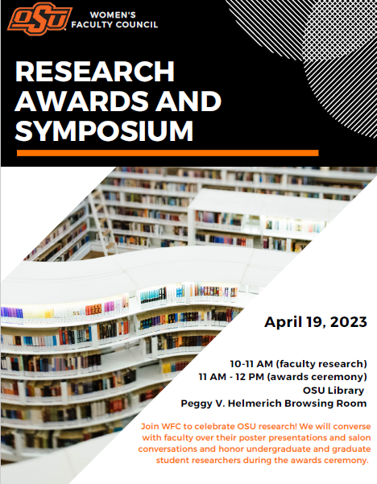

  - Staff Advisory Council – Michelle Stewart
Staff Advisory Council will have a table at the Staff Development Day to answer questions for any staff members on March 28th near the ballroom.

  - Graduate Council – Rebecca Sheehan
  - Student Government Association – Ty McLaughlin
SGA had the opportunity to travel to Washington D.C for the Big 12 on the hill conference from February 26th through March 1st. During this conference we met with both members of congress and senators to talk about issues that students experience within higher education. This was a great opportunity for our association to advocate for students.

We had our annual presidential and vice-presidential debate on March 3rd. We had four state representatives attend Eddy Dempsey District 1, John Talley District 33, Trish Ranson District 34, and Ty Burns District 35. Representative Ranson and Talley both moderated the debate. We were also able to have the O'Colly livestream the debate.

Our spring elections took place on March 7th & 8th. These elections were for living group senators and student body president and vice president. We are still waiting for the results.

  - Graduate & Professional Student Government Association – Marcia Sun
GPSGA General Assembly Meeting
Based on the general assembly's feedback, the topic for the invited guest speaker session of the sixth meeting focused on graduate student wellbeing. Our invited speaker was Dr. Toby Brown, a visiting assistant professor from the College of Education and Human Sciences. Dr. Brown curated resources specifically for the GPSGA assembly through Padlet. The resource packet was shared in the GPSGA general assembly minutes and uploaded to Canvas and distributed through the GPSGA listserv.
The seventh general assembly meeting will be held at 5:30 p.m., Wednesday, March 29, in Social Sciences and Humanities (SSH) 035. An online option will be provided for Tulsa and OKC representatives/liaisons. The invited guest speaker will be Provost Mendez.

New GPSGA Initiatives and Updates
GPSGA Engagement Program
  - Three key pillars of the program:
    - highlighting and raising awareness on existing resources and programming
    - cultivating co-curricular growth
    - fostering friendship, social engagement, and reciprocal mentorship
  - The initiative aligns with the graduate student’s wellbeing research from the National College Health Assessment (NCHA). One of the key best practices highlighted is connecting with other graduate students.
  - The friends pairing process application was distributed and completed:
    - voluntary application process
    - currently 45 participants in the group
  - Currently working on reaching out to other area clubs on campus to promote the initiative.
Impact Report
- The GPSGA President proposed compiling an impact report to be shared with the Graduate College and the graduate and professional student community. The advisor and the current board approved the proposal.
- Key components of the report:
- Collection of a record of the recipients for travel awards and other GPSGA awards for Fall 2022-Spring 2023
- Highlighted testimonials from students on how the awards impacted their academic endeavors.
- A list of events and new initiatives
GPSGA Awards – Spring 2023
  - Applications for Travel Award, Research Material Award, and Co-Sponsorship Award are available on Canvas, and the due date is April 3.
  - GPSGA is currently seeking nominations for outstanding master's students, doctoral students, graduate teaching assistants, and faculty members for the four categories of the Phoenix Awards. Descriptions of each award and eligibility requirements are available via Canvas. GPSGA will receive applications through the GPSGA Canvas Community page, and the due date for all four awards is April 3. For additional questions, please contact gpsga@okstate.edu.
General Assembly Meeting Minutes
Meeting minutes from the sixth/February general assembly meeting are available via the GPSGA Canvas page.

- Reports of standing and special committees
  - Academic Standards and Policies: Kathy Curry - Update
  - Athletics: Aaron Warren – No Report
  - Budget: Maria Ma – No Report
  - Campus Facilities, Safety, and Security: Bruce Noden – No Report
  - Diversity: Divya Jaroni- No Report
  - Faculty: James Knapp – No Report
  - Long-Range Planning and Information Technology: Kris Hiney – No Report
  - Research: Yongwei Shan – No Report
  - Retirement & Fringe Benefits: Lisa Slevitch - Update
  - Rules and Procedures: Karen Neurohr – No Report
  - Student Affairs and Learning Resources: Heather Yates- No Report
- Unfinished business
- New business
- Adjournment

