Peek called the meeting to order with the following members present: Bulut, Cole, Conway, Crick, DeSilva, Dunn, A. Weil for Hall, Finchum, Frazier, Gardner, Gonzalez, Jaroni, S. Parveen for Kaipa, Kakani, Khojasteh, Liu, M. Lovern, P. Lovern, Melancon, Neurohr, Noden, Reichard, Shreffler, Slevitch, Smith, Talley and Yates.
Also present: Bayles, M., Berg, M., Cheves, T., Clark, G., Clarke, S., Colquhoun, C., Eck, T., Essmiller, K., Griffith, H., Habiger, J., Hallenbeck, D., Hargis, B., Kluver, R., Luetkenhaus, H., McCullagh, L., Mendez, J., Miller, B., Newman, S., Ormsbee, C., Peaster, R., Sandefur, G., Sewell, K., Sheehan, R., Tucker, S., Van Den Bussche, R., Weaver, D., Weaver, J. and Wray, K.
Absent: Kazianga, Nelson and Ware.

HIGHLIGHTS

Special Reports:
Scott Newman – OSU IT ..…………………………………..……………………….
Randy Kluver – Dean Global Studies & Partnerships
Remarks and Comments – President Hargis………………………..……………………..….
Report of Status of Faculty Council Recommendations and other Vice Presidents…….…….
Reports of Liaison Representatives …………………………………………………….……..
GPSGA ………………………………………………………………………………..
Emeriti ………………………………………………………………………………..
WFC …………………………………………………………………………………..
SAC……………………………………………………………………………………
Wellness Center….…………………………………………………………………….
Graduate Council………………………………………………………………………
SGA……………………………………………………………………………………
Reports of Standing Committees ………………………………………………….…………..
Academic Standards and Policies ……………………………………….…………….
Athletics ………………………………………………………………….……………
Budget …………………………………………………………………….…………...
Campus Facilities, Safety and Security ………………………………….……………
Diversity………………………………………………………………….……………
Faculty ………………………………………………………………….……………..
Long-Range Planning and Information Technology ………………….………………
Research ……………………………………………………………….………………
Retirement and Fringe Benefits ……………………………………….………………
Rules and Procedures ………………………………………………….………………
Student Affairs and Learning Resources …………………………….………………..

Peek welcomed everyone to the March Faculty Council meeting. The chair has determined that a quorum is present, and the meeting will come to order. Peek stated that next was approval of the February 9, 2021 minutes. The minutes were distributed electronically and are available on the website. Peek asked if there were any corrections. Seeing none, the minutes were approved. Point of order from Peek, according to Robert’s Rules of Order, approval of the minutes does not require a vote. Peek asked for a motion to approve today’s agenda which was also electronically distributed. Peek asked for corrections to the agenda. Seeing none, asked for a motion to approve the agenda. DeSilva moved, Crick second. Peek asked everyone to type their response in the Chat. Motion passed and the agenda is adopted.

Peek introduced Scott Newman from OSU-IT.

Special Report:

- Scott Newman – OSU-IT, Provost and Vice President of Academic Affairs

Newman thanked President Hargis, Provost Sandefur and Dr. Peek for this opportunity and shared his screen with the following slides with those attending todays’ meeting:

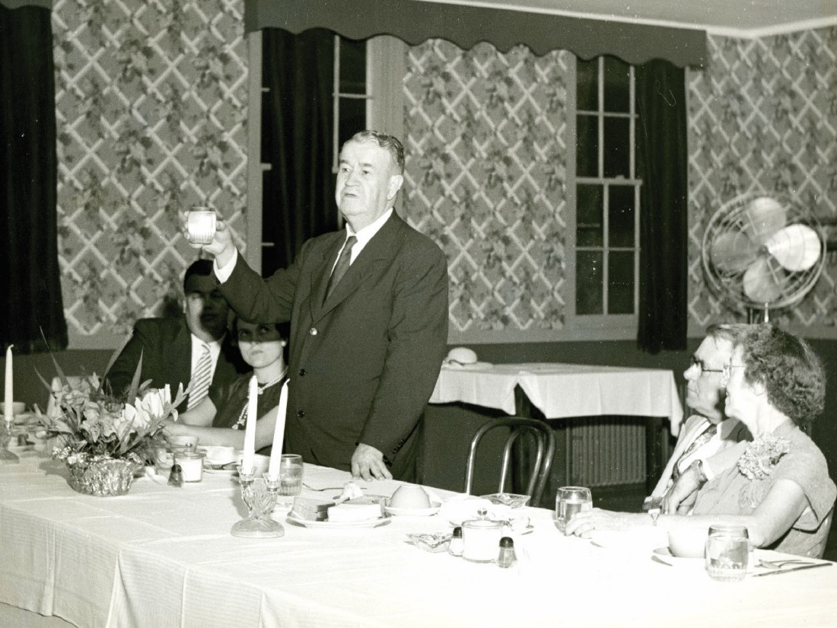

OSU President H.G. Bennett

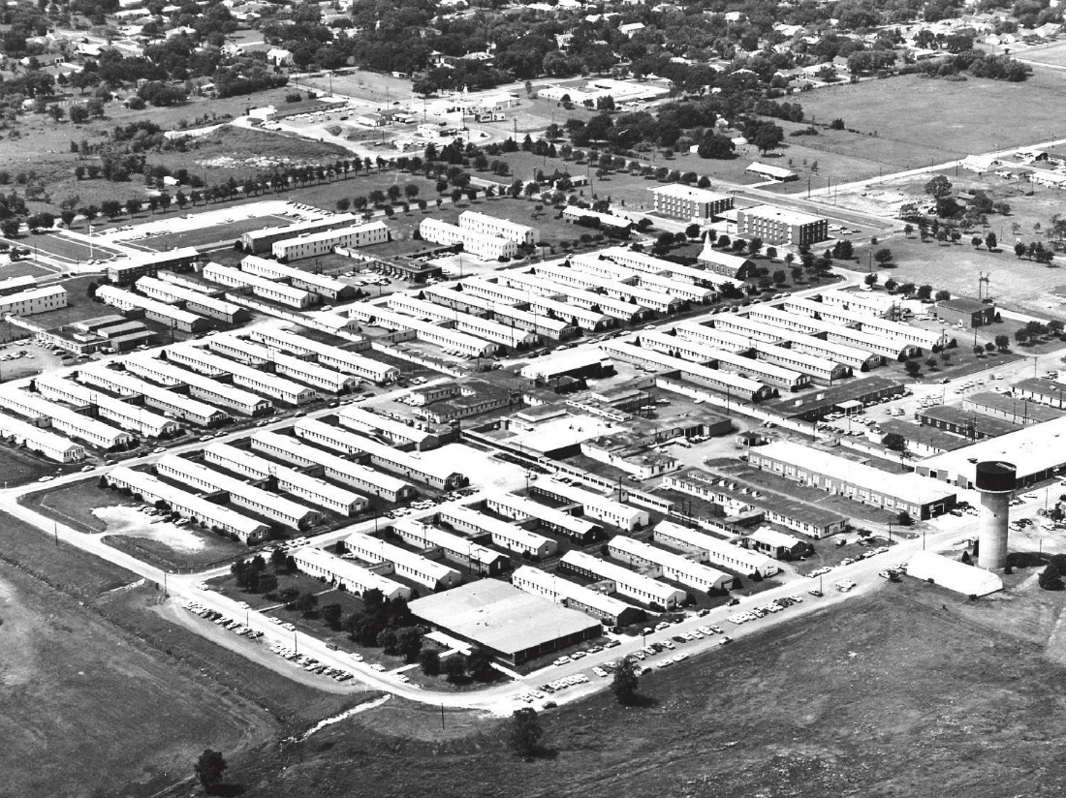
Glennan Army Hospital, 1943 – 1945 OSUIT, 1946 – Present

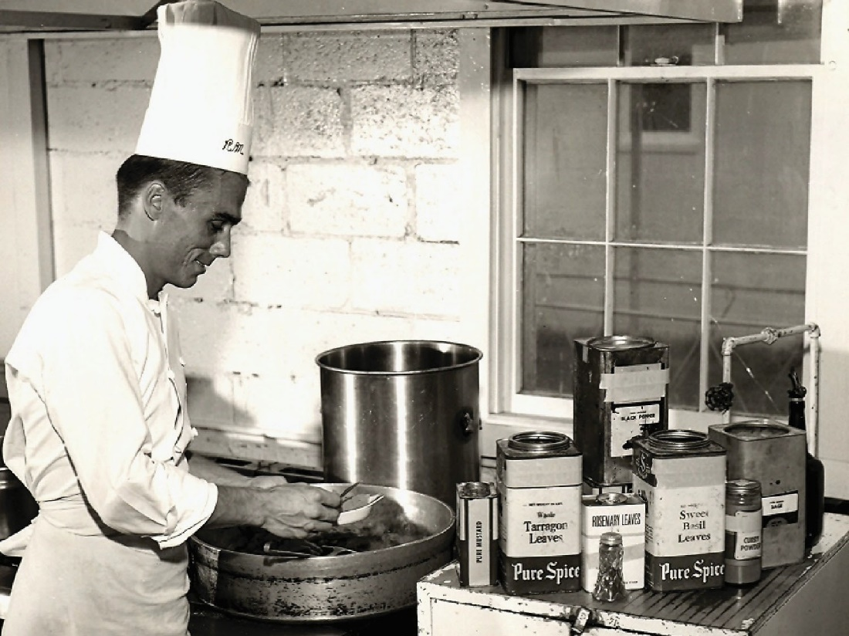

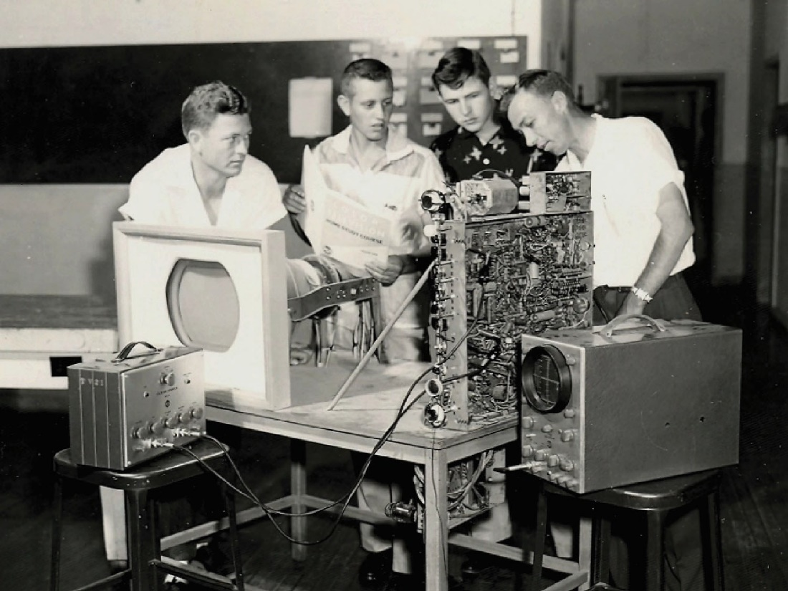



INSTITUTIONAL NAMES

1946 – 1957: Oklahoma A & M College School of Technical Training

1957 – 1986: Oklahoma State University School of Technical Training

1986 – 1990: Oklahoma State University Technical Branch – Okmulgee

1990 – 2008: Oklahoma State University – Okmulgee

2008 – Present: Oklahoma State University Institute of Technology

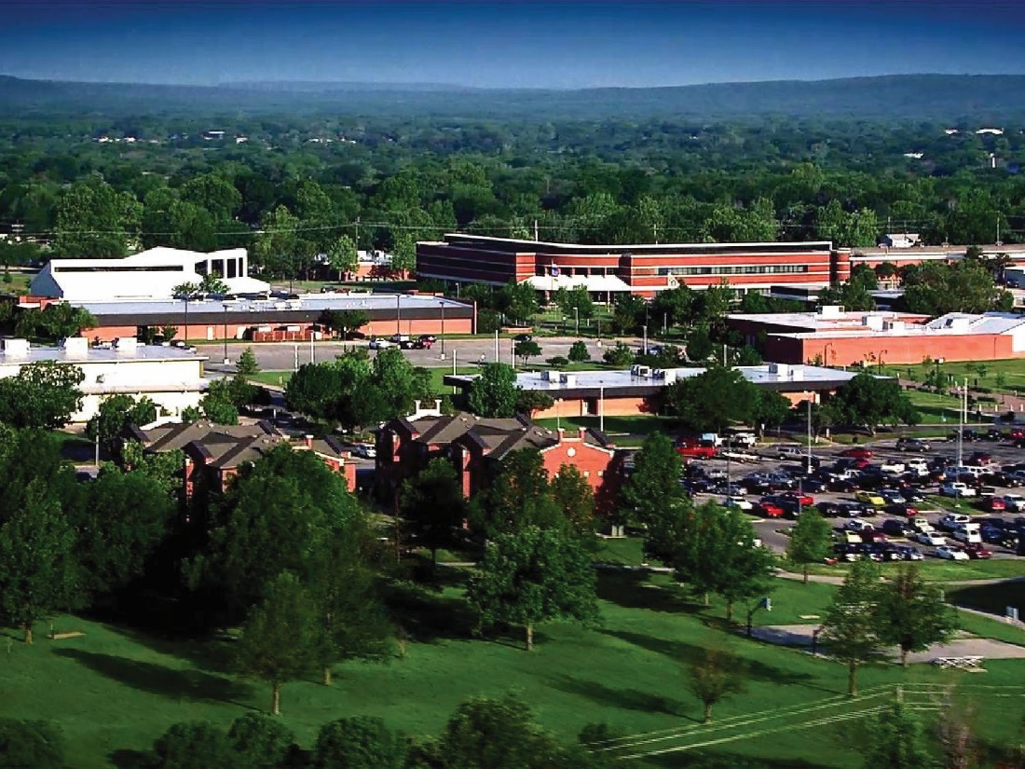

Campus Overview

230 acres

30 building complexes

~300 employees

~2,400 students



STUDENT DEMOGRAPHICS FALL 2020

📊 Average Age 23

🏢Living on Campus 637

Part Time: 38%

Full Time: 62%

Male: 66%

Female: 34%

Historically Marginalized Populations: 40%

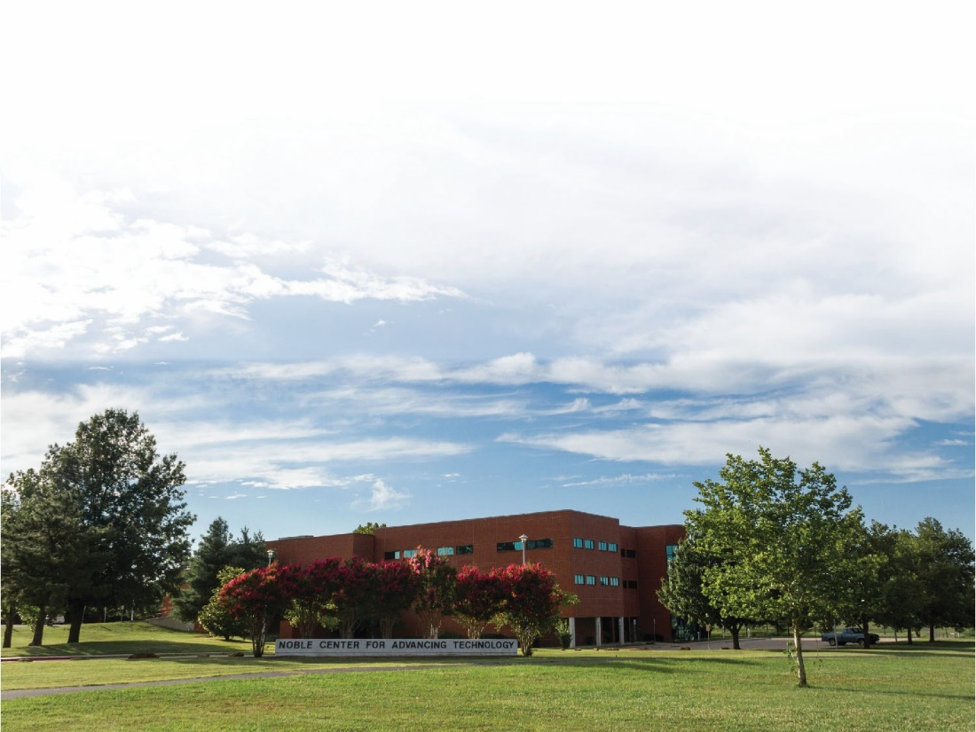

OSUIT MISSION STATEMENT

OSU Institute of Technology’s mission is to serve as the lead institution of higher education in Oklahoma and the region providing comprehensive, high-quality, advancing technology programs and services to prepare and sustain a diverse student body as competitive members of a world-class workforce and contributing members of society.



38 Degree Programs

Associate in Science: 60-63 credit hours

Associate in Applied Science: 61-94 credit hours

Degrees – Bachelor of Technology: 121-128 credit hours

Offered • Information Technologies

Instrumentation Engineering Technologies

Applied Technical Leadership



Allied Health Sciences (AS) Applied Technical Leadership (BT) Business (AS)

Culinary Arts (AAS) Baking & Pastry Food Studies

Enterprise Development (AS) Business Administration General Studies

Nursing (AAS) Pre‐Education (AS)

Pre‐Professional Studies (AS)



3D Modeling & Animation (AAS) Graphic Design Technology (AAS) Information Technologies (AAS) Information Technologies (AS) Information Technologies (BT)

Cybersecurity & Digital Forensics Network Infrastructure

Software Development



Air Conditioning & Refrigeration (AAS)

Civil Engineering/Surveying Technologies (AAS) Construction Technologies (AAS)

Construction Management Electrical Construction

Engineering Graphics & Design Drafting Technologies (AAS)

Engineering Technologies (AAS) Electrical/Electronic Technologies Instrumentation Technology

High Voltage Lineman (AAS)

Instrumentation Engineering Technology (BT) Natural Gas Compression Technologies (AAS) Pipeline Integrity Technology (AAS)

Power Plant Technology (AAS)



Automotive Service Technologies

‐ Chrysler Mopar CAP (AAS)

‐ Ford ASSET (AAS)

‐ General Motors ASEP (AAS)

‐ Pro‐Tech (AAS)

‐ Toyota T‐Ten (AAS) Diesel & Heavy Equipment

‐ CAT Dealer Prep (AAS)

‐ Komatsu ACT ( AAS)

‐ Truck Technician (AAS)

‐ Western Equipment Dealers Association (AAS)

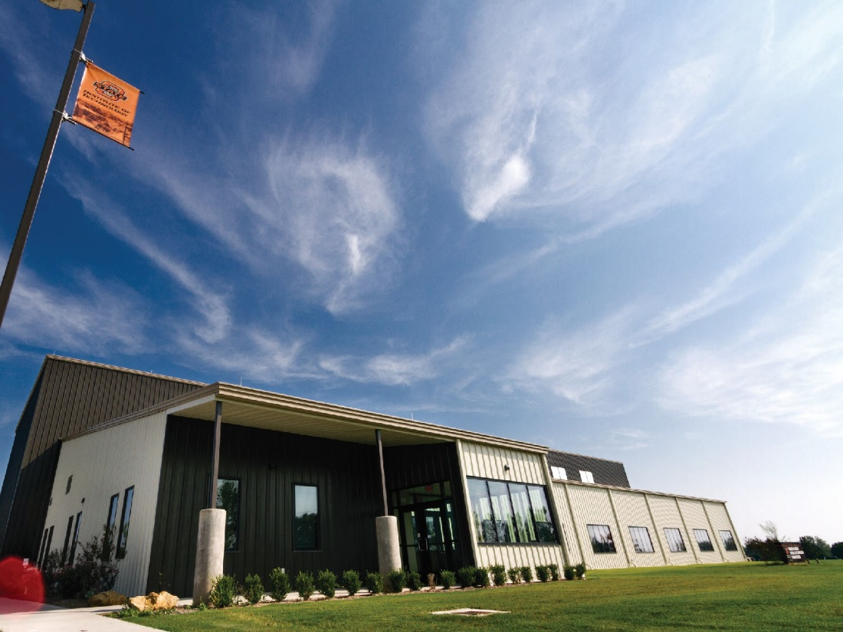

OSUIT Graduate Employment Rate in Field: 91% (5YA)

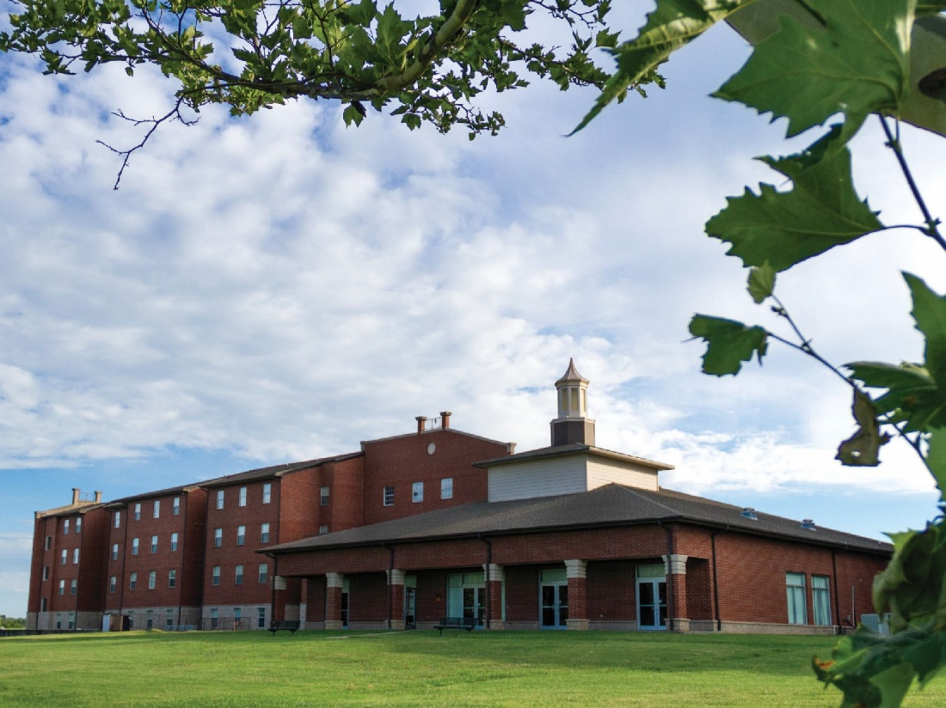

OSUIT Graduate Employer
Satisfaction Rate: 100% (2020)

Employers Who Would Hire an

OSUIT Graduate Again: 100% (2020)



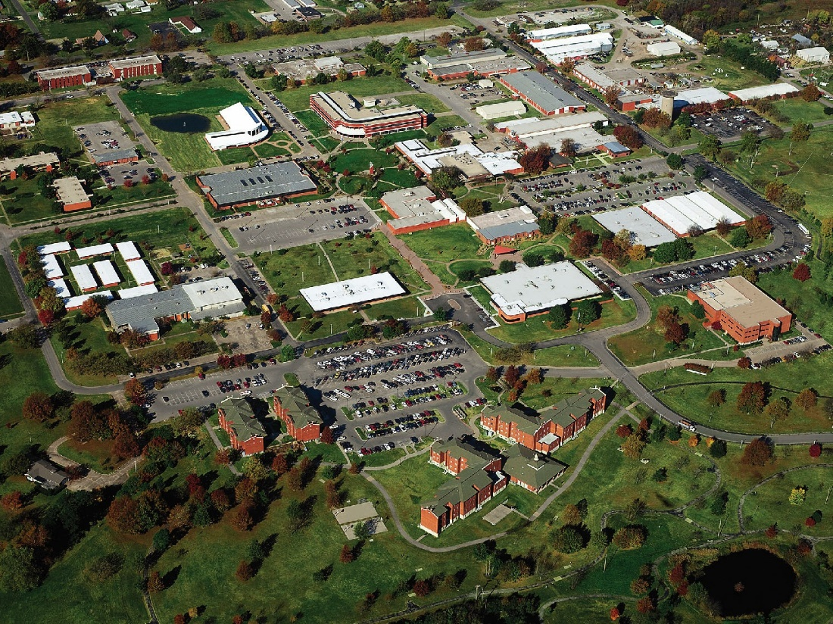

QUESTIONS?

Newman stated that OSU- IT was the brainchild of H.G. Bennett, OSU President from 1928-1951. Bennett was concerned about the number of WWII veterans returning home and OSU Stillwater’s capacity to hold them. Bennett purchased, what is now OSU-IT, from army surplus the land and buildings that were a WWII hospital. OSU-IT began its first class in October 1946. The focus as that time as well as the focus today is trying to provide people with opportunities to get a workforce-oriented education and move into rewarding and successful careers.

Peek opened the floor for questions. Frazier asked for the average graduation rate. Newman stated that it is 41% across the board. Newman stated this is a pretty good rate for a predominantly 2-year institution.

Peek thanked Newman for his presentation and hopes that everyone has a better feel for OSU-IT.

- Randy Kluver – Dean Global Studies and Partnerships

Peek introduced Dr. Randy Kluver. Kluver shared the following PowerPoint with everyone attending the meeting:

Kluver made a correction to slide 4 – the date should be September 1, 2021 not August 1.
This correction will be made to guidance materials. Kluver said this semester there were almost 30 students submit applications. Around a dozen were approved with only two actually traveling. This is due to restrictions on the country the student was approved to travel to. Kluver stated the process is working and they are not seeing much travel.

Peek opened the floor for questions. Peek thanked Dr. Kluver for the information.

Remarks and Comments – President Hargis

Hargis stated that as of yesterday everyone can get vaccinated. University Health Services released a statement for vaccine offerings to phase 3 to include all OSU Stillwater faculty, staff and students. Hargis urged everyone to get the vaccine if you have not already done so. Hargis believes they are doing about 1,000 vaccines a day. This is very good news. Hargis stated that OSU has had a reasonably calm semester in terms of COVID positives. At one point we were under 10 in quarantine. Hargis stated that everyone for the most part have been careful. He thanked the faculty for taking the time to teach students because in-person is so much better especially for the younger students.

Hargis had a good meeting with Governor Stitt yesterday. Hargis believes OSU is in good shape on the endowed chairs. He believes they will have $1.2 billion in one-time money. Hargis believes they will use part of this money to bond for the unmatched chairs which is about $151 million. OSU’s part of this is about $90 million. Hargis said it sounds like the budget might be a little bit better which is hard to believe given the year that we’ve had.

OSU has hired a new dean for Education and Human Sciences. John Pederson is from South Carolina. He was at OU for a few years, then in Nebraska (where he is from) for a few years when they combined their Education and Human Science colleges. We are looking forward to his arrival.

Hargis said that the new Presidential search is going well and should be completed next month.

Hargis stated that we had announced a transition within the Athletic Department where Chad Weiberg will become the new Athletic Director on July 1.

Peek opened the floor to questions. Hargis wanted to let everyone know that he will be around after he steps down as President. He will be involved with the Center for Ethical Leadership. He will hold a $2 million endowed chair for $1 a year. The name will be changed from a Center to an Institute. He believes there is a source for quite a bit more money so we can have a robust Leadership program. Hargis stated we do a great job now but can do a lot more. We will be able to measure a lot better if we are really making headway with turning our students into not only intellects but also leaders. Hargis said this will be a part-time endeavor.

Report of Status of Council Recommendations:
Provost Sandefur and Vice Presidents

Sandefur gave the Council members an update on current recommendations:

21-02-01-Res: Modify P&P 1-0505, The Care and Use of Animals in Research, Testing and Teaching. Pending. Will be discussed with the Council of Deans in March.
20-12-01-LRPIT: Amendment to OSU P&P 3-0601, Appropriate Use Policy.
Accepted. Policy was posted to the OSU P&P website on 3//8/21.
20-10-01-Res: Modify P&P 4-0120, Rights to Results of Sponsored Research Projects or Programs. Pending review by the Office of Research.
18-05-02-Faculty: Proposed changes to the Preface and Body of the “Policy Statement to
Govern Appointments, Tenure, Promotions, and Related Matters of the Faculty of OSU”. Still being reviewed by Legal Counsel.

Sandefur said this is his last meeting and he has enjoyed working with everyone. He has especially enjoyed the close working relationship he has had with the Faculty Council officers and Tricia over these past 7 years. It has been a great pleasure. Sandefur said this a very high functioning, well run Faculty Council and we should all be very proud of this.

Peek thanked Sandefur for all his years of service and dedication. Peek stated that Sandefur has made an incredible impact on her and she is very sad to see him go. Thank you Provost Sandefur, round of applause. Peek is so glad that we will have an opportunity to interact with him with a few functions that are being planned. Peek stated that Faculty Council is soliciting donations to the Foundation in his honor so you have not heard the last of us. We are so grateful to you.

Other Vice Presidents:

Joe Weaver – VP Administration & Finance

Weaver stated that we had about 30 buildings on campus that had water issues due to the cold snap and ice storm. It really brutal. We had a lot of employees struggling to take care of campus keeping things going and open. We had problems in housing with students getting cold. Weaver stated the Hallenbeck and his crew were very understanding because it was a really bad situation. Weaver stated we are “waiting for the shoe to drop”. It won’t happen immediately but we are concerned about the utility companies like OG&E raising rates. Weaver stated the city of Stillwater just found out yesterday they got a $15 million budget increase but theirs does not have to go through the corporation commission. OSU’s does. The jury is still out on how much the utility will hit us with and Weaver is very concerned about it. They are stating that someone has to pay the bill and Weaver is hoping the state will step up and try to mitigate this to some degree. Weaver thanked everyone again for their patience and he hopes no one was seriously impacted the weather. Weaver is worried that we will have hundreds of dead plants around campus that we will have to replace or severely trim back.

Peek opened the floor for questions. Neurohr stated that the Postal Service Facility is moving effective April 1st to a campus location that is further out. Neurohr would like to know if there is a possibility to still have a customer service outpost or something closer to the interior of campus sometime in the future. Weaver stated we can look into this. Weaver said that the demand has been so light this year that this has not been seen as necessary but they can talk about it and look into it.

Doug Hallenbeck – VP Student Affairs

Hallenbeck stated that Joe’s team did a fantastic job during the cold snap.

Hallenbeck stated that we have entered phase 3 as President Hargis mentioned. Hallenbeck stated that we will do as much as the county gives us. Right now we can give 1,000-1,200 a day. Hopefully 2,200-2,500 a week if we can get that much vaccine. Right now we have first shots scheduled for Friday and Wednesday. If we get more vaccine we will work through Barlow and his team as well as Athletics and others to identify other locations that we can do mass vaccinations. We are very excited about this. As President Hargis mentioned, as of yesterday we have less than 10 active student cases on campus. No students are in quarantine housing at the moment. Hallenbeck stated this could change tomorrow and go back up if we are not vigilant but the trend is in a positive direction at the moment.

Hallenbeck stated that the last wellness day went very well. There were several hundred students and staff that participated in the events the Department of Wellness put on. Hallenbeck feels that OSU is well positioned having cancelled spring break and moved the semester back a week and providing these wellness days.

Hallenbeck stated that they are moving forward and have had very good conversations about the Remembrance Garden. Hallenbeck believes that Faculty Council as well as Undergraduate Student Government passed a resolution for a Remembrance Garden. He wanted to let everyone know that they are moving forward with planning for the Remembrance Garden.

Hallenbeck stated that they have added a student support resource page on Canvas. If you have students who need help and you don’t know where to send them, the page is now available in Canvas. This is part of the “Culture of Care” we are putting in place.

Peek opened the floor to questions. Smith stated his son received his Moderna shot in OKC. He lives on campus in Stillwater. Smith asked if it was true that OSU is only offering Pfizer shots. Hallenbeck stated yes, they currently only have the Pfizer shots through Health Service. We may get some Johnson & Johnson. Peek asked if a family member not affiliated with OSU (say a 14-year-old) can get a shot right now? Hallenbeck stated not at the moment, they do not fit into phase 3 unless they have comorbidities. Weaver stated that both Wednesday and Friday appointments filled up fast and we are expecting a lot of people to want to get vaccinated so it will be all that we can do to get our faculty, staff and students done. Once this dies down, we can start bringing more people in.
DeSilva thanked Hallenbeck for making the BMI 25 so people could get vaccinated last week. DeSilva stated that a group of people who are not included in this phase but are very important to campus are the ABM workers. They are the ones wiping down every door and door handle on campus since March 2020. DeSilva does not believe they are considered employees because they are contractual. Is there anyway to get them included as employees to get them vaccinated. Hallenbeck said he doesn’t know the contractual relationship that we have with ABM and how this would work but he said we can look into it. Weaver stated that he was briefed on this and other arrangements had been made for these folks but he does not recall the details. Weaver is certain we can get them in at some point. Since they have a contractual relationship with us, Weaver believes their employer should have made arrangements for them to be vaccinated somewhere. But we will check on it. Hallenbeck stated they are definitely part of the team.

Kyle Wray – VP Enrollment & Brand Management

Wray stated that they had reported numbers before the holidays that were very challenging both in terms of applications and admits. These numbers have come roaring back. We’ve had over 15,000 students apply for admission. This is down about 200 compared to last year but these numbers are increasing by the day. When comparing these numbers to 2019 and 2018 we are up 1,500 and 2,000 respectively. These look very good. Wray stated that admit numbers are approaching 11,000 students admitted to OSU at this point. This is dead even with where we were this time last year. This is all very good news. The last admitted student day is March 12th. This had been one day in Gallagher/Iba with 2,500 students and parents in the past. We could not do this due to COVID and had to break them down into singular days that had 100 students plus one parent each due to social distancing protocol. These have gone very well. We have announced that our new student orientation sessions will be in person starting at the end of May. We will have a few virtual but we are happy to announce these will be in person starting the last week in May.

Peek opened the floor to questions. Seeing none moved the reports of Liaison Representatives.

Report of Liaison Representatives:

- GPSGA – Maegan Berg

Announcements:
- GPSGA elections will be held on March 24, and officer nominations are now accepted. Nominate someone else (or yourself) through campus link.
- Fall semester travel award recipients are advised to submit their post-conference report before March 15.
- Due to inclement weather and rolling blackouts, if you have experienced a power service interruption and were unable to participate in the general assembly meeting, the recording of this particular meeting is available on the GPSGA Student Community page in Canvas.
Spring GPSGA Awards and Application Deadlines:
- Group fund - applications are due midnight today, check the GPSGA canvas page for eligibility and procedure!
- Phoenix Awards (Masters, Doctoral, Faculty) - Mar 15, 2021
- Outstanding GTA Award - Mar 15, 2021
- Co-Sponsorship fund - Mar 24, 2021
- Travel award - Apr 1, 2021
Get Involved or Stay Involved with GPSGA:
- Our Daily Bread mobile market will be at the FRC Parking lot on March 3, 2021, 2-4 PM. To volunteer, sign up here.

- Emeriti/OLLI update – Barbara Miller

Many first-time teachers are surprised to find that our “students” are very advanced. Our first-time class in epidemiology has over 50 students, and the professor is amazed at all the complex questions he gets. Another professor who has taught several philosophy classes has decided to teach a course this fall that he is planning for spring with his grad students. We are currently looking for a political science professor to teach a class in local and state Oklahoma government to discuss various structures of local government in Oklahoma, gerrymandering, etc. these are just a few ideas that show the variety of subjects that draw students to OLLI. OLLI is currently accepting course proposals for summer and fall 2021. We are looking for courses that could be taught online as well as in person, single or multi-week. Class proposals should be submitted on the OLLI website at olli.okstate.edu. Any questions can be sent to olli@okstate.edu or call the OLLI the OLLI office at (405) 744-5868, M-F.

- Woman’s Faculty Council – Liz McCullagh

Anyone interested in the WFC can visit our website at http://womensfacultycouncil.okstate.edu and email wfc@okstate.edu to sign up to be put on our email list.

March 1st’s meeting highlighted “Addressing the Academic Impacts of COVID in K12 and higher education,” featuring Dr. Jessica Metcalf (Colorado State University) and Dr. Kimberly Yuracko (Northwestern University). Both panelists spoke about initiatives that their universities have been trying to implement to address the impacts of COVID on academic productivity and in particular regarding issues related to childcare (or lack thereof).

April 5th (2:30-3:30PM - Zoom): Partnership with EQuAL: “Inclusive Practices in Research” Panel featuring:
Dr. Juniper Simonis (DAPPER Stats)
Dr. Corinne Schwartz (Assistant Professor of Gender Women’s and Sexuality Studies) Dr. Louise Siddons (Associate Professor in Art History)

Announcements:
Seeking reviewers for the Student Research Awards
Please email Sarah Milligan (sarah.milligan@okstate.edu) if interested in volunteering.

Ann Ryder and Clara Smith Undergraduate Leadership Scholarship are also open for applications (https://womensfacultycouncil.okstate.edu/scholarship.html) and due March 15.

- Staff Advisory Council – Tashia Cheves

SAC Scholarships are open and applications are being reviewed. Scholarship deadline is next week.
SAC Elections are upcoming and nomination information is available on our website.

- Wellness Center – Kim Beard

- Graduate Council – Rebecca Sheehan

Graduate Applications. An application, admission and recruiting report will be sent to graduate coordinators and school or department heads in March.

Plan of Study. Enrollment holds will be placed soon due to MS students not filing their POS within two semesters and doctoral students with three semesters.

Graduate Matriculation Videos. Matriculation training videos on using Round Up, etc. will soon be uploaded on Canvas.

Degree Works. Degree Works, which is already used to clear undergraduate degrees, is being piloted by the Graduate College for coursework-only graduate programs.

Virtual Resources. Dean Tucker explained that some aspects of our remote work have been positive, such as higher attendance at virtual Zoom events, and may remain after the pandemic is over.

Pilot Program for Aged Graduate Coursework. The School of Forensic Sciences and the School of Healthcare Administration have proposed professional doctorate programs, the Doctorate in Forensics Sciences (DFS) and the Doctorate in Healthcare Administration (DHA), respectively. These two programs will be participating in a pilot program that allows students who are professionals actively working in their respective fields and who have coursework aged beyond the ten-year window to take refresher courses as pathways to applying their aged, advanced coursework to the doctoral degree.

Graduate Commencement Ceremonies. Dean Tucker announced that Spring 2021 Graduate Commencement ceremonies tentatively are scheduled outdoors as follows: Stillwater – Boone Pickens Stadium; Tulsa – Drillers Stadium; CHS – Broken Arrow High School Stadium. It is anticipated that degree-candidate hooding with minimal contact—no handshaking or hugging—will be allowed. Additionally, the University will be inviting graduates from Spring, Summer, and Fall 2020 to participate and registration will be required.

Graduate Faculty Development Needs Research. Focus groups will begin in March and continue through the spring semester. Dr. Ki Cole also shared a PowerPoint “Professional Development Needs of Graduate Faculty Working with Graduate Students.” She provided information in the following areas:

  - Summary of the nature and type work with graduate students
  - Relationship between number of advisees, advisory committee participations including chairing, and/or graduate teaching/research assistants with other factors
  - Professional development training received
  - OSU Graduate College resources awareness and utilization
  - Areas to interest for training
Graduate Student Wellbeing Taskforce. Dean Tucker gave an update. Three working groups, student, faculty mentor/program coordinators and staff and institutional culture, are being established. The Taskforce will continue examining models, such as those used medical schools and athletics, to develop actionable plans.

Academic Program Committee.
The following degree modifications were approved:
- M.S. Hospitality and Tourism Management- program requirement change
- Graduate Certificate Hospitality and Tourism Analytics – Letter of Intent.
The following program deletion was approved:
- University Faculty Preparation Program Deletion

Academic Program Reviews. Feedback on the five-year, graduate program academic reviews are due to Dr. Van Delinder on March 26, 2021.

Graduate Faculty Definitions. Dr. Van Delinder and the chairs of the subject matter groups will review how graduate faculty levels are defined.

Graduate Education Month. Dr. Smith advised that April is Graduate Education Month, and the College is planning for various events, including a Zoom award ceremony.

Spring General Graduate Faculty Zoom Meeting. 1 pm on March 31, 2021.

BetterU. Dr. Smith reviewed the webpage for BetterU. This self-directed program is designed to facilitate graduate students’ assessment of their overall wellbeing and identify potential action items, resources and programs.

- SGA – Hadley Griffith

1. SGA Elections are under-way and the entire Student Government Association is working hard to ensure a fair and smooth transition and election process.

2. A follow up on last month’s meetings questions regarding our food pantry. At this time we are not accepting perishable items and only accept nonperishables but have hopes to one day have the space and access to proper appliances to keep perishable food items.

3. SGA Senate is continuing on Zoom and working on legislation for our students. Senators are also working on ways to promote SGA and SGA resources like the budget committee who has funds to allocate to student groups who may apply.

REPORTS OF STANDING COMMITTEES:

- Academic Standards and Policies: Cristina Gonzalez – Update
Gonzalez discussed the recommendation that was attached to the agenda. Peek called for discussion. Seeing none, moved to a vote on approval to changes to 2-0217, Attendance Policy for Students. Peek asked Faculty Council members to vote via the chat. Motion passed.
- Athletics: Justin Talley – Update
Talley reviewed the recommendation that was attached to the agenda. These changes clarify things related to university sponsored events. This has been a long process and has gone through both the ASP and Athletics committees. Peek asked for discussion. DeSilva said there was a section regarding military policy which is redundant to what was proposed earlier today so should we take it out? Talley stated that the Athletics committee did not modify anything in the military policy section. With both iterations that were submitted to ASP and Athletics last year and the year before, both committees felt that nothing needed to be addressed at that time. The current recommendation from ASP are separate from this recommendation. Our committee did not address anything with military leave. Peek stated they are mutually exclusive. Talley said that is correct. DeSilva stated the recommendation talks about university sponsored activities which could range from all sorts of things. DeSilva said sometimes there is a doubt about what is or is not a university sponsored activity. This is a day to day occurrence in teaching. There are lots of club sports and lots of other things which are essentially students working on campus but requiring the same accommodations as an athletic event. Is there a way to handle this or can we be more specific? Talley stated at first they were very specific on what a university sponsored event was but then recommendations that came back from ASP the previous year went back to more broad language. To put it simply, this is a compromise. A compromise to say we need to have enough leeway to account for multiple activities but we do have specific language in our recommendation that includes such things as academic teams participating in conferences as well as intercollegiate athletic events. Anything associated with a club we were not specific because we were trying to remain broad to not exclude anyone purposely. Peek asked for more discussion. Seeing none moved to a vote. Please use the chat to record your vote. Motion passed.
c. Budget: Tyrrell Conway – No Report
d. Campus Facilities, Safety, and Security: Tieming Liu – No Report
e. Diversity: Divya Jaroni for Ki Cole – No Report
f. Faculty: Matt Lovern – Update
Lovern reviewed the recommendation that was introduced at the February meeting and will be voted on at today’s meeting. The recommendation was attached to both the February and March agendas. Peek asked for discussion. Seeing none moved to a vote. Motion passed. Gonzalez asked when this would go into effect? Lovern stated given that cumulative review already exists and this is not a new policy it is their intention that the changes go into effect beginning with the next academic year providing these changes are approved today and approved at all levels up the chain. It is their understanding that this document with its changes would start next academic year and not be retroactive in any sense. Just moving forward. This could change as it moves through the approval/consideration process.
g. Long-Range Planning and Information Technology: Christopher Crick – No Report
h. Research: Bruce Dunn – No Report
- Retirement & Fringe Benefits: Sarah Hall – No Report
j. Rules and Procedures: Karen Neurohr – Update
Neurohr stated that Faculty Council elections are looming as most of you know. We are still seeking two nominees from OSU-IT and one more nominee from the Ferguson College of Agriculture. Neurohr asked for help finding candidates for these positions. Elections are slated to be held March 22nd through the 26th.
k. Student Affairs and Learning Resources: Toby Nelson – No Report
Unfinished Business – None
New Business – None

The meeting adjourned at 4:14 p.m. The next regular meeting of the Faculty Council is Tuesday, April 13, 2021 at 3:00 p.m. via Zoom.

Respectfully submitted,
Karen Neurohr, Secretary

