INSTRUCTION COUNCIL

MINUTES

Thursday, September 17, 2020
ZOOM Conference Call
9:00 a.m. – 10:30 a.m.

In Attendance: Richard Frohock, Jami Fullerton, Margi Gilmour, Diane Jones, James Knecht, Marlys Mason, Christine Ormsbee, Rita Peaster, Adrienne Sanogo, Randy Seitsinger, Candace Thrasher, Jean Van Delinder, Denise Weaver, Missy Wikle, Tom Wikle and Cynda Clary, Chair.

- Colvin Classroom Issues – Casey Shell
A request was made from Council of Deans that the Colvin Recreation Center and Boone Pickens auxiliary spaces not be included as viable space for face to face (F2F) classrooms during the Spring 21 semester. Several members of Instruction Council (IC) expressed their concern with forfeiting these large spaces. The only other alternative for these large classes is online. Discussion included the following:
- Sound is the issue mostly due to an echo and the fan noise
- Students attending live stream is not optimal for their complete education
- Contacting students to inquire if they will be attending class F2F or online
- Assigning seats only for students attending class F2F
- Utilizing the above specified auxiliary spaces for common exams
- Submitting a survey to students and faculty regarding their concerns with the large auxiliary spaces in order to address those needs
- Determining if students choosing to go fully online would result in testing online as well, assuming the automated proctored exam fee

Registrar’s Office and academic colleges would like to include the auxiliary areas for enrollment purposes. The survey will allow for changes through technology that can be addressed for the spring semester. R. Peaster recommended that for courses that can be offered both traditionally (F2F) or online there be two sections for that course and then cross listed.

Motion was made by R. Seitsinger and seconded by M. Mason to utilize the large auxiliary classroom spaces with allowance for improvements from student and faculty feedback, and approved.

- New Student Survey of Instruction – Chris Ormsbee
A committee was formed to discuss ways to improve the Student Survey of Instruction (SSI) feedback from students that aligns with effective teaching research. The committee focused 7 questions on the broad constructs of effective teaching, scoring faculty teaching and student learning with the same scoring system. There were also 3 questions with a much wider lens of evaluation, a question regarding the manner in which the student attended class and 2 final open-ended prompts. The committee’s proposal offers the adoption of the new SSI as a pilot, receive feedback and make adjustments by spring. The Faculty Council executive officers approved the pilot and the Deans’ Council offered their support. The Provost Office would like to see more universal assessment at this time, however there will be opportunities to build individual college assessment tools at a later date.

Below is a comparison of the previous SSI with the proposed pilot SSI.

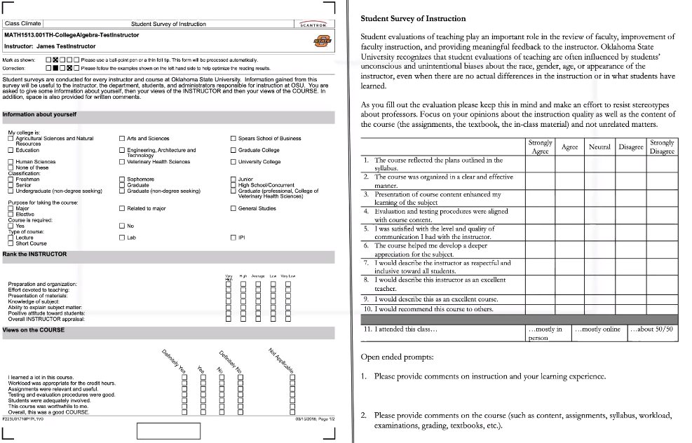
Question 11 – add “fully online” as an option. Recommendation from R. Frohock for the opening disclaimer – “as you complete the evaluation, focus your opinions on the quality of instruction and content of the course.”

Motion was made by J. Van Delinder and seconded by A. Sanogo to accept the proposed pilot Student Survey of Instruction form with the recommended changes, and approved.

- Fall 2020 Semester Updates – General Discussion
Better messaging is needed for F2F classes. When a student quarantines for COVID diagnosis or exposure they should be encouraged to return to F2F classes following the quarantine for the remaining length of the semester.

Many student organizations are meeting online. Some clubs have held F2F meetings and activities. It is important that student organization advisors work with student leadership to ensure that social distancing and other policies are followed.

- Fall Final Exams – Rita Peaster
In light of the fact that students will not be returning to campus after the Thanksgiving break, there is a significant possibility that many students will experience less than adequate technology from their homes during pre finals and finals week. R. Peaster would like to propose that the fall final exam schedule remain as is and provide additional guidance to encourage flexible options:
- Allow margin with final exams for resolution of technology issues – 90-minute exams
- Allow for a timed exam within a large window of time
- Allow other types of final assessments – projects, papers, open book exam, etc.
- Determine whether or not to add the final schedule to the class schedule

C. Ormsbee will submit a survey to faculty to determine the specifics of Fall 20 finals:
- What time is final scheduled?
- Will faculty utilize Examity proctoring during finals?
- What is the estimated length of the final?

- Reverse Transfer Update – Rita Pester
Item to be presented at the 10-1-20 Instruction Council meeting.

- Curriculum:

Information Items Only

- Course Deactivations:
ACCT 4033 – Advanced Federal Income Taxation
VMED 7421 – The Healer’s Art
VMED 7461 – Equine Nutrition in Health & Disease
VMED 7531 – Avian Biology for Veterinarians
VMED 7701 – Small Animal Diagnostic Ultrasound
VMED 7731 – Advanced Small Animal Medicine I – Problem Based Learning
VMED 7802 – Small Animal Emergency Medicine
VMED 7872 – Special Surgical Problems & Techniques, Advanced Small

- Course Action Exception:

BIOC 3653 |  | Survey of Biochemistry |  | Prerequisite: CHEM 3015 or CHEM 3053 | Prerequisite: CHEM 3013 or CHEM 3053 | Change in prerequisite.
NSCI 3133 |  | Science of Food Preparation |  | Prerequisite: HTM 1113 or NSCI 3993 and NSCI 2114, and CHEM 3015 or CHEM 3013 and CHEM 3012 | Prerequisite: HTM 1113 or NSCI 3993, and NSCI 2114, and CHEM 3013 | Change in prerequisite.

Motion was made by J. Van Delinder and seconded by M. Gilmour to accept the above-mentioned course action exceptions, and approved.

- Program Modifications
None to report

- Other
- Discussions are still taking place regarding Spring Break for the OSU community. No definite decision has been made at this time.

Meeting adjourned – 10:30am

Minutes recorded by K. Roark

