Krehbiel called the meeting to order with the following members present: Ahrberg, Avakian, Barnes, Bartels, Clarke, Cornell, Damron, Dare, DeSilva, Emerson, Fisher, Grafton, Harris, Holcomb, Holyoak, Kennison, Lovern, Materer, Meek, Schestokat, Scott, Smay, Taylor, VanOverbeke, Veenstra and Verchot-Lubicz.
Also present: Asamoah, D., Bird, L., Campbell, C., Cannon, J., Elliot, K., Fry, P., Handy, E., Hightower, D., Kerntke, M., McCann, C., Meier, T., Miller, B., Moder, C., Scott, M., Shutt, G., Sternberg, R., and Weaver, J.
Absent: Atekwana, Chung, Miller and Yellin.

HIGHLIGHTS

RPT Review Task Force …………………………………………...………………………………
Student Email Systems …………..………………………………………………………………...
Wired, Wireless and Cellular Service on Campus …………………………………………………
Academic Alert System ……………………………………………………………………………
Report of Status of Faculty Council Recommendations …………...……………………………...
Reports of Standing Committees …………………………………………………………………..
Academic Standards and Policies ………………………………………………………….
Athletics ……………………………………………………………………………………
Budget ……………………………………………………………………………………...
Campus Facilities, Safety and Security ……………………………………………………
Faculty ……………………………………………………………………………………...
Long-Range Planning and Information Technology ………………………………………
Research ……………………………………………………………………………………
Retirement and Fringe Benefits ……………………………………………………………
Rules and Procedures ………………………………………………………………………
Student Affairs and Learning Resources …………………………………………………..
Reports of Liaison Representatives ………………………………………………………………..
GPSGA …………………………………………………………………………………….
Staff Advisory Council …………………………………………………………………….
Women’s Faculty Council …………………………………………………………………

Clint Krehbiel called the meeting to order and asked for a roll call. Krehbiel announced that the 2011-2012 Faculty Council Brochures are published and available. There are copies available at this meeting.

Krehbiel asked for approval of the September 13, 2011 minutes. Ken Bartels moved and Stephen Clarke second to approve the minutes with minor corrections. Motion passed.

Krehbiel asked for approval of the October 11, 2011 agenda with modifications. Udaya DeSilva moved and Smay second to approve the modified agenda. Motions passed.

Special Reports:

- Carol Moder – English Professor and Department Head
RPT Review Task Force

Dr. Moder is the chair of a new task force appointed by Provost Sternberg that is charged with looking at OSU’s reappointment, promotion and tenure procedures. The last time these procedures were reviewed was in 1999. Moder distributed the following information:

Reappointment, Promotion & Tenure Review Task Force Charge

Focus: review best practices nationally for considering reappointment, promotion, and tenure, and then to recommend to the university community, in general, and the Faculty Council, in particular, what best practices for OSU would be.

- review RPT practices within each of our colleges
- review RPT practices at peer institutions, including “aspirational peer institutions,” and take into account our particular needs and goals in making recommendations.

The task force will be charged with recommending procedures that (a) ensure the highest possible level of academic excellence, (b) are fair to all involved in the RPT process, and (c) take into account the varying needs of the different academic units at OSU. The task force is not intended to examine the “level” of the standards, but rather, how to set standards and implement them in an equitable way.

Timeline
- initial work during the 2011-12 academic year
- campus discussion during the 2012-2013 academic year
- implementation during the 2013-14 academic year.

We solicit input from all faculty members and administrators on any issues or concerns related to OSU’s reappointment, promotion, and tenure procedures.

Comments may be emailed to rpt-review@okstate.edu
Please indicate whether you would prefer for your comment to be kept confidential. You may also communicate directly to any member of the task force.

Reappointment, Promotion & Tenure Review Task Force Members

Arts & Sciences - Chair
Carol Moder, Professor and Head, English, x46140

Agricultural Sciences & Natural Resources
Udaya DeSilva, Associate Professor, Animal Sciences, x48847
(Also serving as the Faculty Council representative)

Business
Alex Zablah, Associate Professor, Marketing, x45089

Education
Timm Bliss, Associate Professor & Hardesty Chair, Educational Studies, OSU-T, 918-594-8304

Engineering, Architecture, & Technology
“David” Hyung Jeong, Associate Professor, Civil & Environmental Engineering, x47073

Human Sciences
Brandt Gardner, Associate Professor, Human Dev & Family Science, x45061

Veterinary Health Sciences
Anthony Confer, Regents Professor, Veterinary Pathobiology, x44542

Library
Robin Leech, Associate Professor and Head, Digital Library Services, x49780

Health Sciences
Jenny Alexopulos, Senior Associate Dean and Professor, 918-561-8401

Graduate Council
Shelia Kennison, Associate Professor, Psychology, x47335

Regents Professors
Loren Smith, Regents Professor and Head, Zoology, x45555

Legal Counsel
Scott Fern, Associate General Counsel, OSU Board of Regents Legal Counsel, x46494

Academic Affairs Liaison:
Denise Weaver, Assistant to the Provost, x48782

Krehbiel asked for questions. Kemit Grafton wanted to know if any branch campus RPT programs will be reviewed as well. Moder stated that only the units that are governed by the overall OSU policy are going to be looked at at this point. Bartels asked if this will be disseminated through the listserv. Moder responded that is correct. Moder will be attending the Council of Deans on Thursday and a general announcement will go out after this meeting. Krehbiel thanked Dr. Moder for this very important information.

B. Darlene Hightower – Chief Information Officer
Tina Meier – Director of Server Administration
Charles McCann – Director of Technology Support
Student Email Systems

Darlene Hightower passed around the following fact sheet regarding student email services. Hightower stated that about 2 years ago IT started reviewing the prospect of out-sourcing student email. There were several advantages to doing so. This fall with the authentication for students to be able to use their O-Key credentials to access their email accounts combined with the beginning of the fall semester web traffic plus the traffic for Cowboy and Orange Mail, student email services were disrupted. Tina Meier and the server administration group configured multiple virtual servers add to the web server farm. When this did not help our services it was decided to look deeper. This uncovered that Cowboy Mail was the issue. Cowboy Mail which is hosted by Microsoft Live services never was down. What was down was the method that IT had the students use to authenticate (using their O-Key credentials). Once it was determined that Cowboy Mail was the issue, IT started notifying students and redirected them to the website - Outlook.com. Microsoft provides a vendor username and password to go directly to their website to authenticate. For about 2 to 3 weeks the students that had Cowboy Mail were going directly out to the Microsoft website to authenticate. In the meantime, IT was working with Microsoft to split the Orange Mail and the Cowboy Live Mail off of the current web cluster onto a separate entity. Orange Mail was never affected. The students might have seen a slow response time while trying to log in, but they did not have to change their method of authentication. IT worked with Microsoft, made some tweaks on the OSU server and some other changes. Student employees tested this new server for about a week before it was turned back over to the student body. Since September 27th the students have been able to use their O-Key credentials to get into their Cowboy Mail accounts. Until all the migrations are completed, the emails will remain on three separate web clusters. IT will monitor these and decide if 2 of these clusters can be migrated back together.

Hightower stated that the reason OSU is outsourcing email accounts is cost savings. OSU pays $5.10 per student email account. In addition, it’s a little over $9 for them to have the anti-spam licensing. OSU is looking at saving approximately $14 annually to outsource. OSU is hoping to save over $300,000 with the migration. There is also an expansion of services, see chart below.

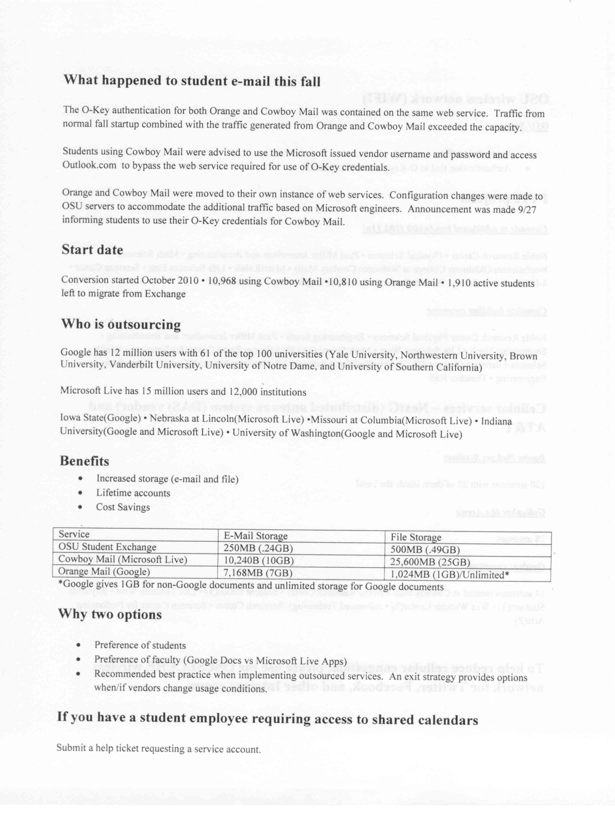
Another plus is with lifetime accounts. OSU needs the ability to stay in contact with students after graduation and it was not cost effective with the current exchange account. So by out sourcing, the students will have their email accounts indefinitely. This will not be paid by the student tech fee. Currently the email service is funded by this fee.

Faculty that are working with student employees and they need to share a calendar, IT needs to have the faculty member submit a help ticket asking for a service account. This will be another account for the student. But they use their O-Key credentials and they are still able to carry on with office procedures.

Hightower opened the floor for questions. Bob Avakian asked when this would be available to the remote campuses. Hightower stated that IT is ready to talk with them about the system. Hightower said that Okmulgee has already addressed this and are ready to go. DeSilva asked how student access their external storage. Charles McCann stated that when the student logs into their Cowboy or Orange Mail account, it is very similar to their Google mail. With Microsoft Live there are sky drives that work the same way. DeSilva asked if these mail programs allow them to use Outlook to download their email. McCann answered yes, absolutely. Meier stated that Pop is available on Google but is not available on Outlook.

Krehbiel stated that the long term benefits will be very good with some short term glitches. Hightower said things have been working great since the first of October.

C. Mike Kerntke – Director of Telecommunications
Wired, Wireless and Cellular Services on Campus

Mike Kerntke updated the council members on the OSU wireless network. OSU has a network set up for faculty, staff and student use called OSU secure. See information below.

OSUs cellular services are through NextG (distributed antenna system (DAS) vendor and AT&T has signed on to provide their services through the DAS system. None of the other carriers have signed on to-date. There have been a few issues this fall. In the student union quad area during class breaks there was an increase in dropped connections. The antenna sectors have been split and hopefully this will provide a solution. A few other areas appear to have similar sort of issues and those are currently being investigated.

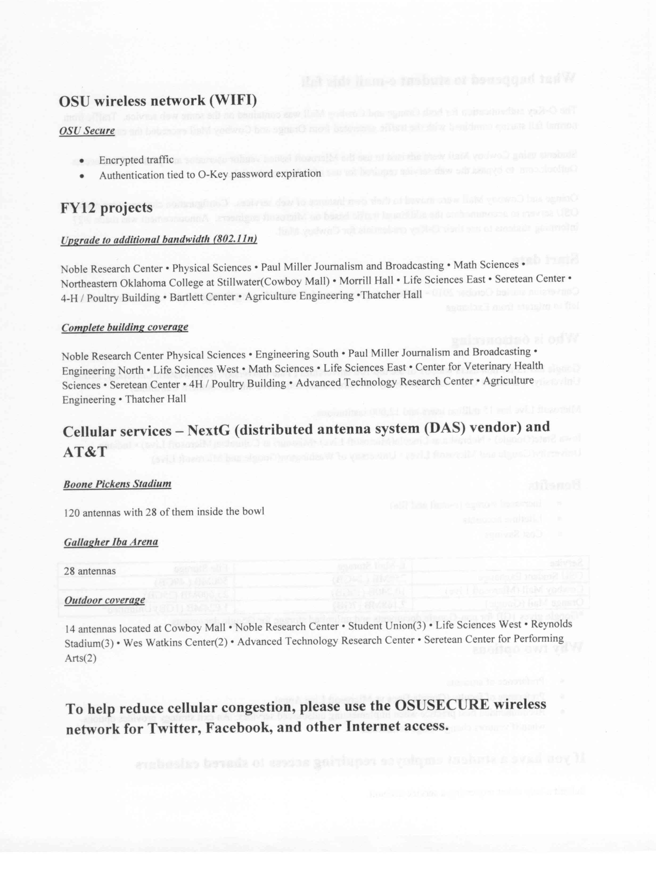
Kerntke opened the floor for questions. Nick Materer asked if all protocols will be supported and Kerntke answered yes. DeSilva commented that there are several wireless towers built outside of campus and asked if these towers are under telecommunications control. Kerntke clarified that the canopy system on the Westside by some of the Ag facilities are covered by his office. DeSilva asked if people could use OSUSECURE login from these facilities. Kerntke responded yes absolutely and if you have a wireless signal you can get into the OSUSECURE system without additional costs. Kerntke did state that some of these connections are slow speed, 10 megs or less. They were originally set up for very specific types of applications and they have not been upgraded to accommodate faster data speeds. This is something that needs to be addressed.

D. Celeste Campbell – University Registrar
Academic Alert System

Celeste Campbell distributed the following information about the Academic Alert System. This new system is a communication tool that is voluntary tool that instructors can use to indicate academic concerns about individual students. The system works through the faculty SIS system, the same system that faculty report grades and excessive absences. The Academic Alert System is available through the 12 week of the fall term. It has been in operation a little over one month. When a concern is reported by an instructor for a student it generates an email to the student. The student receives the email indicating what the concern is and who has reported the concern. The email asks the student to take some type of action – to see the instructor or meet with the instructor to see how the student can improve as well as contacting the students’ advisor. Campbell stated that so far 2,054 individual student submissions have been made over the past month by instructors, 285 unique instructors have made these reports. 52% of the reports were for freshman. 1,126 reports had to do with attendance and excessive absences were reported using the Academic Alert System. 613 of the reports indicated poor work. 670 indicated missing work. 41 reports indicated that the student could not pass the course with the remaining course work available. The peak times for reporting were during the excessive absence request and during the midterm grades. Although midterm grades were not reported using this system instructors were encouraged to report additional information using the Academic Alert System. What instructors will see once they log into the system is their class roll. Similar to the way they see it when reporting grades but instead of reporting grades there are other options. Instructors need to remember that whatever they type or indicate will go directly to the student. It won’t be edited first. Remember that this is a communication with the student as well as the advisers. This is indicated in red at the top of the page. Another component of this system is the advising component. The advisers are accessing reports with this information and are asked to contact the student and the students are being asked to contact the instructors. The advisers can report on the individual student whether or not they have attempted to make contact or have met with the student. Advisers can also add comments as to the status or resolutions for the student are. The next time the instructor logs in; they will see the most recent comments by the adviser. This is a three way communication between the student, instructor and adviser.
The committee is already looking at how to evaluate the pilot. Its effectiveness, what will need to be tweaked or changed? The committee will be asking for input from faculty/instructors that have used the system. Ed Harris has volunteered to help with the evaluation process.

Krehbiel asked if the adviser has to access the system to get information or does the email actually go to the adviser. Campbell responded that it was decided not to send the emails directly to the adviser because that might be overload for a particular adviser. The directors of the student academic services group have appointed someone from each college to check for updates on a daily basis. This person then separates the concerns by adviser and sends them the information. Campbell stated that Tulsa is also using this procedure for their students. Laura Barnes asked if there was one contact person covering all of the Tulsa students. Campbell said that yes, one person in Tulsa is accessing the reports and distributing them accordingly. Pam Fry stated that this system is geared toward undergraduates and she met with administration in Tulsa and they felt this was the most efficient way to handle the information. Angela is the one who accesses the information for Tulsa and distributes the information to the central adviser or whoever is assigned to the particular student. Campbell stated that every student on SIS has an assigned adviser and this is the person who receives the message.

Shelia Kennison asked if there was an option for instructors to submit comments to the adviser that the student does not see. Campbell stated this is not an option currently but if there is a need for this it could be addressed. Kennison feels that some faculty maybe reluctant to use the comment section because it’s going directly to the student. Fry stated that this feature is currently being considered. It was asked if this was an educational record. Campbell said yes it is because OSU maintains the information and it’s personally identifiable to the student. Kennison asked if there were any plans to evaluate student perceptions of the system. Campbell thinks this is a great idea and will address it in the evaluation process. Fry stated that the system is a way for students to take responsibility in their learning experience. Campbell stated that this is a tool and should in no way replace direct communication between students and instructors.

Jim Smay asked if this system is integrated with the D2L system in any way. Campbell answered no, it is not.

Janet Ahrberg asked if this information can be used in a grade appeals. Can a student or faculty member bring this information to a grade appeals. Campbell stated that this is private information. The student is part of the educational record. Someone viewing this information would need to be a university official who has a legitimate educational interest to see it which means you have to see it to be able to do your job. Campbell is not sure in a grade appeals situation if this the student would bring the information forward. As far as a faculty member in concerned Campbell feels this is data on a faculty member’s communications with the student.

Krehbiel asked if the instructor knows the adviser for the student by going through the system. Campbell stated that the advisers name is on the screen. The adviser email is not listed and this would be an additional step to look this information up in the directory.

Avakian stated that Okmulgee has this system and find that it’s mainly used when an instructor cannot contact a student.



Announcement of Fall 2011 Pilot
August 19, 2011

Oklahoma State University is committed to the academic success of our students. To facilitate undergraduate retention and success, a new communication tool will be piloted during the Fall 2011 semester. The Undergraduate Academic Alert System allows instructors to voluntarily report concerns about the attendance and academic performance of the students in their classes. This resource will be continually available during the first 12 weeks of the semester and will use the same online Faculty/Advisor Self Service (SIS) that is used to report grades. The alert will generate an email message to the student as well as provide information to the student’s advisor. The student will be asked to contact the instructor to discuss ways to improve and to contact the academic advisor to obtain help with developing a plan for success. Academic advisors are expected to initiate contact with students identified by the alert to provide advising assistance and appropriate referrals to tutoring services, career counseling, personal counseling, the Learning and Student Success Opportunity Center (LASSO), and other campus resources.

The Academic Alert will not affect the reporting of six-week grades or final grades. Attendance reporting that is requested during the fourth week of the semester will utilize the Academic Alert System.

The Academic Alert will include the following optional indicators.
- Attendance (no evidence of attendance, excessive absences, stopped attending)
- Poor Quality Work (checkbox)
- Missing Work (checkbox)
- Cannot Pass with Remaining Coursework (checkbox)
- Instructor Comments (open ended responses)

Direct technical questions to Bonnie Stone (SIS-DM@okstate.edu, 405-744-6864)
Direct all other questions to the Office of Academic Affairs (academic-alert@okstate.edu, 405-744-5627)

Report of Status of Council Recommendations:

Provost Sternberg gave the status of the following recommendations:

11-05-02-ASP: Undergraduate Research Scholars.
Pending – Recommended designation has been approved by Instruction Council and will be presented to the Council of Deans later this week.

Provost Sternberg reported that Chris Ormsbee has been appointed as the interim director of the Institute for Teaching and Learning Excellence. Ormsbee is a full professor in the College of Education and has extensive background in faculty development.

Sternberg also reported that Cheryl Devuyst has been appointed as the director of the LASSO center and Assistant Provost. She was introduced Friday night to a group of major donors and she gave a terrific speech and has great background having worked as an assistant dean in the College of Agricultural Sciences and Natural Resources promoting student development.

There have been 3 finalists for the Education Dean. These search results will be announced soon.

Sternberg announced a new award – Letting Down the Ladder. This award is for outstanding mentors. One staff and one faculty award will be given this year for the staff and faculty members that are outstanding mentors.

The Visioning Committee has provided Sternberg with their report. These results will be presented to Faculty Council soon. Melanie Page is the chair of this committee.

There is a committee on teaching entry level math courses. They have reported back to Sternberg and his office is in the process of implementing all their suggestions.

There is a new committee on E-Learning that is starting to meet. The first sub-committee is looking at vision of electronic learning at OSU. This sub-committee is chaired by Ed Harris and is looking at the direction OSU should be going with regard to e-learning. OSU is not as far along as some of our peer schools. The other sub-committee is looking at how to distribute the revenue that comes from electronic learning courses.

There is a new task force considering evaluation of teaching and how that best can be done. Should OSU be supplementing student ratings with other types of evaluations. For example, peer ratings, expert teaching ratings, etc.

There is also a new task force on evaluating learning. This task force is considering the issue of by a student’s senior year, does OSU need to have some type of means for evaluating the value of the time spent at OSU. This could be electronic portfolios or other forms of portfolios. This is up to the committee.

The Engineering Dean search is continuing.

REPORTS OF STANDING COMMITTEES:

ACADEMIC STANDARDS & POLICIES – Ed Harris – Update

Ed Harris presented the following recommendation that deals with an adjustment in academic regulations for pre-med students. Representatives from the College of Arts and Sciences and the Registrar’s office have been working together to better align these regulations with State Regents policies, student needs and program rigor. This recommendation was brought before the ASP committee and some minor adjustments as far as language were made. This recommendation will be voted on at the November Faculty Council meeting. The recommendation will be emailed to all council members later this week.
Amended by Passed Failed

Recommendation No. 11-10-01-ASP 1.________________ ______ _________

Moved by: Academic Standards & Policies 2.________________ ______ _________

Seconded by: 3.________________ ______ _________

Passed Tabled Failed 4.________________ ______ _________

Title: Residence Waiver for Certain Premedical Students

The Faculty Council Recommends to President Hargis that: Modifications Proposed by the College of Arts & Sciences and the Office of the Registrar May 20, 2011 to Academic Regulation 7.3: Approval of the reduction of credit hours be modified as follows:

7.3 Residence Waiver for Certain Premedical Students. Students who complete at least 90 semester credit hours in a recognized premedical science program and then transfer to a professional program leading to the doctoral degree at an accredited professional school, including medicine, osteopathic medicine, chiropractic medicine, veterinary medicine, dentistry, optometry, pharmacy, physical therapy, and podiatry, will be awarded the appropriate baccalaureate degree upon the successful completion of 30 semester credit hours in basic medical science courses applicable to the OSU major. This option is available only to students who have completed all other degree requirements for the major, have taken at least the last 30 semester credit hours of work at OSU prior to transferring to a professional school (See Academic Regulation 7.2 Residence Credit Requirements), and have completed at least 60 semester credit hours at a baccalaureate degree granting institution (See Academic Regulation 4.4 Transfer Credit from Community Colleges). Credits from accredited professional schools that are part of baccalaureate degree-granting institutions will satisfy the 60 semester credit hour requirement.

Rationale:

These changes reduce the number of credit hours that must be completed prior to transferring to a medical professional program from 94 to 90 (updated to reflect degrees based on a minimum of 120 credit hours instead of 124 credit hours), expand the selection of applicable professional programs, and clarify how credit hours earned in professional programs satisfy the State Regents’ requirement that baccalaureate degrees must be based on at least 60 credit hours earned at a baccalaureate degree-granting institution.

The current Academic Regulation 7.3 is listed below for reference.

7.3 Residence Waiver for Certain Premedical Students. Students who complete at least 94 semester credit hours in a recognized premedical science program and then transfer to a professional program leading to the doctoral degree at an accredited professional school of medicine, osteopathic medicine, veterinary medicine, dentistry or optometry will be awarded the appropriate baccalaureate degree upon the successful completion of 30 semester credit hours in basic medical science courses applicable to the OSU major. This option is available only to students who have completed all other degree requirements for the major and have taken at least the last 30 semester credit hours of work at OSU prior to transferring to a professional school. (See Academic Regulation 7.2 Residence Credit Requirements.)

ATHLECTICS – Steve Damron – No Report

BUDGET – Rodney Holcomb – No Report

CAMPUS FACILITIES, SAFETY AND SECURITY – Robert Emerson – No Report

FACULTY – Shelia Kennison – No Report

LONG-RANGE PLANNING and INFORMATION TECHNOLOGY – Nick Materer –
No Report

RESEARCH – Jim Smay – Update

Smay stated that the research committee met last week and they are trying to set an agenda for collaborative research. The committee is also reviewing some policies for Steve O’Geary. O’Geary has asked the committee to look at the policy for protection of human subjects in research. Hopefully the committee will have an opinion about some changes that have been made in this policy next week. It appears that the policy was updated last in June of 2007.
Smay has been appointed to a committee within CEAT to consider formulating a policy for joint and courtesy appointments, specifically in CEAT. A need as arisen to address this issue due to the formation of a Material Science and Engineering program in Tulsa. Many CEAT members do research in this area and the idea of jointly appointing faculty from Chemical Engineering, Mechanical Engineering and so forth to this Material Science Department. His committee started searching for an existing OSU policy to govern this type of joint appointment regarding who the faculty member would report to, who would do the A & D, how do you apportion salary when you start splitting appointments between departments. It was quickly determined that his CEAT would like to have Faculty Council review this matter rather than just a 3 man committee within CEAT. Hopefully this will be brought before the entire Faculty Council or the appropriate committee in Faculty Council to review if there is an OSU governing policy for joint and courtesy appointments. If not, can we formulate one to at least guide CEAT if not the university as a whole?

DeSilva asked what was the difference between the CEAT joint/courtesy appointment and the Business school who have joint appointments with the Business school in Tulsa. Smay didn’t know if there was a difference. He believes it is currently being done on an ad-hoc basis. Ken Bartels asked if this includes indirect costs. Smay answered yes.

RETIREMENT and FRINGE BENEFITS – Stephen Clarke – No Report

RULES and PROCEDURES – Robert Avakian – No Report

STUDENT AFFAIRS and LEARNING RESOURCES – Janet Ahrberg – Update

Ahrberg reported that the committee met for the first time on October 6th to work on an agenda for the year. The committee will be looking at the LASSO center and how it will affect students, faculty and learning resources in general. The committee wants to provide support and input. Dr. Bob Miller has invited Dr. Cheryl Devuyst to attend the November 17th meeting. Another issue of concern is the alcohol use in resident housing and the dorms. The committee will also be addressing equity in learning resources across campus. Another item of consideration is the method for dorm room selection and designation of floors. The committee has also talked about the interactions between the Tulsa and Stillwater campuses. In particular, the committee will be looking at the Graduate and Professional Student Associations and the Library of resources. What are the check-out privileges for the libraries on each campus? The last item the committee will be addressing is the student tech fees. The committee will meet on the last Thursday of each month. Dr. Bird asked what time is the next meeting. Ahrberg believes they are at 3:00. The next meeting will be October 27th.

Report of Liaison Representatives:

GPSGA – Daniel Asamoah

Daniel Asamoah reported that Travel Grants in the amount of $8,715 have been disbursed to 20 graduate students. The breakdown is as follows: 9 International students: $3,750; Domestic students: $4,965.
Asamoah also stated that 3 groups submitted applications for co-sponsorship. GPSGA would like to encourage more groups to take advantage of this opportunity and apply for the spring semester.
Staff Advisory Council – Jamaica Cannon

Jamaica reported that campus recreation attendance for faculty and staff is up, which is a lot better than what SAC was expecting. She encouraged faculty to submit ideas for new classes. Intramural is open to faculty and staff.

SAC is currently reviewing survey results regarding benefits and tuition waivers for faculty/staff and their dependents.

The Homecoming raffle is underway and SAC is working on the spring picnic.

Women’s Faculty Council – Barbara Miller

The WFC has sent out about 150 flyers for the Women’s Faculty Council research awards. The information and application is also available on their website. These awards are for graduates and undergraduates.

Miller mentioned that the committee is working on a speaker for research week. Steve McKeever is helping with this task. Hopefully she can announce the speaker at the November meeting.

Old Business – None

New Business –

Krehbiel reminded everyone that the Fall General Faculty Meeting is scheduled for Monday, November 21st from 3:00 to 5:00 in Click Hall at the Conoco Philips Alumni Center. He encouraged everyone to attend.

Sternberg announced that there will be a Faculty Council appreciation dinner Tuesday, November 8th following the monthly Faculty Council meeting the reception will start at 5:15 and dinner will be at 5:30. The reception and dinner will also take place in Click Hall. This is open to all Faculty Council members. Krehbiel encouraged all council members to mark this on their calendars and plan to attend.

The meeting adjourned at 4:00 p.m. The next regular meeting of the Faculty Council is Tuesday, November 8, 2011 in Click Hall, Conoco Philips Alumni Center. Please make a note of the location.

Respectfully submitted,

Udaya DeSilva, Secretary

