Krehbiel called the meeting to order with the following members present: Ahrberg, Avakian, Bartels, Cornell, Damron, DeSilva, Emerson, Fisher, Grafton, Harris, Holyoak, Kennison, Lovern, Materer, Miller, Taylor, Veenstra, Verchot-Lubicz and Yellin.

Also present: Alldredge, K., Allen, S., Barnes, L., Bird, L., Campbell, C., Clarke, S., DeSilva, C., Fry, P., Fuller, A., Hargis, B., Crenshaw, C., Miller, B., Scott, M., Shutt, G., Simpson, J., Sternberg, R., Stump, D., Weaver, J. and Wray, K.

Absent: Atekwana, Barnes, Clarke, Chung, Dare, Holcomb, Lawlor, Meek, Schestokat and Smay.

**HIGHLIGHTS**

Welcome Week Overview ……………………………………………..…………...……………...

Admissions/Panorama Project……………………………………………………………………...

Budget………………………………………………………………………………………………

Report of Status of Faculty Council Recommendations …………...……………………………...

Remarks and Comments from the President……………………………………………………….

Reports of Standing Committees …………………………………………………………………..

Academic Standards and Policies ………………………………………………………….

Athletics ……………………………………………………………………………………

Budget ……………………………………………………………………………………...

Campus Facilities, Safety and Security ……………………………………………………

Faculty ……………………………………………………………………………………...

Long-Range Planning and Information Technology ………………………………………

Research ……………………………………………………………………………………

Retirement and Fringe Benefits ……………………………………………………………

Rules and Procedures ………………………………………………………………………

Student Affairs and Learning Resources …………………………………………………..

Reports of Liaison Representatives ………………………………………………………………..

Women’s Faculty Council………………………………………………………………….

Emeriti Association ………………………………………………………………………..

Staff Advisory Council …………………………………………………………………….

Clint Krehbiel called the meeting to order and asked for a roll call.

Krehbiel asked for approval of the May 10, 2011 minutes. Bob Miller moved and Bob Avakian second to approve the minutes. Motion passed.

Krehbiel asked for approval of the June 14, 2011 agenda. Ken Bartels moved and John Veenstra second to approve the modified agenda moving Pam Fry’s Special report to the Academic Standards and Policies committee. Motions passed.

**Special Reports:**

1. **Dr. Lee Bird, Vice President for Student Affairs – Welcome Week**

Dr. Bird explained that last year the university replaced Alpha Week with Welcome Week. The attached handout provides both the time frame, events and sample programs that will take place during Welcome Week. Move in day for all new or transfer students is Monday August 15th. August 16th through 18th is the Welcome Week programs. August 19th will continue with programs but also include the college “spotlights”. This is where the Deans and others from each college host special events within the colleges to get students acclimated to the environment to learn personnel and special projects within the college to get students more involved.

The next event is the new student Convocation which has been moved up one hour so there is not much lag time between the college events and the Convocation. The Convocation will be held in Gallagher/Iba arena. Last year there were 3,000 students that participated. Since changing the organization of Alpha Week to Welcome Week, the number of students who participate has doubled. The Convocation gives new students a chance to listen to the President, Provost and listen to good music.

Information about the website is listed on the information sheet. Bird’s office is moving the site to the university servers. Last year the website was for students only. No faculty, staff or advisors could access the site. Now there is an opportunity to have a presence on the site. If you need information call Bill Candy or contact Bird’s office and they will help you create a presence on this larger social network for students. Bird’s office answers thousands of questions before the student arrive on campus. Residence Halls and colleges will set up discussion groups and forums online or talk about upcoming events. This has been a great way to communicate with students.

There will be an Ice Cream Social after the Convocation. Special thanks to the President’s office.

There will be about 155 programs offered to students during Welcome Week. These programs are organized in accordance with OSU’s six pillars of student success: academics, leadership, service, finding your purpose, broadening your horizons (which deals with diversity and international perspectives) and wellness.

There is a need for about 200 volunteers. All but 5 positions were filled overnight.

Welcome Week is an exciting time on campus. Bird feels it really helps OSU put its best foot forward by introducing students to campus even before they arrive. And after they get to campus help the students focus on the areas that are problematic - study skills, time management, procrastination, getting involved and looking for leadership positions. These are some things that help with retention.

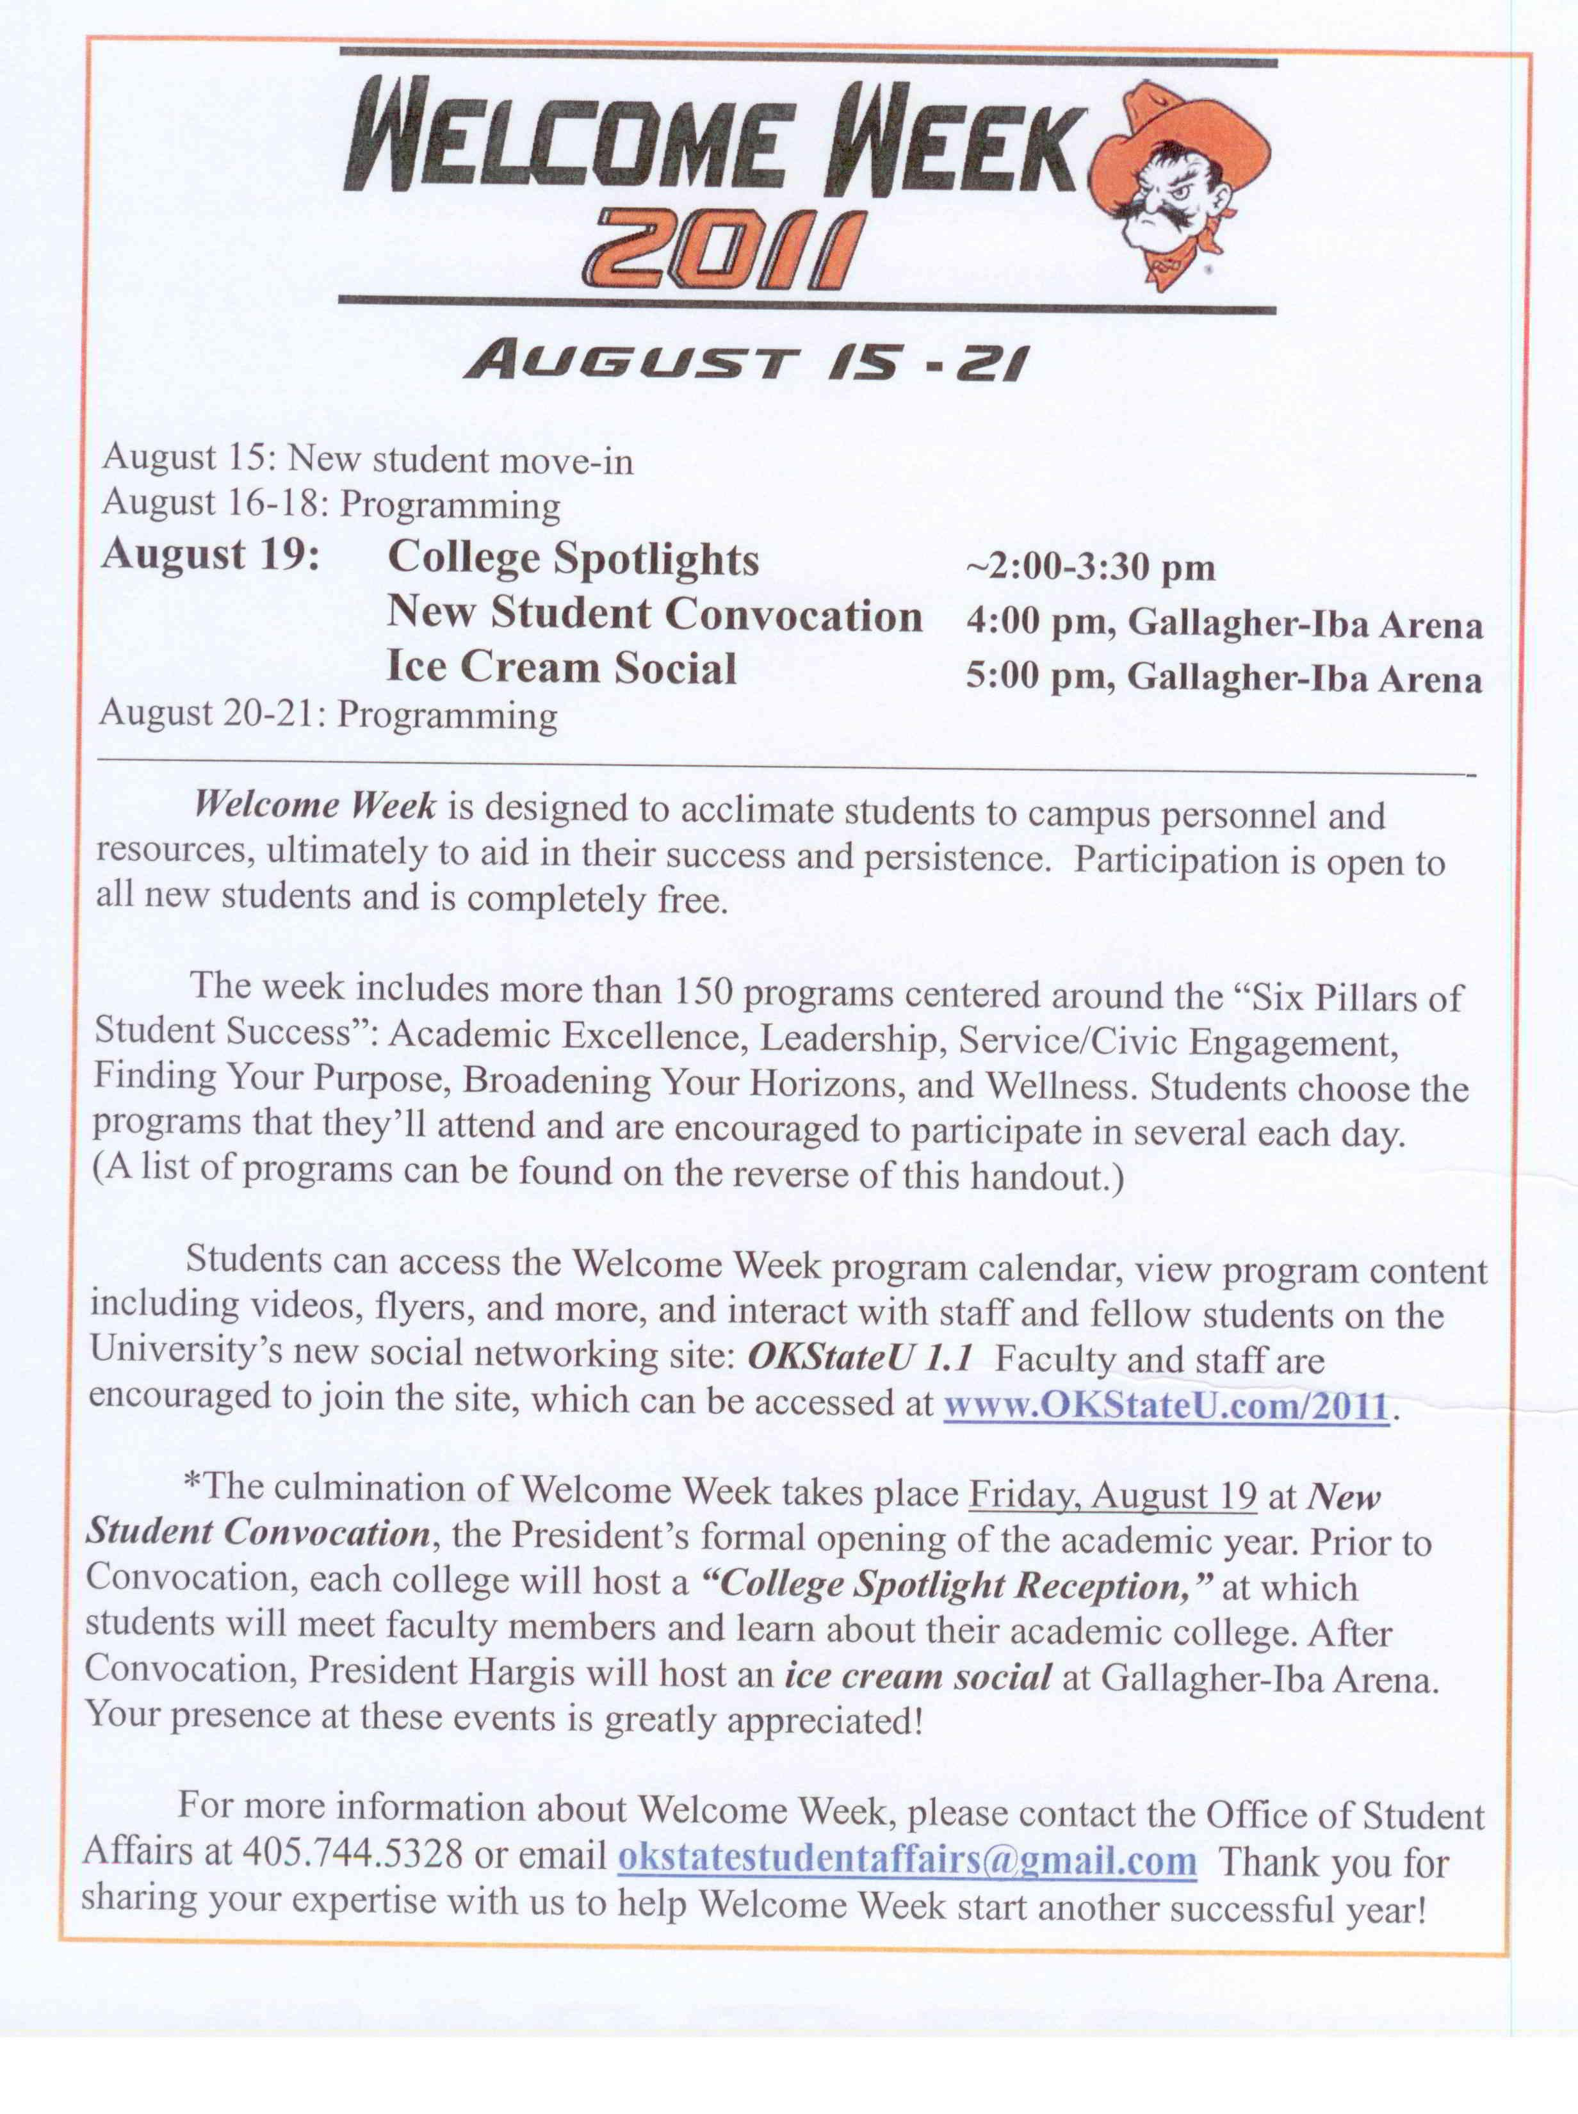

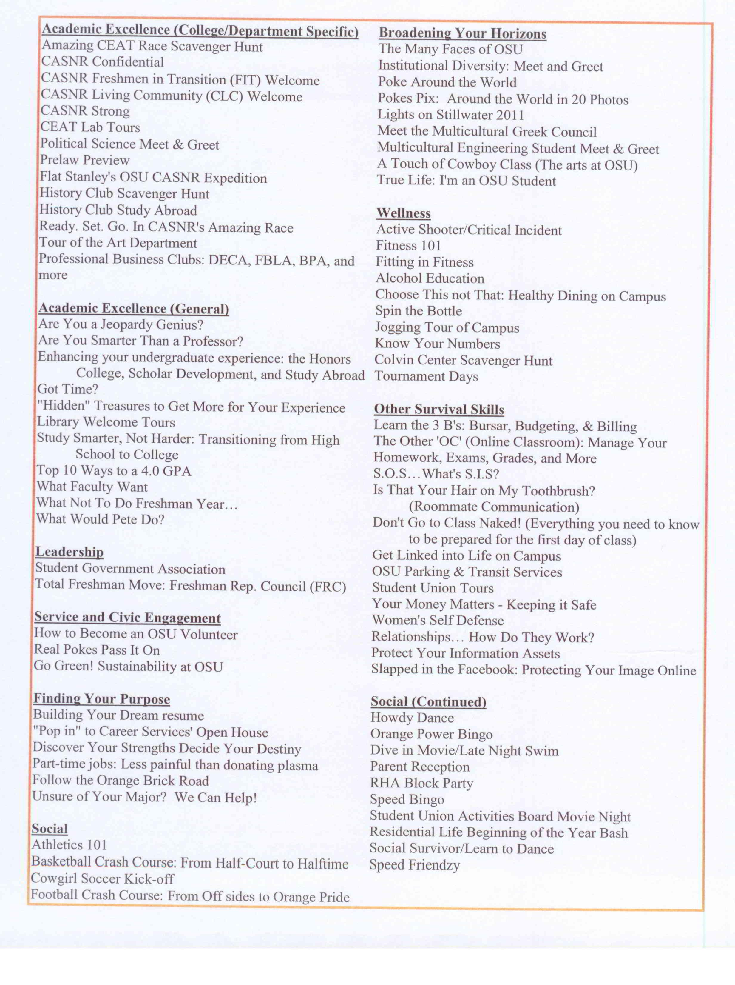

**B. Kyle Wray – Associate VP for Enrollment Management –**

**Admission/Panorama Project**



**Kyle** Wray presented the above PowerPoint presentation.

Please take a few moments to review this presentation. Highlights from the power point presentation are reflected in these minutes.

Wray stated that there are currently questions on the admission applications

and there have been questions on these applications for some time. The university wanted these questions to be more purposeful in evaluating creativity. Wray’s office began working with Provost Sternberg about a year ago on the Panorama Project. The holistic admissions work team was able to develop questions that transform evaluation for admissions at Oklahoma State University. Wray made it known that the university is not changing anything in terms of standardized test scores, but they wanted to ask questions a bit differently to ascertain creativity among OSU students.

The committee used the WICS (Wisdom Intelligence Creativity Synthesized) theory of leadership and each component was accessed as criteria for which these new questions were developed. A team was formed that reviewed the WICS theory as well as many of the articles that Provost Sternberg has written, especially “College admissions for the 21st century. There was an entire team that went through the review process. Wray reviewed each of the four components and then reviewed the questions. Each one of the questions that are presented are not necessarily the one’s the team is proposing be on the admission application. Some of them will. Wray also stated that all students will not be asked to answer each of these questions. Which questions will be on the application and how many questions they will be asked to answer is still to be determined.

Kari Alldredge clarified that several of the following questions will fall in multiple categories. There is quite a bit of overlap. The team put the questions in the categories they thought best described the question.

**Analytical Skills**: Wray went through the 5 proposed questions for this section.

**Creative Skills**: Wray went through the 7 proposed questions for this section.

**Practical Skills**: Wray went through the 5 proposed questions for this section.

**Wisdom-Based Skills**: Wray went through the 7 proposed questions for this section.

Wray reviewed the Panorama Projects next steps and use. The questions will first appear on the applications for the fall of 2012 entering class.

Wray completed his PowerPoint presentation and asked for questions. Nick Materer wanted to know if there were any considerations to have the questions more sensitive to the environment that smaller, rural students are in so they can give a better response. Wray responded that being able to offer multiple questions on the application would remedy this situation. Students would not be asked to answer every question. They would be able to choose a question in which they have some knowledge base. David Yellin asked how much of the evaluation is predicated on just the students’ general writing ability. If they are not strong writers they would be penalized on all of these questions. Provost Sternberg stated that when scorers are given instructions on how to score each application, they are given a rubric to use. In the Creative category, they are looking for the extent to which the response is novel, good and task appropriate; for Analytical - the extent to which it is logical, organized, balanced and analytical; for Practical it is the extent to which it’s feasible with respect to time, place, human material resources and persuasive; and for Wisdom-Based it’s the extent to which the answer helps advance a common good over the short and long term by balancing their own with others who have larger interests. Sternberg stressed that the graders are specifically told not to grade for writing because if you grade for writing it will be the same as the SAT writing section. You’ll be measuring the same thing SAT, ACT and IQ tests measure. Sternberg addressed Materers question regarding kids from a rural or urban backgrounds and stated that the opposite is actually true. It’s the ACT that shows very large effects of socioeconomic status. These questions when they were tested both in a national study and the test study show minimal differences across groups partly because you don’t need much background to answer almost all of the questions. They are sort of take-off on your own. So they reduce differences not increase them. Reed Holyoak asked how this would be adapted to professional admissions such as the Vet School. Holyoak sees where this would be a great value. The Vet school is selecting from a different pool for a different reason but Holyoak can see where this type of questions added to what the Vet School already does could benefit. Sternberg stated that there are questions devised for other schools, not Vet, but for example medical schools. There is a series of questions that present the applicants with cases where they have to say what they would do in a certain situation. They are not knowledge based they are more ethics, common sense based questions. Sternberg would be happy to meet with the Vet School. Bartels asked what is the correlation of success in the undergraduate program when you base it on these measures with ACTs and SATs. Sternberg stated that it is about .1. So it’s positive and very small which is good. If the correlation were highly positive that it wouldn’t add anything to ACTs and SATs and there would be no reason to use it. Avakian stated that none of these questions look value neutral and would you then be inadvertently selecting for certain political or world view of these questions. Example; someone comes in and says I don’t think diversity is important and makes a very good argument to this fact. What would be the reaction? Alldredge responded that it’s all about how you train the readers and what the value and score for the question is based on. Both Sternberg and Fry will be involved in the training and rubric development for the readers. It’s all about putting those biases aside and weighing on the things that is covered for each category. Sternberg explained that the criteria for Analytical are that it’s logical, balanced and organized it doesn’t include the contents. So you are not scoring for the content. People can have very different points of view and still write logical essays. In Wisdom-Based the scorers are not looking at the content either. They are looking at how the student constructed the response. Steve Damron asked who the readers will be. The readers will most likely be developed in the undergraduate admission department. They will be put through extensive training. This is the format that has been used before and the committee is very comfortable moving forward with this format. Ed Harris asked when this would be incorporated and Wray answered this fall. Harris asked if there would be a research component and Wray answered yes. Some of this is already happening with accessing answers to the current questions. It was asked if there is any way to control over who is writing the responses. Is this a proxy to how smart the parents are or if they are creative. How do you know who is actually answering the questions? Sternberg stated that parents are not usually in a better position to answer the questions that are asked. The questions are changed year by year so you can’t build up a storage base of answers. Since these questions are only going to be used at OSU, there is not an incentive for counseling services to develop an entire base of responses as there would be for common application questions. You never really know for sure but remember that this is being used in addition to ACT scores and grades. If a student has bad grades and ACT score, they won’t get in anyway even with a great essay. If you have terrific grades and ACT score, they don’t need this and are in. This is for people who are in between. This is for those students who are in the qualification zone and is to differentiate among those. Alldredge said that at prospective student events there are break-out sessions for students who are looking to apply for admission. These questions are discussed at these sessions. Yellin feels that this will be labor intensive compared to the current process. Sternberg said money will be raised for this. Wray stated that counselors and principals in Oklahoma are excited about this project because they see so many students in their schools that have the creative component but don’t think they have an opportunity to access places like OSU. This will be Avant guard as information is developed to get out in the state of Oklahoma and this general region of the US what we are doing from an admissions standpoint. Sternberg stated that half the reason to do this is the image it projects about the university. This sends a message about who OSU is as a university.

**C. Joe Weaver – VP Admin/Finance – Budget**

**Joe** Weaver prefaced his remarks by stating that OSU materials have been submitted to the board which will be approved on Thursday and Friday. He is limited about the specifics of what he can talk about until the approval is given. Weaver did state that the legislature approved a budget for education that was approximately 4.7% less than the prior year. Common education fared better than higher education. They were only cut 4.1%. This is the second year in a row that the legislature made this decision where all education agencies were not treated the same. They did this to protect health and human services which only received a 1% cut along with public safety and judiciary. They were trying to protect the highway patrol and law enforcement agencies. These agencies have been hammered over the past few years while education has been protected. This is the first year education has had a cut of this magnitude in the economic downturn.

As far as the State Regents are concerned the old budget to 2011 budget is roughly $1 billion. In sum what does that 4.8% mean? It means that the budget has been reduced by $50 million.

The legislature did one interesting act toward the end of the session. They did make a supplemental appropriation to higher ed in the amount of $10 million. They are giving it to OSU this fiscal year and telling OSU to use it next year. Assuming OSU’s board approves it, these funds will be earmarked for next fiscal year for academic expansion. OSU and all its agencies will receive about $2.5 million of the $10 million. The other A&M’s in the system will get about $450,000. As far as OSU and its agencies are concerned the 4.8% cut amounts to $12 million. For the central campus this is roughly $6 million, experiment station $1.3 million, cooperative extension $1.5 million. Cuts to other agencies are smaller in reference to their size, but everyone took a 4.8% cut. OSU is able to manage this because Wray and the admissions and recruitment offices have done an outstanding job getting more students in the queue. OSU is looking at a series of years with solid enrollment growth and new revenues from students. If the university considers raising tuition this enrollment growth mitigates the need to raise tuition as much. There will be significant planning needed to manage this enrollment growth going forward. The impact on housing, parking, dining services, and faculty/student ratios – do we have the classroom space?

Weaver opened the floor for questions. Barbara Miller asked if there was a figure that could be plugged in to the enrollment numbers that would reduce the cut to the budget. Weaver stated that yes there are models that do this but no budget cut will be offset with just enrollment growth. Nor will it be offset by a tuition increase. It’s going to be a combination of these two items plus some budget cutting. Let’s not forget fundraising. As the Branding Success campaign rolls out and we are able to complete our goal that will allow us to deploy more private dollars into our operating budgets which will take some of the pressure off the state dollars.

Bartels asked about the 9 month vs 12 month insurance policy email that went out. This was followed very closely with a News You Can Use email that softened the first email. Weaver stated that the News You Can Use triumphs the first communication and said that the university would never cut off an employee’s health insurance because they had not made payment in the first cycle. Obviously the employee will have to make payment at some point but the university would not cut off insurance. Udaya DeSilva asked if a corrective communication be sent out since there are so many people who are concerned about this issue. Weaver thought the News You Can Use did correct this situation. The information can be sent out again if necessary. Krehbiel asked “when we consider increased enrollment and the implications on the budget, and the resulting increase in the need for faculty and other resources, is the administration planning on working with Deans and Department Heads to look at these issues college by college and department by department?” Sternberg said he has already offered to the Deans and the Deans Council that if the teaching needs will not be met to talk to him and they will work it out.

**Report of Status of Council Recommendations:**

Provost Sternberg gave the status of the following recommendations:

**11-05-01-ASP: Changes to Tuition Appeals and Late Drop Process.**

**Pending** – Proposed changes were approved by the Council of Deans on June 9 and will be sent to the E-Team for consideration.

**11-05-02-ASP: Undergraduate Research Scholars.**

**Pending** – Proposal will be considered by Instruction Council members at their June meeting and then shared with the Council of Deans.

**11-05-03-ASP: Required Syllabus.**

**Accepted –** Proposal received approval by the Council of Deans at their June 9 meeting. P&P 2-0207, University Academic Format and Final Examination Policy, will be updated to reflect this requirement.

The Required Syllabus recommendation has been accepted. The other two recommendations are pending and Sternberg does not anticipate any problems with either recommendation being accepted.

Yellin asked if the university will send out a notice or statement to new faculty letting them know that they will be required to provide a syllabus. Sternberg said that the administration could send out a notice if the Faculty Council would like the Provosts office to do so. The Faculty Council members would like the Provosts office to do this.

**Remarks and Comments from the President – Burns Hargis**

President Hargis commented on Dr. Bird’s presentation about Welcome Week and the Convocation. Hargis feels that convocation is a wonderful welcome and entrance into the academic community. The purpose of the convocation is to let students know that OSU is different than any other place and that OSU values the academic mission of this institution. Hargis asked those who are available to don their robes and participate in this convocation. Bird stated that the event will start at 4:00. Faculty interested in participating should arrive 15 minutes earlier. Hargis urged the Councilors to have their colleagues attend as well. Bird stated that her office has requested a minimum of 10 faculty from each college attend the convocation. If a faculty member needs a cap and gown, please let student affairs know. Last year they paid for the rentals for those who did not have a cap and gown and are willing to do so again this year. 2,800 students and parents attended last year’s convocation.

Hargis thanked Weaver and his team for their hard work. The faculty and staff have played a large part in savings for OSU. The Branding Success campaign is beginning now to yield funds. These funds should be available shortly. The campaign is down to the very difficult last 25% of the billion dollar goal. The matches are over now; they were magical in helping get this far. The enrollment increase is an enormous benefit as well.

Hargis has weighed in on the Westwood Overlay district. There is an effort to require no more than 3 unrelated persons living in a house. Hargis feels it is in OSU’s best interest to preserve the Westwood neighborhood as a single family area. Hargis has urged the city council to approve this overlay district. This is quite controversial especially with people who own rental property in the neighborhood.

Hargis is very excited about next fall. Applications and admissions continue to increase. There should be a very strong freshman class this year. Hargis feels this is due to a positive experience from students who have attended OSU in previous years and they are encouraging their friends to attend OSU as well. The inroads into Texas and Kansas have helped along with the Ross McKnight $5,000 scholarships. These scholarships are given to students from rural areas that have shown strong leadership and academic skills.

Sternberg thanked the Faculty Council Faculty Committee in the RPT process.

**REPORTS OF STANDING COMMITTEES:**

**ACADEMIC STANDARDS & POLICIES – Ed Harris – Update**

Ed Harris and Celeste Campbell addressed the retention problem at OSU. This is especially problematic following a student’s freshman year. Despite the best efforts of the colleges there is still a problem with retention after the first semester. For example in 2000, 18% of students did not return after their first semester. In 2009, 22% did not return. Harris and Campbell introduced the Academic Alert System. This is a pilot program that will alert students and their advisors during the first four months of school. Harris passed around the following overview of the system.





Essentially the system is a communication resource, not necessarily a requirement. Harris feels there will be benefits of the system if faculty will incorporate it. This system will be available continually during the first 12 weeks of the semester. The online SIS system will be used. This system alerts the student and his/her advisor and puts the responsibility on the them to come talk to the instructor and work out a plan. The system will include the following information for instructors to complete: attendance, poor quality work, missing work, cannot pass with remaining coursework and instructor comments. This is a very user friendly system. If a faculty member runs into any problems, they are to contact technical advisor Bonnie Stone. Harris opened the floor for questions. Yellin asked if this system is only for freshman. Harris answered that is open to all undergraduates but is focusing on freshman retention rates. Yellin also asked if instructors would have to contact the students’ advisors separately. Campbell stated that an instructor would go into their class roll and select which student they would like to leave a comment about. The information is automatically sent to the students’ advisor. DeSilva asked how the student was notified. Campbell stated that an email is sent to the student. Barbara Miller asked if students are aware of this new system. Fry stated that a message will be created for students and will be part of Welcome Week. Faculty will also receive prompts throughout the semester to remind them this resource is available. Yellin asked if this also works on the OSU-Tulsa campus. Campbell stated that OSU-Tulsa already has this system in place. Jean Marie Verchot commented that in her department, the advising is done primarily by faculty. Advising is not rewarded through the tenure process or the annual appraisal process. Verchot feels that junior faculty members are often frustrated by the fact that the extent of the advising that they do is never recognized. Verchot feels that this needs to play a role in retention. Verchot also commented she did not see in the measures of this pilot program anything that addresses specific sociological issues pertaining to Oklahoma which are not found in other states. Oklahoma has the highest teenage pregnancy rate which impacts a student’s time management skills. The major minority at OSU is Native Americans and how cultural changes these students may be facing may also impact grade and workloads. Verchot does not see any of these issues being measured. Krehbiel said something that could be related to what Verchot is referring to is that this system is only as good as the advisors response. So if the student is failing but the advisor doesn’t reach out to them there is no incentive for them to do so. Harris said it is his understanding that this is a pilot program and this is a step in making this a university wide endeavor attacking the problem. He feels that as time goes on, these issues could be added to the overall program.

**ATHLECTICS – Steve Damron – No Report**

**BUDGET – Rodney Holcomb – No Report**

**CAMPUS FACILITIES, SAFETY AND SECURITY – Robert Emerson – No Report**

**FACULTY – Shelia Kennison – No Report**

**LONG-RANGE PLANNING and INFORMATION TECHNOLOGY – Nick Materer –**

**Update**

Nick Materer commented that they are looking into problems that students are having migrating email over to the new system. His understanding is that one system is working very well and the other one is not. If students are having trouble they need to contact the help desk directly. One of these migrations is from Microsoft to Microsoft. The other is from Microsoft to Google. The help desk is collecting these reports and sending them directly to the vendor to help resolve the issues.

Materer also stated that his committee has talked about the video taping of lectures and legal issues regarding this matter. Materer stated that there are two competing ideas. One is ownership of copyright and the other is fair use. The immediate issues that people have brought out would be that the faculty member owns the copyright of their lecture. If a student gets videotaped or makes a comment then permission needs to be granted by said student. Any type of taped or videotaped electronic media will be owned by that faculty member and any other comments that people make. There was actually a motion from Faculty Council several years ago that first introduced about extraordinary usage and how that affected copyright. This actually falls in the faculty member’s favor. The other argument that comes out is that if the university uses the lecture, they can use it as an educational resource and therefore showing to a class could constitute fair use of that copyrighted material. The lawyers that have spoken to Materer think that this is a very weak argument and it would be hard to challenge because the faculty themselves are members of the university. The fair use argument is always very complicated. The lawyers will be following up on this and see what opinion they can find. Materer’s personal opinion is that if he knew ahead of time that the lecture was going to be taped and there was a reasonable use for it, at times he could find this acceptable, but he feels this depends on the individual faculty member and the course of study. Bartels asked what the current policy regarding this matter is. Materer said there is no current policy. The current copyright policy states that the faculty members own the copyright of their academic output. So if a faculty member writes a paper or class notes, they own the copyrights. It’s pretty clear from the universities perspective that the faculty member owns the copyright. What is not clear is the usage of that by the university whether it falls under fair use or not. This is the part that the Long-Range Planning and Information Technology Committee will be looking at. The issue is fair use vs. extraordinary use. Fair use is complicated but the committee will be working on this issue. There are cases where OSU has videotaped faculty members for satellite broadcasting. This falls under the extraordinary use clauses of the copyright policy. These faculty members are compensated for making these videotapes. The university owns these tapes and they can do whatever they want with them. So there are questions to compensate a faculty member for making videotaped lectures. There is obviously more effort involved in this lecture. But there is no precedent for copying one without compensation in using it. Bartels asked at the present time who will make the call regarding this issue. It’s perfectly legal for the university to take the tape. The question is the use of the tape. If the university uses the tape they expose themselves to a lawsuit from that faculty member. Then the university would claim fair use. The university would clearly need to get permission from the faculty member before using the videotape. Yellin asked Materer if the university currently has the right to go in and videotape an instructor. Yes the university can but they do not own the recording. The faculty member would still own the recording. Sternberg commented that somehow the students have been removed from this discussion. The main purpose for this is to help students who are absent for a legitimate excuse. Sternberg feels in the discussion of who owns the rights, everyone needs to remember that the university it trying to help students get the content of the lecture. Bob Miller commented that this decision should be up to the instructor. Sternberg understands from OSU legal counsel, Scott Fern, is that the dean has the right to videotape a lecture. It’s not a case of the university or the dean wanting to keep the videotapes, but they want to serve the students. Sternberg hopes that in this conversation everyone keeps in mind that OSU is trying to serve students. There was a case where a student was in the hospital and the faculty member did not want to have the lecture videotaped. Sternberg wants to make sure that the needs of OSU students are being served. Holyoak has had a flip experience where students have an exam the hour after he lectures and the students have said they will be studying during his lecture because I can get access to his lecture late that day. Holyoak agrees that if someone has a family emergency, illness, whatever, those students should have access to the lecture. Holyoak wants to know who will say yes this student has access or do all students have access. Then no students want to show up for class because they have an exam following the lecture. Sternberg stated that for his course attendance is required. His course is a seminar and the value of the class is in the interaction and activities in the class. If a student cannot attend they can get permission not to attend. If someone is in the hospital or they have to be at an important student event Sternberg gives them permission to miss class. If the student does not have a legitimate excuse the absence counts against the student’s grade. Bob Miller stated that with Sternberg’s example, he has made the decision. The way this issue comes down it would appear that the dean will be making these decisions for the faculty. Sternberg would not have any objection to providing any student with a videotape of his class, but it’s still a requirement for them to attend the class unless the absence is excused. Materer feels that the middle ground in all this would be what happens to the videotape of the class. Is it being reserved just for that semester for the students in the class? Will it be used in another semester? Materer feels that this is where the sensitivity comes in – how long is the tape retained and what is it being used for. He wouldn’t object to having his class videotaped if it was being shown to specific students for a specific amount of time. Some of the concerns are these tapes will be held onto for a long period of time. The middle ground could be that if a class is recorded that there is a form or some type of reasonable policy that the faculty member signs that determines the scope of use of the videotape. If the faculty member absolutely doesn’t want to have their lecture videotaped this should be that faculty members decision. The committee will keep working on this issue and report back to Faculty Council.

**RESEARCH – Jim Smay – No Report**

**RETIREMENT and FRINGE BENEFITS - Mark Lawlor – No Report**

**RULES and PROCEDURES – Robert Avakian – Update**

Bob Avakian presented the following motion to permanently change the months of the Faculty Council meetings.

Should this motion be approved, the first sentence of Paragraph A, Section IV, Meetings, shall read (changes in italics):

“Regular meeting of the Faculty Council shall be held on the second Tuesday in each month except during the months of *June and July*.

Also,

Subparagraph 6. Paragraph B, Section II, Elected Officers of the Faculty Council shall read (changes in italics):

“Shall serve as the chair of the Nominating Committee in preparing the schedule of members and chairs of Standing Committees for action at the *August* meeting of the Faculty Council.”

Rationale: The change will bring meeting dates into agreement with the present academic calendar.

The second change is necessary for consistency.

This motion will be voted on at the September meeting. Bob Miller thinks this is an excellent idea and much more reasonable then to have a new Faculty Council hold one meeting and then wait two months for another meeting. Avakian commented that one of the goals of the Rules and Procedures Committee is to go through the by-laws and work out whatever issues do not fit present circumstances. If anyone has questions, please contact him via email or in person.

**STUDENT AFFAIRS and LEARNING RESOURCES – Bob Miller – No Report**

**Report of Liaison Representatives:**

**Women’s Faculty Council – Barbara Miller**

The council has requested a list of committee memberships so there is not an overlap of committees studying the same issues.

The council would like to suggest *in lieu* of raises, the administration could give to staff – cut rates to the Colvin Center or discounts for Daycare. The council has not received an updates on the issue of daycare in a few months. Weaver commented that an RFP has been sent out regarding Daycare and Renaissance is the only organization who has responded and administration is negotiating with them. DeSilva asked about the discounts at the Colvin Center and Weaver stated that the administration is working on this as well.

**Emeriti – Margaret Scott**

The Emeriti Association held their June First Monday Dinner in the Athletic Training Facilities Dining Hall last week. We had an opportunity to view the historical exhibits in that area which overlooks the football field. After dinner, Dr. Marilyn Middlebrook, Associate Athletic Director for Academic Affairs ushered us to the Athletic Student Service facilities and was join by several her staff to present the program on the activities and services provided by her office—and invite Emeriti members to join them by providing tutoring assistance.

There will be no First Monday Dinners in July and August nor will the Emeriti Association Council meet in June or July.

**Staff Advisory Council – Debbie Stump**

Debbie Stump reported that the SAC had the Staff picnic in May and it was very successful. Athletics offered the space under the seats at Boone Pickens Stadium. Two years ago the picnic was moved inside due to rain. Last year it rained but the picnic was held outside. This was a perfect setting – out of the rain and wind.

The SAC has sent out a survey regarding benefits and are awaiting the results.

The new SAC officers for next year are: Chair– Marta Kochenower; Vice Chair - Jean Kerr –Hunter; Secretary – Kathie Tanner; and Treasurer – Mickey Gregg.

**Old Business – None**

**New Business – None**

Clint Krehbiel wished everyone a safe and productive summer.

The meeting adjourned at 4:45 p.m. The next regular meeting of the Faculty Council is Tuesday, September 13, 2011 in the **Browsing Room, Edmon Low Library. Please make a note of the location.**

Respectfully submitted,

Udaya DeSilva, Secretary