Bartels called the meeting to order with the following members present: Barnes, Clarke, Chung, Cornell, Dare, Emerson, Fisher, Grafton, Harris, Holcomb, Kennison, Krehbiel, Lovern, Luttbeg, McBee, Materer, Meek, Miller, Page, Stamper, VanOverbeke, Walker, Yetter and Young.
Also present: Bertholf, D., Blaine, J., Campbell, C., Echols, M., Elliot, K., Fry, P., Hufnagel, B., Jahanshah, F., Masters, B., Ormsbee, C., Sternberg, R, Tucker, S., Weaver, D. and Weaver, J.
Absent: Atekwana, Baeza, DeSilva, Holyoak, Jones and Wu.

HIGHLIGHTS

Special Report - ITLE….....……………………………………………………………………..…
Report of Status of Faculty Council Recommendations …………...……………………………...
Reports of Standing Committees …………………………………………………………………..
Academic Standards and Policies ………………………………………………………….
Athletics ……………………………………………………………………………………
Budget ……………………………………………………………………………………...
Campus Facilities, Safety and Security ……………………………………………………
Faculty ……………………………………………………………………………………..
Long-Range Planning and Information Technology ………………………………………
Research ……………………………………………………………………………………
Retirement and Fringe Benefits ……………………………………………………………
Rules and Procedures ………………………………………………………………………
Student Affairs and Learning Resources …………………………………………………..
Recommendation: Test-Optional Admission of Undergraduates
Reports of Liaison Representatives ………………………………………………………………..
SAC ………………………………………………………………………………………..

Bartels called the meeting to order and asked everyone to please sign the roll call. Bartels asked for approval of the December 11, 2012 minutes. Holcomb moved and Miller seconded. Motion passed. Bartels asked if there were any changes or corrections to the agenda. Miller moved and Harris seconded. Motion passed. Dr. Bartels welcomed the people on Skype – Okmulgee and Tulsa.

Special Report: Chris Ormsbee – Assistant Provost/Director – ITLE

Bartels asked Chris Ormsbee to give a brief bio prior to her presentation. Ormsbee stated that this is her 7th year at OSU. She has been in ITLE the past 15 months, first as the Interim Director and now the Director and Assistant Provost. Prior to this Ormsbee was the department head in the College of Education in the School of Teaching and Curriculum Leadership. She held this position for 5 years. Ormsbee is also a professor in special education. Prior to this she was at another public research institution in Oklahoma. She was associate dean and faculty member at this institution. She has had a fair amount of experience in preparation of teachers, professional development and teaching.
Ormsbee would like to discuss some of the changes that are taking place in ITLE. ITLE is a service agency. Six years ago ETS was merged with Faculty Development with the intent to provide resources and services to faculty to support their teaching. ITLE does this in a number of ways. ITLE does many things that support teaching. ITLE provides instructional design and technology support. ITLE staff work with faculty on syllabus design, course design, course observations as well as software support. ITLE has spent time helping faculty set up their grade books and load content on D2L. If anyone has questions on how to use D2L to improve teaching, ITLE covers this as well. They also cover any instructional technologies that faculty maybe using in the classroom. ITLE is here to help with any technology a faculty may need. ITLE manages the clicker club and just installed smart boards in 10 classrooms. They provide multi-media services. If a faculty member wants any form of video (3-D included) or PowerPoint for their classroom ITLE provides this service. ITLE also facilitates all the distant or broadcast classrooms. If a faculty member teaches in Stillwater and the lecture is broadcast to Tulsa, this technology flows through ITLE and they make sure everything is working properly. ITLE also provides video conferencing services. The interest in video conferencing has increased over the past few years, including Skype interviews. These interviews are done via Web-X. These are high quality video conferencing opportunities. ITLE also manages 160 general use classrooms on campus through technology support for computers, document camera and other technology. A special project that began in the spring was the installation of the smart boards in 10 of these classrooms; there are 7 smart boards and 3 sympodia in the large rooms. This is like an I-pad. These 10 rooms impacted 60 faculty members and thousands of students. In the last 15 months there has been a lot of talk on campus about teaching and what ITLE is trying to do is restructure their capacity to scale up to respond to these needs. ITLE has taken on TA support as well. This amounts to 1, 200 faculty members plus additional TAs and part-time instructors.
The ITLE general plan includes reorganizing to use a faculty driven model through centrally organized services through ITLE as well as embedded services in the colleges. In order to do this, ITLE is partnering more closely with college-based IT staff. These two groups meet regularly. ITLE wants to create faculty mentors. ITLE is restructuring the teaching and learning support so these are more easily accessible and relevant to faculty. ITLE created a new department, Teaching and Learning Services. This department uses a faculty driven model. The plan is to have an associate director lead this unit. This person and position will be held by a faculty member. The position has been designed and is in HR for review. Ormsbee’s hope is to have a campus wide search for this position sometime this semester. ITLE has also created Faculty Teaching Fellows. See handout below:

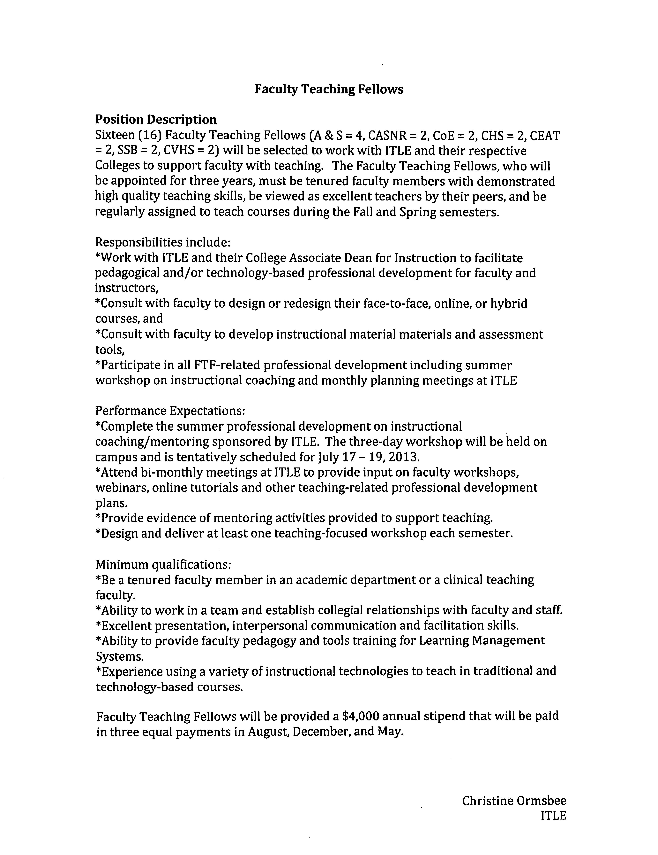
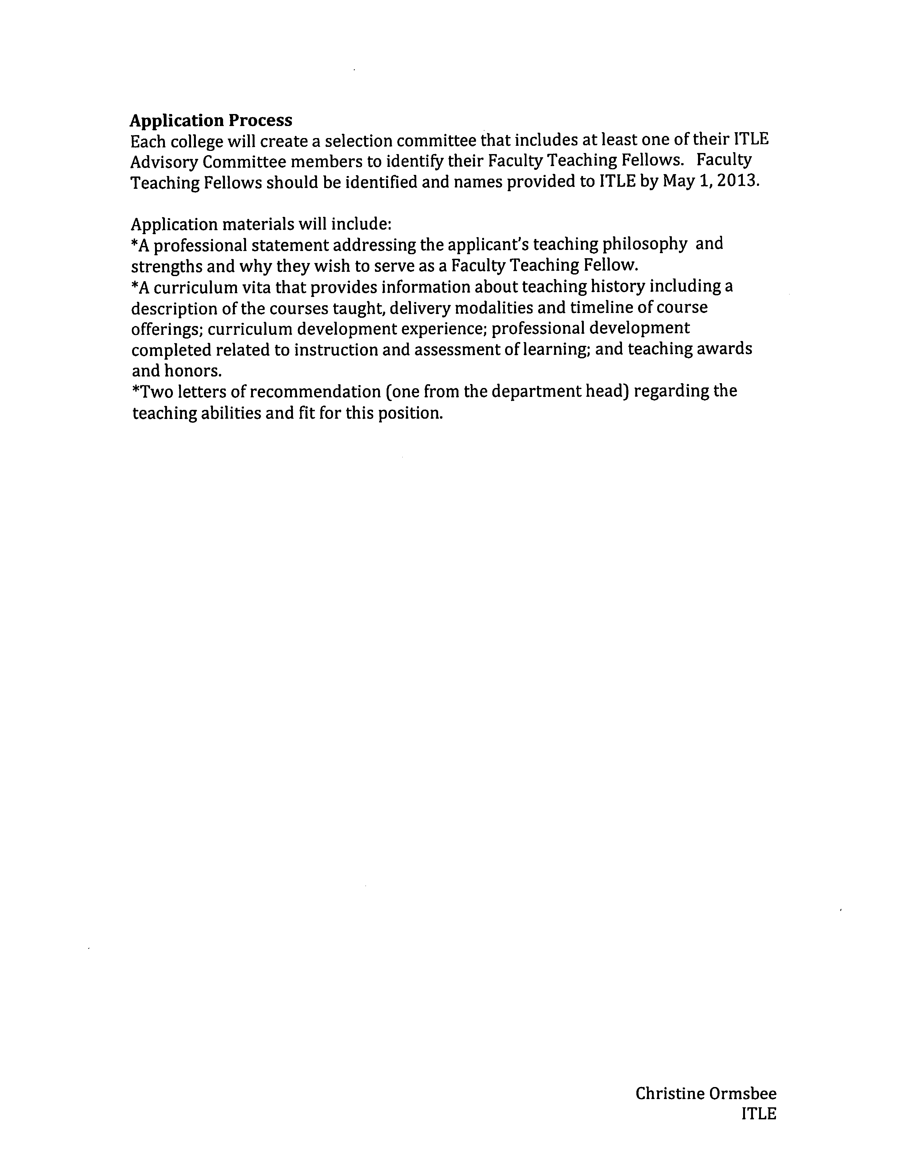
This program has been reviewed by the ITLE advisory committee. The ITLE advisory committee is comprised of two representatives from each college. They meet twice a semester. Instruction Council and Deans Council have reviewed the program and approved it. ITLE will partner with each college to identify two faculty in each college (with the exception of A&S who will have 4 because of their size). There will be 16 faculty teaching fellows. The teaching fellows will be people who are identified as having a history of successful teaching. They are viewed by their college peers as excellent teachers. Their role will be to provide support to their peers. This will be a 3 year term. They will be provided a stipend for their time. Ormsbee feels that one of the exciting things about this program is that each college will be able to make decisions about what kind of services and support they need. For example, if a college is interested in increasing their online offerings they could look for teaching fellow that has been successful in online teaching. The faculty teaching fellows will also work with the staff at ITLE. They will meet regularly to help identify some of the centrally based offerings that ITLE continues to offer – workshops, tutorials and other things. ITLE is trying to increase communications with the colleges and increase the accessibility and relevance of what supports are provided through this service.
All these changes are designed to make the supports and resources through campus wide and college based delivery relevant, appropriate and hopes that this will really help faculty address their teaching concerns.
Ormsbee concluded her presentation and asked for questions. Melanie Page asked if the associate director position would be a full-time position or if it is something that a faculty member could do quarter time and still have their faculty position as well. Ormsbee stated that this will be a part-time position due to funding. Ormsbee hopes over time that this position could be more full-time. Ormsbee hopes the position will office in ITLE and would teach some. Ormsbee stated they would look at some type of release model. Kennison asked the size of the faculty development staff. Ormsbee stated that ITLE is trying to grow the staff. With the addition of the associate director there would be at least 1 faculty development staff as well as the 16 faculty fellows. Ormsbee also stated that one of the colleges has indicated that they want to hire their own internal fellows which they will fund and these will be included. Ormsbee stated this is a growth of the support service by providing additional staff resources. Kennison stated that is sounds like 1 staff person and 16 fellows are not online yet. If someone called ITLE today who would be able to address their problems/concerns? Ormsbee stated that she would be the person to contact. Ormsbee stated that there are two other staff members that could assist depending on what needs to be done. Kennison stated that over the Christmas break she heard that two faculty were laid off because of the reorganization and the person many of her colleagues called for support is no longer on campus. Kennison is concerned that there will be people to help faculty on campus this spring. How quickly will the new fellows be online? Ormsbee stated the new fellows will not be online until August because they have to go through a search process. Hopefully they will be able to move forward on the Associate Director and the other faculty development staff as soon as they are approved through HR. Provost Sternberg stated that his understanding was that the people laid off were staff not faculty. Ormsbee stated this is correct. One of the two laid off was the manager of faculty development. Kennison states that one concern is that many people really like the online course for teaching online courses. Kennison believes that this is required if a faculty members wants to teach online. Kennison asked who will be teaching this course and when will it be offered next? Ormsbee stated that the course will be offered this semester. Ormsbee is hiring someone to teach it. Kennison asked if the reorganization had input from faculty. Not all faculty were aware of the big changes that were taking place in ITLE. Kennison asked what type of faculty input that Ormsbee sees as important in the future for the activities of ITLE. How is the board used and how will it be used in the future? Ormsbee stated that the board meets every other month or twice a semester. Ormsbee talks with faculty across the campus and looked at other sites and sources around the country to get input on how to best provide services to faculty.
Matt Lovern asked who is on the board. Ormsbee stated that it is two people from each college. Some colleges have a staff member and a faculty member. Some have two faculty members. Ormsbee does not know how they are selected within each college. Ormsbee hopes that colleges are mindful what they want in the Teaching Fellow representatives to be able to provide the most information and feedback regarding the kinds of services that need to be provided. Ormsbee believes that the Associate Deans for Instruction in each college will be the ones that coordinate the search for the fellows. She hopes that communications within each college will express what they really want to see in their representatives. She agreed with Materer that having someone who is teaching a large section and maybe is engaged in how to manage their research is an important representative to have. Ormsbee feels the fellows program allows ITLE to address these issues.

Report of Status of Council Recommendations:

Provost Sternberg thanked Chris Ormsbee for the job she is doing at ITLE.

Provost Sternberg gave the following updates on the on-going administrative searches:

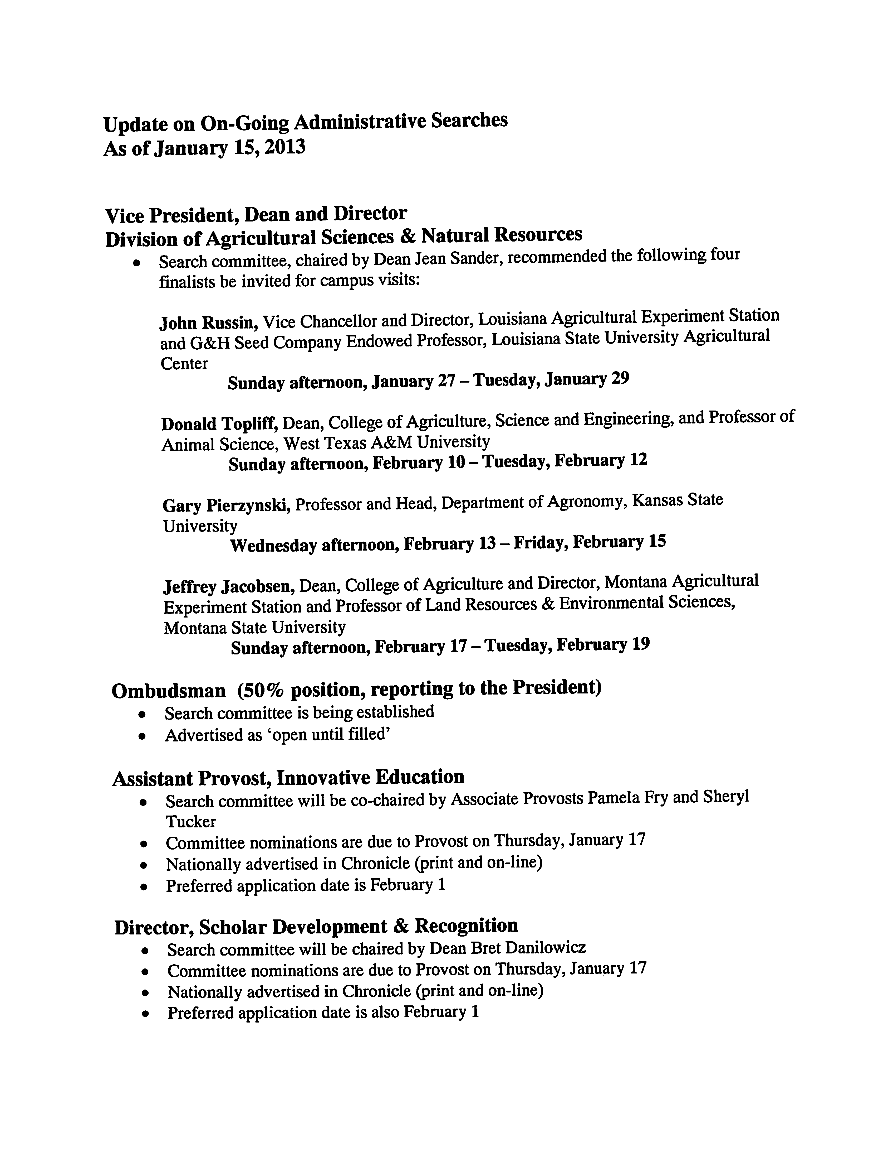

Provost Sternberg asked if there were any questions regarding the searches. Bartels stated that nominations have been sent forward from the Executive Committee for Faculty Council members on each of these searches.

Provost Sternberg gave the status of the following recommendations:

12-12-01-Research: Graduate Student Support Issues (GSSI) Task Force Recommendation:
Accepted – The Council of Deans discussed and accepted the GSSI task force report during their December 13, 2012 meeting.
12-11-01-LRPT: Copyright Usage Warnings:
Pending – Recommendation is under review by administrative areas for implementation.
12-10-01-ASP: OSU Academic Reg. 4.2: Courses Offered Through Outreach and Correspondence.
Accepted in part – On November 8, the deans approved removal of the 8 credit hour restriction on credit hours earned through outreach from another accredited institution. At the December 13 deans meeting, additional clarification on limits for correspondence credit was provided by D. Henneberry. The recommended change was not approved and it was suggested the Registrar’s working group revisit that section of Academic Reg. 4.2.
Provost Sternberg stated that there was a discussion at the Deans Council regarding Correspondence Education and the outcome of the discussion was that it’s important to continue to serve the populations that are served through correspondence education but that OSU thinks about how to organize the way it’s reviewed. Instead of focusing on the method they want to focus on the target populations. And optimally reaching these target populations.
12-10-01-Faculty: Revision of P&P 2-0110: Procedures to Govern Workload Assignments of Faculty Members.
Proposed modifications referred back to Faculty Council – At the January 10, 2013 meeting, the Council of Deans recommended changes to the draft policy, including modifying “credit hours” to “workload units” to be defined by each academic college. Deans confirmed their faculty and administrative teams are working on college-level workload policies.
12-10-02-Faculty: Proposed new Policy to Govern Overload Pay.
Accepted with modifications – On December 13, 2012 the Council of Deans approved modifications to the proposed policy, adding a section on non-credit/non-load activities that will be excluded from the overload policy and clarifying the policy is applicable to tenured and tenured-track faculty only. Deans also confirmed the 13 month compensation limitation would be effective January 1, 2013.
10-10-01-LRPT: Copyright Usage Information Website.
Pending – Recommendation is under review by the appropriate administrative areas.
Provost Sternberg opened the floor for questions. Kennison stated that she recently received an email stating that the correspondence courses will be completely phased out. Kennison asked how many courses are there currently being offered? Provost Sternberg does not know the number and stated that David Henneberry would be the person to answer that question. Sternberg stated that if correspondence education was something that was on a downward spiral so the only question was are we going to do something this year or next year. Correspondence courses are not particularly cost effective and it doesn’t seem to represent the future. In most places it has been phased out long ago.

Vice President Weaver – Update on campus construction projects

Weaver stated that Monroe Street is basically done. He encourages everyone to look both ways before crossing. The entry way markers that are on the south side will be duplicated on the north end. The gates will be closed around 8:30 and open at 4:30 in the afternoon.

Weaver stated that some construction will start developing within the next 12 months or so. OSU received word that the master lease program was finally approved by the Attorney General so we are back on track on some important projects that have been on hold for the last year or so.

Bartels asked what the projected completion date is for the new parking garage. Weaver stated spring break. This date hasn’t changed.

Dean Sheryl Tucker thanked the Faculty Council, especially the Research committee for their work on the GSSI. She appreciates all the work. Tucker stated that there will be a special report once the academic policies and implementation pieces are moved forward. Dan Fisher stated that the report is working its way through the colleges.

REPORTS OF STANDING COMMITTEES:

ACADEMIC STANDARDS & POLICIES – Ed Harris – Up Date

Harris stated that three standing committees – the ASP, Faculty and LRPIT – will be reviewing the student learning task force report. These three committees will be meeting next week to discuss/review the report. At the February Faculty Council meeting Harris hopes to report on the student learning task force report. Bartels asked if they would have a resolution/recommendation regarding the report. Harris stated yes.

ATHLECTICS – Robert Cornell – No Report

BUDGET – Rodney Holcomb – Update

Holcomb stated that late last year the Provost and Vice President Weaver sent the Budget Committee a list of when they would be having their planning meetings with the deans of each of the colleges. These meetings are when the deans meet with the Provost and Vice President Weaver to discuss their wish list of positions and initiatives for the next fiscal year for things they would like to get worked into the budget. The Budget committee was provided this list and was given the opportunity to have a member of the Budget committee at each one of these meetings. These just started yesterday and will be disbursed through the end of January. Holcomb said this is an interesting process and if any faculty member has the privilege of serving on the Budget committee Holcomb recommends that the faculty member take advantage of this opportunity. You learn a lot about what each college it trying to do. What are some of the concerns they face in terms of personal, facilities and where they are trying to take their colleges in the future? Holcomb thanked Provost Sternberg and VP Weaver for the opportunity.

Holcomb stated that last year Vice-Chair Bartels brought an idea before the Budget and Retirement and Fringe Benefits committees regarding tuition waivers for dependents of OSU faculty and staff. Is this something that OSU could achieve at some point in the future? Holcomb stated that this is not a new idea; it’s been around for years. Other institutions have done this while OSU has not. So over the years this idea has come up many times. The Budget committee was discussing this issue this past fall and they talked to Christie Hawkins in Institutional Research and Information Management just to find out what is the number of dependents of OSU faculty and staff. The committee found out for a number of reasons there is not a good answer to this question. The information is not available. One would think this information would be available if health benefits are offered and people are putting their family members on the insurance. However, not everyone is on an OSU plan. So the Budget committee with the Retirement and Fringe Benefits committee will be approaching the Staff Advisory Council about this issue. The SAC will be developing a survey just to find out among faculty and staff what dependents are out there. This would include age groups and spouses. Is there interest in attending OSU or are they already attending OSU. If they are attending now, do they have scholarships or some other type of waiver they are making use of? Granted this isn’t a good long term approach to determine the viability of tuition waivers for dependents but is does give us an idea at least for the time being kind of a snap shot of what’s out there now and what’s coming down the pipeline. Maybe this would give us an idea of the true cost of implementing such a measure.

Bartels added that he appreciates the fact that the Budget committee is being allowed to attend these meetings. The committee members are there to listen to these overviews. Holcomb stated that the committee members are not attending their own college meetings.

CAMPUS FACILITIES, SAFETY AND SECURITY – Robert Emerson – Up Date

Emerson stated that the issue they discussed at their last meeting appears to have been taken care of already. Emerson is referencing the sidewalk on the west side of Monroe Street that has not been completed. The orange cones have now been put up so this is not an issue anymore. Emerson stated that the committee will continue to look at the safe walk program and the assessment of campus safety.

FACULTY – Matt Lovern – Update

Lovern stated that the primary item the committee has been looking at over the break and the better part of the fall semester is the RPT Task Force Final report. The committee is very close to having a recommendation ready to present to Faculty Council. Lovern stated that there is still some discussion and clarification needed and he fully expects to have a recommendation to the council in February.

Lovern stated that the committee has also been helping the ASP and LRPIT committees on the Evaluation of Teaching Task force report. The Faculty committee is also working with these two committees on the Assessment of Student Learning as Ed Harris mentioned earlier.

The committee is also in a steady background state looking at Appendix E, the dispute resolution procedure. This is something that the committee really wants to get out for consideration and input this semester. The committees hope is that this is something that Faculty Council will see perhaps in March.

Bartels appreciates the time and work that the Faculty committee puts into each and every one of these resolutions/recommendations.

LONG-RANGE PLANNING and INFORMATION TECHNOLOGY – Nick Materer –
Update

Materer presented the following committee report:

Response to Evaluation of Teaching Task Force Report

Background
Three standing committees of the OSU Faculty Council – the Academic Standards & Policies, Faculty, and Long-range Planning & IT committees – were asked to review and provide comment on the Evaluation of Teaching Task Force Report. In Fall 2011, this task force was appointed by the Provost to develop recommendations on the evaluation of instruction, specifically, “…to recommend the best practices for the collection of data that can improve instruction at Oklahoma State University-Stillwater.” The final report was communicated to Faculty Council in early Fall 2012 and was posted on the Academic Affairs website in December 2012, at which point general faculty comment was solicited.

Each of the three committees initially met separately to consider this task force report. Additionally, joint meetings occurred between committee members and individuals who served on the task force, including a meeting in November 2012 with the Provost. This response to the task force report is the result of discussions among the committee chairs to represent the findings of our respective committees, input received from task force members and the Provost, and the comments received from the general faculty in response to our solicitation. We appreciate the input we have received, and we particularly appreciate the time and effort invested by the Evaluation of Teaching Task Force to produce their substantive and concise final report.

Summary
As a Land-Grant University, one of the key missions for OSU is teaching. It is clear that OSU faculty strongly support providing students with quality instruction, and therefore, it is not surprising that any discussion of evaluation of teaching generates strong interest. The Evaluation of Teaching Task Force Report recommends that OSU-Stillwater consider implementing four “best practices” for collecting data that could be used to improve instruction: (1) a new, online student survey of instruction that focuses on student learning rather than instructor performance; (2) teaching portfolios to document instructional expertise of faculty; (3) peer coaching and review of instruction; and (4) the use of student focus groups to gain further insight into reasons underlying student ratings of instruction.

We understand that the recommendation of these best practices is intended to serve as a starting point for further consideration rather than a mandate for implementation. We agree completely with this perspective and with the general idea that multiple data sources will be better than single data sources for evaluating instruction, regardless of the department or unit under consideration. However, we feel that it is important to emphasize that there is no “one size fits all” strategy for the evaluation of instruction; some of the recommended best practices will work better in some departments or units, or with some types of courses, than others. Similarly, additional and perhaps previously unconsidered approaches may be best in some cases. Therefore, we recommend that departments/units as appropriate consider whether these or other best practices could be used to gather data that would lead to improved instruction. We further recommend that all such consideration take into account institutional resources necessary for implementing new evaluation metrics as well as the effect that participation in such data gathering would have on faculty workload and productivity.

Below we provide additional points for consideration as they relate to the recommendations.

Best Practice 1: Online Student Surveys of Instruction
We find near unanimous support for a new survey instrument and for regular (3-yr) reviews of the instrument to ensure continued relevancy. Questions that focus more on student learning than on instructor performance are likely to provide faculty with more usable data for determining whether course objectives are being met. Attachment 7 of the task force report, “Student Reactions to Instruction and Courses” is an example of how such a form could be developed.

We find mixed support for moving to an online format for evaluations. On the one hand, there could be a huge benefit to online surveys if they allow for flexibility of the number and types of questions asked, given the very different issues faced by large introductory level courses vs. upper level or graduate courses, required vs. elective courses, major vs. general education courses, etc. Although such flexibility is possible with a paper format, in practice, the online format could make that flexibility easier to achieve with the results more immediately obtained. Students who participated in Academic Standards & Policies meetings were in favor of online evaluations, noting that it would allow everyone the chance to evaluate their courses at a time and place where they can provide full responses. Missing class on the day evaluations were conducted would not be an issue with the online format. On the other hand, among faculty there is some strong concern about what is very likely to be a drop in the number of evaluations submitted and a biasing of those submissions towards students strongly motivated to participate – the very highest achievers and students with a complaint or grudge against the instructor. This would lead to smaller and less representative samples. Having to essentially bribe students in order to increase the number of submissions is viewed as problematic.

Two additional concerns were discussed. First, it is logical that oversight of development, implementation, and review of student surveys of instruction reside with the Instruction Council. But, it is critical that Faculty Council has input and we would like to see that input formalized. Second, the idea of releasing faculty evaluations or portions thereof to the public requires careful scrutiny to ensure legality. These evaluations are used for annual appraisal of faculty including reappointment, promotion, and tenure decisions and as such may be considered part of the faculty member’s personnel file. Thus, many faculty members view this as a slippery slope into the unwarranted intrusion of external politics into the RPT process. If public disclosure is a goal, we suggest it might be better to facilitate an independent survey conducted by the SGA or similar organization. We believe that student leaders would be receptive to this idea and that the goal of providing useful information to our students would be achieved without possible infringement of faculty rights.

Best Practices 2-4: Portfolios, Peer Review of Instruction, and Student Focus Groups
We recognize that each of these best practices has merit under the right circumstances but feel strongly that departments or units will need to carefully consider the benefits gained from implementing one or more of these practices versus the faculty time and institutional resources required.

There was consensus that, in most cases, teaching portfolios would require a lot of effort on the part of faculty with little benefit, particularly because portfolios duplicate effort already put into annual appraisal and development reports as well as documents produced for reappointment, promotion, and tenure files. Although a benefit of portfolios is that faculty have control over the contents, unlike other best practices, it is less clear how the effort required to produce and maintain a portfolio will promote improved instruction.

Peer review of instruction was viewed generally as a best practice that could improve teaching and learning. Faculty members who have experienced peer evaluation view it as a beneficial tool, and many who have not experienced it personally appear to be in favor of some type of implementation. The caveat that always came up in conjunction with the enthusiasm was that while likely beneficial, conducting peer review is incredibly time consuming. There was consensus that annual review of every untenured faculty member and every graduate teaching assistant/associate (GTA) is not practical, even if the faculty members involved are compensated in some way, as recommended in the task force report. We suggest that meaningful information could be gained by reviews of untenured faculty every three years (e.g., in their first and fourth years of service) and post-tenure faculty every five years (coinciding with the already established post-tenure review process). We also suggest that review of GTAs be handled by departments or units, if desired, via a separate mechanism.

Student focus groups were viewed as potentially useful in the right context. As long as student input is used to improve instruction, such input clearly could be beneficial. For example, student focus groups for very large classes could help flesh out the reasons why some courses and/or instructors are viewed as beneficial and others are not by revealing issues that do not emerge in student surveys of instruction. Smaller courses and upper level courses may benefit less because the interactions necessary to improve courses already occur in the context of the class. Additionally, we need to recognize that students’ perceptions of instruction and their reasoning behind judgments thereof is based on limited experience and perspective. Faculty input regarding potential disconnects between student and faculty expectations may provide opportunities to clarify course objectives and expected outcomes in such cases.

Bartels asked if there was a motion from the LRPIT committee. Materer stated the motion from the committee is to receive the report with the comments he just stated and these comments will be added to the minutes. Bartels asked if there were any questions. Harris stated that he wanted to reinforce one of the comments about the online submissions. Harris stated that there were strong opinions but in his opinion and reading the opinions it seemed that the major concern was to ensure that the most evaluations possible could be received. Harris stated that whether they are online, face to face or whatever way, his interpretation of the debate on this issue was not so much the online format or how it was done but more on what can be done to insure the largest number of evaluations. Bartels stated that there is a motion on the floor by a committee to receive the task force report coupled with the comments from the three Faculty Council standing committees. Since the motion came from a committee there does not need to be a second. Bartels asked if there was any discussion or comments. Seeing none, proceeded to vote. Motion passed. Bartels thanked the committees for their work on this issue. Provost Sternberg also thanked the three committees for the work on this report.

RESEARCH – Dan Fisher – No Report

RETIREMENT and FRINGE BENEFITS – Stephen Clarke – No Report

RULES and PROCEDURES – Kemit Grafton – Up Date

Grafton stated that the Faculty Council elections will be coming up soon. The Vice-chair position is available. At the February meeting two nominations will be accepted for this position. Grafton asked the council members to be thinking of potential Vice-chair nominees. In the February meeting the Faculty Council vacancies will also be discussed. The term limit for Council members is three years. Each council member cannot be immediately reappointed. Faculty Council members also need to be soliciting nominees from their colleges to replace retiring members. Each college should have two nominees for each position which will then be placed on the ballots. More information will be coming soon. The elections will be mid-March and the new councilors will be announced at the April meeting.

Bartels stated that the nominees for the position of Vice-chair do not need to be Faculty Council members. They can be general faculty members. Bartels stated that it is essential to reach out to the diverse areas at the university to get candidates for both councilors as well as the officers. Bartels said to not bring names forward unless you talked to the individual about running for the council. Bartels feels it is important to address and achieve balance as well as have the best possible candidates.
STUDENT AFFAIRS and LEARNING RESOURCES – Bob Miller – Update

Miller stated that the committee has spent the last couple of months evaluating the task force report to explore how OSU could go test optional. The committee had members of the task force speak at their meeting, the director and associate director of admissions spoke with them as well. Miller stated that the task force report was very well written and quite well researched. The committee recommendation is the administration continue to evaluate and the potential implementation of the test optional admissions policy for OSU based on the recommendations of the task force. Miller stated that this is not a new concept. Currently anyone that meets the holistic admission requirements of the university can be admitted to the freshman class. The holistic requirements right now do not require nor do they look at a standardized test score; either SAT or ACT. However, at the moment the Regents for Higher Education require that even if they are not used to evaluate the student’s admission, a student’s record contain an SAT or ACT score. So one of the things this task force is looking forward to is to see how the admission requirements can be modified so that those students, who for whatever reason do not want to provide a standardized test score be accommodated. There are students who may not want to take the standardized test. They are expensive. The committee feels that a few parts of the task force report warrant particular attention. First is to identify and implement a viable procedure. Right now the university is using Panorama which is under review. It looks very promising as a set of criteria for admitting students. Secondly to work towards elimination of single criteria in admission options. One of the things the committee found most interesting is that right now a student can be admitted to OSU with only an SAT score of the appropriate number. But this is independent of any grades, courses or performance criteria taken in high school. This group of students whose admission depends solely upon the ACT score are the poorest retention and graduation rate group of students. They also have the lowest GPA. The committee would like to see the university work towards a set of criteria that does not use test scores as the sole option and criteria that does not require the test score to be reported. Miller stated that one of the greatest things they need to work toward is to align this policy with scholarship programs. Many scholarships have primary criteria is in fact the SAT or ACT score. Either a compromise will need to be worked out on how to award scholarships or to at least warm students that even though they may be admitted to the university without the test score, they still may need to take the test in order to be eligible for scholarships. Miller understands that there is a task force being formed right now to look into this coordination. The other thing is to work closely with the OSU Regents for Higher Education. As the committee understands it right now the test optional (for a student to be admitted and not have an ACT score recorded) is against the higher regents policies. Miller knows that the task force and the administration is working with the higher regents and he hopes this can be clarified. Miller would like to enter a recommendation that the university work towards creating a test optional admissions criteria.

Bartels stated that since this recommendation comes from a standing committee no second is necessary. Bartels asked for discussion and questions. Dan Fisher asked if there were plans for continued faculty involvement in the future development and implementation of this policy. Miller stated that the Faculty Council has been asked for nominations for the second round task force. Bartels stated that there has not been a call out made for nominees. Provost Sternberg stated that they are waiting for the Faculty Council to add onto the task force report but he assured the council that the next task force will also have Faculty Council representation. Gary Young has talked with Keith Good who is on the task force and he is not against this and thinks it’s a good idea but for engineering students he is a little concerned and would like to see a higher high school GPA along with the other criteria. Some of Young’s personal experiences include people who are very bright but just don’t know how to work. The engineering department sees a lot of these types of students in their beginning courses. Young’s concern is that if students are admitted to the university who are not going to succeed because they are not working, doing their homework or attending classes the next thing that will be brought up is retention. Young is already seeing this in engineering. Advisors are getting chastised already because they are not retaining their students; they are flunking too many students at the sophomore level. Young would like to make sure the faculty or faculty council is involved in whatever recommendations come forward he thinks this would be a good thing. Miller stated that as he understands it the request that the committee has put into the recommendation “that no single criteria” be used will cover the student with the high test score and low GPA and continue to be worked on. The committee would like to see this eliminated. Miller also stated that if you look at the holistic approach there are a number of things including the interview and a number of essays that have to be written and evaluated, that the grades of college bound students become more important and hopefully show that the student does indeed know how to work.

Provost Sternberg thanked Dr. Miller and his committee for the serious work on this project and being so reflective about the result. Sternberg pointed out that a new task force will be formed now that the other report has been acted on. Sternberg assured the council that there will be faculty involvement. Sternberg also feels that the ACT does not measure work habits. So to the extent that people are not doing well because they do not have good work habits the ACT is probably the last place you will find out about this. Sternberg also pointed out that before the Vice Chancellor for Educational Affairs left for a new job in Georgia wrote Provost Sternberg a letter stating that OSU’s plan to go ACT test option is within the Regents Policy. Whether the new Vice Chancellor will agree is a mute issue. The requirement is not simply that there be a test score but rather the standardized test be used for placement, which the university agrees. The point that some are making is that the ACT is really not a good placement device because it doesn’t give you specific diagnostic information about students strengths and weaknesses in mathematics or anything else. The movement is toward a much better diagnostic placement test such as OSU is now using in calculus that will pin point strengths and weaknesses. It even has review modules that will help students develop the skills they don’t have so they will be ready for calculus. This is something called a dynamic test. OSU is moving toward much more sophisticated placement tests that will be more helpful in increasing retention because there will not be students taking courses for which they are not prepared. Sternberg stated that hundreds of schools have now gone ACT optional. Sternberg stated that the experiences of these schools that he has seen have been positive but the proof in the pudding is that not one school has gone back to using the ACT score. The last point Sternberg wanted to mention is that he just talked with Kyle Wray and some of his team and they have been testing the reliability of the ratings for Panorama. These are the essays. Some people would ask can you actually get reliable ratings from these kinds of essays and over time the reliability has become incredibly high. It is very rare that there is a discrepancy of more than 1 point in the ratings and when there is they get a third reader. OSU has a system so these things can be rated with high reliability. The next question will be what is the validity for predicting academic performance. This is the next thing they will be looking at. Sternberg wanted to assure the council members that they are not going in blindly and just doing this but that they are thoroughly investigating it statistically and consult with Dr. Brenda Masters and others.

Bartels asked for other comments or questions. Seeing none asked for a vote. Motion passed.

Bartels asked if there are any other updates from the standing committee chairs. Materer commented that at the end of his report he mentioned faculty input a study session to help understand why students fail and don’t fail. Materer thinks that the comments about students not understanding how much work they need for college preparation is more appropriate than what students actually think in terms of classes. What can the faculty member do to instruct the students on how to succeed once they get to college? Materer feels this may currently be lacking.

Report of Liaison Representatives:

Staff Advisory Council – Melisa Echols

Echols stated that the SAC also had the privilege of having Dr. Ormsbee and Dr. Bartels attend their last meeting to give them updates. The main concern of SAC was discussing the staff development day which will be February 22nd. The staff appreciation picnic will be in May. The next SAC meeting will be February 13th. The speaker for the February meeting will be Dr. Pamela Fry, Associate Provost.

Bob Miller wanted everyone to be aware that on Thursday a delegation from the National Phi Beta Kappa society will be on campus to install the new chapter of Phi Beta Kappa. As of Friday OSU will be a Phi Beta Kappa university.

Old Business – None

New Business – Dr. Ken Bartels

Bartels stated that there has been some discussion on the school year. This was initiated by President Hargis. The first issue was can we start later in the summer. The Faculty Council officers met with Dr. Celeste Campbell and she provided the officers with good information and reports. The next meeting was as an Executive Committee. Bartels has since met with Staff Advisory Council as well as the President of the SGA. Dr. Campbell’s report brought up two or three issues that Bartels wants to relay to the council and then once he receives input from the students, he will accept a motion from the floor to look at these particular issues. The issues are: 1. can we start a week later?
2. can we have a 4 week intersession between the end of the fall semester and spring semester?
3. what’s the criteria for fall break? Is it a rule or convenience that fall break is placed at a specific date.
4. Bartels was told that students are interested in moving from a 50 minute class time to a 55 minute class time which would take OSU from a 16 to a 15 week term.

Some of these are problematic. They do not meet the requirements of the Oklahoma Regents for Higher Education. Bartels has sent Dr. Campbell’s report to the SGA president and also to SAC. He would like to get input back from both entities. Bartels would like to know in writing what they feel is important to them. This will then be discussed in Faculty Council as a group and move on with a motion to refer it back to the Registrar to work with the administration to see if these issues can be initiated or some not initiated. Bartels stated that these were the main issues that were discussed and he feels that two of them are possible and two of them are not possible. One is really possible and the issue of moving fall break could work as well. He doesn’t know if there is some policy that fall break cannot be moved. Bartels stated that the idea of increasing the class time from 50 to 55 minutes seems to be problematic. Bartels feels that input from SGA and SAC is very important before Faculty Council moves forward with this issue. Gary Young commented that fall break used to be two days and now one of those days is the Wednesday before Thanksgiving. Has anyone suggested that the Friday of Homecoming week the fall break the other day? Bartels stated that yes this has been discussed and considered. Young feels that these two days make sense. Bartels feels that there will be more discussion once the input from SGA and SAC is received. Bartels will report back to the council once he receives all input. Bartels will share Dr. Campbell’s report with each council member. Dr. Sheryl Tucker asked is the GPSGA was included in the potential student feedback. Bartels stated that they will be added and input will be looked at.

The meeting adjourned at 4:30 p.m. The next regular meeting of the Faculty Council is Tuesday, February 12, 2013 in 412 Student Union, Council Room.

Respectfully submitted,

Udaya DeSilva, Secretary

