Bartels called the meeting to order with the following members present: Atekwana, Baeza, Clarke, Cornell, Dare, DeSilva, Fisher, Grafton, Harris, Holyoak, Jones, Kennison, Krehbiel, Lovern, Luttbeg, Materer, McBee, Miller, Page, Stamper, VanOverbeke, Walker, Wu, Yetter and Young.
Also present: Christenson, B., Elliot, K., Fry, P., Hargis, B., Lewis, BK., Lewis, D., Miller, B., Moder, C., Moore, S., Rashdan, N., Robinson, M., Sternberg, R. and Weaver, J.
Absent: Barnes, Chung, Emerson, Holcomb and Meek.

HIGHLIGHTS

OSU Police …………………………………….…………………...……………….……………..
RPT Task Force…………………….………………………………………………………………
Report of Status of Faculty Council Recommendations …………...……………………………...
Remarks and Comments from President Hargis….………………………………………………..
Reports of Standing Committees …………………………………………………………………..
Academic Standards and Policies ………………………………………………………….
Athletics ……………………………………………………………………………………
Budget ……………………………………………………………………………………...
Campus Facilities, Safety and Security ……………………………………………………
Faculty ……………………………………………………………………………………..
Long-Range Planning and Information Technology ………………………………………
Research ……………………………………………………………………………………
Retirement and Fringe Benefits ……………………………………………………………
Rules and Procedures ………………………………………………………………………
Student Affairs and Learning Resources …………………………………………………..
Reports of Liaison Representatives ………………………………………………………………..
SAC ………………………………………………………………………………………..
Women’s Faculty Council………………………………………………………………….

Ken Bartels called the meeting to order and asked for a roll call. Bartels asked for approval of the May 8, 2012 minutes. Kemit Grafton moved and Bob Miller seconded to approve the minutes. Motion passed.

Bartels asked if there were any changes to the August 14, 2012 agenda. Seeing no objections or changes, the agenda was approved as written.

Special Report:

- OSU Police Chief Michael Robinson – Campus Safety

Bartels introduced OSU Police Chief Michael Robinson who is also the Director of Public Safety. Bartels hoped that everyone had a chance to get to the exposition this morning in the parking lot south of the USDA. The demonstration of the capabilities of the OSU police department is tremendous. Chief Robinson appreciates the opportunity to talk to Faculty Council and gave a brief background about the OSU police force.

When Robinson was in school in the 70’s campus security was totally different. At Oklahoma Baptist University there was one security guard who was unarmed. The face of policing on university campuses has changed dramatically over the years, certainly with the tragic events at Virginia Tech and other campuses. The OSU police department is fully staffed 24/7, 365 days a year. Fortunately OSU does have a safe campus and most of the crimes that they deal with are property crimes. Although these are not acceptable, they are better than what they call crimes on persons such as assault, robbery and sexual assault. These do occur but they are very rare and many times they are associated with the overindulgence of alcohol often by underage drinkers.

The OSU police department has 33 men and women who are state certified commissioned full-time law enforcement officers. This sounds like a lot until you break down what it takes to staff shifts 24/7. This means that there are usually 4 or 5 officers on duty at any given time for shifts. They are very service oriented and understand that a university setting is a unique place to police. Chief Robinson wants the Faculty Council to know that the OSU police department has a highly trained group of officers that are extremely dedicated to keeping campus safe. Robinson appreciates those who made it by the exposition this morning and hopefully you learned what some of the capabilities of the OSU police department and some of the equipment they have at their disposal.

Robinson knows that there have been some specific concerns among faculty with regard to the open carry act that will take effect November 1, 2012 and how this will impact campus. The other question to be addressed is how quickly the OSU police can respond to an incident here on campus.

Open Carry – Several years ago the Oklahoma Self-defense Act came into being which is often referred to as Concealed Carry. When this legislation was proposed there were many people around the state who thought there would be a lot of shootings. Obviously, this has not occurred. Thankfully Oklahoma has not experienced this since the law went into effect. The Open Carry laws, Senate Bill 1733, were passed and signed into effect by Governor Fallin in April 2012 and will take effect November 1, 2012. There have been many questions and quite a bit of confusion regarding how this new law will affect campuses. In a nut shell, it doesn’t impact campus at all. That’s the good news. What Senate Bill 1733 really did was amend the Self-defense Act (Concealed Carry Act). What 1733 really says is where throughout the Self-defense Act where it reads Concealed Carry handgun license now it just says handgun license. It really just removed the Concealed wording out of the act so that if you have a previous concealed handgun license in the state of Oklahoma you can now legally carry openly as well. The Concealed Carry Law specifically prohibited carrying guns on a university or college campus. This language was not removed when the act was amended to allow open carry as well. So basically the law with regards to campus has not changed at all. No one can carry a firearm on campus except for areas that are designated for parking as long as the weapon stays appropriately stored and secured in the vehicle. Other than this, you cannot take the weapon out of the vehicle without permission from the President of the University. Basically the law has not changed with the exception of parking lots. If the weapons are properly stored in a vehicle, weapons are not allowed on campus to be carried concealed or openly. The gun laws in Oklahoma are really complicated. If someone without a handgun license brings a gun on campus it is a misdemeanor criminal offense. They can be arrested and charged in a criminal court. This has not changed either. If someone who does have a handgun license brings a gun onto campus it is an administrative violation, still a criminal violation, but they cannot be taken into custody or charged in a court of law. In this case, the OSU police department has 10 days in which to contact the Oklahoma State Bureau of Investigation and they may take an administrative action against the person to either fine them and/or remove their handgun license. There seems to be confusion that if someone carries a handgun on campus the OSU police can arrest them and confiscate the weapon and charge the person criminally. This is not always the case. The Open Carry Law did not really change anything with regard to how the OSU police deal with campus. It simply says where you can carry a concealed previously you can carry openly now.

Chief Robinson opened the floor for questions. Bartels asked that as far as long guns, shotguns and things like that that are kept in vehicles because you went hunting that morning or will be going that afternoon, if they are kept secured that is also covered. Robinson responded that the legislature has been very protective of hunters and sportsman and they realize it’s not practical for someone who maybe going to school or work during the day and hunting that evening to go home to retrieve a weapon. Robinson stated that there is also a state law that says that no governmental subdivision of the state can enact any type of policy or ordinance which is more restrictive than state law. Basically the legislature has said you cannot make any laws that are more stringent with regards to firearms than what is already on the books. Robinson said that Scott Fern and the OSU legal department are working with the OSU police department to draft a revision of the firearms and weapons policy. This will hopefully just mirror state law.

Kennison asked about knives, what happens to students who are found on campus with a knife? Robinson stated that this is a really complicated question as well because state statue says “will not carry any dagger, switchblade and a number of other specific types of knives”. This is pretty subjective and doesn’t specifically define what is a dagger, etc. The law addresses this situation but is so vague that it is really difficult to determine what is and isn’t a weapon in regards to knives. Criminal charges will be filed if any type of knife were used in a threatening manner. These types of incidents usually go through Student Conduct. There is a Behavioral Consultant Team, BCT, that’s made up of members from OSU Police, Counseling, Academics, Legal and a few other departments. When a student or faculty/staff which there is a specific concern, the BCT meets confidentially with the individual and figure out the best way to deal with the situation. Kennison asked if knives were allowed to be in the dorms or in vehicles. Robinson stated the current policy says that no instrument which could be used as a weapon is allowed on campus. This would include baseball bats for intramurals. This is why they are working to revise the current policy. Generally pocket knives are ok but the current policy needs to be revised.

Dr. Sternberg asked how the police would handle a situation where there are say 5 people with guns and not know who the bad guys was. Robinson stated that the police do not know in this type of situation which is a problem with these types of laws. Off duty or plan clothes police officers have dealt with this type of situation for years for this is a disturbing situation. Robinson has concerns with the Self-defense Act in regards to the amount of training that’s required to get a handgun license is so minimal, 8 hours of training. Another dilemma with open carry for municipal officers is, if a vendor calls and says a person is walking back and forth in front of my store with a weapon, please come and check him out. The police officer cannot ask to see the persons permit to carry. This will present some real practical problems.

The other question that was presented to Chief Robinson was regarding response time on campus. Robinson stated that the probability of having an active shooter on campus is extremely rare. The OSU police department does active shooter training and they have a joint special operations team with the city of Stillwater Police department and the Payne County Sheriff’s office. They have special units that are trained to respond to these situations. Line officers are also trained in these types of situations. For any critical call on campus, the OSU police will usually be there in 2 minutes or less.

Melanie Page asked if the OSU officers receive special training in dealing with sexual assaults. Robinson replied not special training in relation to what other officers in the state receive but there was a law passed 2 years ago which mandated a course called Evidence Based Sexual Assault Investigation. This is mandated for all commissioned police officers in the state of Oklahoma. Part of this law and a portion of this course has to be taught by a victims advocate. So officers get training in the academy in sexual assault investigation. All officers within the last few years have had to go through this 8 hour training course. Additionally officers are required by law, in order to retain their certification, to have 26 hours of in-service training each year. This is a minimum. These do not have to be specifically in sexual assault investigation. Kennison said that she had been told that in the past there was a service for someone who was leary of walking through a dark parking lot that they could call for an escort. Is this a service that is still in effect? Robinson stated that there is not an escort service. Some universities have tried this and what they found is that in order to staff this type of service they end up depending on students. Robinson said that male college students are not necessarily the best person to send out when a coed wants someone to walk them to their car because they are concerned. What happens is a female student puts herself in a position of feeling vulnerable and you send a knight in shining armor to rescue her and sometimes it becomes an opportunity for disaster. These programs have not been real successful on campuses. If the OSU police department had a situation where someone was uncomfortable walking to their car, the department tries to be service oriented. They would respond but there is not a program. The police department simply doesn’t have the man power to offer that type of program.

- RPT Task Force – Carol Moder

Carol Moder distributed the following handout. Task force members are:

Chair, Carol Moder, Professor and Head, English
Udaya DeSilva, Associate Professor, Animal Sciences
Alex Zablah, Associate Professor, Marketing
Timm Bliss, Associate Professor & Hardesty Chair, Educational Studies
David Hyung Jeong, Associate Professor, Civil & Environmental Engineering
Brandt Gardner, Associate Professor, Human Dev & Family Science
Anthony Confer, Professor, Veterinary Medicine
Robin Leech, Associate Professor and Head, Digital Library Services
Jenny Alexopulos, Senior Associate Dean and Professor, Health Sciences
Shelia Kennison, Associate Professor, Psychology
Loren Smith, Regents Professor and Head, Zoology
OSU Board of Regents Legal Counsel, Scott Fern, Associate General Counsel
Academic Affairs Liaison, Denise Weaver, Assistant to the Provost

As you can see the task force members are from all colleges and a variety of units in the university.

Moder stated that the Provost asked the task force to fulfill the following charge:

Focus:
➢to review best practices nationally for considering reappointment, promotion, and tenure
➢ to recommend to the university community, in general, and the Faculty Council, in particular, what best practices for OSU would be.

To do this, the task force:

Review RPT practices within each of our colleges. Some colleges have very detailed RPT document and some have very sketchy ones or practically none at all. So there is quite a variation across colleges in how specific the college policies are.
Review RPT practices at peer institutions, including “aspirational peer institutions,” and take into account our particular needs and goals in making recommendations.

The task force is charged with recommending procedures that:
(a) ensure the highest possible level of academic excellence
(b) are fair to all involved in the RPT process
(c) take into account the varying needs of the different academic units at OSU

The task force is NOT intended to examine the “level” of the standards, but rather, how to set standards and implement them in an equitable way across the university.

Timeline:
initial work during the 2011-12 academic year
campus discussion during the 2012-2013 academic year
implementation during the 2013-14 academic year

To summarize what the task force did last year:

2011-12 activities
Examined university and college RPT policies-the task force did not go down to the level of departmental polices. Because the university policy addresses the overall arching policy. But as you will see, the task force’s recommendations are going to have some ramifications for individual department policies.
Solicited campus-wide input on current policies and concerns. The task force went around to a lot of faculty and administrative bodies asking people for input on issues. Asked people to send input to a campus email address that was set up particularly for this purpose. Eventually the task force send out a survey to the faculty which Moder will give an overview of later.
Examined university RPT policies from peer and aspirational peer institutions. These are the institutions that the task force selected as peer and aspirational peers:

Kansas State University University of Minnesota -
Texas A&M University Twin Cities
Iowa State University University of Wisconsin -
University of Missouri Madison
University of Nebraska Ohio State University
University of Illinois at Urbana-Champaign Pennsylvania State University
Michigan State University Purdue University

Based on document review & input that was received from faculty:
➢Formulated a tentative list of issues that seemed relevant. Moder mentioned that the OSU’s RPT policy was last reviewed and changed in 2006.
➢Surveyed tenured/tenure-track faculty.
1,112 Faculty Invited to Participate from the Stillwater and Tulsa campuses.
549 Surveys Completed
Response Rate 49.4%

Possible changes included: The color coding: Red means overwhelmingly disfavored by the faculty. Blue means that the majority of the faculty were in favor of the recommendation. The responses in black had moderate support.
Increase external review letters from 3 to 5
candidate right to identify reviewers that may not be contacted-this is external reviewers
service self-assessment statement-right now there are requirements for statements for research and for teaching but not for self-assessment and those statements are not required for reappointment but are required for tenure.
outreach self-assessment
standardized template-for the RPT packet. The range of items that are included in their tenure/promotion packets vary widely. This is what goes forward from the department level up to the college level not what is in the department itself. This information eventually goes onto the university level.
secure electronic submission-would simplify things to a certain extent but would require a certain amount of implementation with IT.
university-level definition for exceptional performance (early tenure or promotion)
weighting of tenure criteria based on job description and A&D documents-what people are assessed on doesn’t necessary have much to do with what their workload is described to be. Or what they were asked to do in their A&D’s.
academic unit to have written RPT policy with evaluation criteria and standards-Some unit standards are very sketchy or non-existent.
university-level guidelines regarding types of scholarship, teaching, service and outreach that may be considered
technology transfer and/or commercialization as an RPT criterion
public scholarship as RPT criterion
minimum number of service years for promotion to Full Professor
Prohibit granting of tenure at Assistant Professor level

College-wide Committee – these results are interesting because they depend a little bit what college the faculty member is in. Whether the college already has a committee and if so does the faculty member think it works or not. If there is not a college committee the response was: “we don’t have one and it’s too much work and we don’t want one” or “we don’t have one and we think having one would help”. The following breakdown is asking what the college committee does and by whether you have a college committee or not. Moder stated that college committees can do two things:

1. Ensure that established guidelines have been followed Top 2
committee 60% 5.5 max 7
no committee 33% 4.0
2. Make recommendations on qualifications
committee 40% 4.4
no committee 24% 3.3

Generally there was a disfavoring of having people further away from the specialty of the candidate making specific judgments about the quality of the candidate’s research or teaching.

Here are the working recommendations based on the task forces work to date.

candidate right to identify reviewers that may not be contacted
standardized RPT dossier template
secure electronic submission
weighting of tenure criteria based on job description and A&D documents. The task force has some proposed language about how this might be done.
academic unit to have written RPT policy with evaluation criteria and standards
prohibit tenure at Assistant Professor level
technology transfer and/or commercialization be considered as possible criteria for people whose job descriptions include this item.
public scholarship be considered as possible criteria for people whose job descriptions include this item.

Here is an example of some of the language that the task force is looking at for doing the technology transfer and public scholarship:
“The evaluation process must be based on a qualitative assessment of the candidate’s record of scholarly research or creative work, teaching, and service. Interdisciplinary work, public scholarship and engagement, international activities and initiatives, technology transfer initiatives, and other special kinds of professional activity by the candidate should be considered when applicable.”
This should give everyone an idea of how the task force is trying to tie this to a person’s job description.

College Level Committee. What you see in black is already in OSU’s tenure and promotion policy and procedures. What is in red is the proposed changes.

Each college must have a college-level RPT committee consisting of members of its tenured faculty elected by its tenured and tenure-track faculty. The committee must examine the documentation provided by the faculty member, the standards that have been adopted by the department, and the Statements of Recommendation provided by the unit personnel committee and the unit administrator for fairness in procedure and review at the departmental level and for consistency within the college. Where specific college policies so designate, the college-level committee may also be charged with providing the dean with a professional opinion about the qualifications of the candidate for reappointment, promotion or tenure.

Moder pointed out that this recommendation would require that every college have a college RPT committee and furthermore that every college elect that committee from all its faculty and it’s tenured faculty. Right now this is not the case. Most college committees are appointed. Some have faculty, some have administrators and some don’t exist at all. This would be a change for most colleges. Even colleges currently with RPT committees would have to change their policies if this recommendation were to pass. Secondly, the task force has split the two possibilities of what the committee can do. The task force is requiring the committees to look at whether standards have been fairly applied but the secondary thing about making qualification judgments, the task force is suggesting that only if the college policy says that is what the committee does, then the committee will follow those guidelines. This is something that all the colleges would have to look at.

Moder stated that these are the task forces working recommendations. There are more details about these. The task force does have specific policy language that they are generating for many of these recommendations but their charge at this point is to get input on these proposed changes from the faculty as a whole and this is what the task force is working on now.

Next steps

Fall 2012
Bring proposal to various groups for input
Finalize recommendation and pass it along to Faculty Council and other groups that might need to act on it.

Moder opened the floor for comments. Page asked if the committee looked at what happens once the packet is put together and it is going through the levels and there are differential responses – positives/negatives. What levels of review happen at different stages in terms of once it leaves the college and goes to the Provost office? Moder responded that this particular part of the procedure was not raised in the task forces deliberations last year. But again one of the reasons for input at this point is to see if there are issues that the task force has not dealt with that faculty feel needs to be addressed. Moder stated the task force will be meeting in August and one of the first things they will do is to look at any issues that people might have raised after the input inquiry. Moder will be happy to raise this issue with the task force.
Sternberg wanted to thank the committee for all their hard work. Sternberg asked how the issue of the number external reviewers will be handled? Is there a limit on the number of external reviewers? Moder responded that in the language the committee is looking at, the candidate cannot just cross names off the list. The person has to give specific cause why the person should be struck from the list. The committee has not included any language yet regarding the number of reviewers that can be struck from the list. This is due partially to what the candidate sees or doesn’t see vary from department. The language that the committee has suggested is that when the candidate is solicited for names, the candidate at that time may also identify individuals that either for personal or professional reasons should be excluded. The way it is framed right now the task force is not saying the candidate sees the list and then can just strike people. They are saying the candidate needs to identify in advance the people who they would like to not see on the list. Sternberg stated that the committee should be careful about the wording because the way it’s worded sounds like the candidate has the right to identify or decide on the external reviewers. Moder responded that what the council is seeing today is just summaries of what went out in a survey. If the Faculty Council would allow, Moder would like to send out some of the specific language they are looking at and ask the Faculty Council Faculty committee to help with input. The other item Sternberg mentioned was that the academic units have a written RPT policy with evaluations criteria standards. Sternberg discussed the extreme case where the process says the candidate needs 3 referring publications and the faculty member interprets this to mean that if they have these 3 referring publications they are automatically in. This is not what is meant so there needs to be clarification on that point. Sternberg has found confusion are the part of candidates and even faculty who are doing the evaluating. They start counting and say this person has 3 so they should be promoted. Moder stated that the language they are working with right now for the departmental requirements there is a statement that ongoing records or productivity and reputation in the field, etc.

Krehbiel stated that the workload policy is also being looked at and this may clarify some of this. If this language could be written back at the department level to say this is what a full time teaching appointment is and this is how we might quantify what research scholarship looks like. Again, this would be at a minimum level. Obviously OSU does not want a check list and once it’s completed the candidate is automatically in. This would give faculty a target to shoot for so they actually know when they are on the right track. Moder stated the other thing the language they are working with is going to try to take into account not just general departmental standards but also individual workloads as described partially by the letter of offer but also more importantly by the A&Ds. So in the A&D the idea is that faculty and the department head or unit administrator work on what the goals are for the faculty member for the next year as part of their development plan and the language of the proposed recommendation that the task force is trying to draft now discusses the A&D should be tied to the RPT action. The idea here is that the RPT action be tied to the A&D which is tied to your actual job load. That’s the goal.

If anyone has any other comments, Moder asked for them to be emailed to any member of the RPT task force or sent directly to her.

Bartels thanked Carol and stated that this is a function of the Faculty committee to take on and work with the task force to start evaluating the process.
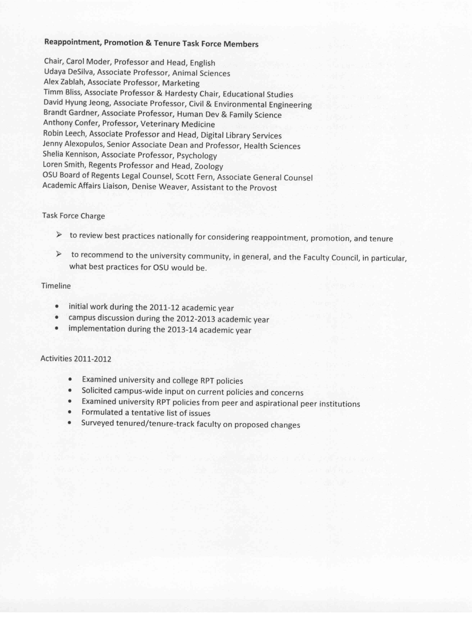
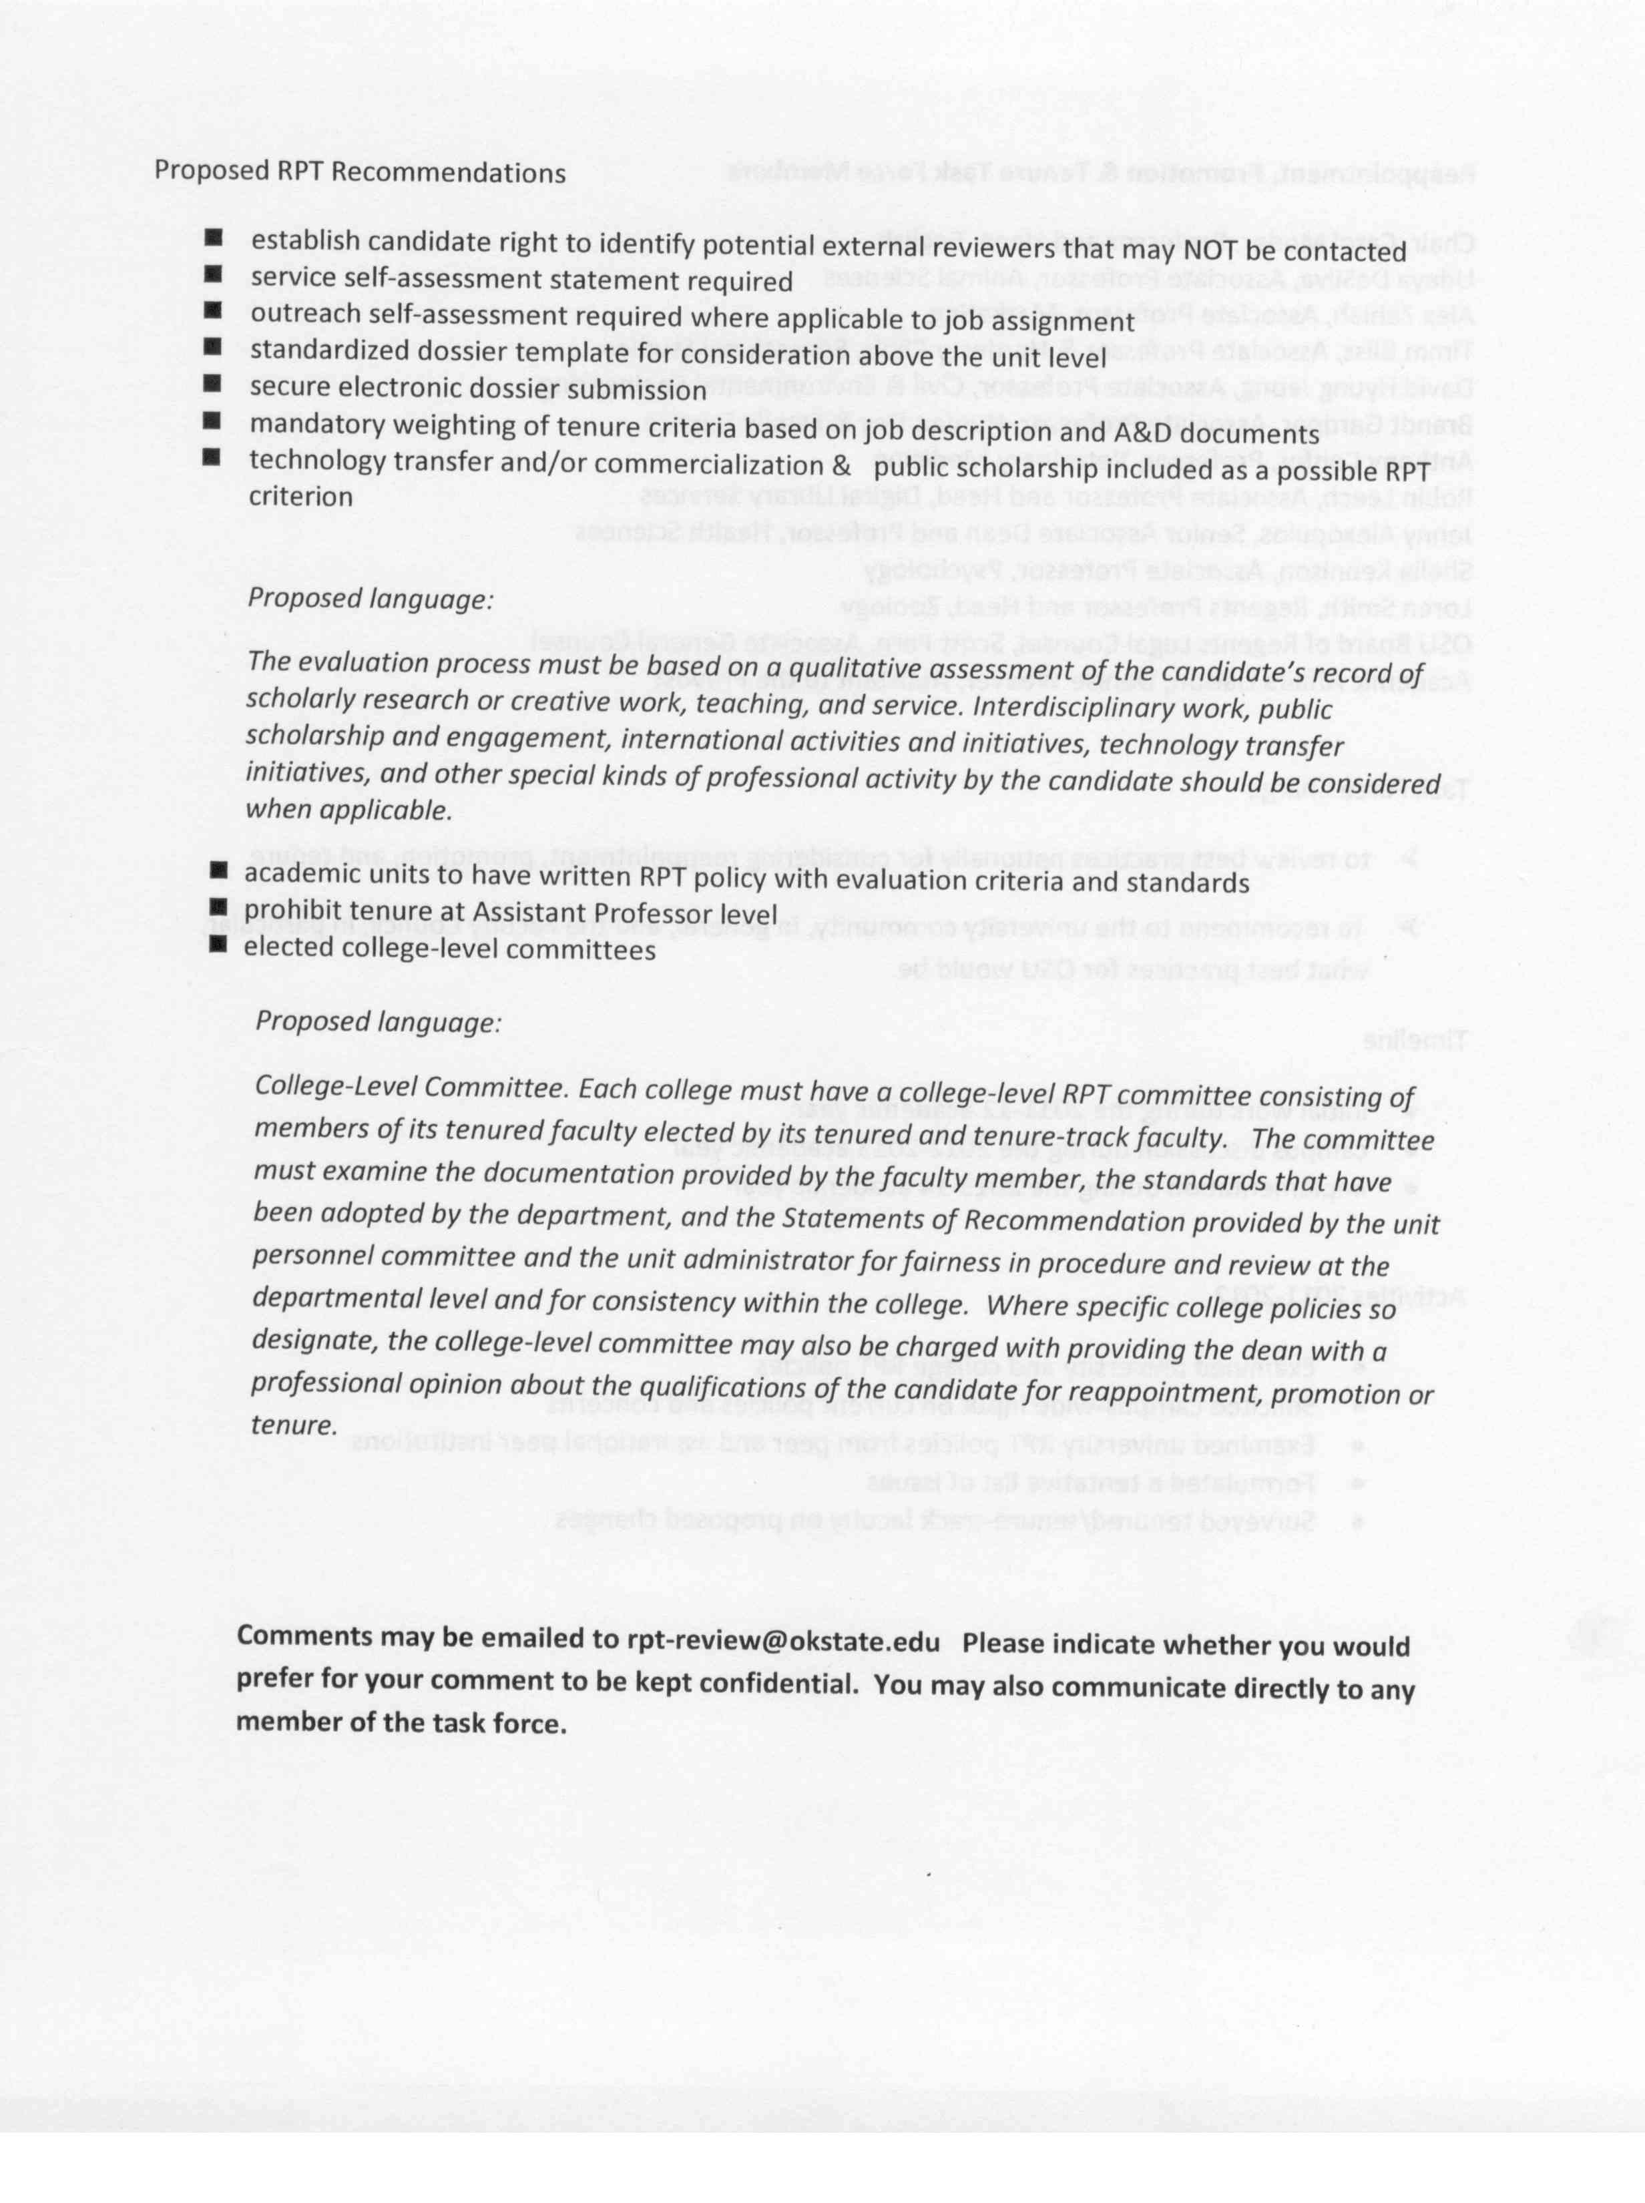

Remarks and Comments from President Hargis:

President Hargis stated that the dorms opened this past weekend and there are many students already checked in for the fall semester. The dorms are over 100% occupancy. There will need to be a new strategy for next year if we keep having record freshman classes. President Hargis wants to make sure that all freshman and sophomores have access to the dorms. President Hargis feels that there will be a big opportunity for online courses.

President Hargis stated that the construction on Monroe street continues and should be completed about a year in advance of what was originally projected.

When President Hargis arrived at OSU he was not aware of the frustrating efforts to have a Phi Beta Kappa chapter on campus. He feels this is critical to OSU students and the university to recognize the excellence that is at OSU. Phi Beta Kappa is for A&S college only. President Hargis stated that the process to receive a Phi Beta Kappa chapter is a long task, over three years. OSU put together a great team who worked hard on the application. A visit to OSU was granted about 1 ½ years ago. It was a very positive visit and it was recommended that OSU be admitted to Phi Beta Kappa. The final step is to attend the National Convention. The OSU delegation attended, received questions and received an almost unanimous vote to join Phi Beta Kappa. President Hargis added his thanks to the team that led this effort for OSU. President Hargis said that there is nothing since he has been President that he is more proud of OSU achieving.

President Hargis mentioned that the Branding Success campaign has had a very productive year at the legislature and OSU hopes to have some substantial funds to match the chairs that money was raised years ago. There is still a long way to go. Boone Pickens $100 million gift has a long way to go to be fully funded again. The money is coming from a hedge fund. Which the legislature decided to repatriate to universities on the chairs and a few other uses. OSU is now at about $910 million on the Billion Dollar campaign. President Hargis is confident that the billion dollar mark will be met before the end of this year or shortly thereafter even though the campaign doesn’t end for another 3 years. Of this campaign about $220 million are estate gifts and the rest is either pledges or outright donations. This is quite an achievement. When this campaign is done, we’ll take a little breather, figure it all out and then start again. As President Hargis has tried to persuade everyone to be engaged. This means faculty. Donors don’t give money to a foundation, they give money to faculty’s work. President Hargis feels that no one is more persuasive to a donor than the person who is actually making use of the money.

The legislature is not in session so there is no budget updates.

Report of Status of Council Recommendations:

Provost Sternberg said that President Hargis has asked him to look into the possibility of changing the calendar for the school year slightly so that OSU might start a little later and end a little later. Right now OSU starts pretty early in August and end in early May compared to other schools. Sternberg feels that the Faculty Council is the appropriate body to start consideration of this issue since it would directly affect teaching and research schedules. Sternberg hopes that the Faculty Council would form a task force, committee or giving this to an existing committee the conundrum if at some future time to reconsider a calendar.

Provost Sternberg gave the status of the following recommendations:

11-12-01- FAC: Revision to OSU Attendance Policy
Pending – Instruction Council recommends modifications to the revision proposed by Faculty Council. Policy remains under consideration by the Faculty Council.
12-02-01-ASP: Veterinary Research Scholars
Pending – Proposed designation was approved by Instruction Council on April 13 and will be reviewed by the Council of Deans at their May 10 meeting.
12-05-02-Faculty: Revisions to the Policy on Research Professorships.
Pending
12-03-01-Faculty: Revisions to OSU Policy on Reappointment, Promotion and Tenure Process for Ranked Faculty
Pending – Pending review by the Council of Deans
12-05-01-Research: Institutional Laser Safety Policy
Accepted - (8/14/2012)
12-05-01-SALR: Revision of OSU Attendance Policy to Clarify Absence due to Military Service
Pending – Review pending of policy modifications relate to military service by Instruction Council
12-04-01-ASP: OSU Academic Regulation 3.4: General Education Requirements
Accepted – (8/14/2012)

Sternberg gave Faculty Council the following update on task forces:

1. Assessment of Student Learning. Pam Fry. This is now completed and has been referred to Faculty Council.
2. Budget Utilization. Completed and some of those recommendations have been implemented in order to save money.
3. Evaluation of Instruction. In July 2012 the final report was received by the Provosts office. The idea with this task force was whether the kinds of evaluation that are currently in place can be supplemented. One strength in the student evaluation system would be to have a better form and to have other means of evaluation. Some very good recommendations were made regarding peer evaluations, portfolios and using ITLE more for diagnostics. This report is now with Faculty Council as well. Provost Sternberg is waiting to hear back from Faculty Council before moving forward.
4. OSU moving to a more strength based admissions policy. This would mean if a student wanted to apply by either ACT alone that could be done or if the student wanted to apply by a combination of ACT or grades a student could do this as well. But if a student wanted to apply only by grades and class rank criteria through the holistic approach the exploration was whether this could be done without having to take the ACT since it is not actually used in the holistic criteria. Sternberg stated that this task force has done an outstanding job and they reported on some of the issues that OSU would face. The three main issues being A. Combating the assumption that this is a lowering of standards; B. Scholarships. There is one external scholarship by the Regents that requires an ACT score of 33 or above. The other scholarship problem is internal scholarships. Are there alternative criteria besides the ACT score; C. Placement tests to assure ourselves that we have standardized placement tests that are at least if not stronger than the ACT. For example, OSU is using ALEX for math and the report from the math department and the engineering school is that this is much better for placement than the ACT was. This report is now with Faculty Council and he is awaiting feedback.
5. General Education. No final report yet. This task force is being run by Steve Damron and Shelia Kennison. Once the report is received it will be sent to Faculty Council.
6. Graduate Student Support Issues. This is chaired by Dean Tucker and no final report has been received yet.
7. Math Curriculum Enhancement. Basically this was to deal with a very large number of D’s, F’s and W’s in introductory math courses. Bus Jaco who is now head of the math department has put a tremendous amount of work and collaboration with other people into enhancing the Math Success Learning Center which is now moving to the 5th floor of the library.
8. Outreach Implementation. The report has been received. This pertains to salaries approved by the Regents. There have been a few salaries way in excess of the Regents approved salary. Sternberg received complaints from the Regents that they are supposed to be the ones approving the salaries and they thought something was wrong when they approved a salary and it’s nothing close to the salary. There was an Outreach committee on Vision for how we can better serve ourselves in terms of outreach education especially electronic education. This report is now with Faculty Council and Sternberg is awaiting input.
9. Improve Transfer Students Platform and how to increase retention. Pam Fry is working on this issue.
10. Undergraduate Retention. This has many sub task forces. Sternberg expects a report from the task force within the next few weeks. It will then be passed to Faculty Council.
11. RPT. Carol Moder reported to Faculty Council on this task force.
12. Visioning and Strategic Planning. Two different task forces that have reported and Sternberg is awaiting input from Faculty Council.

The last item is that there have been 9 searches completed. Dean of Art & Sciences is Bret Danilowicz. Dean of Education is Sissi Carroll. Dean of CEAT is Paul Tikalsky. Dean of the Center for Veterinary Health Sciences is Jean Sander. Associated Provost and Dean of the Graduate College is Sheryl Tucker. Associate Vice President/International Studies and Outreach is David Henneberry. Associate Provost and Associate Vice President for Undergraduate Education is Pam Fry. Assistant Provost and Director of the Institute for Teaching and Learning Excellence is Chris Orsmbee. And the Assistant Provost and Director of LASSO is Cheryl Devuyst. The only outstanding search is the Vice President Dean and Director of the Division of Agricultural Sciences and Natural Resources. This search is active with over 100 applications. There is a large search committee and they are working to find the very best person they can.

Vice President Weaver – Monroe Street Update

Weaver appreciates everyone’s patience during this process. Good news is all the parking lots that have been worked on this summer will be open at 6:30 Monday, the first day of classes. Weaver stated that there is an actual net gain of 65 faculty/staff parking spaces compared to this time last year. OSU has acquired some property and made some adjustments. They are not exactly where he would like them to be, closer to the core. But once the southwest parking garage is completed next spring there will be a few hundred extra faculty/staff parking spaces.
By 6 a.m. Monday, Monroe street will be open from the lower control gate south to University Ave. for access to all the parking lots available. Hall of Fame going south to Farm Road will be completed and also open Monday to access those parking lots. The middle section between the control gates will not be open. This section should be completed by Thanksgiving. Hopefully.
The sidewalks along Monroe have been an issue but the priority was getting Monroe street open. A number of the sidewalks have been completed and the remainder of them should be wrapped up in the next few weeks. You may have noticed that Hester Street has been resurfaced. Some curves have been reconstructed as well. Sections of Farm Road have been improved where the curbs had deteriorated. They wanted to resurface Farm Road as well but decided to do this next summer. Barbara Miller asked for clarification on Monroe Street – Hall of Fame to Farm Road or is it actually Athletic Road, to the gate. Weaver said that there is an issue with Farm Road and some of the infrastructure. The road will eventually be open to Athletic. The first day of school with just be to Farm Road.

President Hargis asked Weaver to talk about the quad north of the Library. The plan is to develop the international mall to a higher standard. Sidewalks have been removed and sod has been laid. An irrigation system has been put down. It will be a wonderful place once it’s done. On the south side of the Library some trees have been removed and the utility infrastructure has been improved and sod is being laid there as well. Next year or next summer this should be a nice wide pedestrian plaza that is comfortable for bikes and people connecting the east and west side of campus.

REPORTS OF STANDING COMMITTEES:

ACADEMIC STANDARDS & POLICIES – Ed Harris – Update

Harris reported that his committee will be handling many of the task forces Provost Sternberg mentioned earlier. Next month, Harris will report on the articulation agreement between Tulsa Community College and OSU. This specifically will address a program that TCC was piloting called EXCELerate. It’s a dual enrollment type program and there were 3 issues that came up that were concerns. One of these was that the program was offered at the high school and they were not getting the college experience of other concurrent programs. Another concern was that these courses were being taught by high school teachers. Another concern was that this program reduced the ACT standards to be accepted. The implications for OSU is that OSU will be getting freshman in the near future that are below standard. Clint Krehbiel appointed a task force and we reviewed all three of these issues and these will be reported on next month.

ATHLECTICS – Robert Cornell – No Report

BUDGET – Rodney Holcomb – No Report

CAMPUS FACILITIES, SAFETY AND SECURITY – Robert Emerson – No Report

FACULTY – Matt Lovern – Update

Lovern introduced the other committee members: Karen McBee, Victor Baeza, Alan Finchum, Jack Dillwith and Sue Jacobs. The Emeritus Faculty member is Ken Bell. The committee has received some issues that they will be looking at over the course of the academic year that are left over from last year as well as a few new items. Last year’s issues the committee is still working on is Appendix E. The committee also has a report it will be preparing regarding clinical track and research track professorships. There was a recommendation approved by Faculty Council regarding the language reviewing the policies for these two positions. The committee hopes to present a more full report of any additional issues that may need to be addressed. The final item is the task force that proposed revisions to the faculty workload guidelines and proposed a new policy on overload pay. These were received over the summer and will be reviewed and a recommendation will be presented to Faculty Council. The committee looks forward to working with Dr. Moder and the RPT task force on the language for changes.

LONG-RANGE PLANNING and INFORMATION TECHNOLOGY – Nick Materer –
Update

Materer stated that he received a phone call last week regarding a policy change that IT will be implementing on the OSU Firewall. This action may affect legacy systems. If any faculty member has a legacy system that uses telnet, please contact Nick Materer (materer@okstate.edu) and we can work with IT to examine options in order to ensure that your system remains operational.

RESEARCH – Dan Fisher – No Report

RETIREMENT and FRINGE BENEFITS – Stephen Clarke - No Report

RULES and PROCEDURES – Kemit Grafton – No Report

STUDENT AFFAIRS and LEARNING RESOURCES – Bob Miller – No Report

Report of Liaison Representatives:

Staff Advisory Council – Sue Moore

Sue Moore reported that SAC has formed an ad hock committee hoping it will increase the participation on campus. This committee will look into the structure for counsel seat representation to develop a more natural constituent base for information transfer rather than an HR based system that does not necessarily put reps in contact with their base. A lot of people do not know how to contact SAC when they have an issue and they want help addressing it. As a key goal of SAC hoping to improve communication the SAC will be doing staff profiles in email communications using the all staff distribution honoring staff achievements and providing short stories and interest to staff. Now that SAC has a foundation account for a staff professional development fund, they are moving to add their fund activities and support services in a different way aside from scholarships and awards. They are looking for money and plan to approach donors soon. SAC appreciates the faculty’s endorsement of the continued exploration of a sick leave transfer policy especially given that is doesn’t affect staff and faculty in the same way. SAC is learning more and more about the intricacies involved as well as how other institutions accomplish this goal. HR has been very helpful in this process. The staff will again be included in this falls convocation. The award process is now beginning with some changes being made. The goal being to get more involvement from areas not heard from in a while. Hopefully there will be additional Dean and Administrative by in.

Women’s Faculty Council – Barbara Miller

Miller mentioned that with so many new deans on campus, she encourages everyone to talk about the Women’s Faculty Council scholarships. Letters are sent every year. 11 or 12 scholarships were funded last year. There are some deans and directors who traditionally have not supported this effort and the WFC would like to get support from all the colleges. Letters will be sent out in November and the applications will be on the website. WFC is looking at under-representation of woman in leadership positions on campus. About 1/3 of the faculty at OSU are woman but there is a much lower percentage of woman in leadership positions on campus. WFC is working with the Women’s Leadership group to set up a mentoring program to encourage woman who are interested in leadership to work on projects with woman who are already in leadership positions. More information is available; please contact Melanie Page or Barbara Miller. A few workshops will be run through ITLE. Provost Sternberg wanted to point out that of the 9 hires he mentioned earlier, 5 of are women.

Old Business – None

New Business – Phi Beta Kappa – Bob Miller

Sheila Kennison sent around the following resolution for consideration.

A Resolution of the Faculty Council of Oklahoma State University

Whereas on 3 August 2012 the 43rd Triennial Counsel of Phi Beta Kappa voted to authorize Oklahoma State University to shelter of chapter of the honor society to be known as Gamma of Oklahoma, and

Whereas the petitioning process to obtain authorization to shelter a chapter was a multiyear process, and

Whereas the petitioning committee has worked diligently to obtain this honor for Oklahoma State University,

Be it resolved by the Faculty Council that the Chair of the Council direct its Secretary to send Greetings and Salutations of Congratulations and Thanks to Dr. Perry Gethner, the chair of the petitioning committee, to the committee’s members: Dr. Charles Abramson, Dr. Bruce Crauder, Mr. Gary Clark, Dr. Robert Graalman, Dr. Bob Miller, Dr. Robert Spurrier and Dr. Robert Sternberg, and to the committee’s critical staff assistant Ms. Melissa Meridith.

Bartels stated that another sheet was distributed regarding Phi Beta Kappa. Dr. Bob Miller stated that what is being distributed is what the members of the triennium received on which they based their vote. This is the report of the site visiting committee. One of the reasons to distribute this is to see that in fact OSU was well received and very highly regarded. OSU received only 13 ½ negative votes out of a possible 300. We don’t know where the ½ came from but each chapter and association has one vote.
The two things Miller would like to talk about as we move forward in forming the chapter, we need to know the names and affiliations of all member of faculty and staff that are members of Phi Beta Kappa. That were inducted into Phi Beta Kappa at their undergraduate institutions. If you could forward these names to Dr. Pam Fry as soon as possible in order to develop the submission for the charter. Moder asked if this is just tenure or tenure track faculty only or all faculty. Miller answered all faculty and staff as well. This does include post-docs, etc. The second thing is there will be a lot of publicity this spring. Hopefully many faculty and staff will join in since members of the National Committee will come to campus to install the chapter and be present for the induction of the first members. Talk it up to students.
David Lewis asked if Emeriti members should be included in the list. Miller is not sure if they will go on the charter but their names will be sent to national. They will make the decision.
Bartels asked for a vote on the resolution. Motion passed. Miller stated that this was OSU’s third attempt to receive a Phi Beta Kappa chapter.

Udaya DeSilva addressed the wildfires of the last two weeks that have affected a lot of people in the OSU community. This includes one of our very own, Deb VanOverbeke. Her family lost their home and all their belongings. DeSilva wanted to take few moments to ask everyone to keep those affected by the wildfires in our thoughts and do whatever we can to help. There are many conduits open to help. In fact there is a cleanup day Saturday. Sternberg mentioned that he thinks it would be a good idea on OSU’s homepage to have a button where people could donate to these victims. The simpler it is made and the more centralized it is the more likely people will donate. Bartels asked DeSilva to follow up on this item.

The meeting adjourned at 4:55 p.m. The next regular meeting of the Faculty Council is Tuesday, September 11, 2012 in 412 Student Union, Council Room.

Respectfully submitted,

Udaya DeSilva, Secretary

