Clarke called the meeting to order with the following members present: Borland, Collins, Depperschmidt, Doust, Frazier (for Jason Vogel), Jones, Lavine, Lewis, Lloyd, Lowrance, , Martin, Miller, Nabar, Oberhelman, Perea-Fox, Piao, Richards, Takacs, Tenorio, Topham, VanOverbeke and Walker.
Also present: Atiles, J., Bayles, M., Campbell, C., Elliott, K., Finchum, A., Fry, P., Gordon, S., Hargis, B., Harrington, S., Haviland, C., Hilbert, K., Knecht, J., Masters, B., Miller, B., Sandefur, G., Sewell, K., Shutt, G., Taber, C., Tucker, S., Weaver, J. and Wright, R.
Absent: Biros, Bliss, Liang, Martin, McCann, Royer and Wansley.

HIGHLIGHTS

Special Report………………………………………………………………………………………
Suzi Harrington – Chief Wellness Officer………………..……………………………...…
Brenda Masters – Academic Affairs Accreditation Update………………………………..
Jorge Atiles – Associate Dean for Extension & Engagement………………………………
Remarks and Comments – President Hargis………………………………………………………..
Report of Status of Faculty Council Recommendations and other Vice Presidents……………......
Reports of Liaison Representatives ……………………………………………………………….
Graduate Faculty Council…………………………………………………………………..
Women’s Faculty Council………………………………………………………………….
SAC ………………………………………………………………………………………..
AAUP……………………………………………………………………………………….
GPSGA……………………………………………………………………………………..
SGA………………………………………………………………………………………...
Reports of Standing Committees …………………………………………………………………..
Academic Standards and Policies ………………………………………………………….
Athletics ……………………………………………………………………………………
Budget …………………………………………………………………………………......
Campus Facilities, Safety and Security ……………………………………………………
Diversity……………………………………………………………………………………
Faculty ……………………………………………………………………………………..
Long-Range Planning and Information Technology ………………………………………
Research ……………………………………………………………………………………
Retirement and Fringe Benefits ……………………………………………………………
Rules and Procedures ……………………………………………………………………....
Student Affairs and Learning Resources ………………………………………………….

Clarke called the meeting to order and welcomed everyone back to campus. Clarke had all members introduce themselves since there are many new faces to the council. Clarke passed around the roll call and asked everyone to sign it. Provost Sandefur introduced the Vice President for Research, Kenneth Sewell. Clarke asked for approval of the May 12, 2015 minutes. VanOverbeke moved, Walker second. Motion passed. Clarke moved for approval of the agenda. Doust moved and Perea-Fox second. Motion passed. Clarke stated there are three special reports this afternoon and introduced Suzi Harrington, Chief Wellness Officer.

Special Reports:

A. Suzi Harrington – Chief Wellness Officer

Harrington thanked the committee for the opportunity to speak to the group. She explained the she is not from the Department of Wellness. Each campus has a department of wellness. She is at today’s meeting representing America’s Healthiest campus and her job is to tie all wellness together to enrich the lives of students, faculty and communities representing all 5 OSU campuses and the 4 A&M campuses as well as the 77 county extension service offices.

Harrington stated there was a wellness retreat back in April that identified 5 top priorities. The 5 priorities are:
1. Wellness commitment statement. This is currently being drafted. Jamie Payne in HR is the chairperson for this committee.
2. Outcome priority task force. There are two parts to this – 1. Outputs – what makes us Americas Healthiest Campus across the system and 2. Outcomes – what type of things show that we are improving our health. And health is defined as being the best we can be, being the most productive, most engaged, most successful, most resilient and how do we prove this. She is working with many national organizations to really pull this together. Americas Healthiest Campus has been trademarked by OSU. But there are no benchmarks that prove it nor are there any that disprove it.
Outcome task forces:
1. Increase the HRA screenings by 20% this year across all campuses. Harrington said they will make sure this is available to all campuses. Harrington encouraged members to get the screening.
2. Increase number of certified healthy departments and innovators. They want to increase these numbers by 20% across campuses. Applications will go out in January. Information can be found on the website right now: americashealthiestcampus.com. Harrington explained the Innovator program which started in January. Innovators are volunteers within departments that are the wellness champions and have information. There are monthly challenges and wellness topics. The Innovators will fill out the application. Harrington stated that there currently are Innovators on all campuses and county extension service offices as well as our A&M campuses. Increase student innovators and student certified healthy organizations. This will begin in January. OSU is the only university in the country that has anything like this.
3. Nutrition
4. Fitness. The goal is to improve both nutrition and hydration amongst all campuses. As well as improve physical activity and decrease sedentary.
Harrington stated that these two task forces have met and are looking at some things to do. Harrington told the council when they talk about wellness it’s really the harmony of our physical, emotional, spiritual, social and professional wellness. It’s much more than diet and exercise. They are focusing on nutrition and physical activity right now because that is what we are strongest on our campus. Harrington believes that next year they will focus on things that relate to stress management and mental health. There are currently pieces in place, Pet Therapy program, and will work to put them together.
5. Student Wellness Council. These will be starting in October.

Harrington presented the following Where’s Pete Discovery Trail information:

Discover the beauty and history of OSU, America’s Healthiest Campus®! Find 15 Pistol Petes hidden along a 2.15 mile trail. Search for answers to the questions along the way, then bring your completed sheet to the concierge desk across from the University Bookstore in the nation’s largest Student Union to claim your prize!
1. Start at the formal gardens on the east side of the Conoco-Phillips Alumni Center. Who are the formal gardens in appreciation of? Pete is there.
2. Walk to the north end of the Seretean Performing Arts Center. There is an egg-shaped concrete bench called “The Spoon” where courting couples could meet (under the watchful eye of the house mother across the street in Bartlett Hall, which used to be a women’s dormitory). What class (year) had the bench built? Pete is near the entrance to the bench.
3. Across the street is a building with very large stairs in front. This is Morrill Hall. On the ground west of the stairs is a benchmark. Benchmarks are placed around the United States with a high degree of accuracy to mark altitudes, latitudes and longitudes. What year was this benchmark placed? Pete is nearby.
4. Walk west from Morrill Hall to cross Hester Street. After crossing the street, walk north. Soon you will see the east end of the Legacy Walk, which runs in front of the Edmon Low Library. It is part of the walking trails on campus. In front of the benches and columns near the street, you will see some embedded medallions. What do the medallions say? Pete is resting near a bench.
5. Follow the sidewalk north to Athletic Avenue, then turn east and you will see the Architecture Building on the north side of the street. How many big boulders are in the two rock gardens in front of the building? Pete is resting in the pavers between the two rock gardens.
6. Continue walking northeast toward Gallagher-Iba Arena, which is at the east end of Boone Pickens Stadium. On the east side of Gallagher-Iba Arena is a plaza with dedicated pavers (including Pete), as well as a line of cypress trees for the men who died in the plane crash in January 2001. How many cypress trees are planted between Gallagher-Iba Arena and the practice field?
7. Turn around and walk west across campus. This is the longest leg of your journey. Return to the intersection of Athletic Ave and Hester Street and walk west, which will take you behind the Edmon Low Library. Past the library, almost to Monroe Street, is the Henry Bellmon Research Center. A sundial is mounted near the top of the building. Read the plaque to learn how to tell time using the sundial, and then write down the year the sundial was placed on the building. At your feet is Pete!
8. Across Monroe Street is Agriculture Hall (“Ag Hall”). Pete is hiding behind the back wall of the plaza in front of Ag Hall. At the top of the stairs is the plaque dedicating Ag Hall. Who was the governor when Ag Hall was built?
9. The big building south of Ag Hall is Human Sciences. There are actually two Human Sciences buildings. One is hidden behind. One houses the Child Development Lab. Look for the “tube” connecting the buildings. Pete is hiding near the tube. Which building houses the Child Development Lab (look for the playground)?
10.A few buildings south of Human Sciences, along Monroe Street, is South Murray Hall. What does the big block in the sidewalk next to Pete say?
11. Across Monroe Street is Theta Pond, which was originally where the OSU workhorses drank their water. Running alongside Theta Pond, at a diagonal from the intersection of Monroe and University streets, is “Greek Walk,”
where plaques representing each OSU sorority and fraternity are placed. At the beginning of Greek Walk is Pete. Next to him is a big walking trail medallion.
What is pictured in the middle of the medallion?
12. North of Theta Pond is Willard Hall. Because of its picturesque setting, many people get married on the back patio of Willard Hall. Pete is near the stairs going up to the patio. How many lamps are on the columns around the edges of the patio (upper level only)?
13. East of Willard Hall are the formal gardens of the Student Union. Pete is near the steps on the west side of the gardens. When will the time capsule in the very middle of the gardens be opened?
14. North of the formal gardens is the Library Lawn. Many events occur here, and it is a popular place for students to relax between classes. At the very northeast corner, at the end of the brick wall, Pete is hiding! He is near the edge of the Beverly Clerico Plaza. What year did Beverly Clerico finish her business degree?
15. Almost done! The Classroom building is on the east side of the Library Lawn. Next to the building is a big stone commemorating the honor band fraternity and sorority. What year was Tau Beta Epsilon founded? Pete
is near the answer.
16. YOU HAVE FINISHED! You have walked a little over 2 miles! Congratulations! To get your prize, take your completed treasure map to the concierge desk inside the Student Union (across from the bookstore entrance).
n
Geocaching available at www.geocaching.com: “Where’s Pete? Discovery Trail Geocache (GC5RFB5)”.

The trail takes about an hour to complete. Harrington stated that an indoor Where’s Pete trail is in the works. Harrington asked if anyone had seen the big net outside the library. This was given to OSU by a donor. It was called the active art area because it is a great collaborative effort with the art school. Art is placed on the outside of the net and a big spider web net is on the inside. This is a place where students can put their hammocks and slack lines. This will keep students from attaching these to the trees. Dedication for this new piece is September 6th at 11:30. There will also be a big swing for students to use.

Harrington opened the floor for questions. Miller asked what percentage of people have taken the healthy check-up last year. Harrington stated that last year they were at 12% and have increased by 60%. Harrington’s goal for this year is to get to 50% but would like to increase it by 20% over last year.

B. Brenda Masters – Academic Affairs Accreditation Update

Masters presented the following PowerPoint presentation to the council.

Masters told the council that the accreditation site visit will be October 19th and 20th of this year. Masters stated that an additional reviewer will review the Center for Health Sciences and OSU-Tulsa on the Thursday and Friday prior to their visit to Stillwater on the 19th and 20th. Open forums will be available during the site visit on the 19th and 20th for faculty, staff and students. These will be advertised broadly and Masters encouraged members to attend. Masters stated that the drafts of the assurance report available through a password protected portion of SharePoint so that faculty who provided input and others to whom the links will be sent may provide comments about the drafts. As soon as the drafts are available they will be posted and the URL will be sent for people to review.

C. Jorge Atiles – Associate Dean for Extension & Engagement

Atiles stated that for the past three years he has worked on campus as a volunteer coordinator for the University Network on Community Engagement. This network is an informal network that meets monthly during the academic year and is represented by all Deans as well as Vice Presidents who would be related to community engagement and outreach. Atiles stated that OSU’s current classification expires in 2015. This is an elective classification but is prestigious among universities and a group was formed to re-apply. The new application requires institutions to show they are engaging students through service learning and other areas. Atiles stated that over time the colleges have been meeting to decide what community engagement means to each college. During a meeting with Provost Sandefur, Atiles was asked if OSU needed an Office of Engagement. Atiles presented the following information to the council members regarding his work and perspective regarding engagement.

Centrality of Engagement in Higher Education

Why an Office of Community Engagement @ Oklahoma State University?

Ideally such an office would be an academic-support unit of the provost’s office assisting all faculty, staff, and students with community engagement.

To efficiently synergize efforts to

1. Document (i.e., accountability, Carnegie & Higher Learning Commission credentialing, APLU Innovation and Economic Prosperity University)
2. Recognize (i.e., support awards, award applications, media, reports, A&D, RPT)
3. Maximize (i.e., engagement training, resources, partnerships, grants, digital engagement). Enhance the learning, discovery, creativity, and service experience at OSU through community engagement
4. Coordinate (i.e. special initiatives, joint efforts by units, agreements, with other efforts such as corporate engagement, etc.)
5. Connect with communities by becoming a portal to all community engagement units and programs of the OSU system.
6. Elevate OSU as an institution engaged with communities in the state, nation and abroad. Give & Receive in a mutually beneficial relationship with the state and other partners. Be able to speak to different constituencies about the OSU’s scholarly contributions to the public good.
7. Participate & Represent OSU at various Engagement networks of association and organizations such as the Council on Engagement of the Association of Public & Land Grant Universities, the Engagement Scholarship Consortium, Campus Compact, Imagining America, National Collaborative for the Study of University Engagement,

About the UNCE: The University Network on Community Engagement (UNCE) at OSU is an informal network that started in January 2013 to help OSU get ready for the Carnegie Classification application; to share across units what type of engagement work takes place across all 3 mission areas; and to share ideas on how to institutionalize engagement in each college/unit. Through the endorsement of the provost’s office, the UNCE is supported by Associate Vice-President Dr. David Henneberry from the Division of International Studies and Outreach. Dr. Henneberry also serves as the OSU institutional liaison on the Board of Directors of the Engagement Scholarship Consortium. Dr. Jorge Atiles volunteers time to serve as coordinator for the UNCE activities. He also serves on the Executive Committee of the Association of Public & Land Grant Universities’ (APLU) Council on Engagement & Outreach.
For more information on the UNCE please contact: jorge.atiles@okstate.edu
What others universities have:
List of Engagement Scholarship Consortium member universities with central units of community engagement: https://engagementscholarship.org/resources/university-based-engagement-offices
Next page has links to engagement offices and structures for OSU aspirational institutions

OSU Aspirational Institutions – offices of engagement

Auburn:
Organization: http://www.auburn.edu/administration/orgchart.pdf ;
Office: http://www.auburn.edu/outreach/
Clemson:
Organizations: http://www.clemson.edu/administration/documents/organization-chart.pdf
Office: http://www.clemson.edu/outreach/
Indiana University-Bloomington:
Organization: http://www.iu.edu/about/org-chart.shtml
Office: http://engagement.iu.edu/
Rutgers:
Organization: http://www.camden.rutgers.edu/pdf/Rutgers-Camden_Organizational_Chart.pdf
http://middlestates.rutgers.edu/pdf/N_AppendixB_draft.pdf
Offices: http://www.newark.rutgers.edu/community-engagement; http://occr.newark.rutgers.edu/; http://community.rutgers.edu/; http://www.camden.rutgers.edu/node/276
University of Arizona:
Organization: http://president.arizona.edu/campus_leadership
Office: http://uaforyou.arizona.edu/
University of Illinois, Urbana-Champaign:
Organization: http://www.pb.uillinois.edu/Documents/staffing/UA-Org-Chart.pdf
http://www.pb.uillinois.edu/Documents/staffing/UIUC-Org-Chart.pdf
Office: http://engagement.illinois.edu/
University of Kentucky:
Organization: http://www.uky.edu/regs/files/ar/President%20-%20Org%20Chart%20(July%202015).pdf
Office: http://www.uky.edu/engageuk/ reports to VP for University Relations (President’s office) http://www.uky.edu/universityrelations/
University of Michigan, Ann Arbor:
Organization: https://studentlife.umich.edu/article/student-life-organization-chart
Office: http://www.ceo.umich.edu/
University of South Carolina:
Organization: http://www.sa.sc.edu/about/division-offices/
Office: http://www.sa.sc.edu/leadershipandservice/community-service/
SUNY, Buffalo State:
Organization: http://financeandmanagement.buffalostate.edu/sites/financeandmanagement.buffalostate.edu/files/uploads/Documents/buffalostate.pdf
Office: http://suny.buffalostate.edu/community-engagement
University of Miami:
Organization: http://www6.miami.edu/provost/images/pdf/TO-09.02.14.pdf
Office: http://www.miami.edu/index.php/civic

Atiles opened the floor for questions. Lewis asked Atiles to differentiate the differences between engagement and outreach. Atiles used the UNCE website to answer her question. The definitions of engagement and outreach are posted on the website. Atiles stated that Outreach is one dimensional. It’s one-sided. I have the knowledge and provide it to you to improve your life. Engagement has to be mutually beneficial. I learn as much from the community as the community learns from me. Atiles explained that the Offices of Engagement and Outreach for Public Service are referring to engaging with the public through means other than school courses.

Remarks and Comments – President Hargis:

Hargis welcomed the council back for the fall semester and welcome week has begun. Convocation is Friday at 4:00. Hargis invited everyone to attend. Hargis stated we have strong new student enrollment. He believes OSU will be over 4,100 which will be the second largest freshman class in OSU’s history. Hargis stated that high school graduation has been declining in Oklahoma but he believes OSU will have the largest number of Oklahoma resident students in OSU’s history; 2,750 is the estimate. Hargis stated that this is a result of the entire OSU experience of which the faculty play a large part. Hargis stated that one of the first events on campus this year will be the launching of the OSU Center for Sovereign Nation and Engagement. Hargis stated that Elizabeth Payne is the director who reports to the Provost. Hargis announced a $6 million grant to OSU along with 3 other universities, but OSU will be the lead. Jamie Jacob will be the principle investigator on an unmanned aerial vehicle program that NSF is funding. Hargis stated that the opening of the Vet Academic Center soon. Hargis thanked the team that was able to get the new University Commons area completed in time for classes. Hargis stated we are almost at 100% occupancy. Hargis said the Human Science expansion is continuing. The basement of the new Business building has begun. The Equine teaching center will be open this year. The old Central Plant will be replaced and will free up some valuable real estate on Hall of Fame. The current power plant was done in 1948. Hargis stated that the Atherton Hotel should open January 2016.

Report of Status of Council Recommendations:

Provost Sandefur stated that the following two recommendations are still pending:

14-05-01-Faculty/14-01-01-Faclty: Revisions to P&P 2-0112: Annual Faculty Appraisal & Development Policy
15-03-01-ASP: Revisions to P&P 2-0902: Reappointment Promotion and Tenure Process for Ranked Faculty.

Sandefur stated that the Deans, Faculty Council and others spent much of last year working of revisions to the A&D policy as well as the RPT policy. Toward the end of the last academic year the Deans accepted the recommendations that had been approved by Faculty Council. The next step will be to have legal counsel in the OSU Regents Office review these recommendations. Once they have approved them, they will go to the Executive Team then the Board of Regents for approval. These were sent to legal counsel and just yesterday Sandefur heard back from legal counsel that the RPT policy had a few observations but no real questions or suggestions for changes so Sandefur believes this will move forward. Sandefur will be talking with Stephen Clarke, Nick Materer and the deans regarding the A&D policy which had changes that were recommended by legal counsel. Sandefur will send the Faculty Council officers these observations from legal counsel. Sandefur stated they are continuing to make progress. The other three policies have been accepted and there is no further action needed on them.

Sandefur presented the following information regarding the implementation of a new online student survey of instruction:

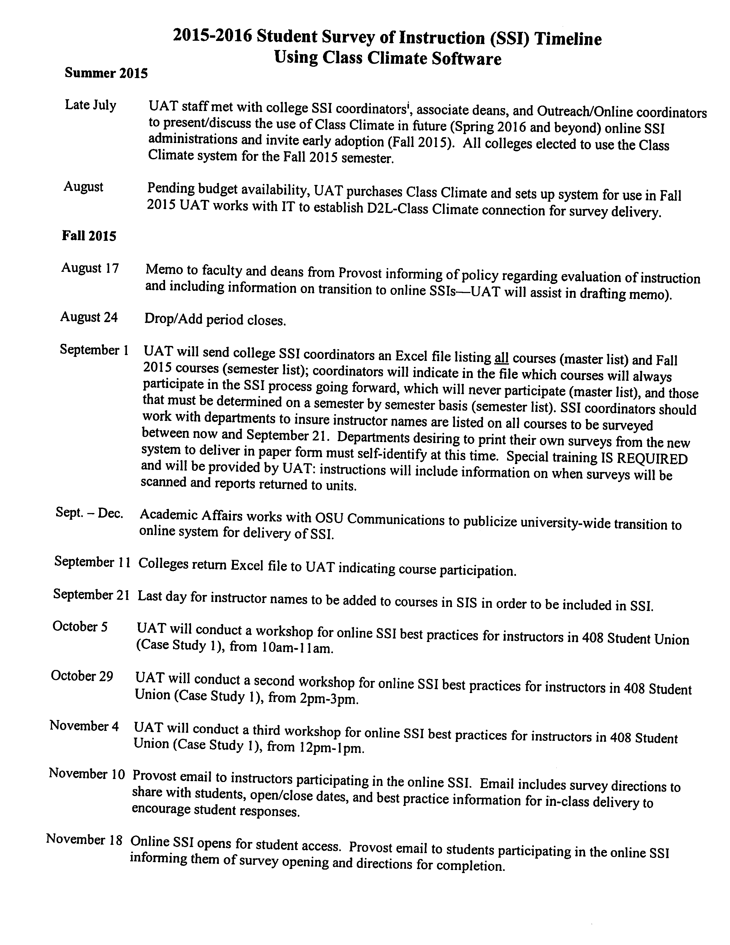

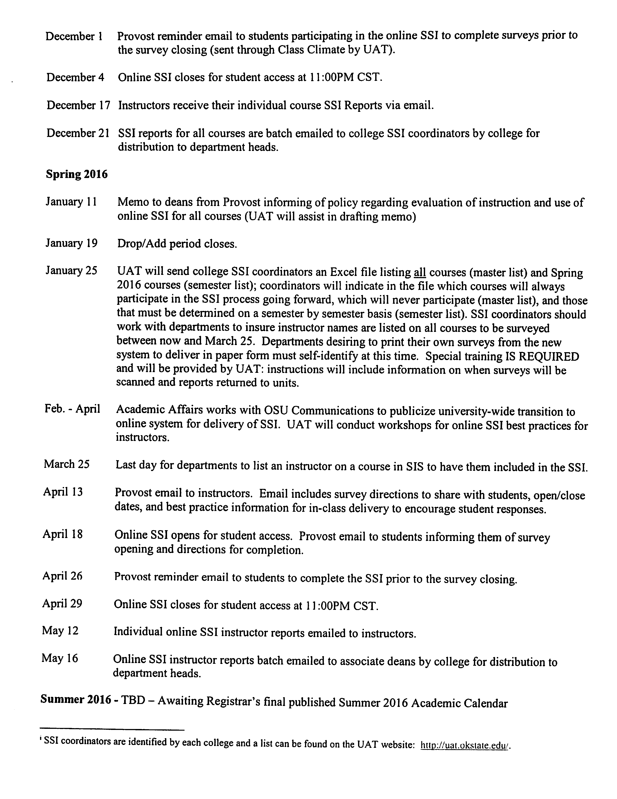
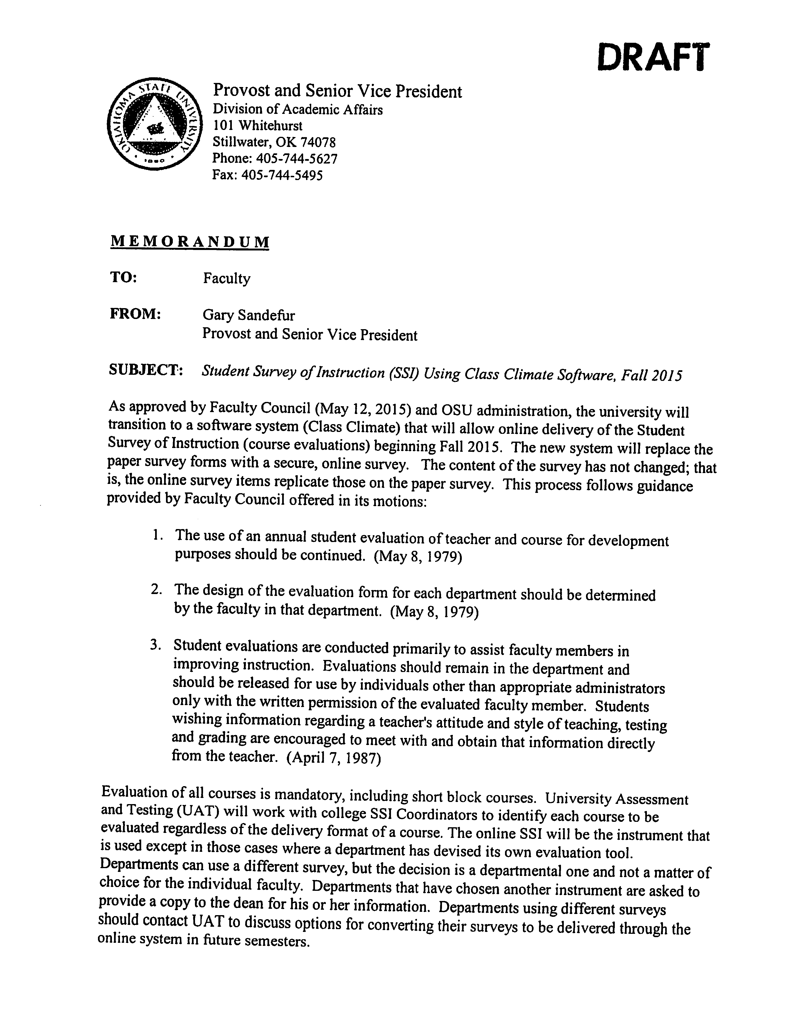
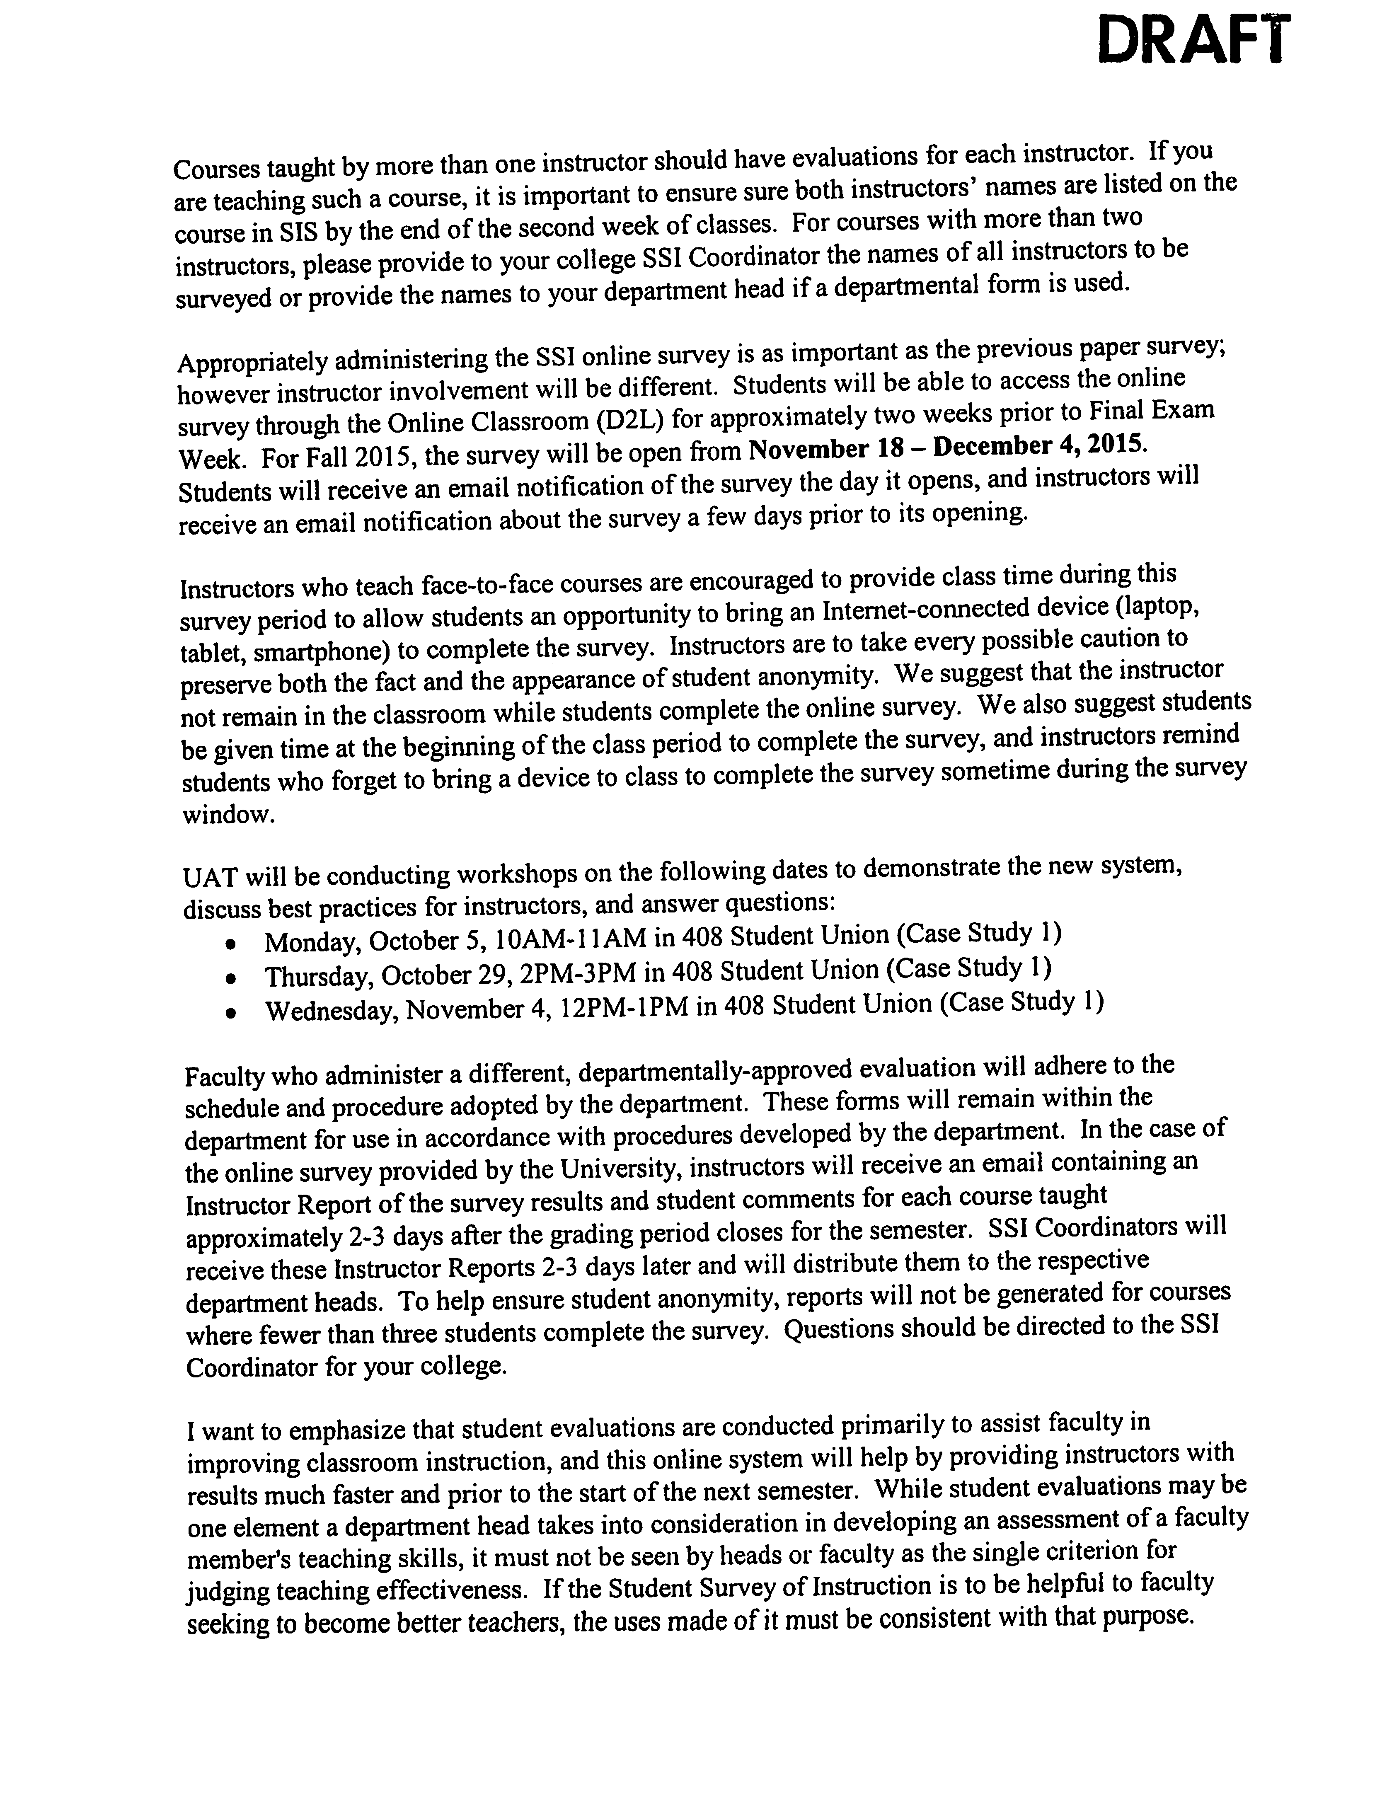
Sandefur commented that the reason for the evaluations is listed on the last page of the draft letter. Sandefur stated that over the course of the summer Clarke, Pam Fry and himself have had a few meetings where they discussed putting together a group of faculty and administrators to look at the broader issue of how to determine whether someone is doing an effective teaching job and how is this incorporated into the A&D and RPT processes. This group will be forming soon. Dr. Fry stated that Knecht and Gordon worked very hard to help get this system. Knecht stated that faculty who are engaged and dedicate time to discuss the new system have seen very little to no drop off. Knecht stated that the drop off tends to occur when faculty completely forget to discuss evaluations. Clarke asked if the results are given back to faculty members in April. Knecht stated they will be given to the faculty member 2 or 3 days after grades close. Normally the results are given to the Provost in January and then distributed to the departments in January or February. So the turnaround is much faster with the new system. Sandefur said he would keep faculty apprised of this issue as things move forward.

Clarke asked Sandefur to remind the council of Title IX training. Sandefur stated that everyone is required to take the Title IX training. This is for anyone who has contact with students. Sandefur said it doesn’t take long to do the online course. Sandefur stated that everyone needs to do it this year and again next year. This could become an annual requirement due to the government’s requirements regarding Title IX. Sandefur stated that hopefully faculty will learn from the training and that it does not take too much time. Sandefur stated that there is a two hour face to face training option for those who are interested. Sandefur said that the Office of Civil Rights could show up at any time and ask OSU to show how many of the faculty have actually completed the training. They may or may not do this but OSU needs to be in a position to say all or almost all faculty have completed the training.

VP Joe Weaver

Weaver stated that the Banner implementation has been going very well. It was kick started in July. There are still some problems with the new system but they are being resolved. Weaver stated the main concern is to protect the integrity of the data that is transferred in as well as the new information that is added as the new system is used this fiscal year. Weaver said to call someone if you are having problems with the system. Problems cannot get solved if administration doesn’t know about them. Weaver stated all signs are the system is going well. Payroll will be added January 1. This is more complicated because they have to work with the State of Oklahoma. Weaver stated that there is a small group of people in IT for the past 8 weeks that are working 10 hour days, 7 days a week working to make sure the issues with the Banner system are taken care of quickly.

VP for Research – Kenneth Sewell

Sewell stated that the first month and a half here at OSU, he has been on his familiarization tour. He has met with most of the Deans. Sewell said he is very impressed with the incredible talent at OSU. Sewell said he will be working closely with the Associate Deans for Research as his primary advisory group. They will be focusing on the research priorities of OSU. Sewell wanted to make sure that everyone knows that the research mission of OSU spans all academic disciplines and drills down into all areas. Sewell stated that this is a value across campus. Sewell wants everyone to know that OSU is not reducing its research and scholarly activity. Sewell wanted the council to know that he will value and celebrate research across campus. Research week will be in a recognizable form this year and will they are looking at expanding it.

Clarke stated that continuing with what was piloted last May, the Liaison reports have been moved before the Standing committee reports. The liaisons send a short report which is included on the agenda.

Report of Liaison Representatives:

A. Graduate Faculty Council – Stephen Clarke for Brenda Smith

In addition to the Graduate Faculty Council’s routine business, anticipated agenda items for the 2015-2016 academic year will include:
1) a review of the grading system used for the creative components;
2) the development of a plagiarism training platform for all graduate students;
3) pilot testing a plagiarism check of all thesis and dissertation documents using the Desire2Learn;
4) exploring the option of moving graduation deadlines up (one week earlier each semester) to allow the Graduate College time to complete all degree checks in a timely manner.
If anyone has additional items that they would like for the Graduate Faculty Council to consider, they are invited to contact their Subject Matter Group representatives or Brenda Smith, Vice-Chair of Graduate Faculty Council (bjsmith@okstate.edu).
B. Women’s Faculty Council – Barbara Miller

- The newly elected officers are: Linda Watson (Chair), Smita Mohanty (Vice Chair), Kim Loeffert (Secretary/Treasurer); the Executive Committee also includes Nicole Sump-Crethar, (Past Chair)
- all OSU faculty will be receiving an email from Linda Watson thru Tricia White with a Doodle Poll to set up a standing monthly meeting time
- earlier this summer, the Provost requested and the WFC provided input into the new Title IX online training; input was provided by the WFC Provost Advisory Committee (chaired by Cinthya Ippoliti) and the WFC officers
-We will be sending out letters to the Deans and Directors soon for funding for next spring’s Research Awards. Miller stated they will try to have a table at the new faculty orientation.

C. Staff Advisory Council – Melanie Bayles

Newly elected members of SAC were installed during our June meeting and new officers of the Council were elected. The following individuals will be serving as the Staff Advisory Council officers for 2015-2016:
Sue Goad – Chair
Jovette Dew – Vice Chair
Shelley Potter – Secretary
Toby Tucker - Treasurer
Earlier this summer OSU Stillwater staff approved revisions to the SAC Constitution and then the Staff Advisory Council approved revisions to the SAC Bylaws which reflected the changes in the Constitution. The revisions streamlined the documents, removed duplication, and simplified procedures.
The Council is now gearing up for the annual Distinguished Service Awards process. We encourage all faculty to consider nominating outstanding staff members from your departments. Nomination materials will be available online at the SAC website at the end of August. The Distinguished Service Awards include an engraved plaque and a monetary award and are presented at the Staff Development Day in February.

D. AAUP – Barry Lavine

Lavine stated that the OSU chapter of the American Association of University Professors has become active and will hold a forum on September 23rd from 3:30 to 5:00 in the Student Union Little Theater. The forum is titled the Roll of the Faculty in Governance at OSU: Q&A with Provost Sandefur. Earl Mitchell a long time faculty member now Emeritus and past AAUP chapter President will be in attendance.

E. GPSGA – Catherine Haviland

Graduate Student Welcome Back Reception August 19th at 5:30pm in the Student Union Ballroom.
We will have a flyer that we will be posting on the website and Facebook page as well.

F. SGA – Kyle Hilbert

Next Wednesday evening, August 19, will be SGA’s annual Lights On Stillwater which takes place on the north side of Boone Pickens Stadium. We’ve sold about 200 booths to businesses in the Stillwater community as well as student organizations. The purpose of LOS is to introduce freshmen to the Stillwater community.
The first Senate meeting of the year will be the following Wednesday, August 26, at 7pm.
Lastly, please spread the word that applications are available for Freshmen Representative Council as well as other positions. Apps are available on the SGA website: sga.okstate.edu.

REPORTS OF STANDING COMMITTEES:

ACADEMIC STANDARDS & POLICIES – Mindy McCann – No Report

ATHLECTICS – Tom Royer – No Report

BUDGET –Pamela Lloyd – No Report

CAMPUS FACILITIES, SAFETY AND SECURITY – Nathan Walker – No Report

DIVERSITY – Lucero Tenorio – No Report

FACULTY – Glade Topham – No Report

LONG-RANGE PLANNING and INFORMATION TECHNOLOGY –Cecil Joe – No Report

RESEARCH – Andrew Doust – No Report

RETIREMENT and FRINGE BENEFITS – Rita Miller – No Report

RULES and PROCEDURES – Deb VanOverbeke – No Report

STUDENT AFFAIRS and LEARNING RESOURCES – Jennifer Borland – No Report

Old Business – None

New Business – Stephen Clarke

Clarke stated that over the last few months the council officers have been discussing ways that Faculty Council can support campus organizations. The idea the officers propose is to support the Allied Arts organization this year and adopt them as the Faculty Council philanthropy. Clarke stated there is no pressure to participate but if faculty are willing to share any amount of money, the funds collected will be taken to the Foundation. Clarke feels this would be a good show of support for the Allied Arts on campus. Clarke will send an email to everyone regarding this option. Clarke feels it’s important to be involved on campus beyond just governance. Miller stated Faculty can support the organization by attending Allied Arts functions. Oberhelman has been on this committee and he is amazed at the type and quality of performances that are brought to Stillwater. Oberhelman stated that the financial and ticket sales support will be greatly appreciated. Season ticket holders are encouraged. Clarke stated they are very reasonably priced as well.

White reminded the council members of the General Faculty meeting will be Wednesday, October 28th in the Student Union Little Theater. More information will be available soon.

The meeting adjourned at 4:08 p.m. The next regular meeting of the Faculty Council is Tuesday, September 8, 2015 in 412 Student Union, Council Room.

Respectfully submitted,

Deb VanOverbeke, Secretary

