Kennison called the meeting to order with the following members present: Atekwana, Clarke, Chung, Cornell, Dare, DeSilva, Emerson, Fisher, Grafton, Harris, Holcomb, Holyoak, Jones, Krehbiel, Lovern, Luttbeg, Materer, McBee, Meek, Miller, Stamper, VanOverbeke, Walker, Yetter and Young.
Also present: Bertholf, D., Bird, L., Blaine, J., Campbell, C., Elliot, K., Fry, P., Gregg, M., Hargis, B., Jacobs, S., Mayfield, B., Miller, B., Shutt, G., Sternberg, R., Tucker, S., Weaver, D. and Weaver, J.
Absent: Bartels, Baeza, Barnes, Page, and Wu.

HIGHLIGHTS

Remarks and Comments from the President……..…………………………………………………
Special Report – Campus Safety…..……………………………………………………………..…
Report of Status of Faculty Council Recommendations …………...……………………………...
Reports of Standing Committees …………………………………………………………………..
Academic Standards and Policies ………………………………………………………….
Athletics ……………………………………………………………………………………
Budget ……………………………………………………………………………………...
Campus Facilities, Safety and Security ……………………………………………………
Faculty ……………………………………………………………………………………..
Long-Range Planning and Information Technology ………………………………………
Research ……………………………………………………………………………………
Retirement and Fringe Benefits ……………………………………………………………
Rules and Procedures ………………………………………………………………………
Student Affairs and Learning Resources …………………………………………………..
Reports of Liaison Representatives ………………………………………………………………..
SAC ………………………………………………………………………………………..
Women’s Faculty Council………………………………………………………………….
Emeriti Association…………………………………………………………………………

Kennison called the meeting to order at 3:05 p.m. and asked everyone to sign the roll call sheet. Kennison introduced the Student Media Board liaison, Sue Jacobs. Jacobs introduced the new editorial staff of the O’Colly. Not in attendance was Brandon Wilken – the current editor-in-chief, and this summer’s editor-in-chief will be Murphy Mitchell. Jacobs introduced the fall editor-in-chief, Sally Asher and the advisor for the O’Colly Barbara Allen. Allen is the advisor to the O’Colly and she is celebrating her fourth year as the advisor. The goal of the O’Colly is to operate as a professional news organization that provides OSU and Stillwater with hard and soft news while providing a learning lab for students. Not just how to be journalists but also professionals and communicators. Allen’s’ roll is to serve as an advisor – to conduct a publication critique, ethics and best business practices. Allen never reads the students work before it goes into print. Allen stated that doing so would undermine the creative process. Allen stated that the O’Colly is a learning lab like many other labs across campus. The only difference is that 10,000 people read their homework. Allen introduced Sally Asher who is a multi-media, journalism junior. She was recently selected to lead the O’Colly in the fall by a board comprised of students, faculty, staff and Oklahoma journalism leaders. Asher stated that the O’Colly is a student run paper who wants to serve faculty and staff as well as students. If there is anything that faculty or staff want to get into the paper (story idea or event) please email her at news@ocolly.com. Asher has an open door policy so she will be available in the newsroom most afternoons. If you want to set up a meeting just email her.

Kennison asked for approval of the March minutes. Holcomb moved and Grafton second. Motion passed. Kennison asked for approval of the agenda. Holcomb moved and DeSilva second. Motion passed.

Remarks and Comments from the President:

President Hargis stated that he had returned from a trip to India with Mike Woods, interim dean of Agriculture and Paul Tikalsky as well as some faculty representatives. They visited a number of universities in four cities. President Hargis stated they made many good contacts and hopefully enjoy several faculty and student exchanges from these various universities. The four cities they visited were Hyderabad, Bangalore, Vellore and New Delhi.

The big issue this time of year is the legislature. President Hargis expects it will be hard to get much past a flat budget. President Hargis stated that the amortization of the 2005 bond issue was changed in 2009 to be interest only. It now goes back to principal and interest commencing in 2014 which will cost the OSU system about $5 million. President Hargis wants these funds to go into the appropriations. For the Stillwater campus this is about $3.8 million. Higher Ed wide it’s a little over $20 million. This is a big issue. President Hargis is also working on a subsidy for the teaching hospital/medical school in Tulsa.

President Hargis stated that enrollment for next year is going well. Probably won’t be quite as robust as last year which was the all-time record for OSU. There are fewer high school graduates from Oklahoma this year which contributes to this figure. Enrollment will be substantially over 3 or 4 years ago.

Kennison asked if there were any questions for President Hargis. Seeing none moved to Dr. Lee Bird’s special report.

Special Report: Dr. Lee Bird – Campus Safety

Dr. Bird stated that a safety committee was started that involved faculty, staff and students. They met November 7, 2012 to chart a course of the things that they would like to accomplish over the course of the year. During this meeting, students were talking directly specifically about a safe walk program.

Dr. Bird presented the Campus Safety Update listed below:

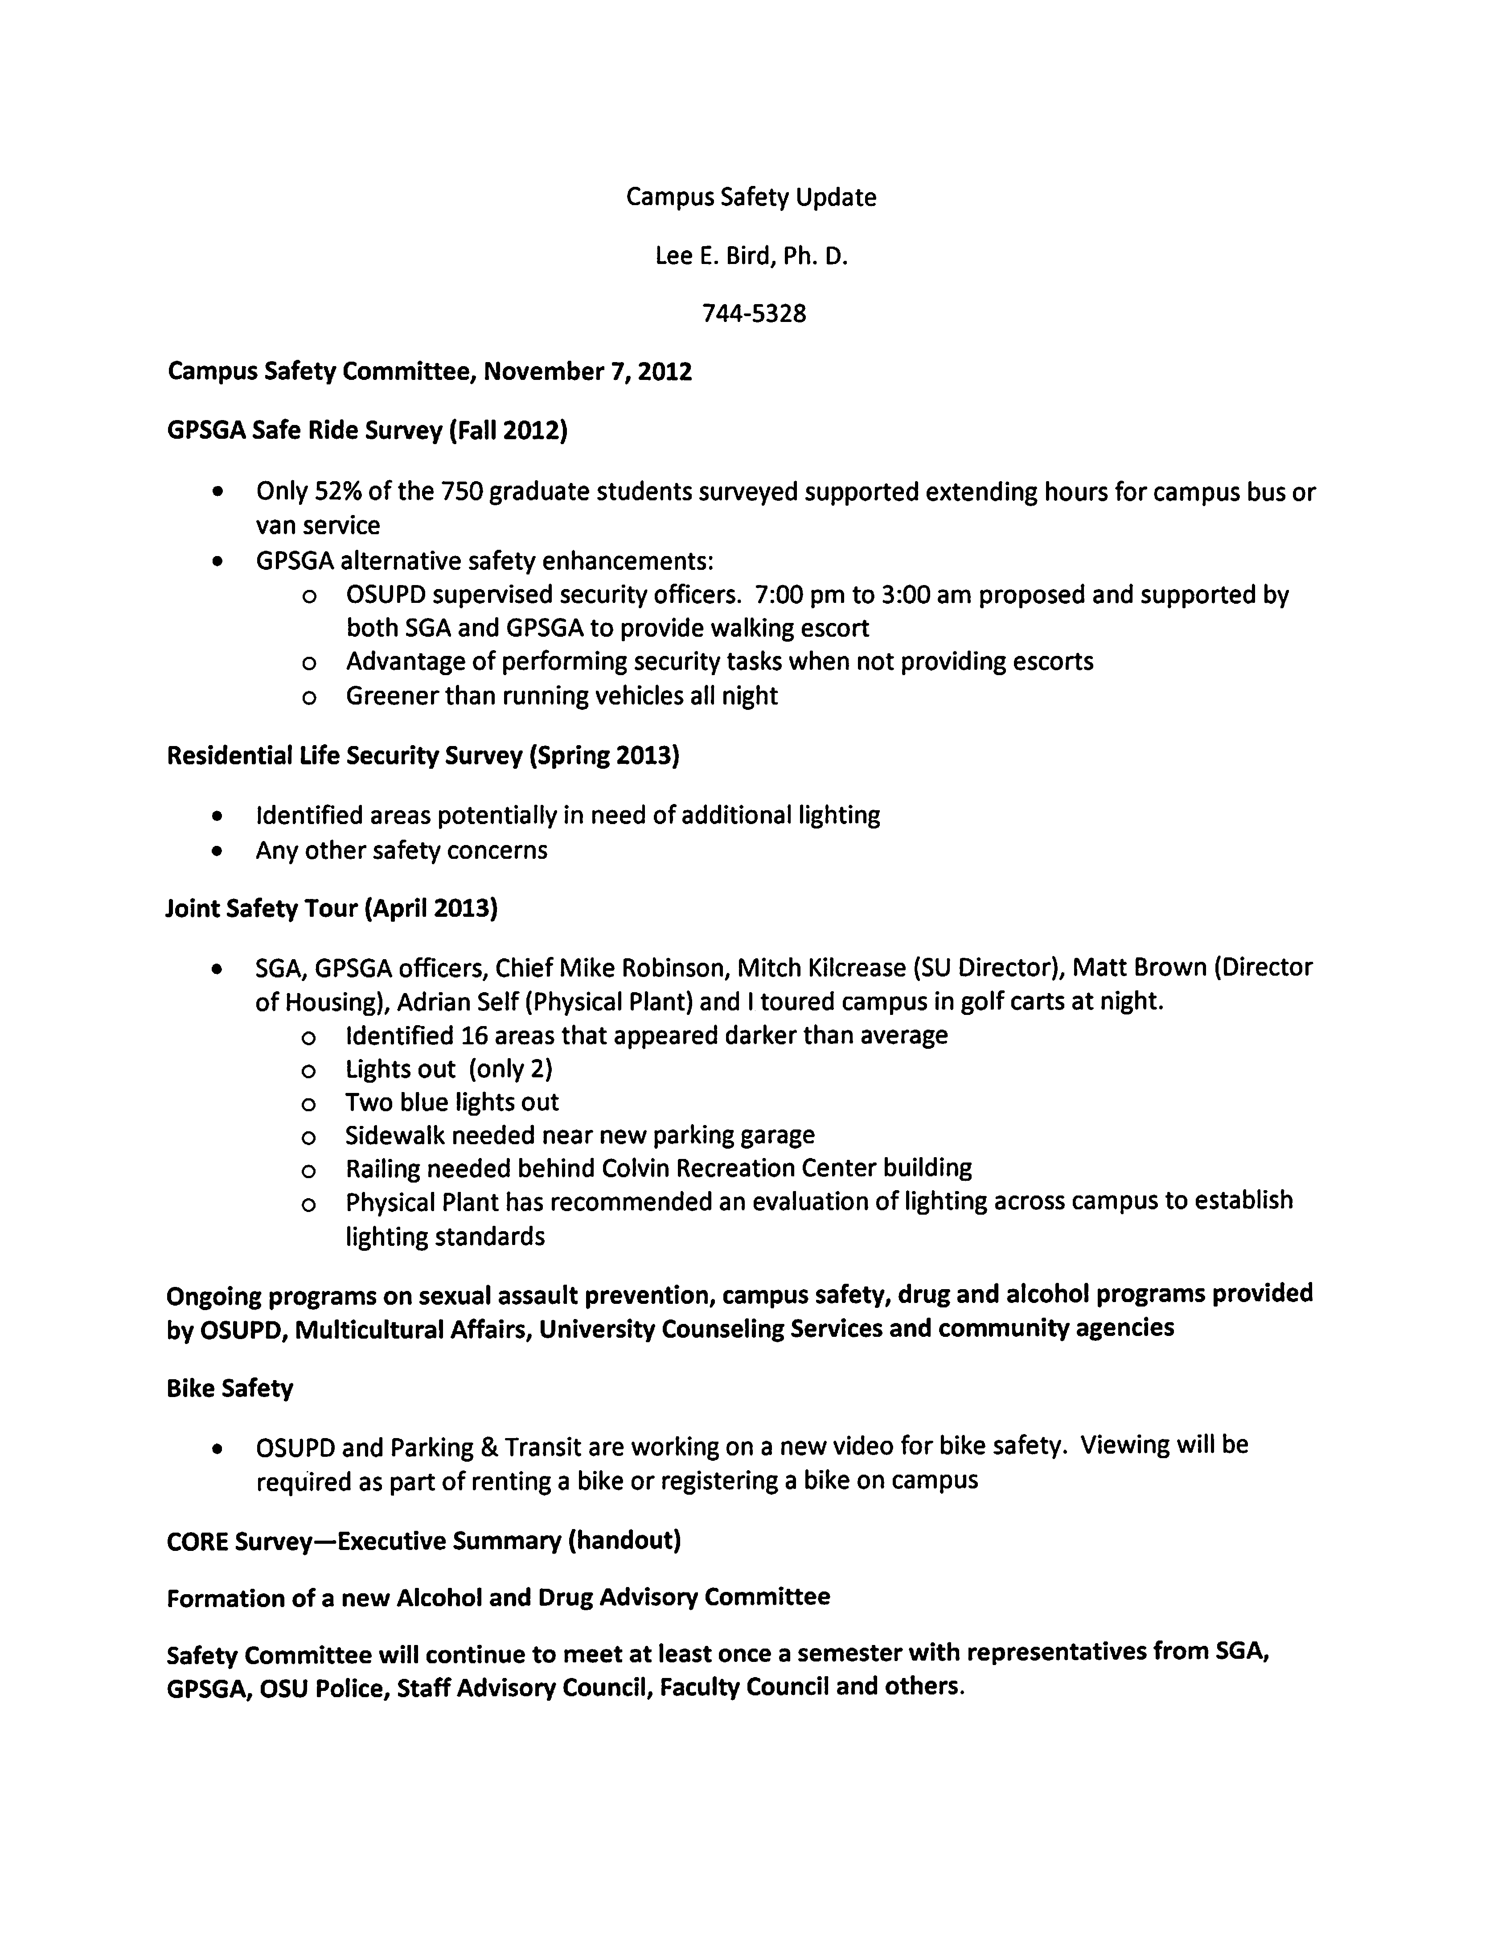

A large survey was conducted – 750 graduate students participated – and there was luke-warm approval of doing a safe ride program. 52% of those surveyed thought they would use it if it was available. GPSGA started investigating other alternatives and has worked with SGA who would like to see a security force (officers) that could do safety checks on campus and also provide an escort if a student wanted one. A joint resolution have been written which has been presented to the committee. They feel it would be better to have walking folks on campus instead of a vehicle running all night.

A residential life survey has also been conducted that included both students and staff to identify any concerns or issues. From this survey, a number of issues have been identified. The committee has identified potential areas that might need additional lighting. Last week, the chief of police along with a number of committee members did a late night safety tour of the areas that had been previously identified by students to review lighting and parking lots to check for potential problems. 16 areas have been identified and have been taken care of. The Physical Plant will be conducting a lighting standards survey this summer. This will help determine which areas need additional lighting.

A bike safety committee met on campus several times this year. A new video for faculty, staff and students will be produced. Anyone renting or registering a bike on campus will be required to watch the video.

Dr. Bird discussed the below handout regarding drug and alcohol use on campus:

Introduction
The Core Alcohol and Drug Survey was developed to measure alcohol and other drug usage, attitudes, and perceptions among college students at two and four-year institutions. Development of this survey was funded by the U.S. Department of Education. The survey includes several types of items about drugs and alcohol. One type deals with the students’ attitudes, perceptions, and opinions about alcohol and other drugs. Additionally, the survey also deals with the students’ own use and consequences of use.
Oklahoma State has conducted the survey six times since 1998 (1998-1999; 2000-2001; 2002-2003; 2006-2007; 2008-2009; and 2012-2013) to assess the extent to which OSU students are affected by alcohol and drug use. In addition to 2012 data, this report contains data from previous surveys on selected items.
2012 Survey Method
In the Fall Semester of 2012 the Core Alcohol and Drug survey was administered online to a random sample of 10,700 undergraduate OSU students. Students in the sample were sent an email message requesting their participation, with a link to the survey provided in the message. Students in the sample also received a letter from President Hargis asking for their participation in the study and directing them to the on-line survey site. Surveys were completed by 681 students, which resulted in a response rate of 6.36%.
For the purpose of this survey the term *binge drinking is defined as consuming 5 or more drinks in one sitting.

Key Findings from students at Oklahoma State University
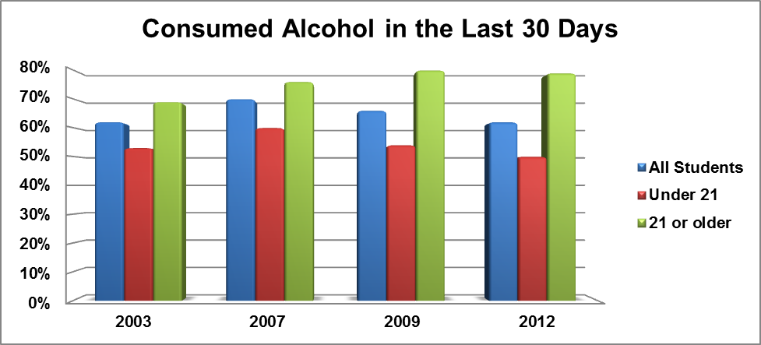
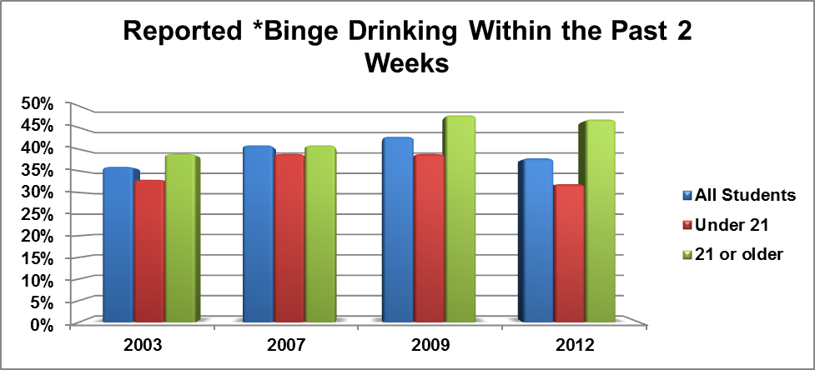
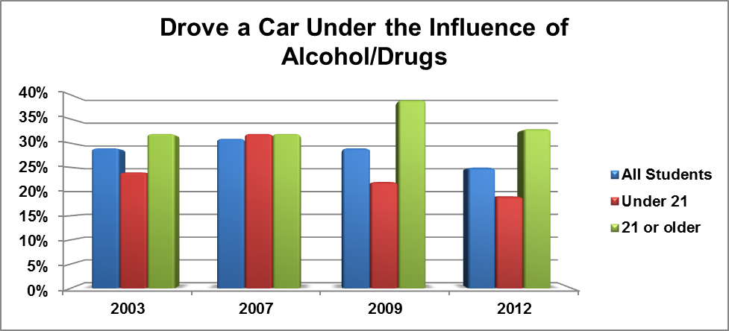
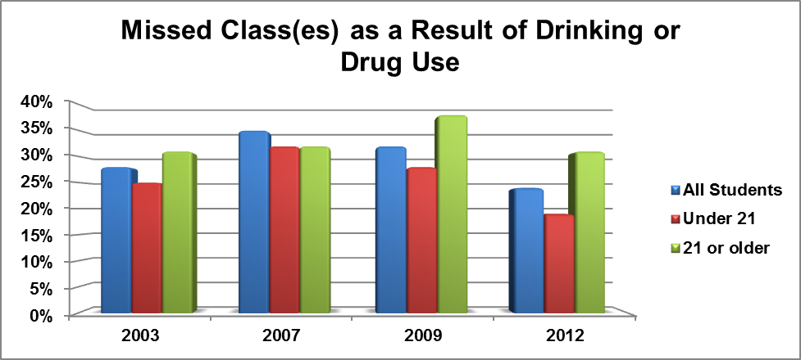
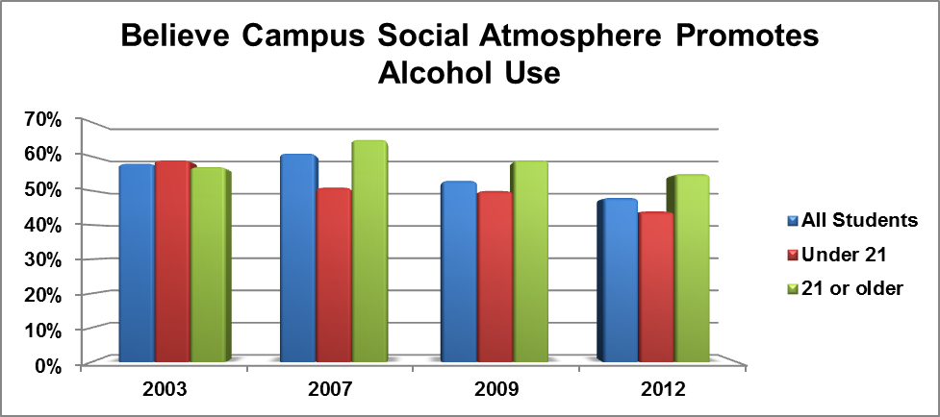
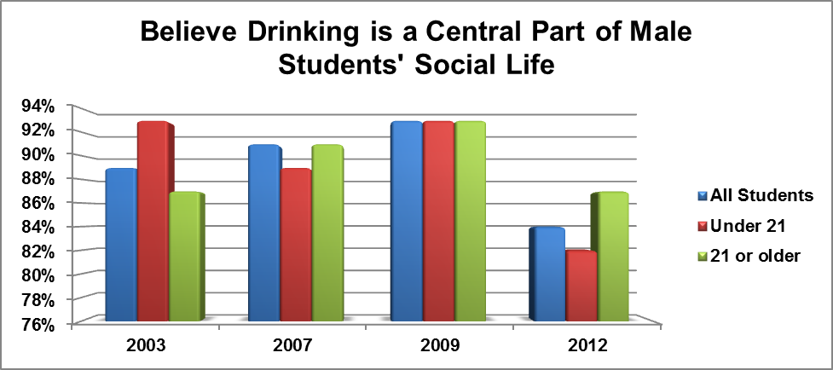
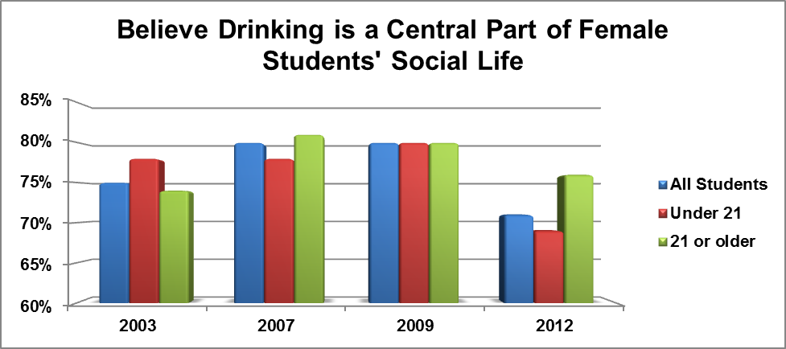
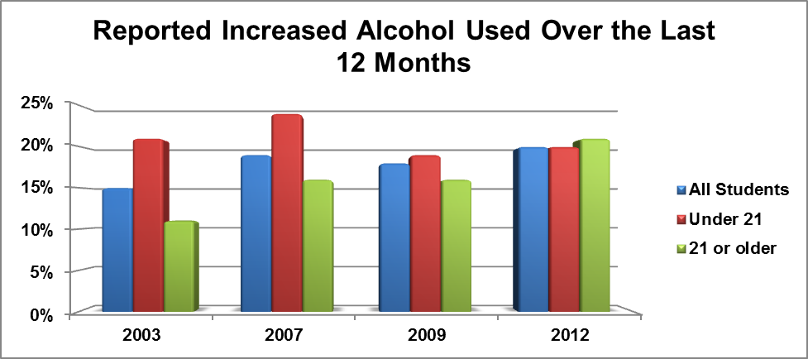
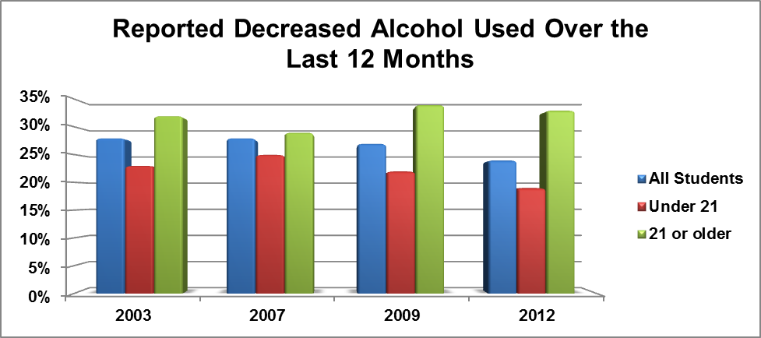
Important Longitudinal Statistics for OSU Students

- Prefer to have alcohol available at parties they attend
 | 1998 | 2001 | 2003 | 2007 | 2009 | 2012
All Students | 65% | 69% | 69% | 49% | 54% | 64%
- Believe alcohol has the effect of enhancing social activity
 | 1998 | 2001 | 2003 | 2007 | 2009 | 2012
All Students | 60% | 63% | 66% | 70% | 71% | 72%
- Believe alcohol has the effect of making it easier to deal with stress
 | 1998 | 2001 | 2003 | 2007 | 2009 | 2012
All Students | 33% | 33% | 39% | 35% | 48% | 46%
- Believe that drinking is a central part of the social life of alumni
 | 1998 | 2001 | 2003 | 2007 | 2009 | 2012
All Students | 46% | 41% | 53% | 49% | 58% | 51%
- Believe that drinking is a central part in the social life of fraternities
 | 1998 | 2001 | 2003 | 2007 | 2009 | 2012
All Students | 94% | 91% | 93% | 95% | 93% | 89%
- Believe that drinking is a central part in the social life of sororities
 | 1998 | 2001 | 2003 | 2007 | 2009 | 2012
All Students | 84% | 81% | 87% | 87% | 88% | 83%
- Believe that they have a responsibility to contribute to the well-being of other students
 | 1998 | 2001 | 2003 | 2007 | 2009 | 2012
All Students | 60% | 69% | 63% | 66% | 63% | 67%

Following are some key findings on the consequences of alcohol and drug use:
25.7% of students reported some form of public misconduct (such as trouble with police, fighting/arguments, DWI/DUI, vandalism) at least once during the past year as a result of drinking or drug use
18.1% reported experiencing some kind of serious personal problems (such as suicidality, being hurt or injured, trying unsuccessfully to stop using, sexual assault) at least once during the past year as a result of drinking or drug use.

The table below shows the percentage of students who reported having experienced any of the following within the last year, and if so, the percentage who reported consuming alcohol or other drugs shortly before these incidents.
Experiences of Harassment or Violence
Experience | Used Alcohol or Drugs | Incident
6.2% | 13.2% | Ethnic or racial harassment
6.2% | 23.7% | Threats of physical violence
2.3% | 53.8% | Actual physical violence
2.0% | 33.3% | Theft involving force or threat of force
4.4% | 65.4% | Forced sexual touching or fondling
4.1% | 84% | Unwanted sexual intercourse

Key findings on the use of illegal drugs:
24% of students have used marijuana in the past year
10.4% of the students have used an illegal drug other than marijuana in the past year
5.0% of the students are current users of illegal drugs other than marijuana
Most frequently reported illegal drugs used in the past 30 days:
13.2% Marijuana (pot, hash, hash oil)
3.0% Amphetamines (diet pills, speed)
1.6% Sedatives (downers, ludes)

The table below compares substance use patterns and consequences of several campus groups: males and females, younger and older, academically more and less successful, and on and off-campus residents

 | Gender |  | Age |  | Average Grades  (self-reported) |  | Campus Residence
 | Female | Male | 16-20 | 21+ | A-B | C-F | On | Off
Sample Sizes | 280 | 398 | 402 | 277 | 565 | 112 | 331 | 347
Currently use alcohol (past 30 days) | 59.5% | 65.7% | 50.1% | 79.5% | 60.0% | 71.8% | 49.2% | 74.1%
Currently use marijuana (past 30 days) | 9.6% | 18.6% | 12.0% | 15.0% | 12.3% | 18.4% | 9.1% | 17.3%
Currently use illegal drugs other than marijuana (past 30 days) | 4.8% | 5.4% | 4.5% | 5.8% | 4.6% | 6.9% | 3.9% | 6.1%
Had 6 or more binges in the past 2 weeks | 2.5% | 8.3% | 4.5% | 5.4% | 5.2% | 3.6% | 4.2% | 5.5%
Have driven a car while under the influence during past year | 25.5% | 24.1% | 19.4% | 32.7% | 25.0% | 23.9% | 15.3% | 33.9%
Have been taken advantage of sexually during past year | 10.0% | 4.4% | 8.4% | 6.7% | 7.7% | 8.3% | 5.6% | 9.7%
Have taken advantage of another sexually during past year | 1.3% | 4.1% | 1.3% | 4.1% | 2.4% | 2.8% | 2.2% | 2.7%

When discussing campus safety, Dr. Bird feels this is one of the areas where the university needs to get more serious about – drug and alcohol use on and off campus. Oklahoma statistics are particularly frightening. The number one for abuse is prescription drugs. Number one for deaths associated with opiates and mixture of drugs. These are things that need to be addressed. Off campus house parties are one of the most dangerous things the university faces. No supervision, lots of alcohol, lots of issues. Binge drinking is highlighted on the above survey. It’s highlighted because other consequences are more likely to occur when the 5 drinks in one sitting are consumed. The students miss class, more likely to have physical altercation with someone, get into fights or arguments and vandalize property. Bird believes that something that would help with drug and alcohol issues on campus is classes meeting on Fridays and tests on Mondays. It seems simple and two things that could really help. These two things have been shown to help reduce the consumption of alcohol on campuses. Bird did state that the safety committee would continue into next year. Bird would also like to pull together a drug and alcohol committee to look into these issues. Bird will be asking for a representative from Faculty Council to sit on this committee

Bird opened the floor for questions. DeSilva was on the bike safety committee and asked if there was any progress on the sharrows on the streets and Monroe Street issues. Bird stated that there is progress but nothing has been decided. They are still under evaluation. President Hargis stated that one of the problems with the bike lanes is that pedestrians do not honor them as well as the bicyclists thinking they can ride at any speed. Bird stated that she is working with the city council regarding OSU being a bike friendly community and they are working on national certification for this. DeSilva asked if there were plans to put cross walks on Monroe. Joe Weaver stated that Monroe Street is completed and the section between the two control gates is entirely a cross walk. The cross walks that are bricked as pavers are designated as cross walks. Weaver stated that at this point there are no plans to do any additional markings. DeSilva asked if this information is available to the general public. DeSilva feels that people do not know the space between the control gates is one big sidewalk. DeSilva feels that people actually speed up when approaching a person crossing the street. Sue Jacobs asked why lines are not painted on the street. Weaver believes that people will adjust to the new construction. The color difference in the pavers mark the cross walks areas. OSU did go by national standards in the construction and the entire section of Monroe is considered a pedestrian thoroughfare. The entire section is a cross walk.

Dr. Bird said to contact her office if there are any questions or suggestions. If anyone sees a light out, please report it and let her office know how we can keep the campus safer. She believes this is everyone’s responsibility.

Kennison thanked Dr. Bird and Vice President Weaver. This has been a very productive collaboration and many good things are happening.

Report of Status of Council Recommendations:

Provost Sternberg reintroduced Pam Fry who has been appointed by President Hargis as the interim provost. She will start as soon as Provost Sternberg leaves. They are already working on the transition and working on issues facing the Provosts office.

Provost Sternberg gave the status of the following recommendations:

13-03-01-CTSS: Employee Travel Policy Amendment:
Pending – Pending discussion by appropriate areas in Administration and Finance.
Provost Sternberg asked Joe Weaver to address the Employee Travel Policy recommendation. Weaver stated that an aviation consultant has been employed to qualify all the airplanes that the campus is currently using. OSU is very close to switching over to the new policy regarding aviation. Weaver expects by the first of the month to be completely switched over to the new policy.
13-03-01-RFB: Phased Retirement Program (PRP) Incentive Amendment:
Pending – Pending discussion by the administration.
13-02-01-FAC: Revision of P&P 2-0902: Reappointment, Promotion and Tenure Process for Ranked Faculty.
Pending – A subcommittee of deans reviewed the draft referred to the administration at the Feb. 12, 2013 meeting. Related issues were discussed at the semi-annual academic governance meeting in early March. A modified draft was referred from the Council of Deans to the Faculty Council on March 22, 2013.
Provost Sternberg’s understanding is that the Faculty Committee is close to a resolution. He believes the issues that are left are minor and this should be finished this spring.
12-11-01-LRPT: Copyright Usage Warnings:
Pending – Work on recommendation continues. IT reps are working with LRPIT members to develop a policy in the format required for dissemination to all campuses.
12-10-01-FAC/: Revision of P&P 2-0110: Procedures to Govern Workload
13-02-02-FAC Assignments of Faculty Members.
Pending – A subcommittee of deans is reviewing the draft policy referred to the administration at the Feb. 12, 2013 meeting. A report from the deans’ subcommittee is expected in the near future.
12-10-01-LRPT: Copyright Usage Information Website.
Pending – Discussion continues between John Price, Anne Prestamo and Instruction Council (IC) members. An IC rep will meet with the LRPIT committee.

Barbara Miller asked if the recommendation regarding Promotion and Tenure will be in place for the people going through this fall. Provost Sternberg stated no but there is a document on how grandfathering in will work. Provost Sternberg believes that the Faculty Committee and the Dean Council have agreed on. This will be phased in gradually.

REPORTS OF STANDING COMMITTEES:

ACADEMIC STANDARDS & POLICIES – Ed Harris – No Report

ATHLECTICS – Robert Cornell – No Report

BUDGET – Rodney Holcomb – No Report

CAMPUS FACILITIES, SAFETY AND SECURITY – Robert Emerson – No Report

FACULTY – Matt Lovern – Up Date

Lovern stated that the Faculty committee is currently working on the following 4 items:
1. Grandfathering document which has been received by the committee. Lovern does not anticipate any issues with the document. It should be turned around pretty quickly.
2. The committee has received the RPT document back and the committee is reviewing it and has begun discussion on it.
3. The committee also has the workload document back from the deans and the committee is reviewing it as well.
4. The committee is still working on the Appendix E – dispute resolution procedure. The committee has met with a few past Faculty Council chairs to get their perspective on how dispute resolutions currently work and to what extent proposed changes might help create a new policy that will be more efficient and more informative.

Lovern anticipates that the committee will have something on the agenda for May. Provost Sternberg asked if these items can be finished this spring semester. Lovern stated it’s possible but he needs to meet with the committee.

LONG-RANGE PLANNING and INFORMATION TECHNOLOGY – Nick Materer –
No Report

RESEARCH – Dan Fisher – Up Date

Fisher stated that the Research committee was asked by the Faculty Council Executive Committee to comment on the recommendations of the University Research Spires of Excellence Task Force. This task force identified 9 research spires of excellence across the university. The key point was the expectation of the task force was that the spires would continue to evolve, expend and even be replaced. In other words they were intended to be exemplary rather than definitive.

See report below:

Research Committee Report on the
Recommendations of the University Research Spires of Excellence Task Force
April 9, 2013

The Research Committee has been asked by the Faculty Council Executive Committee to comment on the Recommendations of the University Research Spires of Excellence Task Force. The Task Force identified nine spires of excellence across the University. The expectation of the Task Force was that these spires would continue to evolve, expand and be replaced. The objective of the Task Force was to provide a springboard for dialogue and development in a dynamic planning process.

The Research Committee has reviewed the recommendations of the Task Force and conferred with both the Vice President for Research and Technology Transfer and the Provost in formulating the following comments on the Task Force Recommendations:

- The Task Force Report clearly defines the desired attributes of established or emerging areas of world class excellence in research at OSU. These attributes, which include scholarship, mentoring and sustainable levels of funding, provide the basis for identifying and developing research spires of excellence. The process of identifying research spires of excellence was further framed by the guiding principles of our land-grant mission, which are also clearly articulated in the report. The Research Committee found the process used by the Task Force to identify research spires of excellence to be a useful concept for identification of strategic research growth areas across the colleges of the university.

- The nine spires of excellence identified by the task force are intended to be exemplary rather than definitive in both number and kind and as such could provide useful background for strategic planning exercises at both the academic unit and the college levels. It is expected that new or modified research spires of excellence would emerge organically from the strategic planning process.

No specific recommendations but Fisher would like to hear from the council on the possibility of a specific recommendation to include this in the university strategic planning documents.

RETIREMENT and FRINGE BENEFITS – Stephen Clarke – No Report

RULES and PROCEDURES – Kemit Grafton – Up Date

Grafton gave the following election results:

Vice Chair – Nick Materer
College of Arts and Sciences – Jennifer Borland, Stacy Takacs and Andrew Doust.
CASNR – Nathan Walker
CEAT – Daquing Piao
College of Education – Tim Bliss
CHS – Tulsa – Richard Wansley
OSU-OKC – Ann Lowrance
Spears School of Business – David Biros

Please give the new councilors a round of applause. Kennison invited all the new members to the May meeting.

STUDENT AFFAIRS and LEARNING RESOURCES – Bob Miller – No Report

Report of Liaison Representatives:

Women’s Faculty Council – Barbara Miller

Miller reported that the Council is concerned about the new restrictions on scholarship offerings and research awards that was passed last fall in the state legislature. Nicole Crethar, chair elect, and Barbara Miller will be meeting with Gary Clark soon to discuss what the ramifications of this new legislation will do to their awards.

Emeriti Association – Dennis Bertholf

Bertholf stated that at dinner last Monday, Carol Hedrick was the guest speaker. Next month the annual meeting will be with the lifelong learning institute. President Hargis will be the guest speaker at the June meeting.

The association has started a new interest group – Making the Most of Retirement. This group will be open to the community and the topics will be dealing with retirement. This way people who are thinking of retiring or other retirees in the city can utilize this service. Zane White will be leading this effort.

Old Business – Spring General Faculty meeting

Kennison invited everyone to the Spring General Faculty meeting on Monday, April 22nd at 3:00. The meeting will be in the Student Union Little Theater. The speakers will be President Hargis and Regent Andy Lester. Please try to attend and bring a colleague with you.

DeSilva reported that to help connect some of our branch campus representatives discussions have been ongoing to have the Council Room equipped to do streaming. This is moving forward. A polycom system will include a plasma screen so council members do not have to carry around a microphone. DeSilva hopes to have this installed in the fall. DeSilva stated that Vice President Weaver is to be thanked for the funding for this project. DeSilva stated that if possible the meetings will be streamed through OState.TV. This would be an additional cost.

Bob Miller announced that the first class of Phi Beta Kappa initiates have been elected. There are 52 students. Their names will be in the O’Colly on Thursday in the form of an advertisement congratulating them. Miller said if you know any of these students to please congratulate them on being selected.

New Business – None

The meeting adjourned at 3:40 p.m. The next regular meeting of the Faculty Council is Tuesday, May 14, 2013 in 412 Student Union, Council Room.

Respectfully submitted,

Udaya DeSilva, Secretary

