DeSilva called the meeting to order with the following members present: Champlin, Crick, Ellis, Emerson, Hurst, Jones, Parveen for Kaipa, Kakani, Khojasteh, Lovern, McCann, McFarlane, Melancon, Moss, Nabar, Nelson, Neurohr, Peek, Pivateau, Ramsey, Rebek, Sheehan, Talley, Wanger, Ware and Yates.
Also present: Bays, B., Beard, K., Cheves, T., Dougherty, P., Hallenbeck, D., Hargis, B., Hartman, J., Miller, B., Quan, T., Roberts, M., Schultz, A., Sewell, K., Tucker, S., Underwood, D., Weaver, J. and Wray, K.
Absent: Bindewald, Frazier, Kak, and Piehl.

HIGHLIGHTS

Special Reports – Dr. Doug Hallenbeck – VP Student Affairs..…..…………………………
Ron Tarbutton, Chief Facilities Officer – Recycling Efforts at OSU..…...
Remarks and Comments – President Hargis………………………………………………….
Report of Status of Faculty Council Recommendations and other Vice Presidents…….…….
Reports of Liaison Representatives …………………………………………………….……..
Emeriti ………………………………………………………………………………..
Women’s Faculty Council……………………………………………………………..
Staff Advisory Council………………………………………………………………..
Wellness Center ………………………………………………………………………
SGA …………………………………………………………………………………..
Graduate Council ……………………………………………………………………..
Reports of Standing Committees ………………………………………………….…………..
Athletics ………………………………………………………………….……………
Budget …………………………………………………………………….…………...
Campus Facilities, Safety and Security ………………………………….……………
Diversity………………………………………………………………….……………
Faculty ………………………………………………………………….……………..
Long-Range Planning and Information Technology ………………….………………
Research ……………………………………………………………….………………
Retirement and Fringe Benefits ……………………………………….………………
Rules and Procedures ………………………………………………….………………
Student Affairs and Learning Resources …………………………….………………..
Academic Standards and Policies ……………………………………….…………….

DeSilva called the meeting to order and asked everyone present to sign the roll call as it is circulating the room and if you are a proxy for someone please sign your name as well as that of the council member whom you are representing. DeSilva entertained a motion to approve the minutes from the March meeting. McCann moved, Crick second. Motion passed. DeSilva entertained a motion to approve the agenda for today’s meeting. Neurohr moved, Jones second. Motion passed. DeSilva introduced Dr. Doug Hallenbeck, VP of Student Affairs.

Special Report –

- Dr. Doug Hallenbeck – VP Student Affairs

Dr. Hallenbeck is excited to be at OSU and is currently on day 8 of his position. Hallenbeck has been visiting and touring OSU getting to know the campus. Hallenbeck stated it feels like the first of the year for him. Hallenbeck stated that he is honored to be the new Vice President of Student Affairs. Hallenbeck is a 2002 graduate of the PhD program from the College of Education here at OSU. His daughter is a 2017 graduate of OSU in Chemistry. Their family has a long history here at OSU. Hallenbeck is glad to be back at OSU. His goal in Student Affairs is to work very closely with faculty and colleagues to do what’s best for the lives of our students. Hallenbeck asked all faculty members to reach out to him if there is anything he can do to help.

- Ron Tarbutton, Chief Facilities officer and Ilda Hershey, OSU Sustainability Coordinator

Tarbutton stated that within Facilities Management there are two programs that are used to drive down and lessen our impact on the environment. These are our Energy Management Program and Sustainability Program. Today, they are focusing on the Sustainability aspect.

Tarbutton introduced Ilda Hershey who presented the following PowerPoint on the recycling efforts at OSU to the Council.

Hershey stated that recycling has been on campus for quite a while. It wasn’t until 2013 that a formal recycling procedure was formed. Hargis asked if #1 and #2 plastic items are accepted. Hershey stated that technically they accept only #1 which are the bottles but they do accept #2 which is jugs. These are plastic ridge containers with a neck. Peek asked if you put something in the container you thought was a #1 and it isn’t #1 what happens? Hershey stated that a little bit of mistake is fine. They actually allow 10% contamination in the bins. The cap can stay on the bottle/jug.

Peek asked what the cost of the recycling bins is. Hershey stated that they range from $1,000-$2,000 depending on the material and how many are in the cluster. Pivateau asked who was responsible for acquiring these, the school/college/department? Hershey stated that the cardboard containers are free, but the “fancy bins” need to be purchased. Pivateau remarked that he is in the new business building and he doesn’t recall seeing any recycling bins anywhere. Hershey stated that they are working on getting some of the fancy bins on the first floor and the cardboard containers in the areas (copy rooms, break rooms) where not many visitors go. Hershey said faculty members can email recycle@okstate.edu to get a bin.

Hershey stated that the water bottle refill stations on campus was an SGA driven initiative. They received a grant to begin in 2013 and these units have become so popular that most departments/buildings have them. There are over 100 on campus currently.

Hershey stated that there is a 2 hour workshop that goes into detail about recycling and sustainability on campus. Next one is May 29th and you can register through HR Training.

Tarbutton stated that OSU even recycles buildings. When Cordell was coming down, we saved 20 pallets of the clay tiles that can be used on other campus buildings. Additionally the concrete, metal, bricks and stone were recycled. OSU salvaged serviceable items prior to old buildings being torn down and these will be reincorporated into other buildings as needed. Tarbutton stated that between Cordell and the Civil Engineering lab, a large percentage of the buildings was recycled. Tarbutton stated they are working in collaboration with CEAT on recycling concrete/sidewalk material. OSU is continuing to find new, out of the ordinary ways to recycle. Tarbutton stated that OSU collects batteries and said that any departments who have a large number of used batteries can collect them and Facilities Management will dispose of them for free. If departments could set up a centralized collection bin, OSU could set up a frequency at which the vendor who picks them up from Facilities Management would come by and collect them from departments at no cost.

DeSilva opened the floor to questions. Tucker asked if the 17% recycling rate stated earlier captures paper from those who have shredding contracts? It is her understanding that the shredding companies recycle the materials themselves. Hershey stated they do not capture the materials shredded offsite. Only the material that is shredded on-site and collected by OSU Recycle. Tucker stated that it’s probably a much higher number since this material is not factored in. DeSilva asked if you are shredding your own paper should a faculty member contact recycling or put it in paper recycling. Hershey stated that if a faculty member is shredding their own paper they ask that you put it in a see-through bag and tie it off so it doesn’t get loose.

DeSilva asked where the Our Daily Bread donations are taken. Hershey stated that they are collecting plastic bags right now only in three of the residential halls. The residential eco-rep students have purchased three bins through the GSI initiative program just for plastic bags. These are located near convenience store areas. They are personally taking these bags to Wal-Mart or Food Pyramid to recycle. Hershey stated they are starting a new bin at Facilities Management for plastic bags and egg cartons. Anyone who would like to bring them please do. Miller asked if they only take the cardboard egg cartons or will they take the foam ones as well? Tarbutton stated they will take either one. Hershey stated that Our Dailey bread will take either type, but Facilities Management will only recycle the cardboard ones. There is no Styrofoam recycling in our region.

Melancon stated that she was cleaning out her lab space, and the recycling department helped her dispose of a lot of material in just one day. Melancon asked if Hershey would tell the council members about options if they are planning on cleaning out their work spaces. Hershey stated they have a special service called Special Event Clean-Out. Hershey said if a faculty member has over and above the normal paper recycling needs, they can do a work order asking for a special clean-out cart with a lid. The recycling department will bring the cart to you, you fill it, then call them to pick it up/change it out for a new cart until the space is cleaned out. Manila folders, magazines and journals can all be put in the cart. Emerson stated that this worked great for the Engineering South faculty. They are moving in June and have a number of these carts.

DeSilva stated that he has seen the move-out program (donate furniture, electronics, etc.) advertised for several years. How is this advertised to students? Hershey said that there was a student group that did this on a regular basis but they have since faded away. The past couple of years the recycling department has been putting out textile boxes so they can at least capture clothing. This year is the first year that the move-out program has come back. The new group is struggling with the logistics, but Hershey is encouraging them to work on their marketing so they can get the word out. Rebek stated that once they get their feet on the ground, working with Greek Life would be a good idea. They have a lot of nice stuff that gets thrown out from the fraternity and sorority houses. DeSilva stated that just yesterday the City of Stillwater announced that next Saturday people can take things down to the south Perkins Rd. location. Hershey stated that each year the convenience collection center does this. People have to take the items down there, they do not pick them up. They give a break to students and do not charge them.

Lovern asked if there was a certain kind of battery that they will take. Tarbutton stated that they will take all types of batteries. They just need to be kept in separate bins. Tarbutton said that in the hallway of their warehouse area, they have the batteries separated and labeled. The vendor comes by, picks them up at a designated frequency at no cost to departments. Tarbutton stated that OSU does not have to pay to have the batteries disposed of properly. The vendor recycles them for free.

Peek asked about the training Hershey mentioned earlier. Is it at the department or college level? Hershey stated that the 2 hour training workshop is through HR and it’s on the university level so anyone who wishes to attend can. Hershey stated that you need to be a full-time employee to take advantage of HR training. The title of the training is “Sustainability in the Workplace”. The next one is Wednesday, May 29th from 9-11.

Remarks and Comments – President Hargis:

Hargis stated that in 2013 OSU included addiction recovery and treatment in our medical school curriculum. OSU received $11 million to start a center. This facility is not located on the CHS campus, but at a separate location on Yale in Tulsa. OSU is ahead of others in opioid/addiction treatment. OU did away with their program two or three years ago.
Purdue Pharma has now transferred $102.5 million which was the deal, to an escrow bank account. The plan is for them to do another $75 million over five years for addiction treatment medicine. Hargis stated the key is they need to stay out of bankruptcy for at least 90 days. This is called a preference, which is the payment of a claim while insolvent within 90 days of bankruptcy. They can be put in bankruptcy they do not have to voluntarily file. Hargis stated that there is a lot that can happen, but we are hopeful that everything works out. OSU does have some guarantees in place from the holding companies. The spending policy on this will be approximately $4.5 million a year. The real value is that this will put us in the lead for really good research grants. OSU will have the infrastructure (financial, human and physical) to be on a level playing field with our competition for research grants. Hargis is hopeful that some of this will spill over to Stillwater, especially the vet school. Hargis stated that this is very exciting and that it is a great thing for Oklahoma. We have a horrible opioid addiction problem.

Hargis also stated that the legislature is still looking flat for education. He’s hopeful they will recognize the need for faculty salary increases for research institutions.

Report of Status of Council Recommendations:
Provost Sandefur and Vice Presidents

Dr. Tucker gave the following recommendation update for Dr. Sandefur.

The following recommendations have been accepted:

19-02-01-ASP: Proposed Revisions to P&P 2-0202 Course Action Requests, UAR 5.1
Course Numbering System, and other Graduate College policies.
19-02-01-FAC: Draft Policy for Verification of Teaching Faculty Qualifications.
19-02-01-SALR: Guidelines for Reducing Textbook Costs.

The following recommendations remain pending:

18-10-01-Exec : Procedures for Consideration of Removing Names of Facilities.
18-05-02-Faculty: Proposed changes to the Preface and Body of the “Policy Statement to
Govern Appointments, Tenure, Promotions, and Related Matters of the Faculty of OSU”.

Hargis mentioned the SGA resolution to do away with fall break and have the entire week of Thanksgiving off. Hargis stated that this makes sense, but when the administration tried to get rid of fall break a few years ago he received a lot of negative feedback from student groups. Hargis stated that OSU starts on a Monday and ends on a Friday. If this change was made, the class schedule would need to be reworked to make sure we have the correct number of days for the semester. Hargis asked the council members for any feedback or suggestions. The Provost’s office is looking into this issue.

Report of Liaison Representatives:

- Emeriti – Barbara Miller

Invitations to join the Emeriti group have gone out to new retirees.

The new 2019 directory of Emeriti membership is ready to go to press and should be distributed shortly.

The Emeriti will be asking the University Archives to archive our webpage, and in addition we will be archiving paper copies of the online newsletter, constitution and bylaws for more permanent preservation.

- Women’s Faculty Council – Tracy Quan

Awardees for the WFC Student Research Awards and the Ann Ryder and Clara Smith WFC Leadership Endowed Scholarship have been selected. Twenty-three students (11 PhD, 8 MS, and 4 undergraduates) earned research awards based on assessments given by Dr. Marianna Patrauchan and her team of reviewers, and one student was selected for the Ann Ryder and Clara Smith Leadership scholarship. All awardees will be honored at the WFC Research Award Ceremony on April 22.

The WFC is looking for members willing to serve as secretary, treasurer, vice chair, and faculty council liaison for the next school year. We are also looking for a volunteer to head up next year’s research award reviewers’ team. If you are interested in participating in any of these roles or have questions regarding the duties involved, please contact Steph Link (steph.link@okstate.edu)

April’s WFC meeting was a discussion on Preparing Future Faculty with panelists Dr. Shida Hennebury, Dr. Li Miao, Dr. Pamela Lovern, and Dr. Ashley Ford-Versypt, with facilitator Kelly Harrison. Panelists talked about their career paths, reflected on the choices they made along the way, and gave advice to future and current faculty.

Upcoming meetings and events:
- Research Award and Poster Symposium April 22 from 2-4pm in the Peggy V. Helmerich Browsing Room, Edmon Low Library
  - Winners of Research Awards and Ann Ryder and Clara Smith Leadership Scholarship will be honored
  - Program will also include research posters presented by faculty
  - Light refreshments will be offered courtesy of the Office for the Vice President for Research
  - Everyone is welcome!

Anyone interested in the WFC can visit our website at womensfacultycouncil.okstate.edu and sign up to be put on our email list.

- Staff Advisory Council – Tashia Cheves

Staff Advisory Council is currently working on two of our major projects for the year.

- Nominations are now being accepted for positions on SAC. Each year 9 seats are up for election. We would ask you to encourage any staff members who might be interested in serving on SAC to complete the application process. Nominations can be made by anyone and self-nominations are accepted. Nominations will be accepted until 5:00 pm on April 15. Elections will open a week later. Complete information is available on at sac.okstate.edu. Look for Elections under the About tab.

- Preparations are underway for our annual Staff Celebration Day. This year’s event will take place on Wednesday, May 22 from 11:00-1:00 (come and go as desired) in the West End of Boone Pickens Stadium. ALL staff are invited to a free lunch catered this year by Rib Crib. There are door prizes and visits with vendors and special guests like Bullet and Pistol Pete. We ask you to make it possible for staff to attend this special thank you event! Please help us to spread the word by talking about it in your colleges and departments.

- SGA – Ashely Schultz

Schultz stated that the SGA elections were finally over and that the new President and Vice President are Katelyn Kirksey and Kristen Ball.

Schultz gave the floor to Lauren Smith and Payton Dougherty, SGA senators for the College of Arts and Sciences and Esther Perkins residential life ambassador. They distributed the following resolution from the fall of 2017 to the council members:
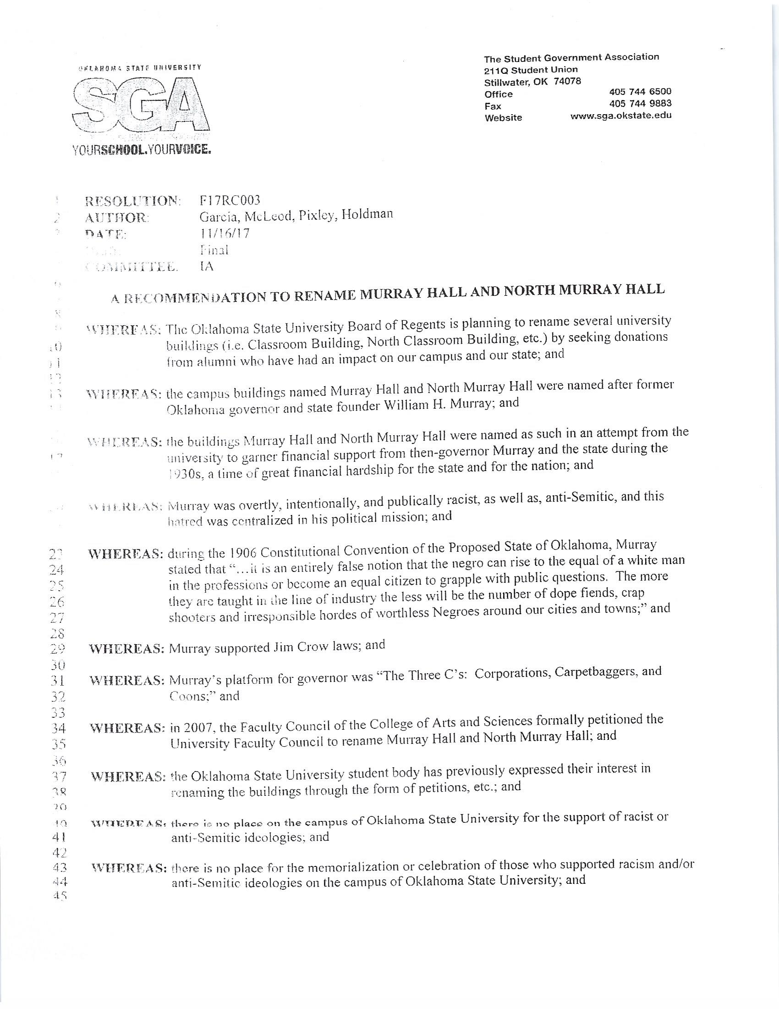

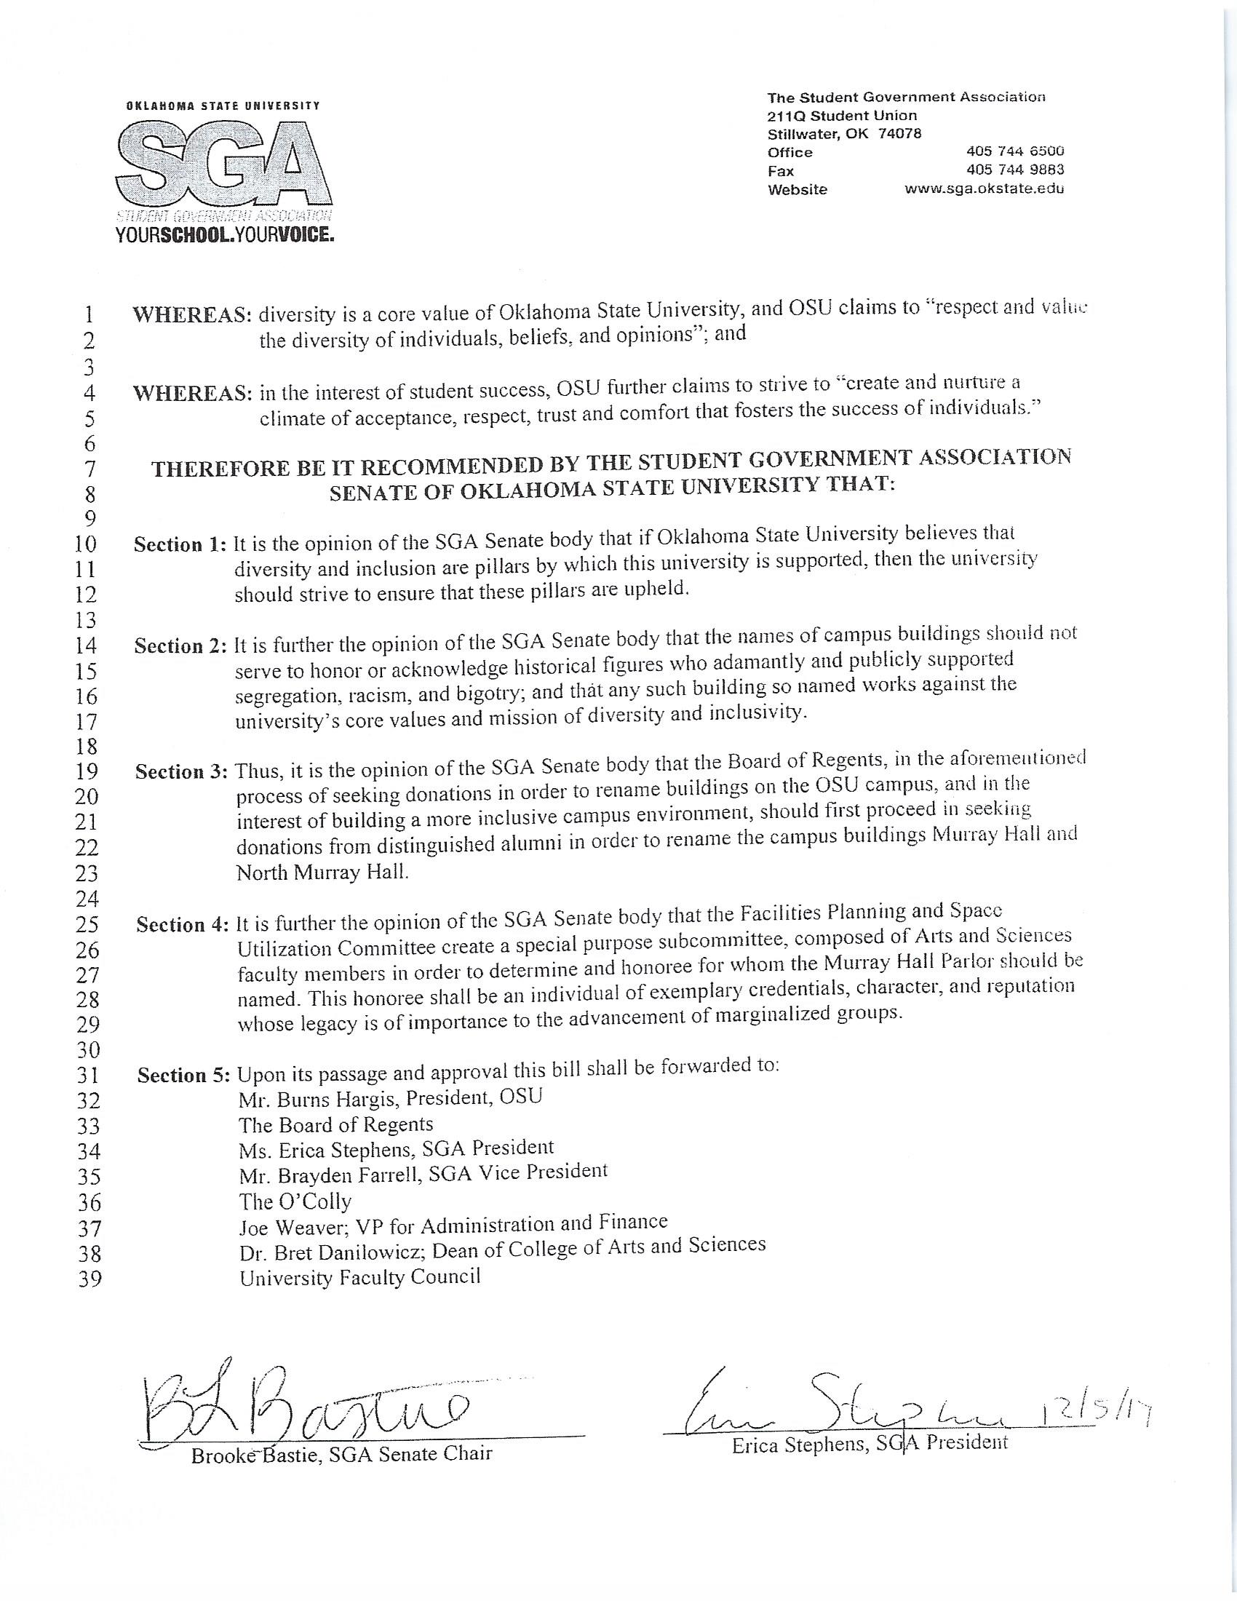

Smith stated that this resolution was made in the fall of 2017 to rename Murray and North Murray Hall. Smith said that Murray Hall was named after state founder and Oklahoma Governor William H. Murray. Smith stated that in 2007 the Faculty Council of the College of Arts and Sciences formally petitioned the university Faculty Council to rename Murray Hall and North Murray Hall. Smith stated that this is something that has been going on since 2007. They have initiated a change and it’s unfortunately somehow not something that’s been taken up. Smith stated that they would like to see it revisited. Smith turned the floor over to Dougherty.

Dougherty stated something that strikes her as important is how this has been ongoing for over 10 years and it doesn’t appear to have been taken seriously and that some form of action has not been taken on this issue. Dougherty said a lot of people have told her that it is really important that Murray Hall be renamed because it is named after a white supremacist, a fascist and an anti-Semite. If it wasn’t that important then they could just change the name to his son who had the same upbringing. Dougherty feels that there are so many students of color on this campus that work so hard and pay to be here just like everyone else. She feels that it’s only respectable that you really need to understand what we are saying and that this should be renamed. Dougherty said she knows that this will cost money but feels that this issue should be moved up higher on the priority list, which it has not been in years. Dougherty said she thinks that every day we fail to do this is a slap at the students of color on this campus.

Smith stated that it is her understanding the reason this did not pass in the fall of 2017 is because there was not a council naming committee to look at this issue. A naming committee was created and then didn’t take up this issue for some reason. Smith specifically suggested that there should be a special subcommittee of Arts and Sciences faculty members in order to determine the honoree for whom the Murray Hall Parlor should be named. This honoree shall be an individual of exemplary credentials, character and reputation whose legacy is of importance to the advancement of marginalized groups, as written in section 4 of the above resolution. Smith asked the committee members to review the handout and hopefully some action will be taken on this issue.

- Wellness Center – Kim Beard

- Graduate Council – Jon Ramsey for Rebecca Sheehan

GPA on the plan of study vs overall-GPA requirements. The Graduate Council approved that the minimum GPA requirements: Plan of Study (POS) and overall GPA must be 3.00.

Graduate Research Excellence Awards. These awards recognize outstanding accomplishments reflected in master's theses or doctoral dissertations and are submitted by each subject matter group. The process for these awards is unique to each group and decisions are due to the Graduate College by April 15th. Contact your group chair or vice-chair for more information.

Academic Program Committee. A variety of degree modifications and graduate certificates were approved.

Graduate Education Month. Graduate Education Week has been changed to Graduate Education Month. April is Graduate Education Month. Please mark your calendars for the last event:
Graduate College and GPSGA Awards Ceremony
Wednesday, April 24 @ 2:30 p.m. in SU 412, Council Room

Academic Program Reviews. Ten programs from College of Arts and Sciences and Human Sciences reports are available on Brightspace. Comments due to grad.dean@okstate.edu by April 22, 2019.

REPORTS OF STANDING COMMITTEES:

Reports of Standing Committees:
a. Athletics: Justin Talley – No Report
b. Budget: Steve Wanger – No Report
c. Campus Facilities, Safety, and Security: Scott Frazier – No Report
d. Diversity: Justin Moss – No Report
e. Faculty: Robert Emerson – No Report
f. Long-Range Planning and Information Technology: Eric Rebek – No Report
g. Research: Dianne McFarlane – No Report
h. Retirement & Fringe Benefits: Griffin Pivateau – No Report
i. Rules and Procedures: Mindy McCann for Pamela Lovern – Update
Lovern gave the election results to the Faculty Council members. They are as follows:

CASNR: Bruce Dunn
CAS: Toby Nelson, Cindy Melancon and Matt Lovern.
Tyrrell Conway for the 1-year term
Cristina Gonzalez for the 2-year term
CEAT: Tieming Liu
CHS: Sarah Hall
SSB: Harounan Kazianga
OKC: Anthony Smith
CoEHA: Ki Cole

Lovern stated that at least a few of these people are already here at today’s meeting, such as Cindy Melancon and Toby Nelson. They will be joining us again next year. All new councilors will be invited to the May meeting.

DeSilva stated that there is one position that Lovern did not mention. That is the Vice Chair position. DeSilva stated that there was a tie for this position. According to our Rules and Procedures, when a tie occurs, it is broken by drawing lots. This was done and the result was then challenged, as allowed in the rules. The next step following a challenge is to have a secret ballot by Faculty Council members, and this will be done today. The Vice Chair nominees are Gina Peek and Jon Ramsey. Before voting, DeSilva asked Peek and Ramsey to address the council members.

Ramsey stated that he appreciated those who took part in the process. He believes there were 288 total votes for Vice Chair. This is about 20% of the faculty eligible to vote. Ramsey stated it is an honor to be asked and nominated and potentially serve Faculty Council. When he thinks about service in the institution and our mission, he feels it’s very important that we as faculty engage in governance. He knows it’s an interesting conversation when you approach faculty members and say you have an opportunity to serve on Faculty Council or Graduate Faculty Council and sometimes they run away from you, but from his personal perspective, this opportunity is what makes our institution unique. Ramsey had the opportunity to go to OU and visit with their faculty. It made him feel really good about the relationship that the OSU faculty have with our leadership team. This is an artifact of the work and investment current Faculty Council members have had and made. He would like to be a part of this. If you are willing and interested in good faculty governance that’s open and transparent, and to have folks willing to meet you and hear your concerns, please vote for Jon.

Peek said in her positon statement that it is an honor to be nominated first of all. It is a pleasure to sit here with Jon. We are friends and will remain friends after this. We’ve had a really good time with this and it’s very unusual to be 144 to 144 votes. Peek stated that if elected, she will connect with you. Her primary appointment is in extension, and she believes in serving the needs of people. She will meet faculty wherever they are. Peek firmly believes in the mission of the university which Ramsey mentioned. Peek often thinks of the OSU logo with the three equal sides – teaching, research, extension – and how important these are to our students, faculty and staff. Peek is truly ready to represent your interests. Peeks feels that Faculty Council must be a strong voice. Peek has enjoyed her time on Faculty Council so far. Peek as served as the chair of the Student Affairs and Learning Resources committee. Peek has had a wonderful chance to meet new people and make a difference. She hopes to continue to make a difference. Peek stated that the means of this committee to serve and communicate with the administration is very crucial and important to the wellbeing of the university to make sure that everyone has a shared voice and the opportunity to say things in a way that they feel comfortable and confident. Peek wants to help maintain the goals of the university and achieve excellence. These are Peeks goals and she truly appreciates Faculty Council members’ consideration.

DeSilva then asked the current members of Faculty Council to vote for Jon Ramsey or Gina Peek for the position of Vice Chair. Tricia White distributed paper and pencils to the Faculty Council members. Lovern and White collected all secret ballots and tallied them, then presented the results to DeSilva. DeSilva announced that Gina Peek is the new Vice Chair. DeSilva stated that this election was a longer process than anyone had anticipated. Peek stated that the rules will be changed in the future so we have a better process in case this happens again.

j. Student Affairs and Learning Resources: Gina Peek – No Report
k. Academic Standards and Policies: Jon Ramsey – No Report

Old Business – None
New Business –
Emerson stated that he broke his leg over spring break. Since this happened, he has discovered that there is a lot of construction on campus. For the most part they have done a really good job with access to areas for those with special needs. But there is a lot of work that needs to be done. Some areas are really hard to get in and out of. Emerson stated that he won’t have to worry about this when his leg heals but there are people out there who still will. Emerson feels that this is something we need to continue to improve. Emerson feels that going beyond the minimum standards for new construction should be considered. Emerson stated that he has never had to use his university insurance before, but had to with his injury. It would have cost a small fortune if he did not have such a great insurance program.

The meeting adjourned at 3:50 p.m. The next regular meeting of the Faculty Council is Tuesday, May 14, 2019 at 3:00 p.m. in the Council Room, 412 Student Union.

Respectfully submitted,
Pamela Lovern, Secretary

