FACULTY COUNCIL MEETING

**3:00 p.m., Tuesday, January 12, 2016**

# Council Room, 412 Student Union

**AGENDA:**

1. Roll Call

2. Approval of the December 8, 2015 Minutes

3. Approval of Agenda

4. Special Report:

A. Jean Van Delinder – COACHE survey

B. Sarah Gordon/James Knecht – Online SSI

5. Joe Weaver for the President – Remarks and Comments

6. Report of Status of Faculty Council Recommendations:

President Hargis, Provost Sandefur, and/or Vice Presidents

7. Reports of Liaison Representatives –

A. Barry Lavine – AAUP

The OSU Chapter of AAUP will hold its next meeting during the last week of January to discuss regular business, upcoming election for officers, and also new business related to faculty members who have contacted the chapter for assistance. One contact related to upcoming changes in minimum faculty qualifications by the Higher Learning Commission (HLC). A second contact related to the cancellation of a play in the College of Arts and Sciences on the topic of gender roles, specifically questioning and breaking gender roles. Many involved in the play viewed the cancellation as an infringement of free speech as well as academic freedom. Later in spring, the chapter will hold a workshop on “Decoding the Faculty Handbook.” We hope to partner with members of the Faculty Council to raise awareness about the contents of the Faculty Handbook and how the Handbook has changed over the last 15 years. Lastly, everyone involved in college instruction is invited to the annual AAUP state conference, which will occur on January 30, 2016 in Oklahoma City from 12:30 to 4:30 at the First Unitarian Church at 600 NW 13th Street. More information is provided in the flyer below. For more information about AAUP at OSU, please email the current President Shelia Kennison at shelia.kennison@okstate.edu.

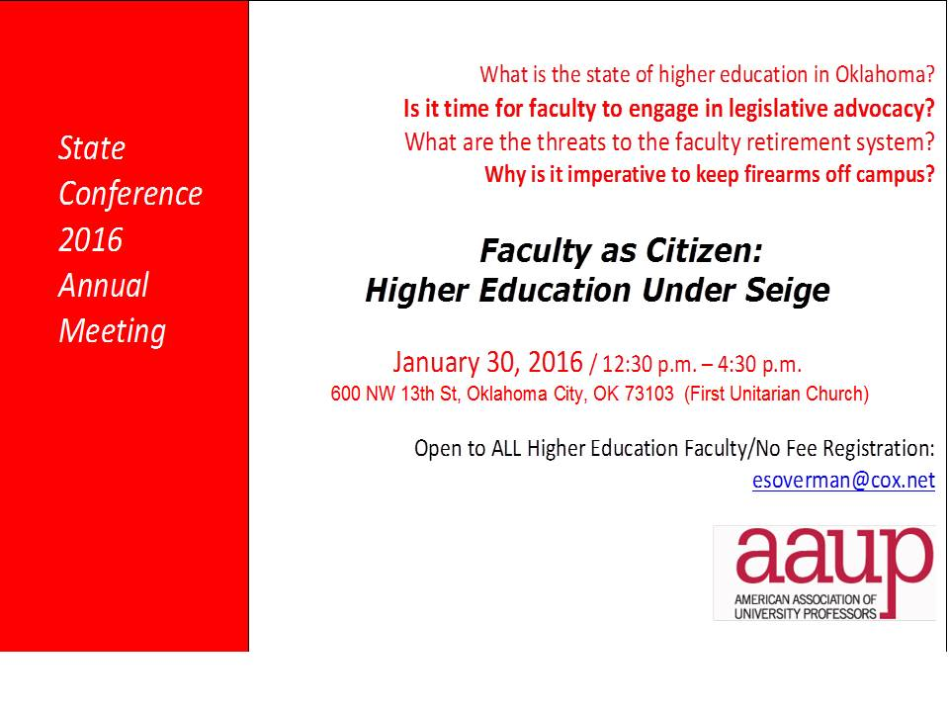

B. Mary Talley – Wellness Center



C. Graduate Faculty Council – Brenda Smith

The Graduate Faculty Council did not hold a December meeting due to the holiday schedule.

Upcoming items to anticipate on the agenda for the Graduate Faculty Council include:  1) a review of the process around the non-thesis, creative component;  2) graduate program handbooks; and 3) a review of the academic integrity policy as it relates to graduate students.

D. Women’s Faculty Council – Linda Watson

1) The Research Awards Competition is open, and proposals are due February 29th. We have over $10,000 to award for research by women undergraduate and graduate students at OSU, thanks to the generosity of several academic deans and administrators. 2) 'The Ann Ryder and Clara Smith, Leadership Endowed Scholarship for Undergraduates' competition is now open. This is a $1000 scholarship for next academic year. Applications are due February 1. Both are online applications and require letters of support from faculty advisors/mentors. See <http://womensfacultycouncil.okstate.edu>

WFC is hosting a 2016 Research Week Speaker, Dr. Crystal Hoyt, Professor of Leadership Studies, University of Richmond. The title of her seminar is: "Mindsets matter for female leaders: The role of leadership efficacy and growth mindsets in buffering against identity threat”. Time/Date/Place: Monday, February 15th, 3:00 p.m., reception to follow. Edmon Low Library, Peggy Helmerich Browsing Room. WFC thanks the VPR Office for the financial support to host this speaker. For more information or the opportunity to meet with the speaker, email [linda.watson10@okstate.edu](mailto:linda.watson10@okstate.edu)

E. Staff Advisory Council – Melanie Bayles

Staff Advisory Council Committees have yet to meet and report anything for January.

The A&R Committee has received two bids to date for the Staff Celebration Day Picnic that is scheduled in May. They have received one bid from the Ranchers Club and one from Celebrations Catering.

The Fund Raising Committee will be working this Spring with other SAC members in their collection of donations from Vendors for door prizes used at the Celebration Day Picnic.

The Distinguished Awards Committee completed their selection process in December for this year’s DSA awards. Twelve Finalists will be honored at the Staff Development Day event this Spring.

The Policies, Benefits and Budget Committee are reviewing and rewriting recommendations that were issued in June, 2015. They were sent back to the committee for clarification.

D. GPSGA – Catherine Haviland



8. Reports of Standing Committees:

a. Academic Standards and Policies: Mindy McCann – Update

b. Athletics: Tom Royer – No Report

c. Budget: Pamela Lloyd – No Report

d. Campus Facilities, Safety, and Security: Nathan Walker – No Report

e. Diversity: Lucero Tenorio – No Report

f. Faculty: Glade Topham – Update

g. Long-Range Planning and Information Technology: Cecil Joe – Update

h. Research: Andrew Doust – No Report

i. Retirement & Fringe Benefits: Rita Miller – No Report

j. Rules and Procedures: Deb VanOverbeke – Update

k. Student Affairs and Learning Resources: Jennifer Borland – Update

9. Old Business

10. New Business

11. Adjournment

*Refreshments will be served at 2:45 p.m.*