Introduction to Accreditation
Oklahoma State University (OSU) will be evaluated for reaffirmation of its accreditation by the Higher Learning Commission (HLC) in the spring of 2026 with the official site visit scheduled for April 20-21, 2026. To prepare for this upcoming site visit and related procedures, the Accreditation Steering Committee, Accreditation Liaison Officer (ALO), and Provost’s office has prepared the following document to outline important information regarding what accreditation is, the criterion that will be looked at by HLC upon their visit, and how different units at the university will aid in this process.
What is Accreditation?
Oklahoma State University holds institutional accreditation with the Higher Learning Commission, which is required for an institution to receive federal funding, for the students to obtain federally backed student loans or transfer credits, and to ensure academic quality. Oklahoma State strives to promote learning, advancement of knowledge, life enrichment and economic development through teaching, research, extension, outreach and creativity. Oklahoma State University is continuously working to lead in the creation of a better Oklahoma, nation and world.
Accreditation is the process by which colleges, universities, and academic programs demonstrate their quality. In the U.S., there are three main types of accreditations: regional, national, and programmatic. Regional accreditation is more common among public and nonprofit colleges, while national accreditation is typical for trade schools and religious schools. Programmatic accreditation is awarded to specialized academic programs or departments in fields such as nursing, education, and business.
According to its website, the Higher Learning Commission defines institutional accreditation’s purpose as:
Institutional accreditation validates the quality of an institution's academic programs at all degree levels, whether delivered on-site, online or otherwise. Institutional accreditation also examines the quality of the institution beyond its academic offerings and evaluates the institution as a whole, including the soundness of its governance and administration, adherence to mission, the sustainability of its finances, and the sufficiency of its resources.
- Higher Learning Commission
For more information about OSU’s history of accreditation, please visit the website: Accreditation | Oklahoma State University (okstate.edu)

What is HLC?
The Higher Learning Commission (HLC) is the accrediting body recognized by the U.S. Department of Education and the Council for Higher Education Accreditation to accredit degree-granting colleges and universities for the Midwest region of the United States. In its website HLC states that its mission is to “Advance the common good through quality assurance of higher education as the leader in equitable, transformative and trusted accreditation in the service of students and member institutions […]HLC is governed by a Board of Trustees elected by the membership and administered by a president selected by and accountable to that Board” (Higher Learning Commision [HLC], n.d.) and has more than 50 staff members.
For more information about HLC please visit the website: The Higher Learning Commission (hlcommission.org)
For HLC’s most recent resource guide please visit the website: Resource Guide | News-Reports (hlcommission.org)
What Criteria Does HLC Use to Evaluate Institutions?
HLC will evaluate OSU based on five major criteria with various core and subcomponents. OSU must pass on all subcomponents to be considered reaccredited by the review team. The five major criteria are:
- Criterion 1. Mission: The institution’s mission is clear and articulated publicly; it guides the institution’s operations.
  - The core components of this criterion focus on the overarching use of the mission by all facets of the institution; the institution’s commitment to good of the public; and opportunities that the institution provides to aid with civil engagement in our multicultural and connected world.
- Criterion 2. Integrity: Ethical and Responsible Conduct: The institution acts with integrity; its conduct is ethical and responsible.
  - The core components of this criterion focus on the implementation and transparency of the institution’s policies and procedures; the integrity of the institution’s governing board and its associated actions; the guarantee of academic freedom and freedom of expression; and the ethical maintenance of funding, research, and academic endeavors.
- Criterion 3. Teaching and Learning: Quality, Resources, and Support: The institution provides quality education, wherever and however its offerings are delivered.
  - The core components of this criterion focus on the rigor and content of academic offerings (including general education courses); the qualifications and sustainability of staff and faculty to support said academic offerings; and the provision of resources to support student learning (both academic and cocurricular).
- Criterion 4. Teaching and Learning: Evaluation and Improvement: The institution demonstrates responsibility for the quality of its educational programs, learning environments, and support services, and it evaluates their effectiveness for student learning through processes designed to promote continuous improvement.
  - The core components of this criterion focus on the assessment and ongoing improvement of academic programs through the assessment of student learning. This takes place on the program level through student learning outcomes assessment and programmatic improvements as well as institutionally through educational improvement plans regarding student retention, persistence, and completion of programs.
- Criterion 5. Institutional Effectiveness, Resources and Planning: The institution’s resources, structures, and processes are sufficient to fulfill its mission, improve the quality of its educational offerings, and respond to future challenges and opportunities.
  - The core components of this criterions focus on administrative procedures and collaboration that supports the current endeavors of the institution as well as the role of evidence-backed improvement planning for the future of the institution.

- To see the current HLC criteria in more detail, visit the website here: Criteria for Accreditation (CRRT.B.10.010) | Policies (hlcommission.org)
- For video explanations on each criterion, visit the webinar series here:
  - Criteria 1 & 2: https://www.youtube.com/watch?v=FnRLRfb92fw
  - Criteria 3: https://www.youtube.com/watch?v=MkzONSKppA4
  - Criteria 4: https://www.youtube.com/watch?v=df0-lRp3toQ
  - Criteria 5: https://www.youtube.com/watch?v=v25irEjyL3Y
What are the Processes of Accreditation?
There are two major processes associated with accreditation:
- Seeking accreditation with HLC, which can be achieved by one of two paths:
  - The eligibility process and candidacy, and,
  - The accelerated process for initial accreditation.
- Maintaining accreditation. To maintain the standard of superior education, HLC conducts periodic evaluations of member institutions' adherence to its requirements. This can be achieved by one of two pathways:
    - Standard, under which institutions must undergo thorough evaluations in both Year 4 and Year 10, and
    - Open in which institutions undergo an Assurance Review in Year 4, a comprehensive evaluation in Year 10, and conduct a Quality Initiative between Years 5 and 9.
To learn more about the difference between levels and their requirements, please visit Overview of the Accreditation Relationship | Accreditation (hlcommission.org)

What is the Difference Between Standard and Open Pathway?
HLC's Pathways for Reaffirmation of Accreditation helps accredited institutions ensure that they continue to meet the Criteria for Accreditation and strive for institutional improvement through periodic reviews conducted every 10 years. These reviews are done concurrently with HLC's regular oversight activities, such as the Institutional Update, substantive change requests, institutional monitoring, and other processes.
Currently, there are two primary pathways available- Standard and Open. An institution's pathway is usually determined after the completion of its current cycle, which is after the 10th year of reaffirmation of accreditation. Institutions can choose their pathway at that time, unless they meet the conditions that would require them to follow the Standard Pathway. Institutions on the Open Pathway may also be transferred to the Standard Pathway if any of these conditions arise during the cycle.
To learn more about the pathways for reaffirmation of accreditation, please visit Standard and Open Pathways | Accreditation (hlcommission.org)

Oklahoma State University’s Accreditation Path
OSU is currently part of the Open Pathway for accreditation. See the below chart for more information about the steps to this pathway.
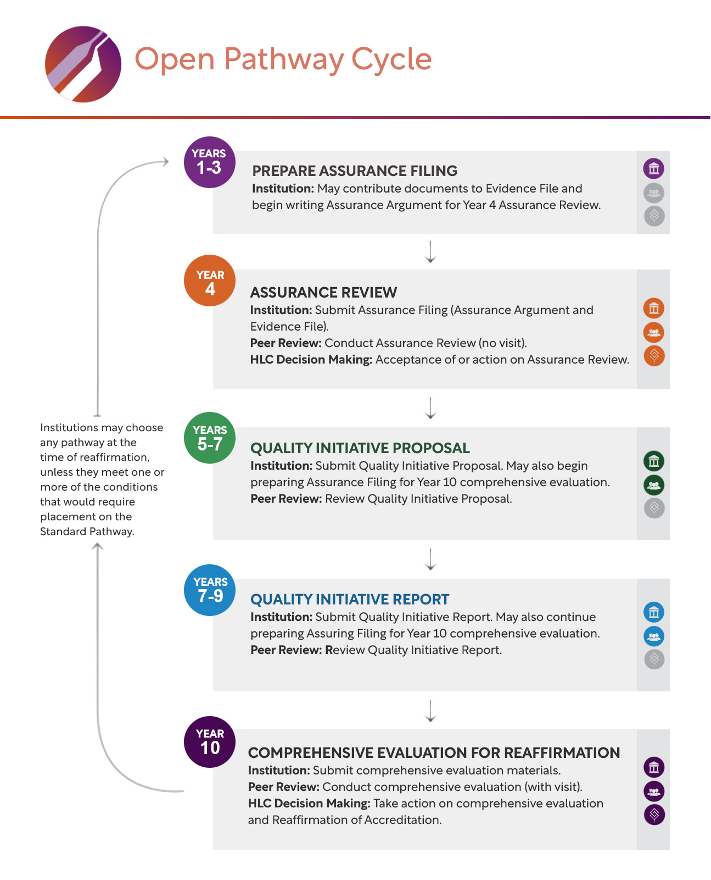

Quality Initiative
Once on an Open Pathway of reaccreditation, an institution is expected to create and propose a Quality Initiative project to HLC reviewers. This project can be anything beneficial to the growth or betterment of the institution but must be separate from other review processes already taking place. For provided examples of project topics, please visit the HLC website: Quality Initiative | Accreditation (hlcommission.org)
The institution will first create the project they intend to submit for review to HLC. It will then submit a formal proposal of the project along with a project progress timeline to HLC for review. See the following webpage for the associated proposal template: QualityInitiativeProposalTemplate_FRM.docx (live.com)
A peer review process will take place at which point the project will either be approved (with or without minor modifications) or the institution will be asked to resubmit their proposal following more extensive changes. The peer reviewers will judge the proposal based on the following criteria:
- Sufficiency of the Initiative’s Scope and Significance
- Clarity of the Initiative’s Purpose
- Evidence of Commitment to and Capacity for Accomplishing the Initiative
- Appropriateness of the Timeline for the Initiative
After a proposed initiative project is approved, the institution will move forward with the initiative. The final step will be to submit a Quality Initiative Report via the template provided by HLC (QualityInitiativeReportTemplate_FRM.docx (live.com)) in the final year of the Quality Initiative timeline. The report itself will be peer reviewed and the reviewers will provide a recommendation based on the perceived effort on the part of the institution. The Quality Initiative recommendation will be submitted as part of the reaffirmation process during year ten of the Open Pathway process (see the timeline above) and will accompany the reassurance argument provided by the OSU (see the next section).
For more information about the Quality Initiative process, see the website: QualityInitiativeProcess_PRC.pdf (hlcommission.org)
What is a Reassurance Argument?
A reassurance argument is one of the documents through which OSU supports their accreditation status and provides evidence for each criterion. The reassurance argument is submitted through an online portal prior to the HLC site visit (see the next section for more information about this step of the process).
As part of the reassurance argument that OSU will provide to the HLC peer review team, OSU will need to identify evidence in support of each criterion. This evidence will be compiled by a team of OSU faculty, administrators, and staff who are best able to provide information regarding OSU’s ongoing processes and procedures in place to support the HLC criteria.
For examples of evidence that supports each criterion, visit the website here: Providing Evidence for the Criteria for Accreditation (hlcommission.org)
Important to note is that certain practices are assumed to be practiced by all institutions and are not required to be described within the reassurance argument; examples of these can be found here: Assumed Practices (CRRT.B.10.020) | Policies (hlcommission.org)
HLC provides examples of institutions willing to share examples of what a reassurance argument looks like. For more information, please visit pages 75-77 of the 2023 HLC Resource Guide: 2023 Resource Guide (hlcommission.org)
What is a site visit?
A team of HLC Peer-Reviewers will visit the OSU campuses as part of the reaffirmation of accreditation review. The Peer-Reviewers will examine the reassurance argument provided, meet with stakeholders of the university, and provide the recommendation regarding the institution’s reaccreditation standing.
Approximately one month prior to the site visit, the peer review team will send out an anonymous survey to students, faculty, and staff of the university to gather first-hand accounts of stakeholder experiences within the institution.
For more information about the site visit, see the procedural document for reviewers provided on their website: On-Site Visits (hlcommission.org)
Campuses and Locations
HLC differentiates between campuses and additional locations in the following way:
“campus/branch campus (Based on federal definition)
A physical facility that is geographically separate from and independent of the main campus of the institution and within the same ownership structure of the institution. HLC considers a location of an institution to be independent of the main campus if it has all four of the following attributes:
- It is permanent in nature.
- It offers courses in educational programs leading to a degree, certificate or other recognized educational credential.
- It has its own faculty and administrative or supervisory organization.
- It has its own budgetary and hiring authority.”
- Higher Learning Commission
The Peer-Reviewer team will visit OSU’s campuses, including OSU-Stillwater, OSU-Tulsa, and CHS. They will not visit OSU’s additional locations such as OSU-OKC and Cherokee Nation Health Center as they operate independently from the main campus and under their own accreditation schedules.
Roles and Responsibilities of OSU Units
With a reaccreditation of the university such as this one, all stakeholders play a role in the process. Faculty, staff, administrators, and students will be kept informed throughout the process as well as consulted for aid when appropriate. Upon the peer review site visit, these stakeholders will likely be contacted and asked to provide their insight into the university processes, procedures, and general welfare.
- Assistant Vice Provost of Accreditation, Assessment, and Testing – The Assistant Vice Provost of Accreditation, Assessment, and Testing will head the reaccreditation efforts. They will select and charge the steering committee with their role in the upcoming accreditation visit. They will be charged with submitting the reassurance argument via HLC’s online portal. Lastly, they will coordinate with the university’s HLC liaison regarding any questions or concerns proposed by the committees as well as schedule and coordinate the site visit occurring in fall of 2025.
- Steering Committee – The steering committee will be a small group in charge of creating and aiding each subcommittee regarding their assigned criterion. The Accreditation Steering Committee advises OSU through accreditation processes, coordinates the self-evaluation process, monitors responsible parties' work, ensures evidence is shared within the institution, and involves relevant internal stakeholders in the analysis of data and evidence. In short, the Accreditation Steering Committee is responsible for guiding the institution through the accreditation process.
- Subcommittees – A separate subcommittee will be established for each of the five criteria. The members of each subcommittee will be identified by the steering committee due to their position and knowledge relevancy for each of the associated criterion. Each subcommittee will be charged with:
  - Meeting regularly to discuss and identify evidence related to their specific criteria,
  - Drafting their criterion’s section of the reassurance argument,
  - Reporting progress and concerns to the steering committee, and
  - Consolidating and finalizing their criterion’s section of the reassurance argument before turning it over to the director of UAT for final submission.

If you have any questions about any of the information provided here, please contact University Assessment and Testing via our email: osu.accreditation@okstate.edu.

HLC has proposed a newly constructed list for the criteria to be used by institutions. If the revised Criteria are adopted in June 2024, the following information will be updated to reflect those changes.

