Pam Lovern called the meeting to order with the following members present: Bach, Cole, Conway, Curry, Dimotakis, Dunn, Fathepure, Finchum, Gardner, Lewis, Hall, Hiney, Jaroni, Khojasteh, Krishnan, M. Lovern, Liu, Ma, Melancon, Nelson, Neurohr, Noden, Parveen, Peek, Perkins, Pranger, Reichard, Shan, Slevitch, Smith and Stansberry.

Also present: Burns, L., DeSilva, U., Eastman, G., Francisco, C., Grover, A., Hawkins, K., Kirksey, J., Knapp, J., Louthan, C., Mariott, D., Mendez, J., Miller, B., Peaster, R., Pope, A., Roberts, M., Ruby, M., Sheehan, R, Shrum, K., Sewell, K., Stephens, J., Tucker, S., Weaver, D. and Weaver, J.

Absent:

**HIGHLIGHTS**

Special Reports:

Dr. David Mariott, Director Constituent Relationship Management (CRM) Institutional

Research and Analytics – Academic Alert System……………………………

Mr. Larry Burns, Associate Director Institutional Research and Analytics – SLATE

contact tracing …………………………………………………………………

Remarks and Comments – President Shrum………………………..……………………..….

Report of Status of Faculty Council Recommendations and other Vice Presidents…….…….

Reports of Liaison Representatives …………………………………………………….……..

Emeriti…………………………………………………………………………………

Graduate Council………………………………………………………………………

Wellness……………………………………………………………………………….

WFC …………………………………………………………………………………..

SGA……………………………………………………………………………………

GPSGA ………………………………………………………………………………..

SAC……………………………………………………………………………………

Reports of Standing Committees ………………………………………………….…………..

Academic Standards and Policies ……………………………………….…………….

Athletics ………………………………………………………………….……………

Budget …………………………………………………………………….…………...

Campus Facilities, Safety and Security ………………………………….……………

Diversity………………………………………………………………….……………

Faculty ………………………………………………………………….……………..

Long-Range Planning and Information Technology ………………….………………

Research ……………………………………………………………….………………

Retirement and Fringe Benefits ……………………………………….………………

Rules and Procedures ………………………………………………….………………

Student Affairs and Learning Resources …………………………….………………..

Pam Lovern announced it was 3:00 and the chair has determined that a quorum is present so the meeting will now come to order. Lovern sent the roll call around and asked everyone to sign it. Pam Lovern asked those attending via Zoom to make sure your name is displayed correctly on the screen and put their name in the chat so your attendance will be recorded. If you are a proxy for a Faculty Council member Lovern asked for them to put their name and the person they are attending for on the roll sheet. Pam Lovern asked those attending via zoom to stay muted to help with the audio. Pam Lovern stated that the first item of business on the agenda is the approval of the minutes from August 17, 2021. The minutes were distributed electronically and are available on the Faculty Council website. Pam Lovern asked if there were any corrections. Seeing none, the minutes were approved. According to Roberts Rule of Order the minutes can be approved by unanimous consent. Pam Lovern stated the second item of business on the agenda is the adoption of the agenda which was also electronically distributed and is also available on the Faculty Council website. Pam Lovern asked for corrections to the agenda. If there are no corrections, Pam Lovern asked for a motion to adopt the agenda. M. Lovern moved and Conway second that we adopt the agenda. Pam Lovern called for a vote and asked the Faculty members on zoom to note their vote in the chat. Motion passed and the agenda is adopted.

Pam Lovern introduced our first special report, Dr. David Mariott.

**Special Reports:**

1. **Dr. David Mariott, Director Constituent Relationship Management (CRM) Institutional Research and Analytics – Academic Alert System**

Mariott stated that we are currently in the process of implementing a Constituent Relationship Management (CRM). We have used these on campus for a number of years for prospective students. CRM’s have also been used at the Foundation and the Alumni Association. This technology is not new to OSU but there is a need for something to better serve our students.

Mariott walked those at the meeting through the website. The information is below:

**Slate Academic Alert Guide for Instructors**

**Updated 8/9/2021**

**About Slate:** Slate is a new constituent relationship management (CRM) system being implemented to serve current OSU students. Slate has been utilized at OSU since 2012 for prospective students. Academic alerts are the first of many features being developed in the new instance of Slate. More information will be provided as new functions and features are available.

**Slate Help:** For any technical issues with Slate, you can email [osustudentsuccess@okstate.edu](mailto:osustudentsuccess@okstate.edu) or Dr. David Mariott at [david.mariott@okstate.edu.](mailto:david.mariott@okstate.edu)

**Navigating to the Instructor Academic Alert Dashboard**

1. Log into my.okstate.edu and navigate to your Faculty tab. A link to the new Academic Alert system will be visible.

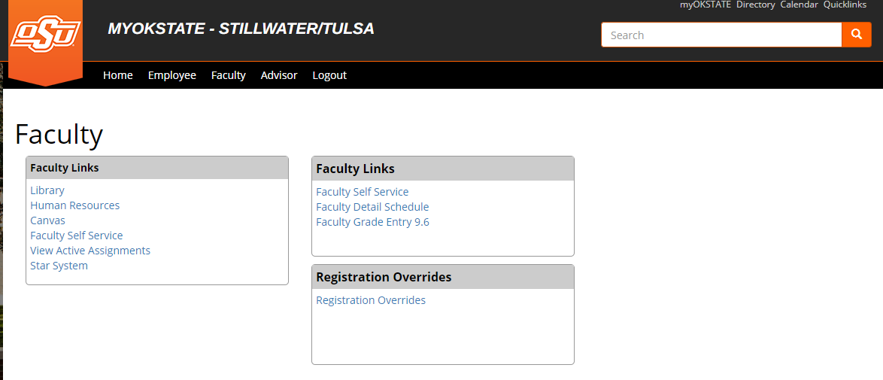

1. The new link will take you to a personalized dashboard in Slate where you can view alert instructions, a list of undergraduate students currently enrolled in your courses, a list of alerts submitted by you in progress, and a list of all alerts you have submitted. The instructions tab includes a link to this document, a video tutorial, and email samples of the system-generated emails used to communicate to instructors, advisors, and students.

**Instructions Tab Screenshot**

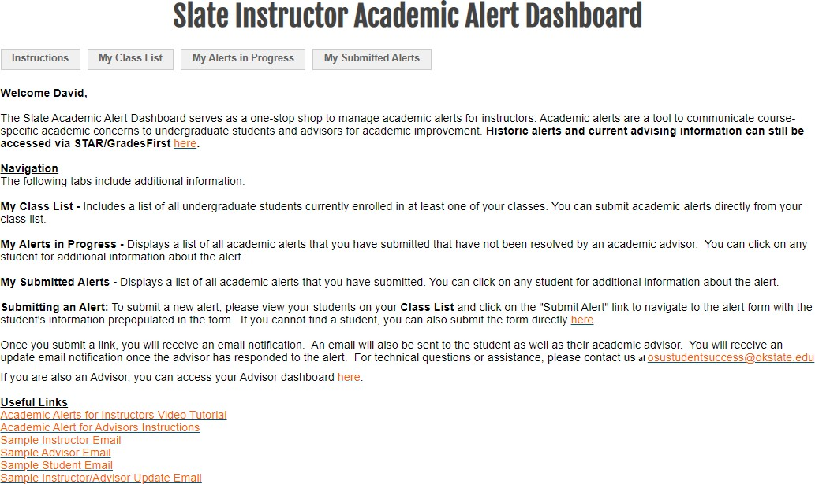

**Class List Tab Screenshot**

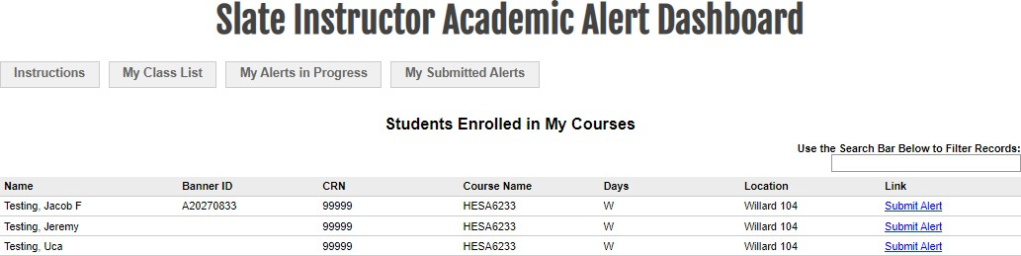

**Alerts in Progress Tab Screenshot**

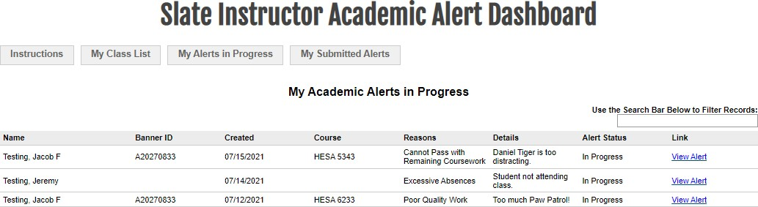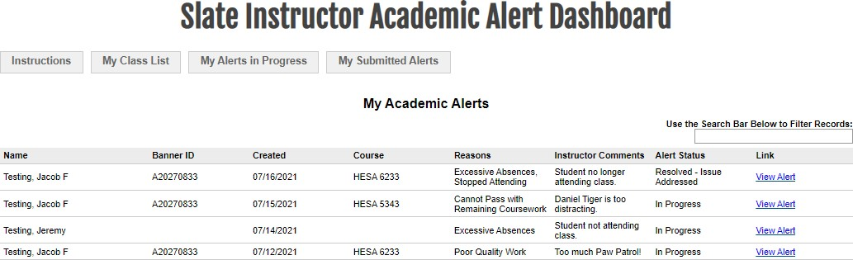

**Submitted Alerts Tab Screenshot**

**Submitting an Alert**

1. To submit a new academic alert, select the Class List tab to view a list of currently enrolled students in your course(s). Each column is sortable and you can also use the search bar to identify specific students.
2. Once you have identified the student to submit the alert, click the link on the right side of the portal. This will navigate you to an internal Slate form with the student’s information already prepopulated. Please make sure that the student information listed on the form is correct prior to submitting it.

**Academic Alert Submission Form Screenshot**

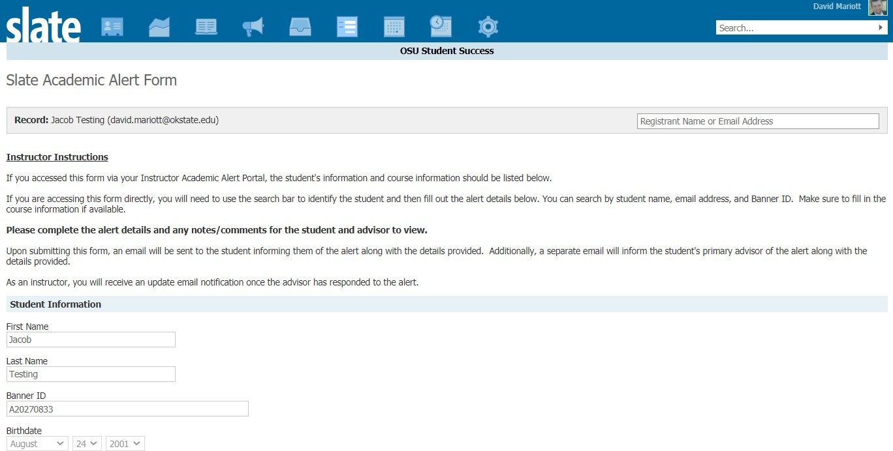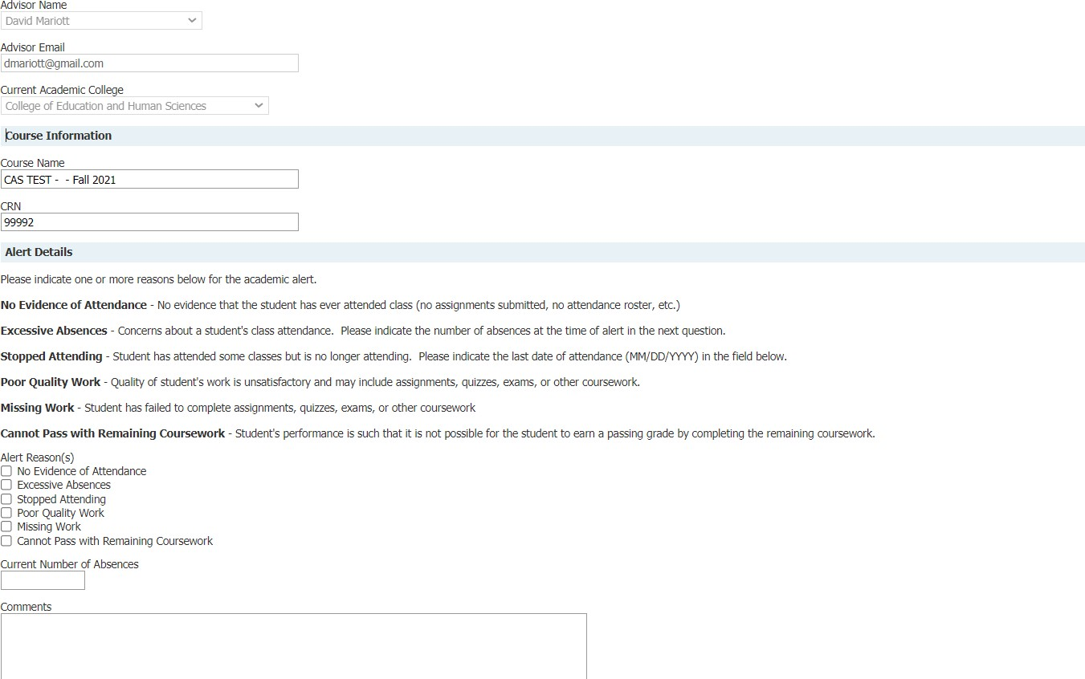

1. Two sections must be completed prior to submission.
   1. Please indicate one or more reasons in the Alert Details section. Descriptions are provided in the form and you may choose as many as appropriate.
   2. If you track attendance, enter the current number of absences the student has accumulated up to this point. If you do not track attendance, please leave this field blank.
   3. If you indicate that the student has stopped attending your course, please provide the last date of attendance in the field provided (MM/DD/YYYY format).
   4. The alert reason(s) and comments will be shared with both the student and their primary advisor so it is important to be as detailed as possible.
2. Complete the alert by clicking the Submit button. Disregard the advisor section of the alert.
3. Upon submission, Slate will send several system-generated emails.
4. You will receive a confirmation email with the alert details.
5. An email will be sent to the student on your behalf with your contact information and encouraging them to contact you and their primary advisor.
6. An email will be sent to the student’s primary advisor with the alert details. If there is no primary advisor assigned, the email will be sent to the student’s primary academic college.
7. Samples of all emails can be found on the instructions tab of the academic alert dashboard.

**Resolving Alerts**

1. OSU employees who serve as primary advisors can access a separate academic alert dashboard with the details of the alerts submitted by instructors.
2. Advisor are notified upon submission of the academic alert
3. Advisors can add comments and update the alert status.
4. Any update to the original academic alert will send you an email notification with the alert notes and current status.
5. Instructors can also view the advisor comments by selecting the “View Alert” link on the Alerts in Progress and Submitted Alerts tabs on the dashboard.

**Other Notes:**

* Dashboard views for students and alerts will reflect the current academic semester.
* Alerts can be submitted for the same student multiple times for the same course or different courses. Advisors will receive notification for each submitted alert.
* The academic alert is tied to the student’s record in Slate. If the student changes their major and/or academic college, the academic alert follows the student to the new major/college and will be visible to the advising staff in the new college.
* Slate will eventually replace STAR/GradesFirst as the academic advising platform in addition to several other functions. Historic data will be migrated from STAR and stored in Slate.

Lovern opened the floor for questions. Ma asked if there was a direct email. Mariott state yes, his direct email is [David.mariott@okstate.edu](mailto:David.mariott@okstate.edu). Mariott stated that there is an email on the portal [osustudentsuccess@okstate.edu](mailto:osustudentsuccess@okstate.edu). Mariott stated that any feedback is welcome. This is also the place to go for troubleshooting.

DeSilva asked if there was any way to make the search function work for all students? DeSilva stated that right now it just focuses on one screen. So faculty members have several pages of students to look at. Is there any way to fix this so we do not have to scroll down? Mariott stated that there are some options. They wanted it to be by the page for scrolling for system performance reasons but they can take a look at this and see what they can do to make this. Mariott repeated the question - it was about page loading. Right now whenever you look at your class list there is a limit to how many rows it shows per page. You will need to scroll to see the next page.

Dimotakis asked a question about contact tracing. He is currently teaching fairly small classes so taking attendance is not a big deal but he is thinking about faculty that have 100+ students in a class where taking attendance is more burdensome. He asked if there was a possibility that we could offer them some sort of assistance. Mariott stated that Larry Burns will be talking about contact tracing but anyone who is listed as an instructor for a course can see the same course listings.

1. **Larry Burns, Associate Director Institutional Research and Analytics – SLATE contract tracing**

As part of IRA’s role in the preservation, protection and ethical use of institutional data, they were asked to create a quarantine management system last academic year. This system successfully managed the communication and quarantine tracking needs for 2,800 students during the 2020/2021 academic year. The realities of the situation began to appear this fall. We were asked to build a tool to improve contact tracing as well as make adjustments to the quarantine management system. Because of the joint management and supervision of the SLATE between the Division of Finance, Administration and the Division of Brand Management, IR was able to use the functions of both the SLATE CRM and Cowboy Data Roundup to expand the capabilities of the quarantine management system to develop a fully online centralized system. This system was developed in-house in a manner of days. This is the result of a talented team. The goal of this project was to increase and improve COVID notifications for both students and faculty, upgrade quarantine management by improving data access for case managers, increase contact tracing by allowing faculty to enter close contact information and improve the secure reporting to institutional leaders and the community to the COVID-19 task force leaders.

Burns stated that the system had to be built with one concept in mind – change. We based previous work with contact tracing and quarantine management that we would be able to quickly adapt to new CDC and local official guidance. As part of the COVID management system, faculty were asked to do two things: 1. to report positive cases that were given to them directly from students to the academic alert system, 2. to report any close contacts for positive students through the academic alert system. This includes the last date of contact. Burns stated that as of today there have been 3,000 close contacts and 200 positive students reported through the academic alert system. This should not be used to say that we have had 200 positive cases or 3,000 close contacts. Burns stated that the COVID dashboard remains the definitive source for COVID-19 related statistics. The data reported by faculty is duplicate checked. They are validating self-reporting vaccines. Communications are all automated as much as possible to allow case managers and UHS staff to attend to their other duties. The system was built to allow for different communication tracks based on vaccine status, college and previous positive status.

Burns presented the following PowerPoint presentation to the council members.



Lovern opened the floor for questions. Seeing none introduced President Shrum.

**Remarks and Comments – President Shrum**

Shrum shared encouraging news and updates on COVID-19 with the council members. The dashboard on Friday showed that we were just under 10,000 vaccination doses. We continue to encourage vaccines and rolling out more positive encouragement. Shrum stated that the cases on campus are declining as well as our positivity rate. It is just over 5%. Shrum stated that this is the important number to follow. Shrum stated that at the federal level, below 6% is where we want to be. Shrum feels we are turning in the right direction and she appreciates all the work everyone has done in the classroom. She attributes this to our contract tracing and she is very pleased to see this start to go down.

Shrum thanked everyone for the outreach that Faculty Council, Dr. Mendez and faculty have done to help address concerns. Shrum believes Mendez is beginning to plan for the spring, summer and fall. We will engage faculty in this process.

Big news last week is we added four members to the Big 12 for conference stability. This is great and allows us all to move forward over the next 4-5 years. We are looking forward to bringing these four institutions into the Big 12. They are a good group for us to expand the geographical footprint as well as diversity of our conference.

Shrum stated that Congressman Frank Lucas and the Director of the Natural Science Foundation (NSF), Dr. Sethuraman Panchanathan, will be visiting tomorrow. We are excited to have Congressman Lucas on campus. Lucas is the ranking member of the House Committee on Science, Space and Technology. His committee has jurisdiction for NSF. Lucas will be accompanied by both his staff as well as the house SST professional staff. This is Dr. Panchanthans first visit outside of DC since his appointment. We are very excited that his first trip is to Oklahoma State. They will be touring several places on campus – the Center for Cyber Physical Systems with a demonstration of the VR (virtual reality) Equipment, our mixed reality lab at the department of Design, Housing and Merchandising as well as the touring the Endeavor and Excelsior Engineering and Aerospace labs.

Shrum is looking forward to the General Faculty Meeting on Tuesday, September 28th.

Shrum opened the floor for questions. Seeing none, P. Lovern introduced Mendez.

**Report of Status of Council Recommendations:**

**Interim Provost Mendez and Vice Presidents**

Mendez gave the Council members an update on current recommendations:

21-05-01-ASP: Modify P&P 2—0212, Approval of General Education Courses. Pending. Proposed modifications were recommended by the General Education Advisory Council and edited for clarity by FC’s ASP Committee. The revised document was presented for discussion at Instruction Council on 5/20/21 and table for further review. On an interim basis and with consent of IC and Council of Deans, part of the GEAC and FC recommended changes was implemented with the addition of GEAC representatives in the diversity and international subject areas.

21-04-01-LRPIT: NEW P&P, Digital Accessibility Policy. Accepted. Executive Team approval was received on 8/20/21 and the OSU/A&M Board of Regents approved on 9/1/21.

21-04-01-ASP: Modify P&P 2-0701, Family Education Rights and Privacy Act. Accepted. Approval by the Executive Team received on 8/25/21.

21-03-01-ASP/ Modify P&P 2-0217, Attendance Policy for Students. Accepted. Approval

21-03-01-ATH: by the Executive Team received on 8/25/21.

21-02-01-FAC: Modify P&P 2-0109, Cumulative Review of Tenured Faculty. Accepted. Approval by the Executive Team received on 8/25/21.

21-02-01-RES: Modify P&P 1-0505, The Care and Use of Animals in Research, Testing and Teaching. Pending. Revisions have been reviewed and approved by the Office of Research and by the Council of Deans on 3/11/2021. The draft has been approved by the OSU-OKC campus reps and has been shared with the OSU Board Legal Counsel for review prior to Executive Team for final approval.

18-05-02-FAC: Proposed changes to the Preface and Body of the “Policy Statement to

Govern Appointments, Tenure, Promotions, and Related Matters of the Faculty of OSU”. Pending. Proposed policy modifications are under review by the OSU Board of Regents Legal Counsel, along with potential modifications to existing P&P documents affected by the proposed changes. If needed, a working group of Faculty Council and Council of Deans representatives will be formed before the final draft is reviewed by the Council of Deans and the OSU/A&M Board of Regents.

Mendez thanked Chris Francisco, David Mariott and Larry Burns who have been head of the All-Star Team on everything that was just presented. They are taking ideas that were just put out there and making things happen. We encouraged your feedback the first week regarding contact tracing in the classroom. We pitched an idea to the three of them and they made it happen. They are refining constantly as we see problems and hear things from faculty members.

Mendez stated they are forming a few new committees as we begin to think about spring, summer and fall pertaining to a longer-term pandemic. We are working with Faculty Council on two committees with some planning purposes. From Mendez’s perspective she wants everyone to know that administration is hearing your concerns. We’re creating formal processes so we can continue to work with faculty and staff. We care deeply about you and the student experience as we navigate where we are with the pandemic. We are listening and adjusting as we can. The 3 classroom options that were sent out previously are still in place even as we see the numbers going down. We are staying the course right now. Keep sending your feedback.

Lovern opened the floor to questions. Seeing none asked for other Vice President reports.

**Other Vice Presidents:**

**Johnny Stephens – Interim President at OSU Center for Health Sciences and Senior VP for**

**Health Affairs at the OSU Stillwater Campus**

Stephens addressed a question in the chat: Are you going to have a vaccination mandate? Stephens believes this question is in response to last week’s announcement from the Biden Administration and that Legal Counsel, the Covid team and the Administration are all looking this. There is a lot of constituencies on campus and everyone could be affected differently. There is not a clear answer to this question. They are monitoring and working with Legal Counsel.

It was asked, why aren’t we doing social distancing in classrooms? Stephens stated this has been looked at and the numbers from August 30th continue to decline. At the level we have the classrooms in it’s difficult to social distance. We continue to monitor this and will put mechanisms in place.

Knapp is curious how we should portray or interpret the fact that the last two weekends we have tens of thousands of people unprotected in Boones Pickens Stadium, is it an encouraging sign that we have not seen an uptick in the number of cases on campus. Stephens stated that with the pandemic in general it’s difficult to make decision around this. Stephens would like to look at this as a positive that our numbers have stabilized to decline but we know that people come from across the state and even out of state so he will not make any inferences into this. We will watch our numbers on campus and community. It doesn’t appear to have an effect on the numbers and he couldn’t make generalities around this.

Chat question regarding seat assignments. Mendez stated as we get feedback from faculty, administration did pivot to classes with 100 or more students now do have seat numbers. She is getting requests for other classrooms to have seat numbers. This is something that will be discussed and can be implemented in the future. They were trying to help with larger classes initially.

Lovern stated there was a chat question about sanitizing classrooms. Stephens stated that we work closely with and are adding facilities management to our Covid Task Force team. We have doubled down to make sure we have hand sanitizer and masks available.

A question came in about the hospital having no open beds. How is administration using information to inform their decision about staying open and having football games? Stephens stated that hospitals across the state are full but there are a lot of answers that go into why there are no beds. Stephens stated they work closely with the hospital and the City of Stillwater to address as many concerns as we can. It is difficult on healthcare providers across the state of Oklahoma and across the United States and worldwide and this is a part of the pandemic that we continue to monitor and watch. The state was able to partner with Stillwater to open a tent facility at the hospital. To his knowledge the tents have not been needed.

Lovern asked if there were more questions. Seeing none asked for other Vice Presidents.

**Joe Weaver – Sr. VP Administration & Finance**

Weaver spoke about the healthcare plan specifically if there has been any noticeable impact during Covid. The direct answer is no, not really. Where we have been impacted is all our members did not go for voluntary procedures last year. They all stayed away and only did what was necessary. This year we have seen an increase as people feel more comfortable going to the doctor for general procedures. Weaver stated that Covid has not ramped up our costs as far as we can tell. We are running at about 101% which means our expenses are exceeding our premiums so it’s looking like a rate adjustment of some kind at the first of the year. Weaver stated around 2% for premiums. This has not been determined with finality yet. Weaver stated that from informal conversations with people at the hospital and the city, OSU does not have personnel in the hospital. It’s community people from broader Payne County that are in intensive care. Covid is not driving up our healthcare plan. We are in solid financial shape as far as the plan goes. Weaver stated it appears to be really close to a normal year.

Weaver stated that the Health and Wellness Task Force has been tracking our healthcare plan. Weaver feels it has exceeded its useful life and he would like to consult with campus in a different way going forward. What he believes they would like to do is have our HR director, Christa Louthan, and himself come to the Faculty Council benefits committee meeting and report periodically to show the plan experiences as we go through the year to keep you more informed about what we are facing/dealing with. We would do the same thing with the Staff Advisory Council. Weaver believes this would be a better way to get representative input from our faculty and staff instead of through the task force which is comprised of mostly administrators. Weaver hopes to work this out in the coming month. Weaver believes we would all benefit from this experience. It’s all about monitoring our plan and premiums to make sure we are in balance. Weaver did mention a rate increase but stated that we have not had one in two years. It had been three year prior to this with no premium increase. Weaver stated that we have managed our costs with Blue Cross/Blue Shield very well. He hopes to continue to do this.

Miller asked if there was any information about flights in and out of Stillwater Airport. Do you think faculty will be doing more traveling/flying this year? Do you think we might be able to add a flight back to the schedule? Weaver stated that the city and the university have been talking to American Airlines about getting service increased. We are also starting conversations with other carriers about perhaps developing a route to Denver or Chicago to expand our air service. The American Airlines flights have been really successful throughout the year. We are watching, there seems to be seats available on the current flights but we know we need to increase it.

Lovern asked for additional questions, seeing none moved to the reports of Liaison Representatives.

**Report of Liaison Representatives:**

1. Emeriti – Barbara Miller

The Emeriti Board Met on Sept. 1 via Zoom.  The main focus of the meeting was to analyze responses to our survey questions about future dinners.  The responses indicated that about half of those responding indicated they would probably not attend the scheduled in-person dinner on Sept. 20, due to Covid.  The Board voted to cancel the September meeting and to plan to hold the next dinner, scheduled for October 18th.  The feeling was that many seniors may have had the chance to get a third vaccine by that date and may feel safer attending in-person activities.  The Board also voted to resume our regularly scheduled monthly meetings beginning September 27, at 1:30, via Zoom. There has been no decision as yet on the possibility that some Committees and/or other activities of the Association may be discontinued.  As of now the various travel activities will still be scheduled.

1. Graduate Council – Rebecca Sheehan

***Graduate College Forms*.** All forms are now accessible in electronic format through the Round Up portal. Faculty can sign electronically, and it is not necessary to print a form.

***Graduate Student Recruitment.*** There will be a virtual graduate recruiting fair on October 15th. Dr. Smith provided an overview of the webpage, which will be live in the next few weeks. So far, 23 graduate coordinators have expressed an interest in participating.

***Graduate Student Enrollment.*** Dean Tucker reported that Fall 2021 graduate enrollment is up on all three campuses: Stillwater - 6%; Tulsa - 8%; CHS - 10%.

***International Teaching Assistant Program.*** Dr. Smith discussed changes to the ITA program making it more robust with workshops for students throughout the semester (Cultural expectations and instructional situations in the American classroom; Linguistic features of the American classroom; Solving communication breakdowns; Organizational and presentation strategies for academic presentations). The workshop schedule may be found here: https://gradcollege.okstate.edu/prospective-students/international-students/ita-exam-overview/ita-workshops.html.

***Graduate Student Wellbeing Taskforce***. Dean Tucker and Dr. Smith reported that based upon the taskforce work, a wellbeing advisory committee, including a committee head, will be appointed. The committee will provide guidance for graduate students, faculty, and staff to better navigate OSU’s existing robust resources.

***Graduating Faculty Bylaws.*** The proposed changes to the Graduate Faculty Bylaws approved by Council last May were approved by the voting members of Graduate Faculty. The approved changes included: 1) Full Membership requires affiliation with a graduate program. 2) Refer to the Faculty Handbook for faculty titles instead of listing them in the bylaws.

***APC Items***. The following were approved by Council:

Changes to programs:

1. OSRHE repeat-request from 2014 due to a clerical error on the Letter of Intent to offer the already approved MPH degree in Tulsa
2. M.S. Educational Leadership Studies – option addition in Workforce and Adult Education; course requirement changes for all option in School Administration; removal of the M.A.T. as an admission requirement for School Administration
3. M.S. Educational Leadership Studies– option in Higher Education – course requirement changes

New Degree Programs:

1. Graduate Certificate in Merchandising
2. Graduate Certificate in Learning and Motivation

***30-Hour Masters***. Dean Tucker asked for comments about setting the minimum hours to 30 for a master’s degree irrespective of the master’s being a thesis or non-thesis option.

***Thesis and Dissertation Titles on Transcripts***. Council approved adding thesis and dissertation titles to transcripts retroactively, since Banner was adopted. The Graduate College will work with the Registrar to accomplish this.

***General Graduate Faculty Meeting.*** Fall 2021 General Graduate Faculty Meeting is Wednesday, October 27th at 2 p.m. via Zoom.

1. Wellness Center – Kim Beard



1. WFC – Aditi Grover

**Announcements:**

* Details about the submission process for the WFC Faculty Awards will be announced shortly, with nominations accepted through mid-October.
* WFC has published to our website [a revised version](https://womensfacultycouncil.okstate.edu/site-files/images/bestpracticescovid19_2021.pdf) of our “Best Practices for Supervisors Supporting OSU Faculty, Staff, and Student Caregivers During COVID-19”

**Past Meeting:**

Our first WFC meeting of the semester was held on Monday, September 13th, 2021 from 2-3 PM via Zoom.

“Engaging Equity: Learning with and from the CAS Equity Advocates Council”.

We were joined by OSU faculty members - Dr. Laura Talbott Clark, Associate Professor of Violin and Chair, CAS Equity Advocates Council; Dr. Stephanie Link, Associate Professor of TESOL/Applied Linguistics, Equity Advocate for the Dept. of English; and Dr. Kim Loeffert, Assistant Professor of Music Theory, Former CAS Faculty Fellow for Diversity, Equity, and Inclusion.

**Upcoming Meetings:**

**Fall 2021 Monthly Meetings**

Our WFC all-membership meeting will be on the second Monday of every month from 2-3 PM via Zoom.

We look forward to our next meeting on 11th of October 2021 from 2-3 p.m.

Anyone interested in the WFC can visit our website at [http://womensfacultycouncil.okstate.edu](https://nam04.safelinks.protection.outlook.com/?url=https%3A%2F%2Fwww.google.com%2Furl%3Fq%3Dhttps%3A%2F%2Fwww.google.com%2Furl%3Fq%253Dhttp%3A%2F%2Fwomensfacultycouncil.okstate.edu%2526amp%3Bsa%253DD%2526amp%3Bsource%253Deditors%2526amp%3Bust%253D1628813758358000%2526amp%3Busg%253DAOvVaw2qprLSPr4hvMFx1e3NkD_r%26sa%3DD%26source%3Deditors%26ust%3D1628813758367661%26usg%3DAOvVaw3JRdo5Rt3fHMuGPtqlHKXZ&data=04%7C01%7Caditi.grover%40okstate.edu%7C706189d28b1e4a324efc08d974e18c64%7C2a69c91de8494e34a230cdf8b27e1964%7C0%7C0%7C637669334331320294%7CUnknown%7CTWFpbGZsb3d8eyJWIjoiMC4wLjAwMDAiLCJQIjoiV2luMzIiLCJBTiI6Ik1haWwiLCJXVCI6Mn0%3D%7C1000&sdata=Xgnm3%2FhMrx%2Bs1eIbSZDgWaku7eXjp4%2FYos0z6Hvv7EM%3D&reserved=0) and email [wfc@okstate.edu](mailto:wfc@okstate.edu) to sign up to be put on our email list.

1. SAC – Melanie Bayles

Staff Advisory Council is currently seeking nominations for the Staff Distinguished Service Award. This award is designed to honor staff members who go beyond the call of duty, enhance their career path, and represent OSU in a positive light. The award consists of a cash award and plaque. Nominations may be made by either faculty or staff and are due no later than Friday, October 1. Each nomination must be supported by three different OSU Faculty or Staff members. Go to sac.okstate.edu > Staff Awards for more information and nomination forms. We hope you will take the time to nominate deserving staff members from your area.

1. GPSGA – Megan Ruby
2. GPSGA Liaison and Representative

* GPSGA Membership-Liaison

Student Organizations are required to send one (1) liaison to GPSGA General Assembly meetings. In the case of an organization that represents both a Student Group and the Academic Unit, dual representation is allowed.

* + GPSGA Membership Application-Representative

Academic units are required to send two (2) representatives. In the case of an organization that represents both a Student Group and the Academic Unit, dual representation is allowed and only two (2) representatives are required.

* + **Membership Benefits:**
* The opportunity to apply for Graduate Student Group Funds for their student organizations
* The opportunity to apply for a travel award for individual students represented within academic units or student organizations (*more information on travel award guidelines*)
* The opportunity to make choices about funding graduate events through co-sponsorship and voting on legislation that directly impacts graduate students (*e.g. health insurance, daycare, etc.*)
* The opportunity to work within a multidisciplinary, multicultural organization with many leadership and collaborative professional opportunities

2. GPSGA Membership Application Forms for Liaison and Representative (Please see attachments)

 

3. Below is the list of departments/student organizations we currently have affiliated with GPSGA. The ones highlighted in yellow are the ones that are currently without representatives or liaisons. If the respective department would like to remedy this, the forms for representative and liaison are attached to this email.

Department Name/Student Org

• Agricultural Economics

• Agricultural Education, Communications, and Leadership Graduate Student Association

• Animal Science Graduate Student Association

• Automation Society

• Biochemistry and Molecular Biology Graduate Student Association

• Biomedical Sciences Graduate Student Association (BSGSA)

• Biosystems and Agricultural Engineering Graduate Student Association

• Black Graduate Student Association (BGSA)

• Boone Pickens School of Geology

• Botany Graduate Student Organization (BGSO)

• Business Analytics Student Association

• Chemical Engineering Graduate Student Association

• Chemistry

• Civil and Environmental Engineering

• Computer Science Graduate Student Association

• Counseling Psychology (CPSY) Student Group

• Creative Writers Association

• Department of Art History and Graphic Design

• Design, Housing and Merchandising

• Economics

• Educational Media and Technology Student Association (EMTSA)

• Educational Psychology Student Society (EPSS)

• Electrical and Computer Engineering

• English Graduate Student Association

• Entomology and Plant Pathology Graduate Student Association

• Family and Graduate Student Housing Leadership Council (FGSHLC)

• Finance

• Fire and Emergency Management Program (Political Science)

• Fulbright Students and Scholars Association

• Geography (Forum of Geography Graduate Students)

• Geology Graduate Student Association

• Graduate Professionals in Student Affairs (GPSA)

• Graduate Society of Interdisciplinary Toxicology (GSIT)

• Health, Leisure and Human Performance

• Hispanic Graduate Student Society

• History (Phi Alpha Theta)

• Horticulture and Landscape and Architecture

• Hospitality and Tourism Management

• Human Development and Family Science

• Industrial Engineering and Management\

• Interdisciplinary Toxicology

• International Association of Emergency Managers

• Leisure Studies GSA

• Management and Information Systems Graduate Student Association (MISGSA)

• Marketing and International Business

• Master of Public Health Program

• Materials Sciences and Engineering (OSU-Tulsa) [MSE]

• Mathematics Graduate Student Society

• MBA Association (Master of Business Administration)

• McNair Scholars

• Mechanical and Aerospace Engineering

• Mechanical and Aerospace Engineering GSC

• Microbiology and Molecular Genetics Graduate Student Association

• Natural Resource Ecology and Management Graduate Student Organization (NREM GSO)

• Nutritional Sciences

• Nutritional Sciences

• OSU Chapter of the Optical Society of America (formerly Optics Club)

• Physics

• Plant and Soil Sciences Graduate Student Organization (PSS-GSO)

• Plant and Soil Sciences Graduate Student Organization (PSS-GSO)

• Plant Biology, Ecology, and Evolution

• Psychology Graduate Student Association

• School of Educational Foundations, Leadership, and Aviation (SEFLA)

• School of Teaching, Learning, and Educational Sciences (STLES)

• School Psychology Graduate Organization (SPGO)

• Sociology Graduate Student Association

• Statistics

• Student Association of Global Affairs (SAGA)

• Student Organization of International Agriculture

• TESLing Club

• Theatre

• Veterinary Biomedical Sciences

• Zoology Graduate Student Society (Integrative Biology Department)

1. SGA – Georgia Eastham

The Public Affairs committee of the SGA Senate is hosting the Stillwater City Council on September 21st at 6:30 PM in the student union theatre. The council will be polling and presenting on upcoming projects as well as encouraging the student population to vote and be politically involved in the Stillwater community. There will be a register to vote station.

**REPORTS OF STANDING COMMITTEES:**

* 1. **Academic Standards and Policies: Brandt Gardner – No Report**
  2. **Athletics: Cindy Melancon – No Report**
  3. **Budget: Tyrrell Conway – No Report**
  4. **Campus Facilities, Safety, and Security: Tieming Liu – No Report**
  5. **Diversity: Divya Jaroni – Update**

Jaroni discussed the recommendation to add Juneteenth to the university holiday list. Lovern asked for discussion. Seeing none moved to a vote. Motion passed.

* 1. **Faculty: Matt Lovern – No Report**
  2. **Long-Range Planning and Information Technology: Kris Hiney – No Report**
  3. **Research: Bruce Dunn – No Report**
  4. **Retirement & Fringe Benefits: Sarah Hall – No Report**
  5. **Rules and Procedures: Karen Neurohr – No Report**
  6. **Student Affairs and Learning Resources: Toby Nelson – No Report**

Unfinished Business – None

New Business – We have two presentations to make for our past chairs, Udaya DeSilva and Gina Peek. Each received an honorary gavel this year since we conducted our meetings via zoom last year. Lovern thanked both DeSilva and Peek for their service as chair of Faculty Council.

Lovern asked for other new business. Lovern reminded everyone about the Fall General Faculty meeting which will be September 28th in the Recital Hall at the McKnight Center. The meeting will be livestreamed on OStateTV if you would prefer to watch online. President Shrum will be our guest speaker.

Lovern announced that Faculty Council has been working on a survey to be distributed to all faculty to get their views and experiences regarding Covid on campus. The survey was approved by IRB this morning. It will be distributed to all faculty tomorrow. Lovern encouraged everyone to complete the survey. Faculty Council members please encourage your constituents to complete the survey as well.

Lovern called for a motion to adjourn. Motion passed.

The meeting adjourned at 3:53 p.m. The next regular meeting of the Faculty Council is Tuesday, October 12, 2021 at 3:00 p.m. in the **Regency Room, 460 Student Union.**

Respectfully submitted,

Karen Neurohr, Secretary