FACULTY COUNCIL MEETING
3:00 p.m., Tuesday, April 12, 2022

Room 412 Student Union
AGENDA:

1. Roll Call

2. Approval of the March 8, 2022 Minutes
3. Approval of Agenda
4. Special Reports:
A. Randy Kluver – Asst. Provost/Dean – School of Global Studies & Partnerships –
OSU’s Standings in Global Rankings of Higher Education
B. Rob McInturf – OSU Alumni Association

5. President’s report and comments on matters of interest to the faculty

6. Provost’s report on recommendations made by the Faculty Council and comments on matters of interest to the faculty

7. Vice President’s reports and comments on matters of interest to the faculty

8. Faculty Council Chair’s report

9. Reports of Liaison Representatives –

- Emeriti Association – Barbara Miller

Our monthly dinner was held March 7, and Vice President for Research Kenneth Sewell was our speaker. He reaffirmed our Land Grant research commitments, including the strong push towards Public Impact Research at OSU, with such initiatives as Rural Renewal, Opioids, Drone initiatives, and Microbiome initiatives. He also mentioned high impact areas such as energy, aerospace, feeding the world, and childhood adversity. He mentioned ways in which faculty are reaching out to the public with Conversations on the internet and Iron Monk presentations which will generate more public discussions. Thank you, Dr. Sewell!

Our final dinner of the semester is co- sponsored with OLLI and will take place on Monday, May 2, at Legacy Village. We will also hold informal summer gatherings at Hideaway on July 11 and August 8.

Note from OLLI: Our spring programs are wrapping up, and attendance is up with the reduction of covid cases. Many classes are still being offered online and in person, which seems to be working out well. Summer classes are up on the OLLI website. Summer session runs from mid-May through mid-June. Mid-June is the deadline for course offerings to be submitted for the fall semester, and if you are thinking about a possible course you wish we could schedule or which you would like to teach, please contact the OLLI office.

- Graduate Council – Rebecca Sheehan

Graduate Faculty Mentor Training. Council voted for the Graduate College to develop graduate faculty training for new and existing graduate faculty based upon the research group’s recommendations. Those recommendations include four training/development sessions covering: Graduate Faculty Policy and Procedures; Serving on Graduate Student Committees; Commitment to Inclusion and Diversity; and Mentoring. All new faculty are expected to complete the four training sessions in their first one to two years. Current faculty are encouraged to complete the four training sessions every five years (or time recommended by the Graduate College). All training sessions do not need to be completed in the same semester. Upon completing all four training sessions within a two-year period, participants receive a Certificate of Completion from the Graduate College and the Department/School head is notified.

April 15 CGS Resolution Vacation. Council voted to exit the CGS Resolution effective Spring 2023.
Units (e.g., graduate programs, auxiliary units, academic advising offices) making financial offers are required to provide applicants appropriate time to consider offers. The OSU Graduate Council has set a minimum consideration time of two weeks or 14 calendar days post official, written notification (e.g., via the Slate portal) for applicants to accept offers of financial support (e.g., a graduate fellowship, scholarship, assistantship or traineeship). Acceptance of such an offer by a prospective or enrolled graduate student is an agreement that both student and graduate program are to honor. Acceptance of a financial offer commits the individual not to accept another offer without first notifying the institution to which the original commitment was made.

Possible Policy Language at the Graduate College Level Requiring Research Advisor/Chair. Council further discussed requiring students to find a new chair/research advisor within a certain timeframe to continue in a program. The graduate College will work on rewording the language to address students in good standing and SR/UR grades. Council will continue to discuss potential policy in future meetings.

Graduate Student Health Insurance. Dean Tucker reported that the graduate student insurance plan is being reviewed and is expected to have a premium increase this year. It is currently $20.

Application to Graduate. Dr. Van Delinder reminded Council that graduate students must complete an application to graduate and a diploma application with the Registrar, to graduate.

Graduate Education Month. April is Graduated Education Month and the Graduate College has activities planned, including an Appreciation Breakfast on April 6th and Award Ceremony on April 27th.

Academic Program Review. The follow-up meetings for APR have been delayed until Fall 2022.

- Wellness – Kim Beard
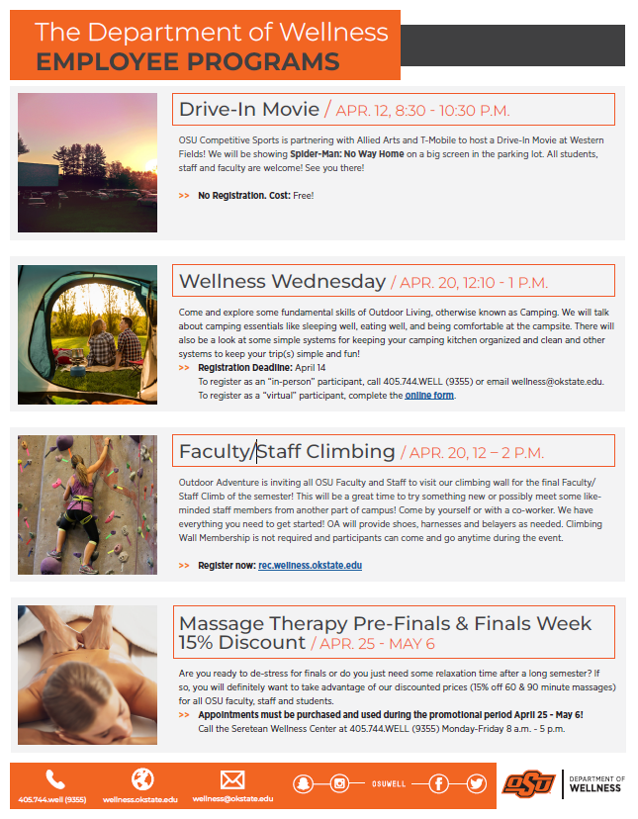

- Staff Advisory Council – Melanie Bayles

- We had a very successful Thank You to University Health Services Day on Wednesday. SAC members delivered donuts to UHS for staff to enjoy in the morning and in the afternoon Council members collected and delivered cards from university faculty, staff, and students. There were around 150 plus cards and a plastic container of survival kits that included popcorn bags, M&Ms, gum, Snickers, etc. with some very cute sayings. Thanks to all who contributed to the effort.
- Plans are going well for Staff Celebration Day on May 18. It is a come and go event from 11-1. Please make sure that your staff are given every opportunity to attend this lunch-time event. There will be a free lunch from Smokin Joes and lots of door prizes.

e. Student Government Association – Ty McLaughlin/Georgia Eastham

Pete's Pantry has a freezer now and it is stocked with pork. If anyone interested in donating fresh product, we ask that they coordinate with the Food Insecurity Director, Lara Hays.
f. Graduate & Professional Student Government Association – Megan Ruby

We want to welcome the new executive board for the 2022-2023 school year: President – Marcia Sun, Vice President – Lauren Haygood, Secretary – Mahesh Sivasubramanian, Treasurer – Michael Afolabi, Communications Director – Mehnaz Sharna, Intergovernmental Liaison – Haridas Das, International Affairs Officer – Eshan Maitra, Parliamentarian – Ravinder Singh, Social Chair – Open (will hold a mini election at this month's general assembly meeting since no one ran for this position last month). The current board is working on transition documents, so the change of command goes smoothly.

All award applications for the Spring have closed and our Treasurer, Karleyda Sandoval, and her finance committee are working on processing the travel awards, co-sponsorship awards, and group funds. Our current vice president, Marcia Sun, will be working with her committee to process the Phoenix awards.

g. Women’s Faculty Council – Aditi Grover/Erin Dkye

- We have selected our student research award and scholarship winners. We are excited to distribute $16,500 in award monies among 23 stellar graduate and undergraduate student researchers. Announcements will be made via our website (https://womensfacultycouncil.okstate.edu/), social media, and our email list.
- Our WFC Poster Symposium and Student Research Awards Ceremony, to be held on Wednesay, April 20th, 2-4pm in the Edmon Low Library’s Browsing Room.
    - 2-3pm - Faculty from across colleges and disciplines will present research posters.
    - 3-4pm - We will hold a ceremony to recognize our student research award recipients and provide them a chance to briefly share their work.
  - We will be seeking nominations soon for our WFC Executive Board members, including Vice Chair and Treasurer.

Anyone interested in the WFC can visit our website at http://womensfacultycouncil.okstate.edu and email wfc@okstate.edu to sign up to be put on our email list.

10. Reports of Standing Committees:

a. Academic Standards and Policies: Brandt Gardner – Update
22-04-01-ASP: Proposed Updates to UAR 7.3 Residence Waiver for Certain Premedical
and Prelaw Students*
b. Athletics: Cindy Melancon – No Report
c. Budget: Tyrrell Conway – No Report
d. Campus Facilities, Safety, and Security: Tieming Liu – No Report
e. Diversity: Divya Jaroni – No Report
f. Faculty: Matt Lovern – No Report
g. Long-Range Planning and Information Technology: Kris Hiney – No Report
h. Research: Bruce Dunn – No Report
i. Retirement & Fringe Benefits: Sarah Hall – No Report
j. Rules and Procedures: Karen Neurohr – Update
k. Student Affairs and Learning Resources: Toby Nelson – No Report

11. Unfinished Business –
12. New Business –
13. Adjournment -

*Attached

Amended by Passed Failed

Recommendation No. 22-04-01-ASP 1.________________ ______ _________

Moved by: Academic Standards & Policies 2.________________ ______ _________

Seconded by: 3.________________ ______ _________

Passed Tabled Failed 4.________________ ______ _________

Title: Proposed Updates to UAR 7.3 Residence Waiver for Certain Premedical and Prelaw Students

The Faculty Council Recommends to President Shrum that:

OSU’s UAR 7.3 Residence Waiver language be updated to clarify the requirement that students who qualify for this waiver must earn at least fifty percent of the hours in the major field at OSU to ensure compliance with minimum State Regents residence credit requirements.

Rationale:

The existing language in UAR 7.3 is vague and could be interpreted to imply a potential waiver of OSRHE’s residence requirements. It only states that the last 30 hours before transferring to a professional school must be earned at OSU (which doesn’t comply with OSRHE policy 3.15.5.C.5) and does not reference a minimum number of hours in the major be earned in residence.

A review of degree requirements for programs with pre-professional options reflects a design to ensure that students earn at least 50 percent of the upper-division hours in the major block at OSU, thus in compliance with both OSRHE and OSU’s residence credit policies. Students will still meet the minimum Regents residence credit requirements if at least 50 percent of the hours in the major field are satisfactorily completed at OSU, and UAR 7.3 serves as a waiver of the stricter OSU residence requirement that these hours are upper division.

