FACULTY COUNCIL MEETING
3:00 p.m., Tuesday, April 14, 2026
https://okstate-edu.zoom.us/j/97132843836
126 ITLE

AGENDA

- Roll call
- Approval of the February 10, 2026 minutes
- Approval of agenda
- Special reports
- Jennifer Glenn: Career Track Faculty Survey Results
- Merle Eisenberg: Salary compression update and recommendation
- President’s report and comments on matters of interest to the faculty
- Provost’s report on recommendations made by the Faculty Council and comments on matters of interest to the faculty
- Vice Presidents’ reports and comments on matters of interest to the faculty
- Faculty Council Chair’s report
- Reports of liaison representatives
  - Emeriti – Tom Royer – No Report
  - Staff Advisory Council – Sam Morse/Aaron Lively
  - Graduate Council – Veronique Lacombe
  - Student Government Association – Sam Hiltz
  - Graduate & Professional Student Government Association – Marcia Sun
GPSGA General Assembly Meetings Reminder – Spring 2026
- Eighth/Final General Assembly Meeting
- Wednesday, April 22, 5:30pm, ANSI-123
GPSGA Phoenix Awards

Information regarding the GPSGA Phoenix Awards is available on the GPSGA Canvas page! The four award categories include the Master’s Student, Doctoral Student, Graduate Teaching Assistant (GTA), and Graduate Faculty Mentorship Awards. Applications and nominations were open from December 2025 through March 2026 and are now closed. Recipients will be announced and recognized at the Graduate College Awards Ceremony on April 29.

GPSGA Assistance/Grant/Fund Information
- Travel Assistance – The GPSGA Travel Assistance Award helps graduate and professional students fund travel for academic conferences. Visit the GPSGA Canvas page for details.

  - College of Arts and Sciences Faculty Council – Natascha Riedinger
- Reports of standing and special committees –
  - Academic Standards and Policies: John Michael Riley – Recommendation*
  - Access and Community Impact: Aimee Parkison –
  - Athletic, Health and Wellness: Jill Joyce –
  - Budget: Merle Eisenberg – Special Report & Recommendation*
  - Campus Facilities, Safety, and Security: Jentre Olsen –
  - Career Track: Jennifer Glenn – Special Report & Recommendation*
  - Faculty: Joe Haley –
  - Long-Range Planning and Information Technology: Melanie Boileau –
  - Research: Jared Fitzgerald – Recommendations*
  - Retirement & Fringe Benefits: Mark Weiser –
  - Rules and Procedures: Christopher Crick –
  - Student Affairs and Learning Resources: William McGlynn –
  - Special Committee on Faculty Governance: Mark Weiser – Update

- Unfinished business
- New business
- Adjournment

*Attached

Amended by Passed Failed

Recommendation No. 26-03-01-ASP 1.________________ ______ _________
Moved by: Academic Standards & Policies 2.________________ ______ _________
Seconded by: 3.________________ ______ _________
Passed Tabled Failed 4.________________ ______ _________

Title: Amend OSU Academic Policy 2.0207, section 1.05

The Faculty Council Recommends to President Hess that:

Amend section 1.05 of Academic Policy2-0207, UNIVERSITY ACADEMIC FORMAT AND FINAL EXAMINATION POLICY, to emphasize the importance that both instructor and student have documented evidence of course expectations.

Current Policy:
1.05 Courses without regularly-scheduled meeting times (of which the most common examples are independent study, directed readings, thesis [5000] and dissertation [6000] research, and the like), are exempted from this policy, though even in these cases a written plan or agreement of some kind between student and instructor can prove helpful and prevent subsequent grade or credit disputes.

Recommended change to the policy:
1.05 Courses without regularly-scheduled meeting times (of which the most common examples are independent study, directed readings, thesis [5000] and dissertation [6000] research, and the like), should incorporate a syllabus, written plan, or contract between the instructor of record and the student which defines course expectations. This documentation can prove helpful in alleviating miscommunication of course expectations and should prevent subsequent grade or credit disputes.

Rationale:
The Graduate Council approached the Academic Standard and Policies Committee about the policy change due to recent grade disputes for thesis and dissertation credit hour courses. They discovered that, often, no documentation of student expectations were ever shared.

Amended by Passed Failed

Recommendation No. 26-03-01-BUD 1.________________ ______ _________
Moved by: Budget Committee 2.________________ ______ _________
Seconded by: 3.________________ ______ _________
Passed Tabled Failed 4.________________ ______ _________

Title: Recommendations to Address Faculty Salary & Compression Issues

Faculty Council Recommends to President Hess:

To update the 2025 recommendation with new data that includes revised structural recommendations to bring overall salaries up to peer institution averages, as well as recommendations to address salary compression and inversion issues between Assistant, Associate, and Full professors at OSU. Details concerning the recommended structural and compression-related salary changes are contained in the accompanying document.

Rationale:

Market-aligned faculty salaries are essential for maintaining a high-quality academic environment, fostering research excellence, and supporting student success. Competitive salaries benefit the university community and are a key factor in sustaining academic excellence and long-term institutional success. This updated recommendation reflects an increased gap that now amounts to $13.3 million across the university (a 23% increase in one year).

OSU faculty salaries are below the Big XII average in most departments, and the disparity increases for senior faculty.
- Approximately 745 out of 872 faculty salaries (85%) are below the Big XII average for their department and rank.
- 62% of faculty ranks and 64% of all departments are more than 10% below market value
- Recommends a 5% across the board salary increase that reduces the Big XII deficit along with salary increases for lowest paid faculty and long-term solutions to compression and inversion issues.
Without intentional action, the salary gap is expected to grow by approximately $2.5 million next year.

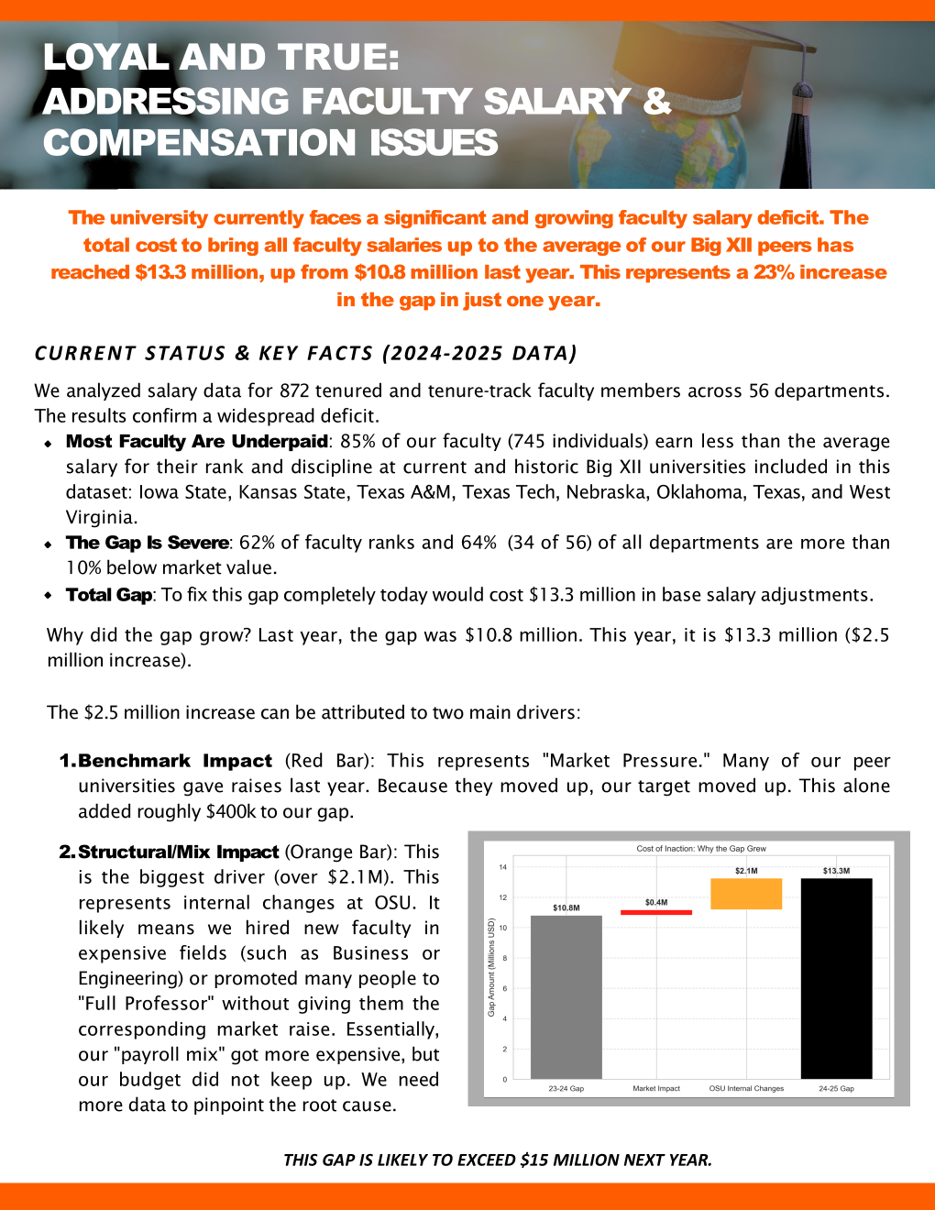

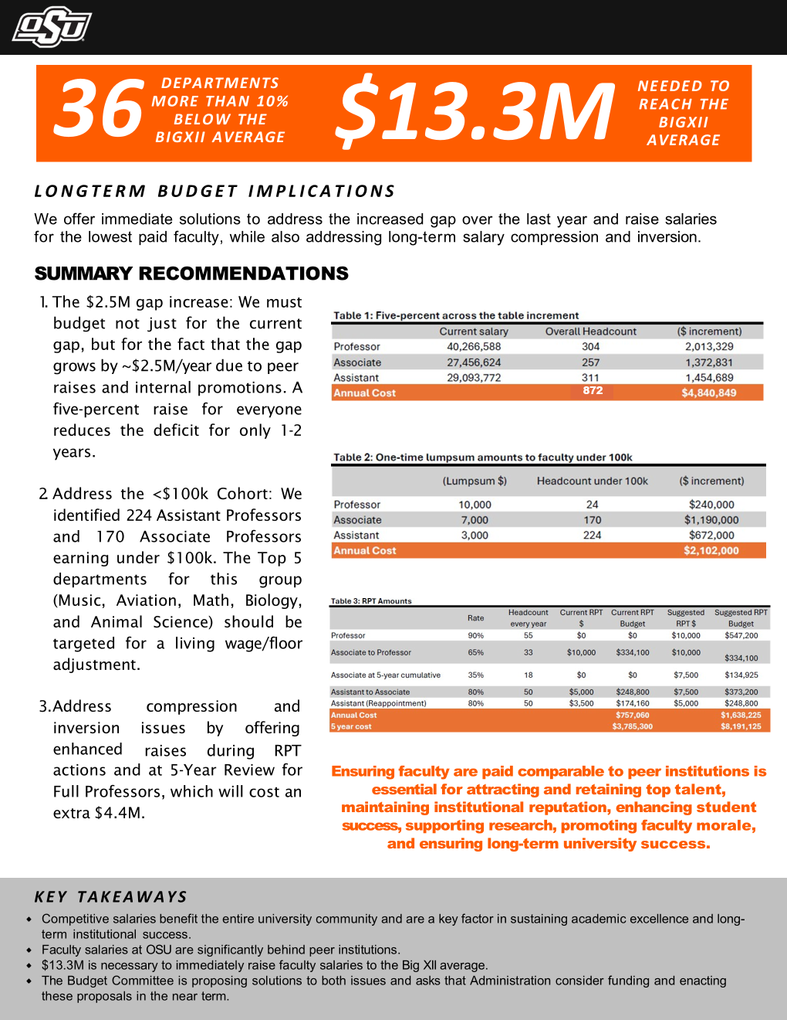
Amended by Passed Failed

Recommendation No. 26-04-01-CarTra 1.________________ ______ _________
Moved by: Career Track Committee 2.________________ ______ _________
Seconded by: 3.________________ ______ _________
Passed Tabled Failed 4.________________ ______ _________

Title: Updated Career-Track Faculty Committee Description

Faculty Council Recommends to President Hess:
The following updates be made to the Career-Track Committee description.

The Career-Track Standing Committee shall consist of three (3) Faculty Council members and six (6) members appointed from the Career-Track General Faculty (as defined by the most recent Career-Track Faculty Position Policy 2-0903), ensuring representation from OSU-Stillwater, OSU-OKC, OSU-IT, and OSU-CHS campuses. Career-Track faculty members from these campuses are encouraged to contact the chair or a representative of Faculty Council’s Career-Track Committee with issues or concerns relevant to members’ Career-Track appointments. As part of its charge, the Career-Track Committee shall consistently report to OSU Faculty Council and the University administration concerning issues raised by committee members, or those raised by Career-Track faculty deemed worthy of investigation by the committee.
Specifically, this committee shall support, review, revise, and/or recommend policies governing Career-Track faculty status, including appointment, reappointment, dismissal, promotion, leaves, summer work, performance standards, employment, working conditions, workloads, research activities, and similar concerns of the members.
In addition, the committee shall be available to consult with and advise the President of the University on matters which require application or interpretation of policies concerning the General Faculty not otherwise provided for within these Bylaws.
Rationale:
The description for the Career-Track committee should be updated as the original description was for the initial three years of the committee’s work. Spring 2026 marks the end of the three years for this initial phase.

Amended by Passed Failed

Recommendation No. 26-04-01-RES 1. _______________ _______ ________
Moved by Research Committee 2. _______________ _______ ________
Seconded by 3. _______________ _______ ________
Passed Tabled Failed 4. _______________ _______ ________

Title: Approval of Updates to Employee Travel Policy (1-0134) __________________

The Faculty Council Recommends to President Hess that:

The updates to policy 1-0134 “Employee Domestic and International Travel” be amended as indicated in the attached documents. The attached documents include the existing policy with tracked changes, a clean version of the existing policy and a clean version of the policy with the proposed changes.

Rationale:

The proposed changes to the “Employee Domestic and International Travel Policy” (1-0134) were provided to the Faculty Council Executive Committee and Faculty Council Research Committee for review by Tammy Eck, Associate Vice President for Administration and Finance. The policy updates are, in part, the product of requests by executive leadership regarding updated wording as it relates to requiring prior approval for international travel on Official University Business.

The Research Committee reviewed the initial proposed changes and provided feedback about some of the proposed changes. The feedback was taken into consideration and all the major concerns raised by the Research Committee were addressed.

Amended by Passed Failed

Recommendation No. 26-04-02-Research 1. _______________ _______ ________
Moved by Research Committee 2. _______________ _______ ________
Seconded by 3. _______________ _______ ________
Passed Tabled Failed 4. _______________ _______ ________

Title: Approval of Updates to Compensation to Human Subjects Policy (4-0401) _____

The Faculty Council Recommends to President Hess that:

The policy 4-0401 (Compensation to Human Subjects) be amended as indicated in the attached documents. The attached documents include the existing policy with tracked changes, a clean version of the existing policy, and a clean version of the policy with the proposed changes.

Rationale:

In July 2025, a memorandum was sent from the OSU Institutional Review Board Office to faculty indicating that University Accounting was working on updating the policy guiding compensation for human research participants. The OSU Faculty Council Research Committee met with Tammy Eck, the Associate Vice President for Administration and Finance, to discuss the rationale and provide input on the proposed changes to the policy. There are two primary motivations for updating this policy from the Accounting Office: 1. To allow greater flexibility with gift card purchasing that brings OSU in line with other peer institutions; 2. Reduce the potential for mistakes and abuse/misuse of cash payments.

The proposed changes significantly change the rules guiding compensation to human subjects. The primary change is a shift from primarily cash payments to primarily gift card payments. As a part of this shift, there will be much increased flexibility for the purchasing and disbursements of gift cards with the OK Corral system. The purchase of gift cards for specific retailers as well as general VISA gift cards will be available. These will be available for purchase in bulk as well.

The Research Committee voiced concerns about the complete exclusion of cash payments and successfully maintained an option for cash payments in limited circumstances (such as research involving vulnerable communities where gift cards/checks may not be appropriate). The norm will shift to gift cards, but this concession is important for many researchers at OSU.

Support documents are attached separately.

