Perkins called the meeting to order with the following members present: Beckmann, Bennett, Charter, Crick, Daglaris, Du, Emerson, Fathepure, Fitzgerald, Glenn, Haley, Harp, Hildebrand, Joshi, Manning-Ouellette, Joyce, Lutter, McGlynn, Olsen, Parkison, Riley, Shear, Slevitch, Weiser, Xie and Yates.
Also present: Colquhoun, C., Cro, M., Francisco, C., Fuxa, R., Hess, J., Hiltz, S., Hoff, W., Hopper, J., Horton, M., Lacombe, V., Latham, L., Maynard, R., Marsh, B., Mendez, J., Morgan, M., Nickles, G., Peaster, R., Pederson, J., Sanborn, H., Sewell, K., Taylor, B., Trainor, S. and Whitham, M.
Absent: Boileau, Eisenberg and Pranger.

HIGHLIGHTS

President’s Report and Comments on matters of interest to the faculty – President Hess………
Special Report:
Dr. Brent Marsh, VP Student Affairs and Dr. Melanie Morgan, Graduate College Dean – Preparation for updating the Strategic Plan………………………………………………...……
Provost’s report on Recommendations made by the Faculty Council and Comments on matters of interest to the Faculty – Chris Francisco for Provost Mendez…………………………………
Vice-Presidents’ Reports and Comments on matters of interest to the faculty…………………...
Faculty Council Chair’s Report……………………………………………………………………
Reports of Liaison Representatives
Emeriti…………………………………………………………………………………….
Staff Advisory Council……………………………………………………………………
Graduate Council.…………………………………………………………………………
Student Government Association…………………………………………………………
Graduate and Professional Student Government Association…………………………….
CAS Faculty Council ……………………………………………………………………..
Reports of Standing and Special Committees
Academic Standards and Policies ……………………………………….………………...
Access and Community Impact ……………………………………………………………
Athletic, Health and Wellness ………..………………………………….………………..
Budget …………………………………………………………………….…………….....
Campus Facilities, Safety and Security ………………………………….……………...…
Career Track…………..………………………………………………….………………..
Faculty ………………………………………………………………….…………………
Long-Range Planning and Information Technology ………………….……………...……
Research ……………………………………………………………….………………...…
Retirement and Fringe Benefits ……………………………………….……………...……
Rules and Procedures ………………………………………………….……………...……
Student Affairs and Learning Resources …………………………….…………………....
Special Committee on Faculty Governance……………………………………………….

Perkins welcomed everyone back for the first the Faculty Council meeting of 2026. Perkins established that a quorum was present and brought the meeting to order. Perkins asked those present to sign the attendance sheet. Perkins asked everyone on Zoom to please put their name in the chat so their attendance can be recorded. Perkins asked anyone who has a question to raise their hand or type their question in the chat, and to direct questions to Yates who is watching the chat. She will then communicate the questions to the group. Perkins reminded everyone to please set their microphones to mute. Perkins stated the first item of business was the approval of the December 9, 2025 minutes. These were electronically distributed and are available on the Faculty Council website. Perkins asked for corrections or objections to the approval of the minutes. Seeing none, stated the minutes are approved. Perkins stated the second item of business is adoption of the agenda which was also electronically distributed and is also available on the Faculty Council website. Perkins asked if there were any corrections to the agenda. Seeing none, Perkins asked for a vote to adopt the agenda. Du moved and Riley seconded the motion. Perkins asked those in favor to say “Aye”, those on zoom to enter their vote in the chat. Those opposed do the same. Motion passed and the agenda was adopted.
Perkins stated that today we are shifting things around a little bit. The President’s report is going to be next. We moved it up to precede the special report. Our special report today is going to consist of Dr. Brent Marsh, the Vice President of Student Affairs, and Dr. Melanie Morgan, the Dean of the Graduate College, who are going to discuss the initiation of the planning for this Strategic Plan. Perkins thought it would be good for President Hess to give us his take on the beginnings of why we need a new Strategic Plan and what the opportunities are. Once President Hess is done, we'll go to the special report. So, we're front-loading President Hess in this regard. Perkins stated, President Hess, the floor is yours, sir.

President’s report and comments on matters of interest to the faculty - President Hess:

President Hess stated thank you, Mr. Chairman. I greatly appreciate the opportunity to talk about our Strategic Plan in global terms for a moment and then, Doctors Morgan and Marsh will
get into some details. President Hess wanted to talk philosophically for a minute about the Strategic Plan.
Hess stated we have a Strategic Plan that we've been operating under at this institution for the last few years, but we have the opportunity now to reimagine and revision what we want Oklahoma State University to look like 5 or 7 or so years from now. President Hess stated I want to be very frank about something. There are really only two ways to develop a Strategic Plan. One is from the top down. And the other is from the bottom up. And there's nowhere in between.
President Hess stated, I'm fully committed to you all to make sure that our Strategic Plan is from the bottom up, that it's inclusive, and that we are getting as many ideas and concepts about what our vision is for this beloved university over the next few years. President Hess stated, I have had conversations with many of you, collectively and individually, and I heard you loud and clear. Some of you may not have been particularly pleased with the process of our last Strategic Plan. Thus, I'm fully committed to making sure that we do this collaboratively. We cannot say that we have shared governance if we're not inclusive. Drs. Morgan and Marsh will talk about our processes and then open the floor for questions. President Hess stated I wanted to say to you unequivocally, categorically, unilaterally that this will be an inclusive process.
President Hess stated there have been comments about how long it should take to develop strategically. Lots of times, institutions will embark upon a very long and lengthy process to describe what the vision of the university should be. President Hess stated this is my personal feeling, and not anyone else's. If we can't describe what we want for this university in 4 months, if we had 40 years, we couldn't do it. Because so many of you are engaged every day in activity, research, instruction, all of the things that make up our land grant mission. President Hess stated I think you're in the perfect position, as your colleagues are, in departments across this university to help us describe what it is that we want to be in the future. Having said this, Mr. Chairman, I won't belabor it, but I just wanted to commend to you all about a collaborative, open, and inclusive process. Because that's how we're going to get our best ideas. Our best initiatives. Our best vision.
Perkins thanked President Hess and stated this puts the onus and burden on us to listen carefully, to do our work so when the strategic plan comes out, we have given input. It's a two-way street. If it's asked for, we should provide it. Perkins stated this is one of the reasons I suggested to Dr. Marsh and Dr. Morgan that they come here as a starting point, and then we get the word out. This is underway and pay attention to the process as it goes along. Perkins stated we're pleased to welcome Dr. Brent Marsh, Vice President for Student Affairs, and Dr. Melanie Morgan, Dean of the Graduate College.

Special Reports:

- Dr. Brent Marsh, VP Student Affairs and Dr. Melanie Morgan, Graduate College Dean – Preparation for updating the Strategic Plan

Dr. Morgan thanked everyone for the opportunity to speak today and give an update on where we are, where we are going and what the process is. Also to give everyone a chance to ask questions. Dr. Marsh echoed the opportunity to speak today and touch on some of the points that President Hess mentioned. Drs. Morgan and Marsh presented the following PowerPoint to the Council members:

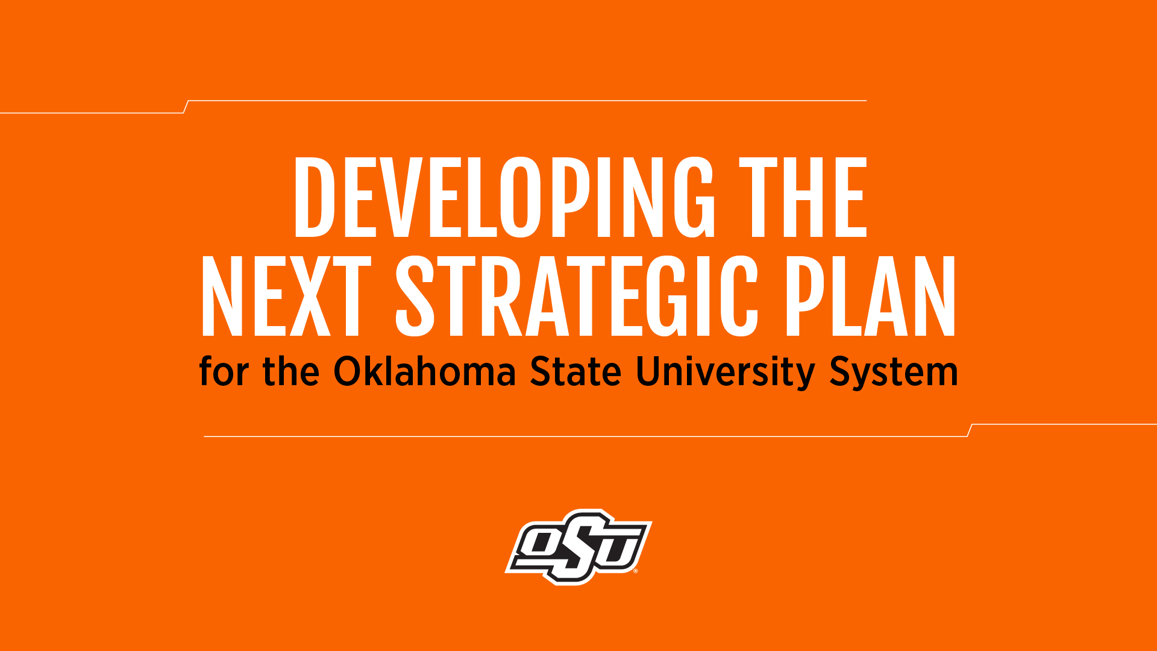
Dr. Marsh stated they envision a process that will involve a lot of stakeholder engagement. Dr. Marsh stated you are going to hear a little bit more about this as we lay out some steps, and you will hear about the steering committee and the working groups that we're going to be forming. We want to have a lot of engagement in this process, but certainly this plan, as the President has just mentioned, will help set our direction for the coming few years. We want it to be certainly exciting and ambitious, and something that hopefully everyone can find their place. Where their work helps support that plan. It can be very exciting and energizing, in that regard.
Dr. Morgan stated I think one of the things that President Hess emphasized to us is that this plan be something that would be very quantifiable, very measurable as we go along the way. Dr. Morgan stated this is really important to me, if you get engaged in one of these working groups really thinking about what does that mean? How do we enact this? And as a person that studies this, how do I get involved? Dr. Morgan stated I think that's the hardest piece for faculty is to see where their role overlaps. Dr. Morgan stated we are going to give you a lot of opportunities to engage in dialogue with them to help make those things happen.
Dr. Marsh stated I think one more thing that's worth mentioning is that President Hess has his bosses, our Board of Regents. They have certain priorities and things that are top of mind for them as they think about the future of Oklahoma State University. Dr. Marsh stated it would do us well to pay attention to those ideas, and through President Hess, we'll keep them informed along the way.
Dr. Marsh stated we know there are some broad categories that we need to pay a lot of attention to. We hear about the student experience a lot, and we want to really invest in how we can give our students the very best experience possible. The Strategic Plan will include elements focused on the student experience. We're a land-grant university, so of course, areas like research and extension will find a prominent place within the Strategic Plan. We understand there are some basic components that will already be in place that we'll be looking for as we think about the formation and development of our Strategic Plan.
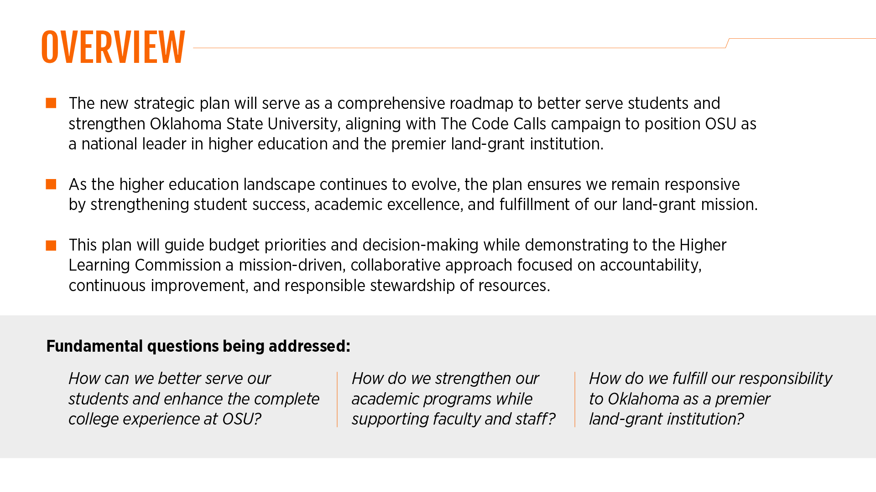
Dr. Marsh wanted to say a few things about the timeline. Dr. Marsh stated that President Hess said about 4 months. This wasn't just a made-up number. We are on an ambitious timeline to really develop the next Strategic Plan over just the next few months. Dr. Marsh wanted to begin with the end. Number 5 on the slide below is review and governance approval. Our hope is that, and really what we've committed to, is to have a plan ready for the President Hess to present to the Board of Regents at their June meeting.
We'll just work backwards from there.
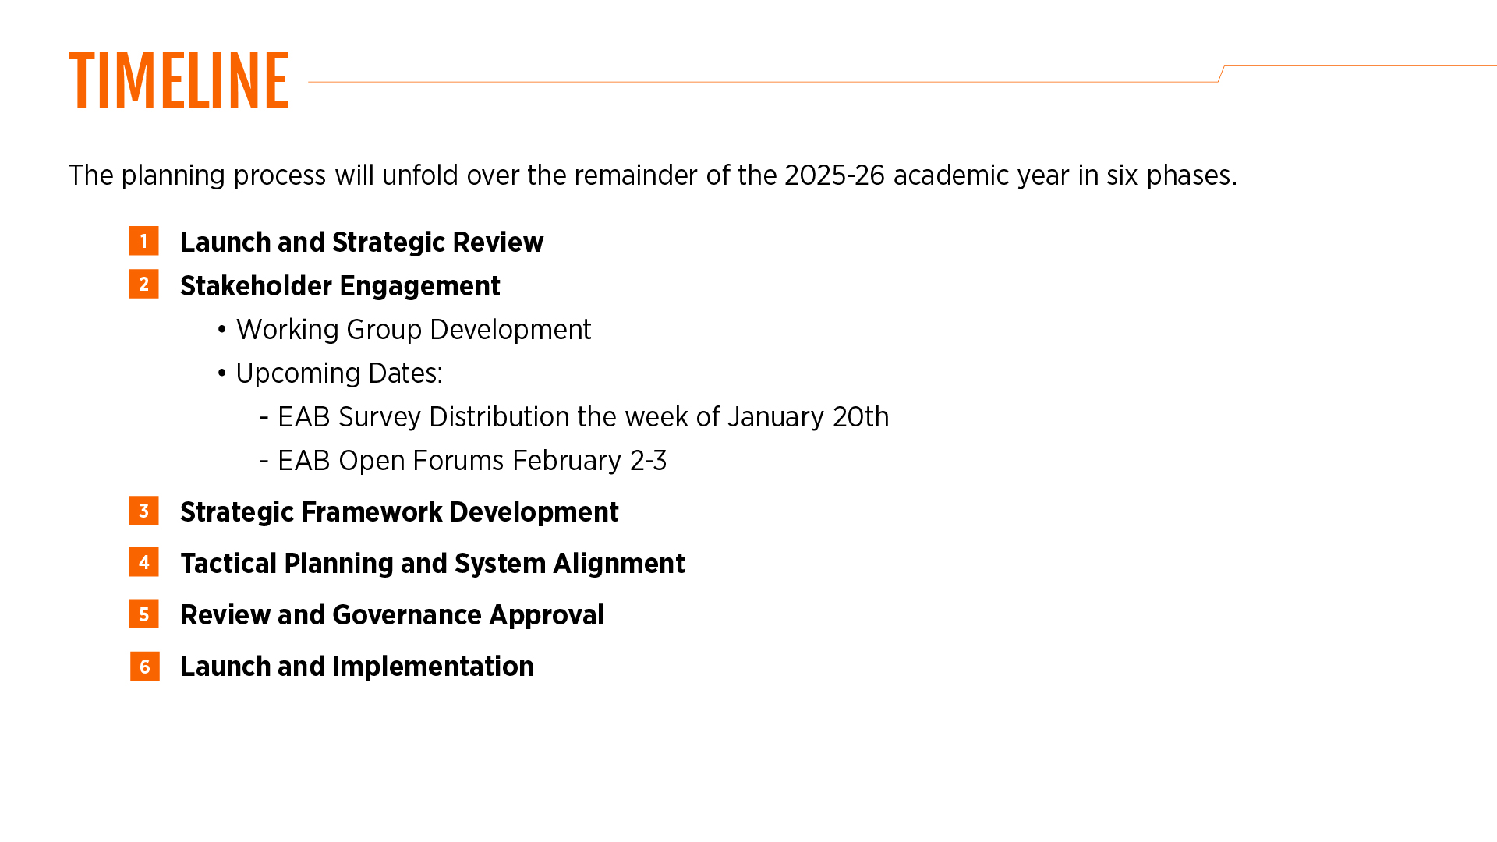
Dr. Marsh stated our steering committee has been formed. Everyone should have received an email about that in mid-December from President Hess announcing the launch of this process and introduction of the steering committee. Dr. Marsh stated the steering committee has already met two times and will meet again this Friday. We are working quickly. We already have our entire set of dates as a steering committee set for the entire spring semester.
Dr. Marsh stated in the coming weeks and coming days, you're going to be receiving emails and invitations to engage more in this process, to react to some initial ideas, and that will help our working groups that you'll hear more about shortly have something that they can begin to react to and wrestle with and think through. Marsh stated the steering committee is meeting again this Friday. We are going to be discussing the formation of different working groups, probably 7 or 8, that will tackle some of the main areas spoken about a moment ago: the student experience, research, extension, and more. Dr. Marsh stated we will have co-chairs from our steering committee. I don't want to get ahead of myself, because you're going to talk more about the steering committee shortly, but those folks will be our liaisons. They'll help coordinate the work of these working groups.

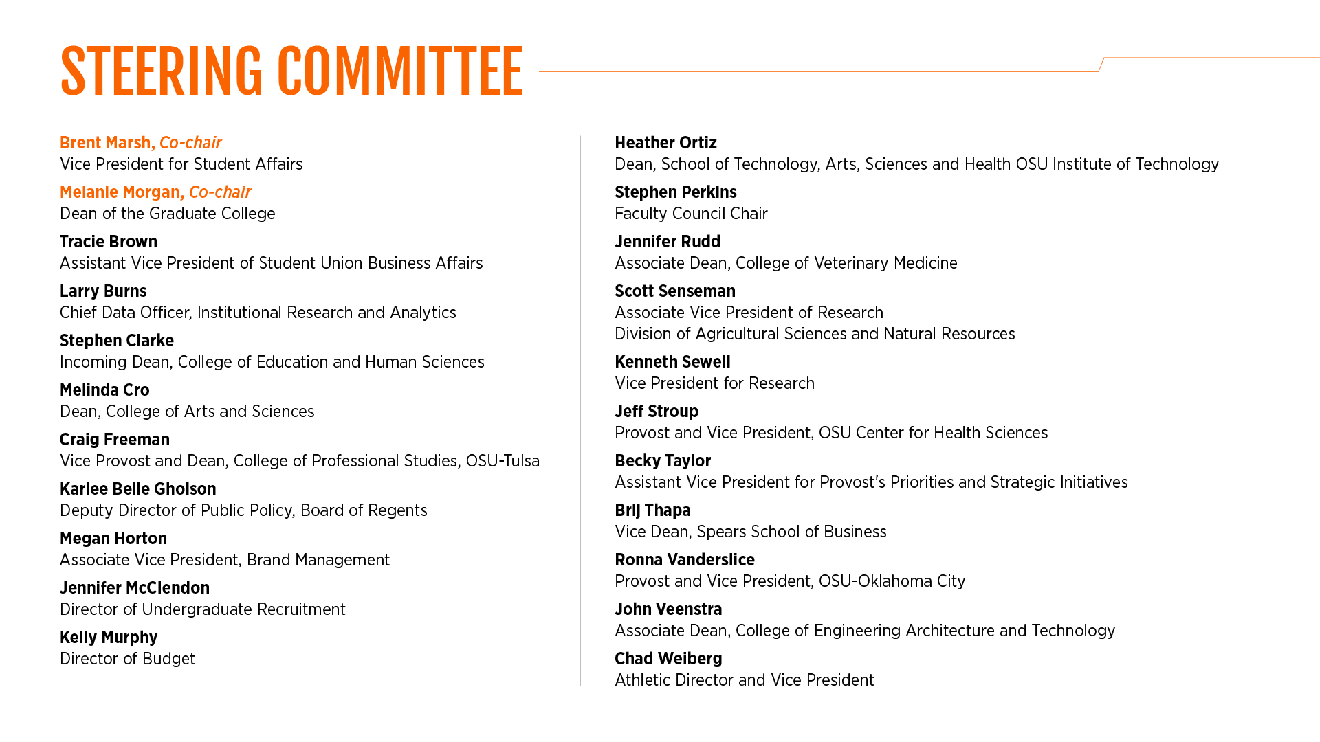
The working groups. Dr. Marsh stated they want to populate the working groups with experts from all across campus who have content knowledge, expertise, maybe research background, etc., that can really help us form possible strategies.
Dr. Marsh stated other ways they want people to be involved and asked to sit on a working group is by virtue of their role and expertise.
Dr. Marsh stated a survey that will go out, next week sometime for students, faculty, and staff. This will be an important source of data and feedback. Dr. Marsh stated there will be some open forums on February 2nd and 3rd. Stay tuned for those. There will be two for faculty and two for staff. Each will have an opportunity for folks to join remotely.
Dr. Marsh stated we are partnering with and receiving support from EAB. They have been great partners so far and will continue to help us as we work through this process. They will come, for instance, to facilitate the forums.
Dr. Marsh stated the working groups will then begin in earnest, meeting in February, probably weekly. Don't let that scare you off if you get invited, but we're going to rip the band-aid off. We're going to do this in a few weeks. The working groups are going to meet a lot, reviewing the data from the survey, the input from the forums, and other sources of data. The steering committee will also continue to meet. They will be hearing back from the working groups, understanding how they're doing, making sure that they provide them with the resources that they need to be effective and successful as they meet. We will see how that strategic framework begins to take shape, what we see bubbling up and how this plan will come together.
Dr. Marsh stated by mid-April, they hope to bring the work that the working groups have been doing together as a steering committee. Then we can begin to organize, summarize and synthesize it. Dr. Marsh feels there will be a ton of great ideas. A lot of important ideas will surface from these working groups. Dr. Marsh stated we will have to then become realistic about what is attainable and achievable. There will be resource considerations as we move this plan forward.
Dr. Marsh said President Hess will have opportunities along the way to keep the Board of Regents aware of the progress so as the plan is written and pulled together for that June meeting, that won't be their first time to hear about it. It won't be a surprise for them. Dr. Marsh stated ideally, the Board of Regents will adopt that Strategic Plan at their June meeting. The work will then begin with our brand management colleagues and others preparing for a campus-wide launch once faculty and students are back in August and have an exciting time to launch the new
Strategic Plan. Dr. Morgan stated we will have a website that brand management will run for us that will continuously update the community on where we are in the process, what's happening, and what's coming next. Dr. Morgan stated we will also have an email account that anyone can use. It's not up and ready today, but it should be probably by tomorrow. If anyone has an idea and would like to submit that anonymously, or saw something interesting that you wanted to add, you could do that as another way of being involved.
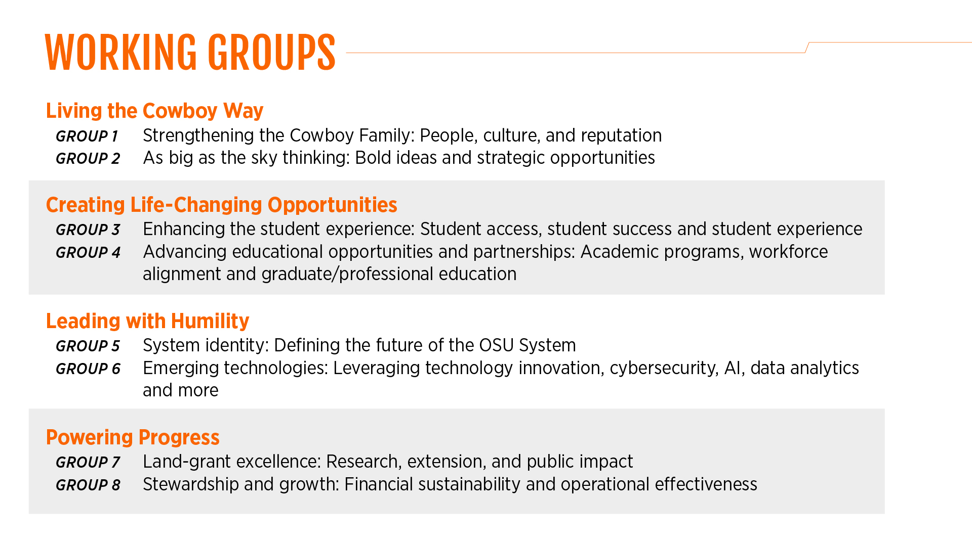
Next up is the steering committee. Dr. Morgan stated the steering committee is quite large, as you can see. We really wanted to try to get as many people as possible across a variety of different positions, from staff and faculty and different experts, so that everybody was at the table. Dr. Morgan thinks we have a great group of people and faculty, and our conversations so far have been very animated, people have been very passionate. Dr. Morgan stated these folks will help us solidify those working groups, which we hope comes to fruition on Friday. Dr. Morgan stated on the working groups, we may have 7 key areas identified so we could have 7 working groups. We could have 10 working groups. Some areas may decide to break down into more working groups than just one. Those working groups may decide to do some things like collect some extra data, do some more focus groups, so we're not locked in and just constrained by the data we collect in the next week or two. The committees will continue to solicit input as we move along with this process. Dr. Marsh stated that Samuel from SGA is here and certainly there are some of these working groups we want to have student involvement. As well as graduate students. Dr. Marsh stated the students will receive the survey as well.
The floor was open for questions.
Haley asked if the steering committee would identify/solicit people for the working groups or look at people that they know or they think will do a good job. Dr. Morgan believes there will be a variety of different people, asking for some volunteers, and then thinking about content experts in a particular area. If Dr. Sewell was drafted to run the research group, Dr. Morgan stated he has a good sense of who has large grants, whose voice would need to be heard at the table, who was at different stages of their career that would be important to be at that table, that type of thing. Haley stated if the committees were formed, but then the Faculty Council felt like there was something that wasn't represented, would there be input from faculty? Dr. Morgan stated they are lucky that Dr. Perkins has agreed to serve, and so he will be your conduit back and forth on that committee. Perkins stated that he is hoping we will have a lot of faculty involvement in the working group. Dr. Marsh stated the benefit of this Friday’s meeting, our plan is for the steering committee, some who have been here longer than both Dr. Morgan and Dr. Marsh, is they will know a lot of people across campus that will fit into the working groups. Example, so when we start thinking about technology and emerging technologies, and AI, if that becomes a working group, let's say, then we want to know who our experts across campus in data security or artificial intelligence are, and so at least as we're brainstorming. We're going to whiteboard the lists of potential candidates, but there may still be space and an opportunity for us to round out those working groups with maybe other names that we just hadn't thought of.
expeditiously.
Hildebrand stated as I looked at the list of steering committee members, she didn't see anyone, with an extension appointment. Who do you anticipate bringing that voice to the committee? Dr. Morgan stated that Scott Senseman is our extension expert in Ag and who is representing that area. Dr. Morgan stated the names of people that are extension have been batted around to serve on that subcommittee, like Gina Peek, for example, and people like her.
Manning-Ouellette stated this might be a President Hess question. She has seen a lot of different strategic plans at different universities. Some span 5 years; some span 10 years. Is this a strategic plan that has a timeframe? Is it something we reevaluate? How do you envision that in this process? President Hess stated I think anything beyond 5 years would be irrelevant just because of market and technology changes. President Hess stated higher ed seems to be changing a lot and thinks an outward view longer than 5 years would probably not be a relevant exercise. President Hess stated our viewpoint is to try to keep it within a 60-month window, because if we're going to have measurable objectives and initiatives, then getting beyond that is pretty, hard to accomplish and predict. We would like to keep it to no more than 5 years, if we could. Manning-Ouelette stated that was my next question. The previous Strategic Plan had objectives. Are we measuring towards those objectives? Sometimes it's just here are our priorities, but there's not a follow-up to that, so are we executing what the measurables are going to be? President Hess stated one of the criticisms if we're going to call it that, or observations that he has received, from some in this room and others, was the previous plan did not have a lot of measurability to it to determine if we got there or not. President Hess stated because this has resource allocation consequences and implications, we really need to have performance measures, so that we can also brag on ourselves and celebrate the things that we accomplished. If it's not measurable, it's hard to hang your hat on it or determine whether you really got there or not. So, to your point, it has to be measurable. Manning-Ouellette asked how does the HLC visit inform or not inform our Strategic Plan. President Hess stated our HLC visit will be largely based on our existing Strategic Plan. There are some expected aspects of HLC, but in large measure, it's somewhat retrospective. Since the last accreditation visit President Hess believes the fact that we're engaging this will be positively received by our peer reviewers. They will see that we have embarked on something for the future. To your point, specifically, our HLC will be based on the existing Strategic Plan.
Slevitch asked, as we embark on the journey of development of the Strategic Plan, what constraints should we be aware of? What are the sources of feedback and engagement in this process. Dr. Marsh stated he would encourage folks to enter the forum and other opportunities to engage. Dr. Marsh quoted the Cowboy Code: “We dream as big as the sky”. Dr. Marsh believes we will be open to those big, bold and exciting ideas. He does not want people to be constrained. He believes this will be one of the challenges as we move forward. Dr. Marsh stated how many of these great ideas can we execute within a 5-year window and what resources might or might not be available to try to advance some of those goals. Dr. Marsh stated we want to hear a lot of ideas, so he does not want people to hold back that phase. Dr. Morgan stated be as creative as you can. We are framing this whole process as "The Code calls" within the materials so it goes hand-in-hand with our campaign. Slevitch asked in addition to the open email or comment box that's going to be on the website, will there be other engagement opportunities? Dr. Marsh stated one thing we also hope to do later, as we begin to bring all these ideas together, some framing has taken place, we want to have some opportunities for people to react as the plan is in development. Dr. Marsh thinks that by later in April, we would have an opportunity in some form or fashion for our colleagues across campus to review and react to what's coming together. Slevitch stated just one concern, I looked at the steering committee list and its primarily administrators. Slevitch feels a representative of Staff Council might be a good addition. Dr. Marsh stated we will certainly round out a lot of the working groups and will no doubt find a place for some staff member engagement across the board. Dr Marsh stated they have talked about doing a presentation like this to Staff Advisory Council as well.
Fathepure asked about including Global Studies. Dr. Randy Glover brings a totally different angle to this. Dr. Morgan stated certainly. He could go almost under any topic. We haven't forgotten about it.
Du stated since I'm on the budget committee, I have a question about the budget. He’s pretty sure the steering committee and the working groups will come up with a great strategic plan, but it requires very careful budgeting to execute this plan. Du stated we are creating this new budget model. His question is what's the implication of the new budget model and/or maybe vice versa, what's the implication of this new plan for our budgeting process? Are these two processes happening at the same time? President Hess indicated at our last meeting that they were slowing down our budget model proposals. Because the strategic initiatives and our vision will have financial implications, 2e didn't want to adopt a new budget model first, and then say, oh, by the way, now we're going to do some strategic visioning about where the institution should go. We really need to have our vision first. President Hess thinks it’s fair to have the vision first because it has resource allocation implications. President Hess stated the idea of slowing down our budget model was really a primary factor was engaging in the strategic planning process first, so that the budget model would be related to that strategic vision, as opposed to it being first, and the strategic vision being an afterthought.
Weiser stated this is related to what Slevitch earlier. He has heard a couple times about bottom-up in the plan, and he believes that was the complaint about the previous one, undoubtedly. Weiser asked how will you achieve a perception of bottom-up when the steering committee that's driving it is all up and no bottom. Weiser stated there are no lower-level representatives. Weiser stated presumably you'll be doing surveys and those sorts of things, but they'll be more anonymous. The results of those will be culled by the top and no one at the bottom. It will be very difficult with this steering committee to end up with a perception of bottom-up, even if it's the reality. Dr. Marsh stated that it is a keen observation. He does think one of the things, and we probably need to double down on this with our steering committee, is to remind them that part of the role of representing is to be that liaison, back and forth. Dr. Marsh said for instance, take one of the academic colleges, we have Dean Cro, from Arts and Sciences. Dr. Marsh stated one advantage is that where Dean Cro sits, she'll have a good understanding of the entire breadth of the College of Arts and Sciences, and hopefully a good pulse on what's happening within the different departments. But if we were to take a faculty member, maybe one, they’d have a very strong sense of what's happening within their department. Total conjecture on my part, but maybe not have the total visibility into the totality of what's happening within the entire college. Dr. Marsh stated there's probably trade-offs to be had, but you have a great point. President Hess stated the other thing that, in these working groups, that's where most of the work is going to happen. No offense to the steering committee in any way. President Hess is not in any way belittling the steering committees’ contributions, but the majority of the work is going to be done at the working group level. The way it's designed is to make sure that that is a bottom-up approach, to say if most of the work and the input and gathering this information for expertise across campus really needs to occur at the working group level. The majority of the work is going to be done in these 7 or 8 or 10, whatever the number ends up being, because it will change as we design the working groups. But the intent of it was to make sure that the bottom-up approach is to make sure that the steering committee is not going to sit in a room and decide this is the vision for the institution. It's going to be largely happening in the working groups. Weiser stated they will, though, ultimately be sort of the filter. We've all been on committees that the majority ideas get filtered out at higher levels. Then the reference is, after extensive meetings by the committee, here's the result, even though that's not where the committee was! Weiser stated he is not distrusting the process, he is talking about perception here. If the higher-level filtering doesn't include some bottom, there will not be a perception of bottom-up. Just an observation. Dr. Marsh said as we get later in the process, part of the work of the steering committee is going to be qualitative research. The thematization and trying to bring some meaning and organization to all the ideas that are coming up. This is a great observation. Dr. Marsh said perhaps the moment that people will see the beginnings of the strategic plan as it's coming together, and to have a chance to react to it. Hopefully that will help reinforce that we really do want folks' input, not just at the very beginning on a survey, but as it's taking shape.
Yates stated I have a personal comment, and then I have a comment from the Zoom. I think what Weiser brings up is the biggest challenge, but also the biggest opportunity. Everyone in this room has been on committees at Oklahoma State University where there is a predetermined outcome. Yates thinks the biggest opportunity that we have in front of us is to get people to buy in and understand that there is not a predetermined outcome and this is true. Because everyone is expecting, based on previous experiences, that the outcome is already formed. Dr. Morgan asked if Yates had any suggestions on ways to approach this. Yates said trying to be open with some of the meeting minutes, or open with some of the outcomes from the working groups, even if they are not selected. Every idea isn't a great idea. Every idea is not appropriate. But to acknowledge that there were ideas that weren't selected, Yates thinks that's fair. President Hess stated he does not think any of us are going to have any problem when we set up this website on our intranet for the survey results, meeting minutes, all of that, particularly the survey results, would be meaningful. President Hess said the whole idea of the website was to create this openness and transparency about all of the input that's coming in. President Hess stated he is really, really sensitive to the notion of predetermined outcomes, and he thinks the website is the initial answer. And then, from a faculty point of view, Dr. Perkins will be sitting in the room. Dr. Marsh wants to tag one more thing onto that idea, because you made me think of something that we wanted to share. There will be not only the opportunity, but really the challenge, once we finish the plan and launch it, then for OSU-IT, OSU OKC, though they're represented here, because we need them to be represented, they also, for their own accreditation purposes, must have their own strategic plan. The colleges, the divisions will have their own chances, as it makes sense in the cadence of the work, to begin to develop their own strategic plan. It's perfect timing for Student Affairs, because our last strategic plan as a division wrapped up in 2025. We're ready and excited to begin our own strategic planning process that will sort of hitch our wagon to the broader university Strategic Plan. The other thing about putting all the ideas out there, even if some of them maybe don't make it into the final plan, there might be an entity or a unit that's like, we could execute on that, and that might find its way into our strategic plan. Yates stated the Zoom comment, and she thinks it was addressed, but wanted to directly address it, since it came in on Zoom. Several committees gathered information during the development of the last strategic plan and were wondering whether this information would be shared and utilized. Yates stated the “We Are Land Grant” plan is essentially what this is referring to. Yates asked if any of that information from the “We Are Land Grant” be made available to the steering committee and working groups. President Hess stated there's no reason for it not to be. Dr. Marsh stated there may be very valid ideas within that. Dr. Morgan stated there is a desire to review any documentation, anything that exists with past plans, to provide context for the new plan. Manning-Ouellette wanted to add to an earlier comment is you have to have students, and you mentioned that earlier, but there has to be student input. Otherwise, what are we doing? Because this is an institution where students go. I think holding that and centering that is really important in the undergrad and grad level. President Hess said they will be on the working groups.
Riley stated this is piggybacking off of what Weiser and Deanna brought up: not having an extension appointment on the steering committee is disingenuous. Riley believes this is missing in the steering committee. Riley believes there's going to be plenty of stakeholders that will agree with this. President Hess said he suspects that we are going to have a whole working group on extension. Weiser stated the issue is the word. It is steering. They're going to steer it, right? And it's all top and no bottom. This is why Riley said piggybacking on Mark, the perception. Riley feels the perception outside looking in is going to be there's no representation of extension on this steering committee. President Hess stated perhaps the word steering should be changed. It's really more facilitation and coordination, but I understand. Weiser stated his comment was purely one of perception, not reality. Weiser said we will see reality in a year. Dr. Marsh said it's funny, in fact, we had our initial meeting with our EAB consultants, and we told them about our timeline, and once they brought their jaws back up, they suggested maybe 12 to 16 members, and so we came back with 21. We want as broad-based participation as possible, but recognizing the larger the group, the more challenging it will be to be nimble and to meet on the interval we're going to need to meet. Dr. Marsh stated that at some point, we had to just stop adding people, but we wanted as many as we absolutely could to represent all the different areas of our campus well. Haley said maybe this is the plan, on each of the subcommittees as well as the steering committee, it would be good if you could add someone from Extension and Outreach. Have at least one normal, average, everyday faculty member. But on the individual committees, you should have at least one student and one faculty member of different ranks. Maybe not every single committee but make sure that it’s very heavily loaded with faculty and students. Haley asked how do you make sure everyone hears the messaging. Tell people exactly that you are doing a bottom-up and show them this in all the messaging. Haley thinks this will help a lot.
Hoff stated he was excited about this new strategic plan, and he particularly likes the specific timelines and measurable outcomes. My question is, is the expectation that the lion's share of the work, to plan that all out, collect the data, how do we measure that? What is realistic? Will this fall on the members of the working group committees and is there an estimate for the workload for these members? To get a feeling of how big a project this is. President Hess said we have been necessarily vague about that. Dr. Marsh said the classic undersell when you're asked to volunteer for something, but we think there will probably be weekly meetings for those working groups for about 5 weeks -- early February up till Spring Break. We anticipate these working groups will be meeting probably each week and so making quick work of this. It is a big lift for a short duration of time. Hoff asked if this was enough time. Have you ever made such a plan with measurables and everything? My guess is that's a lot of work. Dr. Morgan said like President Hess said earlier, if we give ourselves 2 years, this process takes 2 years. And the market changes, and educational trends change in that time. If we give ourselves 4 months, we get it done, we buckle down, and we do it. Dr. Morgan stated they had meetings during finals, and honestly, if he had said, you have a year, we wouldn't have met in December, and we would have had our first meeting this week. Dr. Morgan does think it amps up the pressure, and you feel it. You get going. Let's do this thing. President Hess stated his experience in dealing with and serving on working groups or committees for a strategic planning process over the last 45 years was that work expanded to fill the time allotted. I went to lots of meetings and felt like we had the same meeting over and over again. Having had that experience, I came to the conclusion that I would rather just get in there and get it done, qs opposed to being dragged to a monthly meeting over a 12-month period of time that didn't feel relevant. I went to all of them. I was present and accounted for, but I didn't always feel it was a meaningful exercise. I would rather have got the work done so that I can move on to the other things that I had to do. This is really the thought process here. To give it a lot of intensive effort, give us a really good vision then we can start to execute at the beginning of our fiscal year in July.
Xie stated she really likes the idea of this bottom-up. She thinks that it would be more motivating for the majority. She also likes the discussion of how to implement it. Xie asked if it would be possible instead of individual input, which is useful, but also have unit input. Xie said we have department discussions regarding what we want to accomplish in the next 5 years. What are our missions. Then come up with ideas from our department’s point of view. This is what we want or what support we'd like to help university, or college, or interaction with other departments. Each department will work on their plan, and then maybe build on that. Would this be less effort for the coordination or steering committee? President Hess stated we would love for departments to develop their ideas and submit those. The mechanisms that have been developed, the survey, the forums, are all just input mechanisms that we've designed to promote the idea of input. They are not the only items. And so, in your department, for instance, if you all said, this is what/how we see our departmental world that's exactly what we really want to achieve. Where the rubber meets the road level. That's exactly the input and the design of what we're trying to do here. President Hess encourages this. If your department wanted to develop a vision of how you see that, that's exactly what we want. Slevitch wants to piggyback on that. She was thinking about the unit level, systematically way of getting feedback at the unit level, because that's where people gather, we have meetings all the time. If there is a certain area where the steering committee or the working groups raise questions that they are discussing and that is being communicated to the departments, we can provide answers at the department level. What we at the department level think about those. But it has to be addressed as what do you think about this, or how you believe we can improve student experience, or faculty experience, so it has to be some kind of structure. Perkins stated if you look at the committee, all the colleges are represented. The leaders of those colleges would then communicate to the departments what we need or whatever. Dr. Morgan said she does anticipate these working groups doing some focus groups and some data collection. It could be more systematic within programs and things, as you suggest.
Perkins thanked Drs. Morgan and Marsh for taking the time to do this, we really appreciate it.

Provost’s report on recommendations made by the Faculty Council and comments on matters of interest to the faculty – Chris Francisco for Provost Mendez:

Franciso stated that Provost Mendez is on her way to an event out of town, but she welcomes everyone back for the spring semester and is sorry she couldn’t be here today.
Francisco has a couple of quick items he would like to mention. We are closing in on our
mock site visit for HLC, which starts two weeks from tomorrow. We will have several open forums on Wednesday the 28th. The schedule will be announced soon. They're just finalizing a few details with the peer review team. We would welcome your presence at those open forums. Fracisco believes there will be three on Wednesday the 28th, and we'll send out those schedules. We are happy to have you provide your perspective on the University team will help us kind of refine what our argument will be as we prepare for that actual site visit in April.
Francisco stated that an email was sent out right before the break that we're going to be conducting a search for the Dean of the Honors College. We are working on preparations for that right now. Dean Garbutt announced his retirement this summer, and so we're very excited to be able to form a search committee to be able to search for the next Honors Dean. Dean Garbutt has done a remarkable job in his time here. We really appreciate his efforts. Francisco stated that Dean Garbutt and his team have done a lot to modernize that Honors College and bring it in line with the changing students we have. We have students who bring in a lot of concurrent credit these days, come in with a lot of courses that they might not have had 20 years ago, and we had to offer them different sorts of opportunities. Francisco stated we have moved the Honors College forward a lot in recent years, and we'll be excited to put out a search and see who can come in and continue to move us forward.
Francisco stated that he has been working closely with Dr. Haley and Dr. Glenn on the RPT document. We've talked about that for the last couple of years, and I think we're nearing completion at this point. Francisco is waiting for some additional feedback from those groups and ironing out just a couple more issues at the end. Francisco thinks we are close to consensus on those. The main highlights of the revisions that we are going to put forth for you to look at and give us some comments on are revising the descriptions of the career track ranks. That's something we've wanted to do for quite some time. The current document really is written for tenure track ranks and not career track ranks. We want to make sure that the positions that our career track faculty have are well described and that our expectations are well described. Francisco stated that Faculty Council and folks in administration have done a lot over the last several years to try to make sure that career track faculty truly are included as part of the faculty. Francisco believes this is a necessary step that we take as well to make sure that they are addressed specifically in that document and really described as they should be. We are also working a little bit on the structure of the reappointment process for career track faculty. Trying to make sure that we can balance minimizing faculty time and effort of bureaucratic sorts of things and still protecting institutional interests and making sure that we have a rigorous process. Francisco had good discussions with the Career Track Faculty Committee in December. Francisco stated we are working a on timeline as well. Francisco stated the closest thing to a unanimous request I ever got from a group of department heads was to try to give more flexibility to units and colleges in the timeline for the RPT process. A lot of department heads and personnel committees are struggling to get external letters from experts in the field, because we start a little bit later than a lot of folks do. Requests from Big Ten schools, SEC schools, other places that are starting that process in June and asking for letters. If you ask someone who's well-known in the field and well-respected, they may have already agreed to write 3 or 4 letters by the time you come to them in September. Francisco stated that we have tried to do in the draft document is give a little more flexibility to units and to colleges to move that timeline back if they would like. They don't have to do it if they don't want to, but if they're struggling getting those letters from external experts, that'll give a little bit more flexibility to start earlier in the process.
Perkins opened the floor for questions. Slevitch asked are they expecting some changes in terms of contract renewal for entity faculty? Yes, this is what he was saying about changing/looking at the structure and the reappointment. Francisco stated we are still talking about some of the details. What we are aiming for is a process that reduces the amount of time and effort that the career track faculty and the faculty evaluating those dossiers have to do when they're having to do those reappointments every several years. Looking for a structure that will minimize that effort, but also still protect institutional interests and make sure we are doing a rigorous evaluation of folks when we're supposed to. Balancing those two interests. We have had good conversations with both faculty committee and career track faculty committee on that.

Vice Presidents’ Reports and Comments on matters of interest to the faculty: None

Faculty Council Chair’s Report:

Perkins stated for the Chairs report, he was yielding his time to Dr. Robin Fuxa who is the new director of OSU’s Osher Lifelong Learning Institute (OLLI).
Dr. Fuxa thanked Perkins for the opportunity to speak today. She stated that OLLI has an
endowment from the Bernard Osher Foundation that helps them offer all kinds of classes to folks who are 50+ which is their focus population. She stated if you have any class ideas please send them her way. Fuxa stated that one of the things she loves about her job, as a former faculty member, is finding out what you are most excited about in your research or your teaching and bringing it to us.
Faux stated they are developing a faculty fellows’ program. Faux stated one of the demands of our council is trying to engage faculty better, but we know your lives are very, very busy. Having been a faculty member for about 15 years myself, I understand this. Faux talked with Dean Garbutt early in this role and asked how do you structure your stipend? We talked about this and now we're piloting in the fall a stipend for faculty. Because teaching with OSHER, you don't have grading and everybody wants to be there. Fuxa stated our classes vary in length. We have an awesome group of students. They ask the best questions, lots of emeriti faculty. Once you're with us, you're going to be hooked. That was my experience. I taught in 2023 at Town Hall. It was an incredible conversation. Fuxa stated Dr. Sewell will be with us at our last town hall this year, talking about research at the institution, and we're looking forward to that.
Fuxa asked everyone to think about reaching out to teach with us at OLLI. We're going to do $1,000 for an 8-week class, 2 hours a week or $500 for a four-week class. I will be very open, the four-week class is far more attractive to us, because it's difficult for our membership to commit to anything longer than that. They're traveling, they're doing retired life, but you do not have to be retired to be part of OLLI, you do not have to be 50. Come take classes, too. It is incredibly joyful. Fuxa stated the stipend is available to folks who want to offer those more long-term courses, 4 weeks or 8 weeks. We'll do up to 10 of those in the fall for 8 weeks. We can do more if we have the shorter course offerings. Fuxa stated the application form to teach is super, super simple. Just tell us what you want to do, we are more flexible than our form. Fuxa said to shoot her an email if you just want to do a one-shot sometime. If that doesn't align with our town hall schedule, we will plug you in somewhere. We would love to have you but also just spread the word about us.
Fuxa stated we are rebuilding post-COVID. I'm a high-energy person. I'm super excited to spread the word about OLLI, but I need your help. Think about family and friends. Our membership is incredibly inexpensive, thanks to our donor funding. It's $200 for a premium membership for the entire year. Folks can register for any classes, unlimited, at no additional charge. There is a $40 fee for an a la carte where they pay $25 per class, just about, give or take. It is incredibly inexpensive, and then we offer a public servant discount. That's new as part of our 20th anniversary celebration this year. Think about that for family and friends, teachers, first responders, PK-12 teachers, military personnel, or folks retired from any of those fields get a full 50% standing discount. OSU retirees, when they leave the institution, get a 50% discount off premium their first year with us. Lots of opportunities. Please think about spreading the word about OLLI. Fuxa left catalogs for faculty members to take back their departments. Fuxa shared the following flyer.
Fuxa opened the floor for questions. Manning-Ouellette said you mentioned faculty teaching and asked if staff can also teach? Yes, also, okay. Fuxa stated absolutely. Anybody who has that expertise, I want to find it and share it with our membership, so absolutely. Slevitch asked if there were online classes. Fuxa stated yes, we have online options. We are in person in Stillwater, Oklahoma City, and Tulsa. Depending on where you live and or your willingness to travel, think about teaching in any of those spaces, and we offer online classes too. We'd love for you to consider that. Yates asked for a flavor of the wildly popular classes they have had. Fuxa stated it varies widely. The beauty of OLLI is we have so many backgrounds and interests. If you have a strong interest in teaching something, I bet we have an audience for it: the sciences, history, current events. Meredith Woodruff, who was part of the CIA and very involved with Dr. Kluver in Global Studies, she offers a class that's very popular, as you might imagine, because she can talk about her interactions with Vladimir Putin, and those kinds of things. Dr. Brennan is doing a class this spring on Latin America. So, all kinds of things, literature, everything under the sun. Haley asked if there is a set place that you meet? Fuxa stated our classes are primarily off campus because it's really difficult for our membership to get here. Parking and walking are the issues. Our classes are usually held at the public library or the Stillwater Community Center here in town. In Tulsa, we're going to be on campus very soon at OSU Tulsa. I've just finalized that arrangement, starting this summer, which would be when your proposal would come in for. The other thing Fuxa wanted to add, if you're worried about your class schedule changing, because I know that sometimes happens the week before classes start, because things happen, if you're committed to a class and something changes for you, we'll work with you to find you a new spot for your class, so don't stress about it. The catalog has to print way ahead of time, but we can make changes if we need to. Haley asked if the classes were during working hours or can they be on the weekend. Fuxa stated it varies quite a bit. We're working hard starting in the fall to be much more accessible to folks who are currently working. That's one of our big goals moving forward. Fuxa said they will have a Lunch and Learn series that she hopes everyone will consider jumping into in the fall. As you think about future possibilities, because that needs to be accessible to our folks on and off campus, so most likely student union, easy parking for everybody for this one. Fuxa stated we're also looking at some early afternoons where folks can duck out of work a little bit early, 4:35, and join us for those. But most of our classes right now are 10 to noon, 1.30 to 3.30, usually Monday through Thursday so it's workday right now, but we're working to shift that. We’re looking at other possibilities, so we may end up doing some weekend offerings. We also have day trips, international travel, and visits to museums. Dr. Shanedra Nowell is teaching a Holocaust class for us in Tulsa this spring, that's going to involve a visit to an exhibit at the public library there, and the Sherwin-Miller Museum, alongside some on-campus stuff. We have a lot of flexibility is the short answer to those questions.
Perkins stated he has been directly involved with OLLI for years and it’s fun. It certainly is a change from the 18–22-year-old crowd. They know what you are teaching. It’s a well-educated, non-traditional student. Fuxa stated that her favorite thing about non-traditional students is they are going to tell you what they think. Haley asked about class size. Fuxa stated that it varies widely for some of the more popular classes. There is room for 80 people in person at the public library. Often, they are between 15-30, depending on the class. We are working to grow this number. Haley asked if there was at least a minimum of 10 people. Fuxa stated that the instructor can set a class cap if they feel the class doesn’t lend itself to a big crowd. They can say no more than this number.
Perkins thanked Fuxa for the information and moved on to liaison reports.

Report of Liaison Representatives:

  - Emeriti – Tom Royer – No Report
  - Staff Advisory Council – Aaron Lively/Sam Morse – No Report
  - Graduate Council – Veronique Lacombe – No Report
  - Student Government Association – Sam Hiltz – No Report
  - Graduate & Professional Student Government Association – Marcia Sun
GPSGA General Assembly Meetings Reminder – Spring 2026
Fifth General Assembly Meeting
Wednesday, January 28th, 5:30pm, ANSI-123
GPSGA Phoenix Awards
Information regarding the GPSGA Phoenix Awards is available on the GPSGA Canvas page! The four award categories include the Master’s Student, Doctoral Student, Graduate Teaching Assistant (GTA), and Graduate Faculty Mentorship Awards. Applications/Nominations will be open from December 2025 through March 2026.
GPSGA Assistance/Grant/Fund Information
-GPSGA Travel Assistance
The GPSGA Travel Assistance Award supports graduate and professional students fund travel for academic conferences.
Award recipients for Fall must submit their Post Meeting/Conference Report by Jan. 15, 2026.
Application materials and instructions will be available on the GPSGA Canvas page.

  - College of Arts and Sciences Faculty Council – Monica Whitham for Natasha Riedinger
Perkins welcomed Monica Whittem from the College of Arts and Sciences Faculty
Council. The new representative, Natascha Riedinger will be attending next month’s meeting.

REPORTS OF STANDING AND SPECIAL COMMITTEES:

a. Academic Standards and Policies: John Michael Riley – No Report

b. Access and Community Impact: Aimee Parkison – No Report

c. Athletics, Health and Wellness: Jill Joyce
Joyce stated that the committee had a great meeting with Susan Bain. Joyce stated in October the committee has talked about better understanding our benefits so they could better benefit the system. They invited Bain to discuss this more with the group. Bain stated to the group that her big goal for next year is to increase the availability of different modes of education when it comes to utilizing benefits better and serving everyone in terms of what we need. The committee has offered to assist in whatever way necessary. The committee is exploring the idea of looking at faculty engagement with students and how this ties in with wellness.

d. Budget: Rui Du for Merle Eisenberg
Du stated there was no report, but he wanted to let everyone know that they are working on the updated compensation numbers from last year. The committee is meeting next week to see if there is additional analysis they can make. The committee will meet again in February to try to finalize a draft for the two-page report to be submitted to the Executive Committee for feedback in March.

e. Campus Facilities, Safety, and Security: Jentre Olsen – No Report

f. Career Track: Jennifer Glenn
Glenn stated they have completed their survey of the Career Track faculty and are working on the analysis of the results. The committee plans to present these results at the March meeting. Glenn thanked both the President and Senior Vice Provost for meeting with the committee last semester. It was extremely helpful in shaping their work. They have been looking at the policy and will hopefully have it completed today and look forward to feedback. Glenn stated it’s a very important policy for career track cycling and she appreciates the opportunity for the input they have had on it.

g. Faculty: Joe Haley
The committee had to change their meeting time for this semester due to schedule changes. They will be working on updated draft reviews.

h. Long-Range Planning and Information Technology: Melanie Boileau – No Report

i. Research: Jared Fitzgerald
The committee is meeting next week. No report for today.

j. Retirement & Fringe Benefits: Mark Weiser
Weiser stated that he has received information that he will be distributing to his college. Weiser stated they have received numerous complaints which they have discussed. They will bring forward issues which are within the purview of the committee. The committee received a lot of complaints about facilities fees being charged and then not covered. Weiser gave the following example: a person needs to see a cardiologist every 3 months. You check BCBS and your co-pay is $50. You go to the doctor with your $50 to cover the co-pay. You then get an additional $350 bill for the cardiologist at Stillwater Medical Center (SMC) which you are responsible for and it’s not covered. There is no way to see the cardiologist for $50 without paying $350. This information was distributed in the “News You Can Use”. Human Resources (HR) discussed this with SMC in December. Weiser stated that the billing for the facility fees is not covered under the No Surprises Act, which is a federal act with the idea of making sure that a patient knows what they will be charged for a service before they the service with no surprises. This is not a “service”, it’s a “facility”. You cannot get the service unless you use the facility. This can also affect other procedures. Weiser stated that HR suggested using the benefits advisor to verify the costs. Unfortunately, the benefits advisor will say it’s also $50 in this case. What Weiser suggests you do is call the billing office and ask if you will be charged/billed for a facility fee that is not covered by your insurance. If they say no, record the person’s name. It’s one thing to not be obligated to disclose, it’s another thing for an agent of the facility to expressly tell you you will not be charged then fraudulently charge you the fee. SMC did not start doing this until they moved down to a tier 2 provider and are not the only ones doing it. Weiser stated you may literally save hundreds to thousands of dollars, on certain things, by going to Cushing, Edmond or Perkins. This information was in the January News You Can Use. Weiser stated it appears there is nothing we can do about it except inform everyone.

k. Rules and Procedures: Christopher Crick – No Report

l. Student Affairs and Learning Resources: William McGlynn – No Report
m. Special Committee on Faculty Governance: Mark Weiser
Perkins stated the committee is working on a meeting time for this semester.

Unfinished Business – None

New Business

Perkins reminds everyone that we will need to nominate two Vice Chair and two Secretary candidates at the February meeting. Yates will move up to the Chair position; Perkins will move to the Past Chair position. The Vice Chair and Secretary position are three-year terms. The officers are working on nominees. Perkins asked everyone to check with colleagues and approach them with this opportunity.

Perkins asked for a motion to adjourn. It was moved and seconded to adjourn. The meeting was adjourned at 4:18 p.m. The next regular meeting of the Faculty Council is Tuesday, February 10, 2026 in room 126 ITLE.

Respectfully submitted, Christopher Crick, Secretary

